Practical No. 10
Website Hosting

Study and Implementation of Web Application Deployment Problem Statement 1: Basics of Deployment
- What is web application deployment, and why is it necessary?
Ans -
Web application deployment is the process of making a web application available on the internet so users can access it using a URL.
It is necessary because:
- Local apps are only accessible on your machine
- Deployment makes the app accessible globally
- Enables real-world usage and testing

- Differentiate between local development and production deployment.
Ans -

Feature | Local Development | Production
Environment | Local machine | Cloud server
Access | Only developer | Public users
Database | Local DB | Cloud DB
Performance | Not optimized | Optimized
Security | Minimal | High

- Explain the role of a web server (e.g., Apache, Nginx) in deployment.
Ans -
A web server:
- Handles incoming HTTP requests
- Serves static files (HTML, CSS, JS)
- Acts as reverse proxy
- Improves performance and security
Example:
- Nginx routes traffic to backend (Node.js)

4. What are environment variables, and how are they used in deployment?
Ans -
Environment variables store configuration values like:

PORT=5000
MONGO_URI=...
JWT_SECRET=…

Used for:
- Security (hide secrets)
- Different configs for dev & production

5 . How do you configure a Node.js/Express.js application for deployment?
Ans -
Steps:
- Use process.env.PORT
- Use .env for local, dashboard ENV for cloud
- Add start script:

"scripts": {
"start": "node index.js"
}

6. What is the difference between manual deployment and automated deployment (CI/CD)?
Ans -

Type | Description
Manual | Developer deploys manually
CI/CD | Automated deployment on push
Example:
- GitHub → Auto deploy on Render

7. Explain the concept of hosting services (Heroku, Netlify, Vercel, AWS, etc.).
Ans-

Platform | Use
Render | Full-stack apps
Vercel | Frontend
Netlify | Static sites
AWS | Enterprise
Heroku | Easy deployment

8. What are the common challenges faced during deployment, and how can they be resolved?
Ans -

Issue | Solution
DB not connecting | Use cloud DB (MongoDB Atlas)
Env missing | Add in hosting dashboard
CORS error | Configure backend
Port issue | Use process.env.PORT

9. How do you ensure security (HTTPS, authentication, environment secrets) in deployment?
Ans -

Use HTTPS
- Store secrets in ENV
- Use authentication (JWT)
- Avoid exposing .env

10. What is the importance of logging and monitoring in deployed applications?
Ans -

Helps debug errors
- Track user activity
- Tools:
- Render logs
- Console logs
- Monitoring tools

Problem Statement 2: Deploying a Basic Express.js Application Requirements
- Create a simple Express.js application with routes:
  - GET / → Responds with "Application Deployed Successfully".
  - GET /status → Responds with a JSON object {status: "running",
environment: "production"}.
Code -

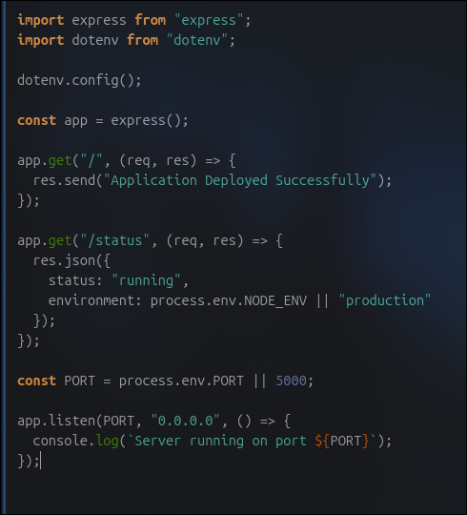

- Configure the application to run on a specified port using environment variables.
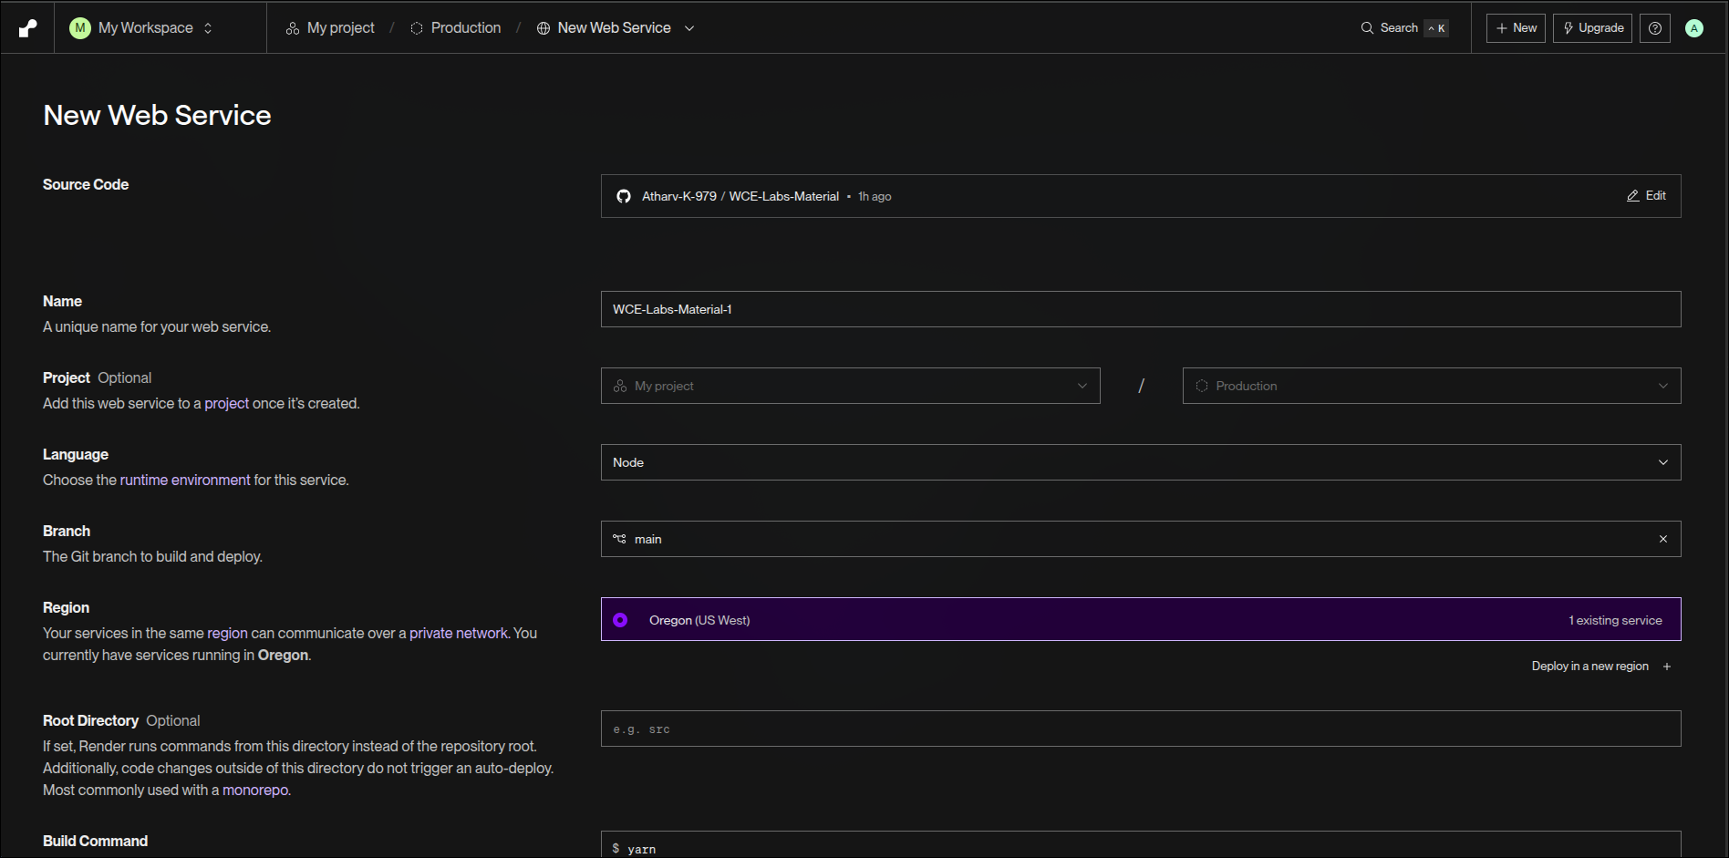
- Deploy the application on a free hosting platform (e.g., Heroku, Render, or Vercel).
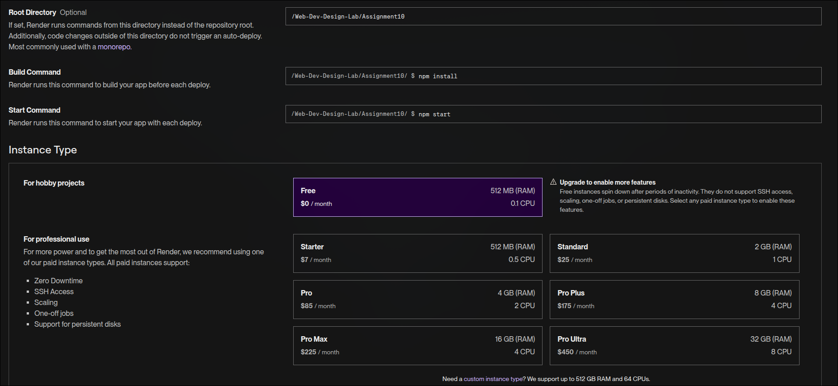

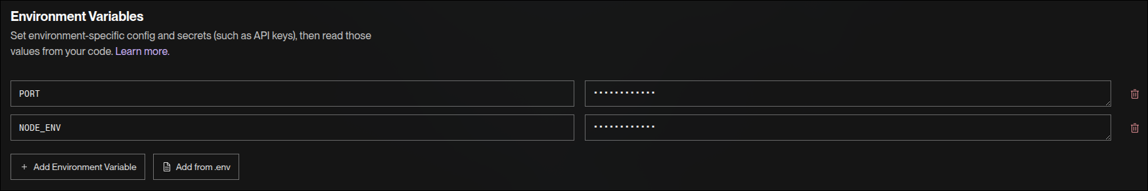
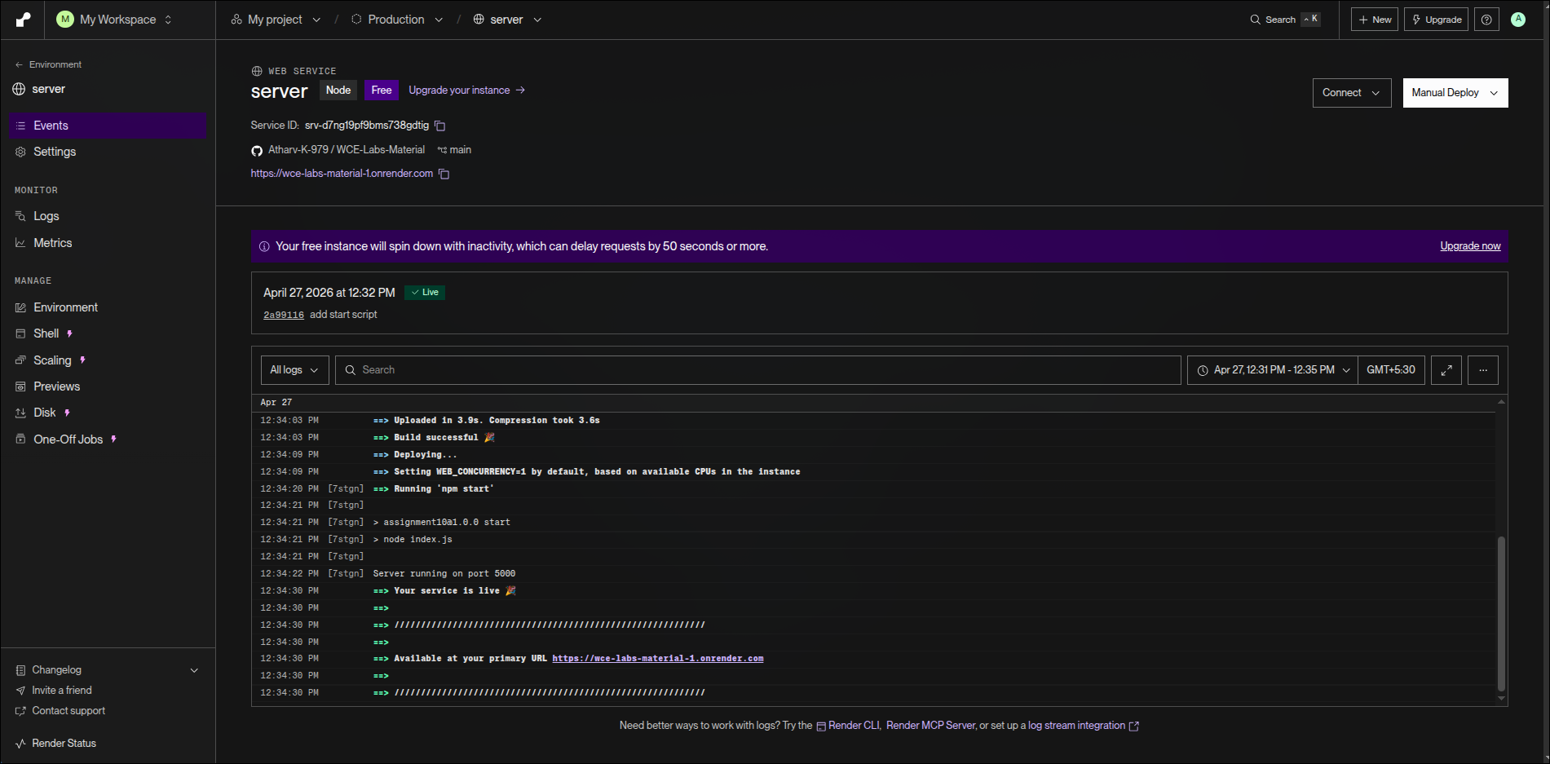
- Verify deployment by accessing the live URL in a browser.



Problem Statement 3: Advanced Deployment Features Requirements
- Add a route:
  - GET /info → Responds with application details (name, version, author).
- Configure error handling for invalid routes (404).
- Implement logging middleware to track requests.
- Demonstrate environment-specific configuration (development vs. production).
- Document the deployment steps (installation, configuration, deployment, verification).

Submission Instructions

- Create a document containing:
  - Source code of the application.
  - Screenshots of local execution.
  - Screenshots of deployment steps.
  - Screenshot of the live deployed application running in the browser.
- Scan the document and create a PDF file named:

“PRN_Assignment_10_Deployment”
- Upload the file on the WCE ERP before the given deadline.

