WEEK 1 PROJECT REPORT
Data Exploration and Agribusiness Landscape Analysis
Exploratory analysis of Indian crop production data for 2024–25, with historical IMD monsoon rainfall context for June–September 2024
Name | Atharv Vyahalkar
Internship | Yuva Intern
Role | Junior Machine Learning Data Analyst – Agriculture & Agribusiness
Reporting period | Week 1
Table of Contents
1. Executive Summary 4
2. Introduction and Study Objectives 5
3. Data Sources and Description 6
3.1 Crop production dataset 6
3.2 IMD monsoon rainfall maps 6
4. Tools and Methodology 7
5. Data Quality Assessment 8
6. Exploratory Data Analysis and Findings 9
6.1 Crop-category production 9
6.2 State-wise production 9
6.3 Seasonal production 10
6.4 Relationship between cultivated area and production 11
6.5 Yield comparison 12
7. Historical Climate and Rainfall Context 14
7.1 Source and interpretation of the maps 14
7.2 June 2024 14
7.3 July 2024 15
7.4 August 2024 15
7.5 September 2024 16
7.6 Seasonal rainfall, 1 June–30 September 2024 16
7.7 Why spatial variability matters, and limits of the maps 17
8. Integrated Interpretation of Crop and Climate Findings 18
9. Key Findings and Agribusiness Relevance 19
10. Limitations and Data Interpretation Risks 20
11. Recommendations and Future Work 21
11.1 Immediate next steps 21
11.2 Longer-term possibilities 21
12. Conclusion 22
References 23
Appendix A: Reproducibility and Calculation Notes 24
Appendix B: Data-Quality Notes 25
Appendix C: Figure Inventory 26
Appendix D: Outstanding Verification Items 27

List of Figures
Figure 1. Top 10 crops by recorded production (full dataset, lakh tonnes) 9
Figure 2. Top 10 states by recorded production, 2024–25 (analysis copy, lakh tonnes) 10
Figure 3. Recorded production by agricultural season, 2024–25 (lakh tonnes) 11
Figure 4. Cultivated area versus crop production, 2024–25 (10,134 observations) 12
Figure 5. Average recorded yield for selected crops, 2024–25 (unweighted mean, kg/ha) 13
Figure 6. IMD rainfall over the country for June 2024: actual, normal (1971–2020) and anomaly (mm) 14
Figure 7. IMD rainfall over the country for July 2024: actual, normal (1971–2020) and anomaly (mm) 15
Figure 8. IMD rainfall over the country for August 2024: actual, normal (1971–2020) and anomaly (mm) 15
Figure 9. IMD rainfall over the country for September 2024: actual, normal (1971–2020) and anomaly (mm) 16
Figure 10. IMD subdivision rainfall map for 1 June–30 September 2024 16
List of Tables
Table 1. Data dictionary for Crop Data 24-25.csv 6
Table 2. Data-quality summary 8
Table 3. Top ten states/UTs by recorded total in the current analysis (apy, lakh tonnes) 10
Table 4. Recorded production by season in the current analysis (apy, lakh tonnes) 11
Table 5. Yield summary for selected crops (apy, kg/ha) 12
Table 6. Summary of verified findings and their status 19
List of Abbreviations
Abbreviation | Meaning
EDA | Exploratory data analysis
IMD | India Meteorological Department
ha | Hectare
kg/ha | Kilograms per hectare (yield unit used in the dataset)
UT | Union territory
CSV | Comma-separated values file
APA | American Psychological Association citation style

1. Executive Summary
This report documents the first week of an agricultural data analysis assignment carried out during the Yuva Intern programme. The objective was to explore an Indian crop production dataset for 2024–25, understand its structure and quality, produce a first set of descriptive findings on crops, states, seasons, area and yield, and place those findings alongside official India Meteorological Department (IMD) monsoon rainfall maps for June–September 2024. The work is exploratory and descriptive. No predictive model was trained and no causal analysis was attempted.
The primary dataset, Crop Data 24-25.csv, was loaded in Google Colab with Python (NumPy, pandas and Matplotlib). It contains 25,239 rows and seven columns covering 31 state and union territory names, 723 distinct district-name strings, 19 crop categories and four season labels. Forty-seven values are missing in each of the production and yield columns, and no exact duplicate rows were found. The original dataset was left unchanged; an analysis copy excluding three aggregate categories (Total Food Grains, Cereals and Nutri/Coarse Cereals) was created for the grouped comparisons.
Within that analysis copy, Uttar Pradesh (1,333.60 lakh tonnes) and Madhya Pradesh (1,006.27 lakh tonnes) recorded the highest totals, followed by Rajasthan, Punjab and Maharashtra. Kharif (1,822.67 lakh tonnes) and Rabi (1,710.57 lakh tonnes) were of similar magnitude, while Summer recorded 201.42 lakh tonnes. Across 10,134 eligible observations the Pearson correlation between area and production was 0.823, a strong positive association. Among five selected crops, unweighted mean yield was highest for Maize (3,494.75 kg/ha) and lowest for Tur (979.79 kg/ha).
The IMD maps show that monsoon rainfall in 2024 was spatially and temporally uneven, with the pattern of departures from the 1971–2020 normal changing from month to month. Because the rainfall information exists only as maps, it was used for context and was not linked statistically to crop outcomes.
Principal limitations. Several broad categories that may overlap with individual crops remain in the analysis copy, so the state-wise and season-wise totals are exploratory results from the current filtering approach and are not validated national totals. Yield means are unweighted record-level averages. The correlation pools different crops, regions and seasons. The next steps are to verify dataset metadata and aggregation rules, inspect the missing records, source numerical district-level rainfall data, and match rainfall to crop seasons before any relationship is tested.

2. Introduction and Study Objectives
Agricultural statistics are among the most widely used public datasets in India, and exploratory analysis is a sensible first step before any modelling. Examining how production is distributed across crops, states and seasons, how cultivated area relates to output, and how yields differ between crops reveals both the shape of the data and its weaknesses. In agribusiness settings these early checks matter because decisions about sourcing, logistics or risk assessment rest on whether the underlying numbers are well defined and consistently measured.
The scope of this Week 1 study was limited to one crop production dataset for 2024–25 and to the visual review of IMD monsoon rainfall maps for 2024. The specific objectives were:
- to inspect the structure, completeness and category composition of the crop dataset;
- to document data-quality observations, particularly missing values, duplicates and overlapping categories;
- to summarise recorded production by crop category, state and season;
- to quantify the association between cultivated area and production;
- to compare mean and median yields for selected major crops;
- to review IMD monthly and seasonal rainfall maps as climate context; and
- to identify what the evidence can and cannot support, and to propose next steps.
This is an exploratory study rather than a predictive machine learning project. Although the internship role concerns machine learning in agriculture, no model was trained, validated or deployed in Week 1, and none of the findings below should be read as a forecast.

3. Data Sources and Description

3.1 Crop production dataset
The crop data were supplied as a CSV file named Crop Data 24-25.csv and loaded into a pandas DataFrame named Df. Each row records one crop category in one district for one season label, with area, production and yield for 2024–25. The columns, as read from the notebook output, are described in Table 1.
Table 1. Data dictionary for Crop Data 24-25.csv
Column | Type | Description | Unit / note
State | Text (object) | State or union territory name | 31 distinct values
District | Text (object) | District name string | 723 distinct strings; not verified as unique districts
Crop | Text (object) | Crop or crop-group category | 19 categories, including aggregates
Season | Text (object) | Season label | Total, Kharif, Rabi, Summer
Area-2024-25 | Numeric (float64) | Cultivated area | Lakh hectares; no missing values
Production-2024-25 | Numeric (float64) | Crop production | Lakh tonnes; 47 missing
Yield-2024-25 | Numeric (float64) | Yield | kg/ha; 47 missing

Units for production and area (lakh tonnes and lakh hectares) are those used in the axis labels of the original notebook analysis; the yield unit (kg/ha) is that used in the notebook's yield chart. The dataset's official catalogue entry and metadata were not part of the supplied materials, so unit definitions and aggregation rules have not been independently confirmed (see Appendix D).

3.2 IMD monsoon rainfall maps
Five reference images from the IMD South-West Monsoon Season 2024 page were supplied: one map for each of June, July, August and September 2024, and a subdivision-wise seasonal map for 1 June–30 September 2024. Each monthly image contains three panels showing actual rainfall (mm), normal rainfall (mm) and the anomaly (mm), the difference between actual and normal. The normal is the 1971–2020 reference climatology printed on the maps. The images were obtained from the IMD page https://imdpune.gov.in/swmonsoon24.php. The official Monsoon Report 2024 is available at https://mausam.imd.gov.in/imd_latest/monsoonreport2024.pdf but was not used to extract any statistic in this report.
The rainfall information is therefore available only as maps. It is not a district-level numerical dataset, and no rainfall values were read off or reconstructed from map colours. Note also that the crop data cover the 2024–25 agricultural year, while the rainfall maps cover June–September 2024 only. The two periods overlap but are not the same.

4. Tools and Methodology
All analysis was performed in a Google Colab notebook (Agriculture_Data_Analysis_Week_1.ipynb) running Python 3, using NumPy, pandas and Matplotlib. The workflow, reconstructed from the notebook code and outputs, was as follows.
- Libraries were imported (numpy, pandas, matplotlib.pyplot).
- The CSV was loaded into the DataFrame Df, and the load was confirmed by a printed message.
- Dimensions, the first and last five rows, column names, data types (Df.info) and descriptive statistics (Df.describe) were reviewed.
- Missing values per column, exact duplicate rows and unique values per column were counted.
- Crop and state coverage was examined through unique counts and value counts, and all crop and season categories were listed.
- Total recorded production by crop was grouped on the full DataFrame Df, and the ten largest were plotted.
- An analysis copy, apy, was created by excluding the rows whose Crop was Total Food Grains, Cereals or Nutri/Coarse Cereals. The notebook confirmed that the original dataset remained unchanged (25,239 records in Df; 17,823 in apy).
- Production was summed by state and by season using apy, with sums computed with min_count=1 so that groups containing only missing values returned missing rather than zero. The Total season was dropped before plotting the seasonal comparison.
- The Pearson correlation between area and production was computed for apy rows with non-missing area and production, area greater than zero and production of at least zero.
- Count, mean and median yield were computed in apy for Rice, Wheat, Maize, Gram and Tur, excluding rows with missing yield.
- Bar charts and one scatter plot were produced, and the IMD maps were reviewed visually.
No imputation, outlier removal, normalisation, statistical testing, causal analysis or predictive modelling was performed. The only data transformation was the row filter that produced apy, and the original DataFrame was retained in memory throughout.

5. Data Quality Assessment
Table 2 summarises the checks performed on the full dataset before any filtering. All figures were verified by re-running the notebook logic on the supplied CSV and matched the notebook output.
Table 2. Data-quality summary
Check | Result | Implication
Dimensions | 25,239 rows × 7 columns | Row-level data at crop–district–season granularity
States / UTs | 31 distinct names | Names were not cross-checked against an official list
District names | 723 distinct strings | May differ from the number of unique administrative districts
Crop categories | 19 | Includes individual crops and broader groupings
Season labels | 4 (Total 10,163; Kharif 7,335; Rabi 5,330; Summer 2,411 rows) | Total appears to be an aggregate label; its relationship to the three seasons is unresolved
Missing: Production-2024-25 | 47 | Excluded from sums by default; not imputed
Missing: Yield-2024-25 | 47 | Excluded from yield statistics
Missing: other columns | 0 | State, District, Crop, Season and Area complete
Exact duplicate rows | 0 | No exact repeated rows; near-duplicates not tested

The most consequential finding concerns categories. The Crop column mixes individual crops (Rice, Wheat, Maize, Gram, Tur, Moong, Urad, Jowar, Bajra, Ragi, Barley, Lentil, Small Millets) with broader groups (Cereals, Nutri/Coarse Cereals, Shree Anna /Nutri Cereals, Total Food Grains, Total Pulses, Other Pulses). The three most frequent categories in the file are in fact aggregates: Total Food Grains (2,597 rows), Cereals (2,525) and Nutri/Coarse Cereals (2,294). Summing production over the whole Crop column would therefore count the same output more than once. The analysis copy removed only three of these groups, so other overlapping aggregates, such as Total Pulses, Other Pulses and Shree Anna /Nutri Cereals, remain. The exact relationship between each group and its constituent crops could not be established from the supplied materials, and no hierarchy was assumed.
The missing production and yield values are limited to 47 rows (about 0.19 percent of the dataset) and affect 14 of the 19 categories, with the largest counts in Ragi (8), Moong (7) and Lentil (6). Chhattisgarh (14) and Rajasthan (11) account for the most rows with a missing value. The pattern was not investigated further. Finally, the dataset reports yield as a stored column, so it was not recalculated from area and production, and the consistency of the three columns was not tested.
The original dataset was retained intact. No values were imputed, corrected or deleted from it.

6. Exploratory Data Analysis and Findings
Each result below is labelled as a calculated notebook result. The charts were regenerated from the supplied CSV with the same code as the notebook, and the underlying numbers were checked against the notebook output.

6.1 Crop-category production
Figure 1 shows the ten largest crop categories by summed recorded production, computed on the full DataFrame Df, before the aggregate categories were excluded. It therefore ranks individual crops and aggregates together.
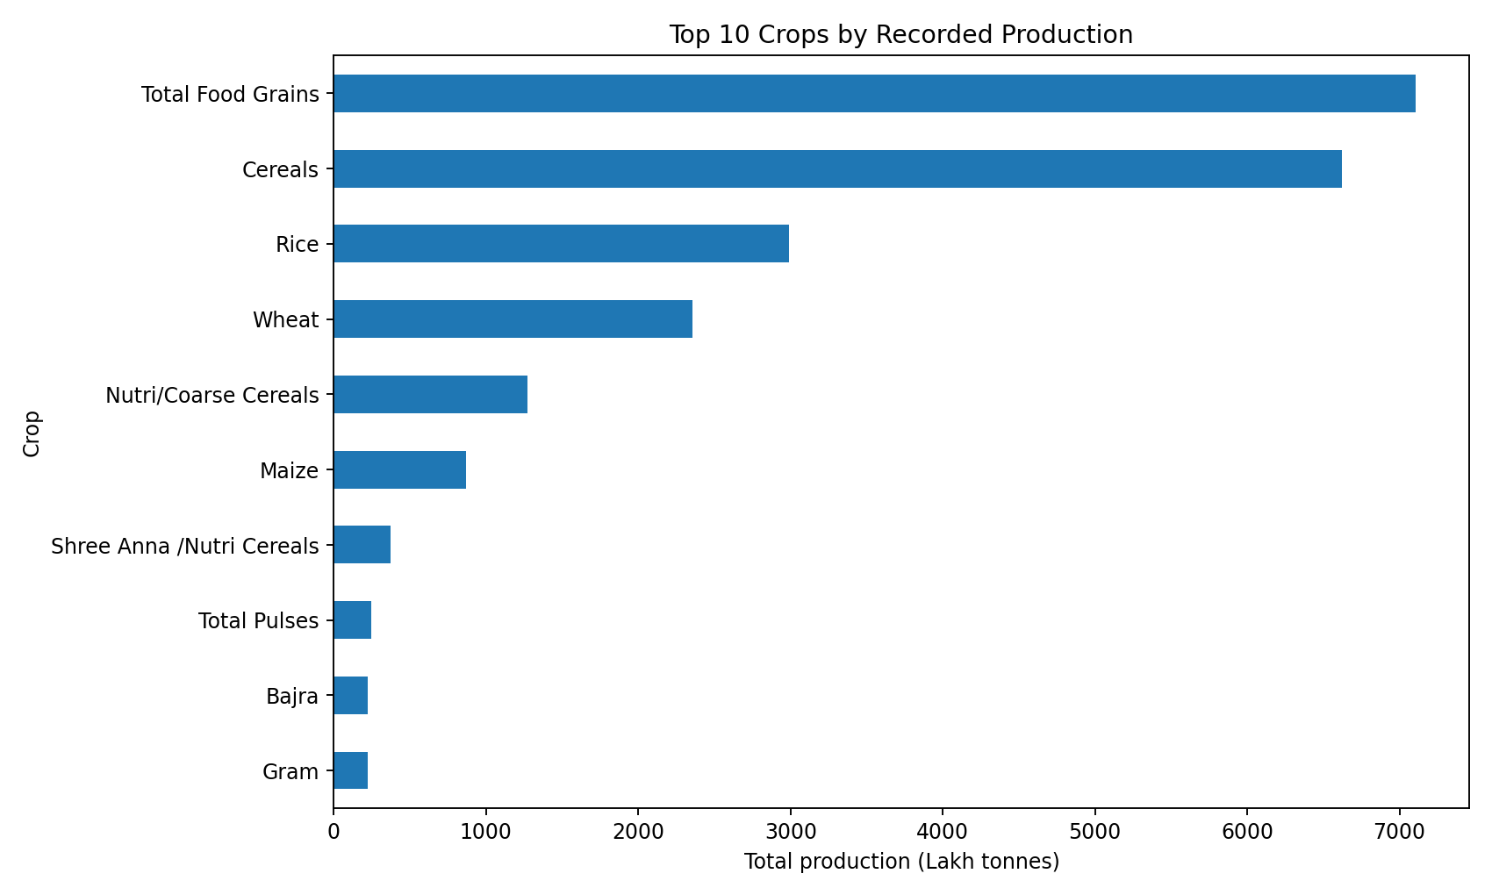
Figure 1. Top 10 crops by recorded production (full dataset, lakh tonnes)
Source: Notebook cell output regenerated from the supplied CSV using the notebook code.
Total Food Grains and Cereals dominate the chart, followed by Rice, Wheat, Nutri/Coarse Cereals and Maize. This ordering is largely an artefact of aggregation: Total Food Grains and Cereals are broad groups that presumably contain several of the crops listed below them, so the chart should not be read as a ranking of crops by output. It is better understood as evidence of the category ambiguity described in Section 5 and as the reason the analysis copy was created. Among the categories that look like single crops, Rice and Wheat are clearly the largest, with Maize some way behind.

6.2 State-wise production
Using the analysis copy apy, production was summed by state. Table 3 and Figure 2 present the ten highest recorded totals in the current analysis. These values come from a filtering approach that removed only three aggregate categories, so overlapping categories may still contribute to them. They must not be treated as validated official state production totals.
Table 3. Top ten states/UTs by recorded total in the current analysis (apy, lakh tonnes)
Rank | State/UT | Recorded production (lakh tonnes)
1 | Uttar Pradesh | 1,333.60
2 | Madhya Pradesh | 1,006.27
3 | Rajasthan | 660.60
4 | Punjab | 655.76
5 | Maharashtra | 470.19
6 | Telangana | 444.13
7 | Bihar | 431.23
8 | Haryana | 404.04
9 | West Bengal | 401.03
10 | Karnataka | 359.41
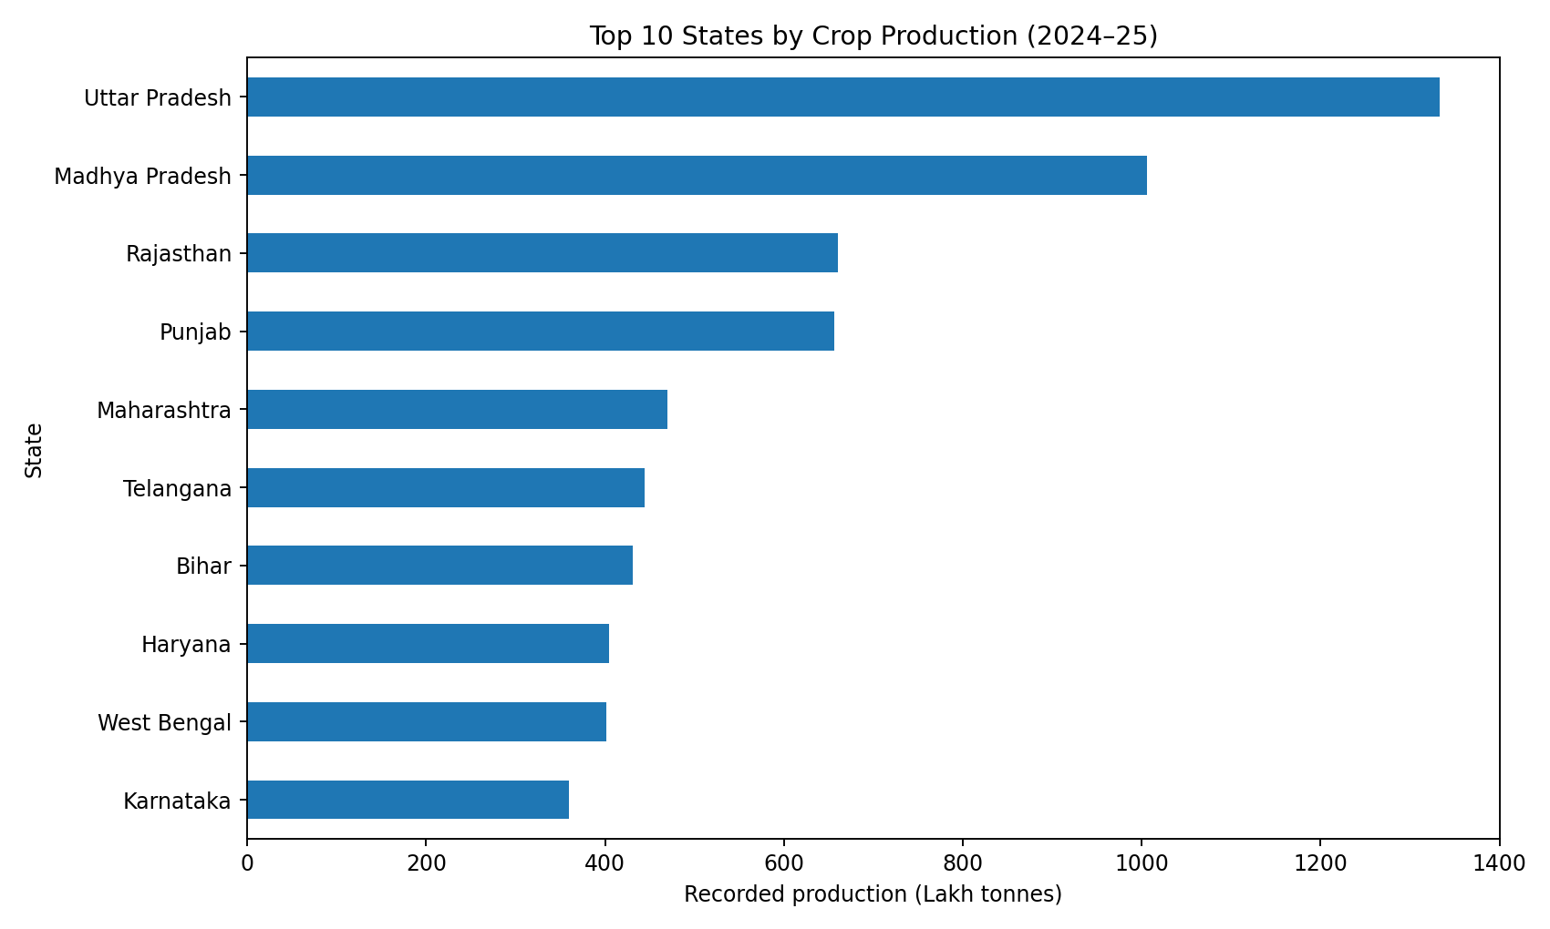
Figure 2. Top 10 states by recorded production, 2024–25 (analysis copy, lakh tonnes)
Source: Notebook cell output regenerated from the supplied CSV using the notebook code.
Uttar Pradesh leads by a wide margin, and Madhya Pradesh is second. Together with Rajasthan and Punjab they form the top four, and the totals fall steeply after the second state. Uttar Pradesh also has the most rows in the dataset (3,171), and Madhya Pradesh the second most (2,360), so some of the ranking may reflect how many crop–district–season records each state contributes as well as how much it produces. Whether the ranking changes after the remaining aggregates are handled has not been tested.

6.3 Seasonal production
Production in apy was summed by season. The Total label returned 3,978.04 lakh tonnes. It appears to be an aggregate label rather than an independent season, so it was excluded from the comparison in Figure 3. Table 4 lists the values.
Table 4. Recorded production by season in the current analysis (apy, lakh tonnes)
Season | Recorded production (lakh tonnes) | Note
Kharif | 1,822.67 | Included in comparison
Rabi | 1,710.57 | Included in comparison
Summer | 201.42 | Included in comparison
Total | 3,978.04 | Total label; excluded from comparison
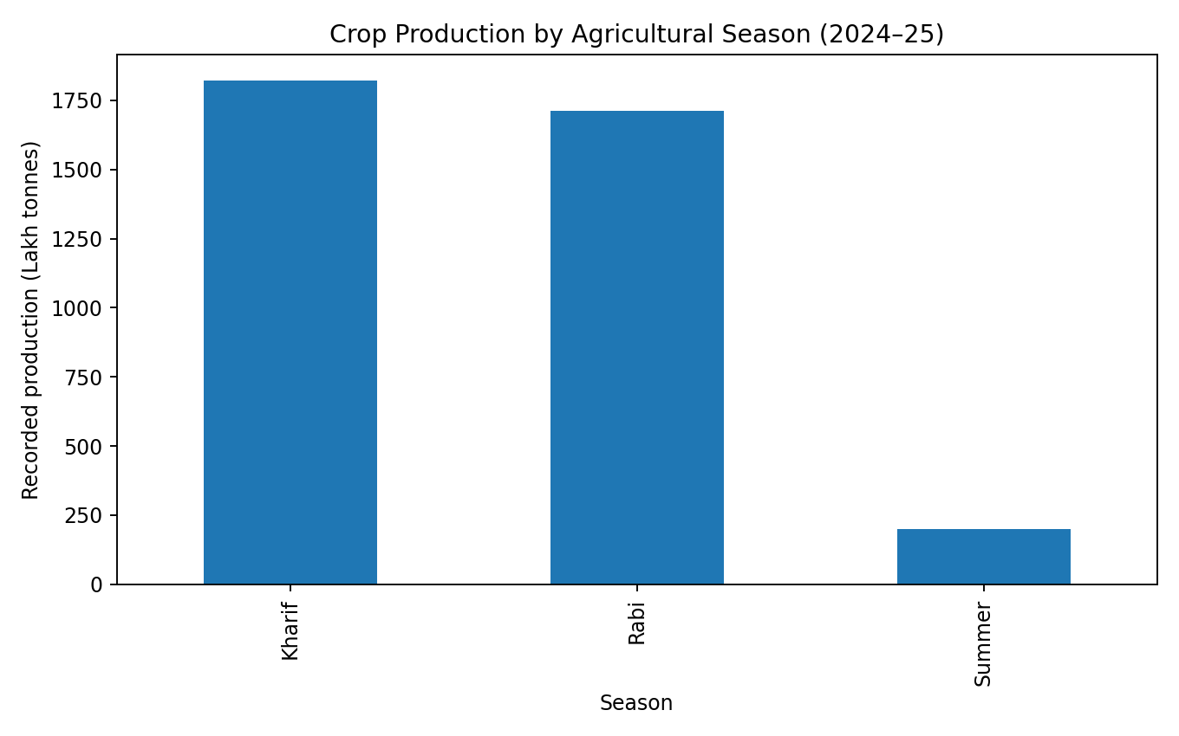
Figure 3. Recorded production by agricultural season, 2024–25 (lakh tonnes)
Source: Notebook cell output regenerated from the supplied CSV using the notebook code.
Kharif and Rabi are of similar magnitude, with Kharif slightly higher, and Summer is roughly one-ninth of Kharif. The Kharif, Rabi and Summer values sum to 3,734.66 lakh tonnes, which is less than the Total label's 3,978.04, so the Total rows are not a simple sum of the three seasons in this data. The reason for the difference has not been established, and no explanation is assumed here. As with the state totals, these seasonal figures remain exploratory because of the unresolved category issue.

6.4 Relationship between cultivated area and production
Figure 4 plots area against production for the 10,134 observations in apy that had non-missing area and production, area above zero and production of at least zero. The Pearson correlation coefficient for these observations was 0.823.
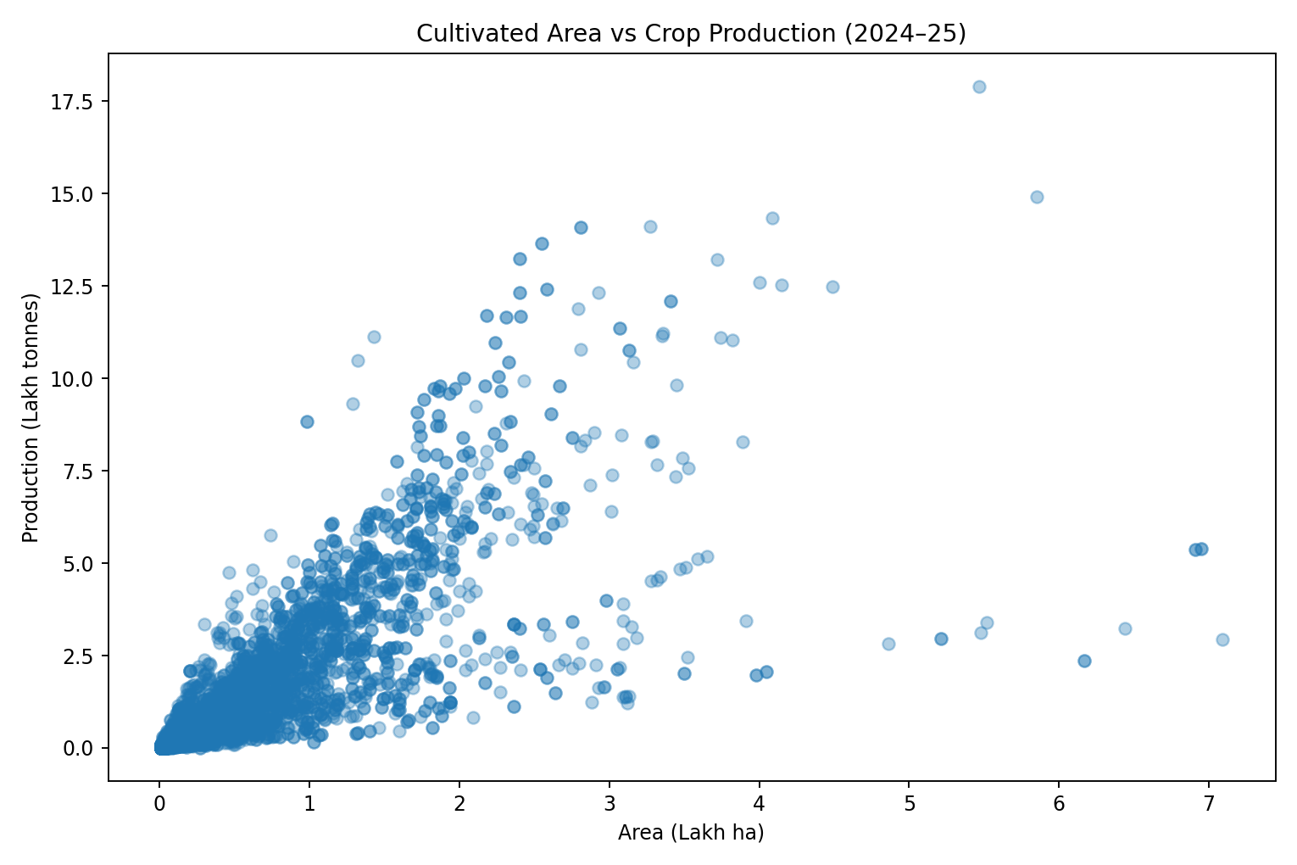
Figure 4. Cultivated area versus crop production, 2024–25 (10,134 observations)
Source: Notebook cell output regenerated from the supplied CSV using the notebook code.
The cloud rises from the origin, and most points lie below roughly 2 lakh hectares and 5 lakh tonnes. A coefficient of 0.823 indicates a strong positive linear association among these observations: records with larger area tend to have larger production. This is unsurprising, since production is the product of area and yield. The plot also shows considerable spread, including a visible band of points with large area but comparatively low production. These presumably correspond to lower-yield crops, seasons or regions, which the pooled data cannot separate. The coefficient describes association only and does not demonstrate causation. It applies to the included observations, which combine different crops, states and seasons, and it would be expected to differ within any one crop. The observations also include rows from overlapping categories, which may influence the figure.

6.5 Yield comparison
Table 5 and Figure 5 compare yield for five selected crops in apy, after excluding rows with missing yield.
Table 5. Yield summary for selected crops (apy, kg/ha)
Crop | Records | Mean yield (kg/ha) | Median yield (kg/ha)
Maize | 2,026 | 3,494.75 | 3,177.50
Wheat | 1,062 | 2,795.78 | 2,790.00
Rice | 1,792 | 2,687.83 | 2,698.50
Gram | 1,014 | 1,219.02 | 1,216.00
Tur | 1,040 | 979.79 | 935.50
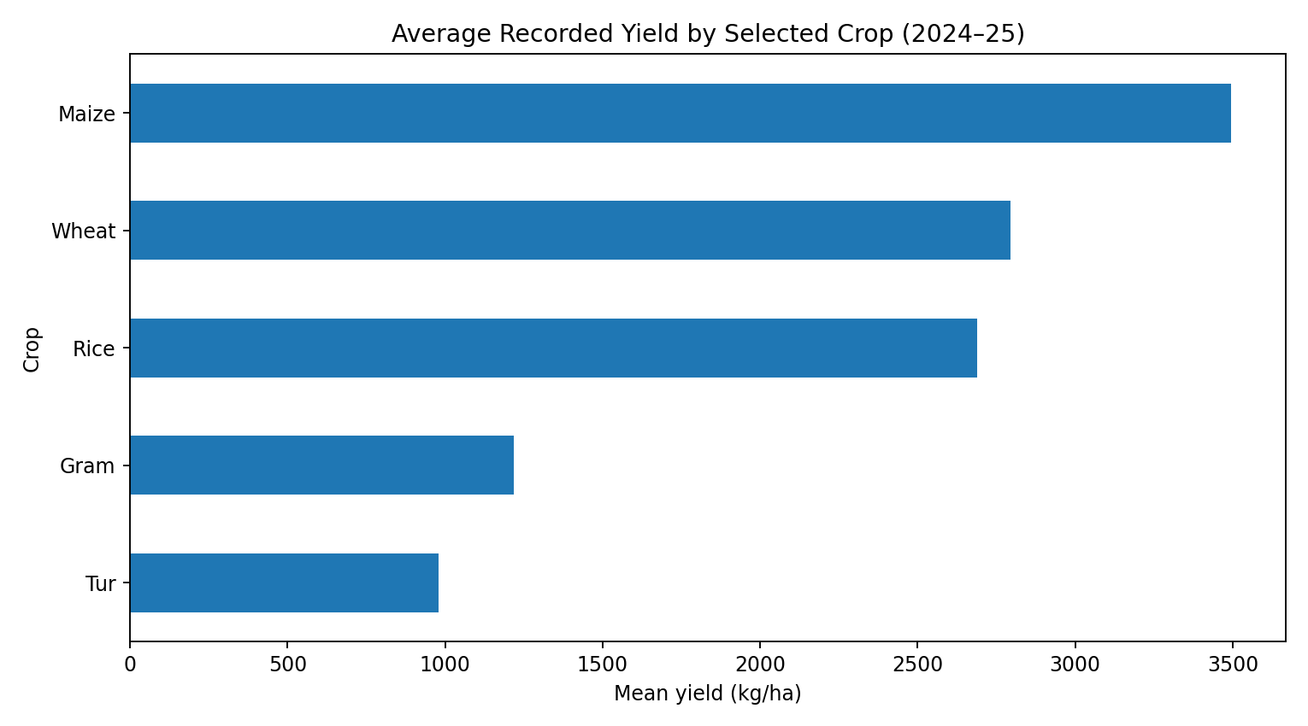
Figure 5. Average recorded yield for selected crops, 2024–25 (unweighted mean, kg/ha)
Source: Notebook cell output regenerated from the supplied CSV using the notebook code.
Maize has the highest mean yield, followed closely by Wheat and Rice, while the two pulses, Gram and Tur, are far lower. The mean and median are relatively close for Wheat, Rice, Gram and Tur, indicating similar central values for these crops. However, distribution shape and skewness would require further examination of the underlying observations. For Maize the mean exceeds the median by about 317 kg/ha, which is consistent with some high yield values pulling the mean upward, but the distribution itself was not examined.
These means are unweighted averages across district-season records. A district with a few hundred hectares counts as much as one with several lakh hectares, so the figures are not area-weighted national yield estimates and should not be compared with official national yields. An area-weighted yield would divide total production by total area for the group in question. Maize records can also span several seasons and regions, which may help explain its wider spread.
Note on record counts. The Maize and Gram counts above (2,026 and 1,014) are the values printed in the final notebook output, and the same counts were obtained by re-running the notebook logic on the supplied CSV. They differ from the reference values given in the project brief (2,005 and 1,054), which neither the notebook output nor the CSV supports. The notebook values are therefore used throughout, and the mean and median yields were not altered. The discrepancy is recorded in Appendix D.

7. Historical Climate and Rainfall Context

7.1 Source and interpretation of the maps
The monthly maps come from the Climate Monitoring and Prediction Group of IMD and show three panels: actual rainfall in millimetres, normal rainfall in millimetres for the 1971–2020 period, and the anomaly in millimetres. The anomaly is actual minus normal, so red shades indicate a deficit and blue shades an excess. Colour scales differ between months and panels. For example, the actual-rainfall legend runs to 300 mm in June and September, 400 mm in August and 600 mm in July, so colours can be compared reliably only within the same panel and month. The observations below are visual impressions and are not measurements.

7.2 June 2024
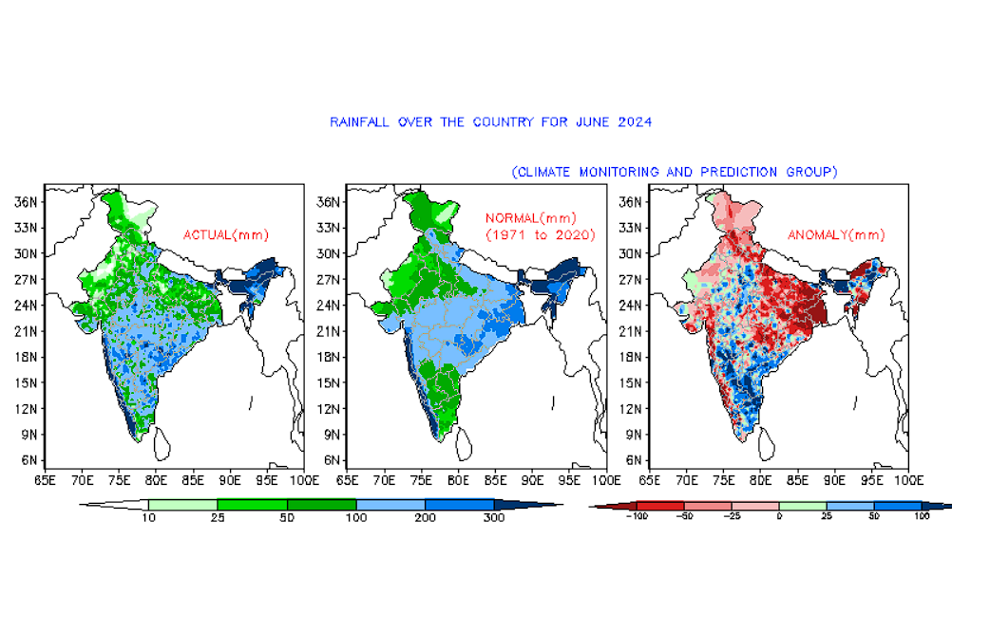
Figure 6. IMD rainfall over the country for June 2024: actual, normal (1971–2020) and anomaly (mm)
Source: IMD, South-West Monsoon Season 2024 (https://imdpune.gov.in/swmonsoon24.php).
In Figure 6, the anomaly panel is dominated by deficits (red) across much of the north, northwest and the east and central-east of the country, with the deepest reds over parts of eastern India. Positive departures (blue) are concentrated along the southwest coast and adjoining peninsular India, and appear in patches over parts of central India and the northeast.

7.3 July 2024
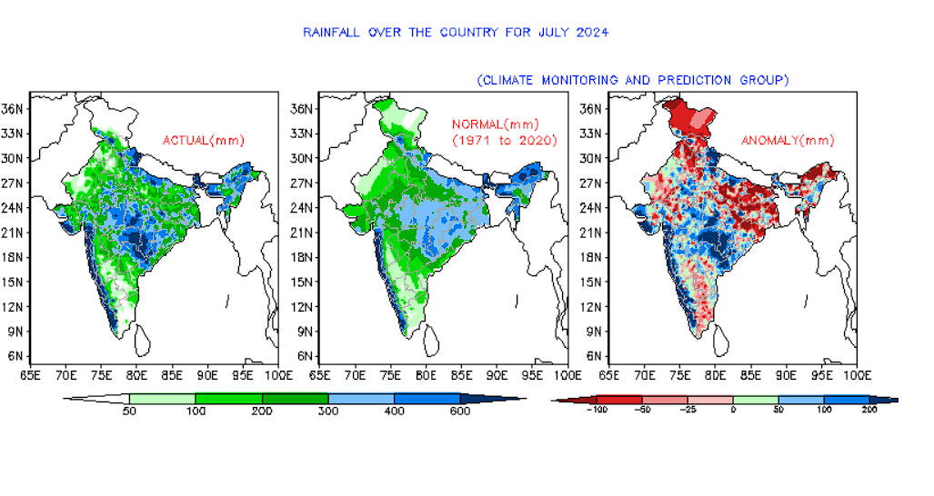
Figure 7. IMD rainfall over the country for July 2024: actual, normal (1971–2020) and anomaly (mm)
Source: IMD, South-West Monsoon Season 2024 (https://imdpune.gov.in/swmonsoon24.php).
Figure 7 shows a strong July deficit in the far north, with further red areas across the northern plains and parts of eastern and northeastern India. Blue departures are widespread along the west coast and across Gujarat, central India and parts of the peninsula, and the actual-rainfall panel shows the heaviest rainfall over the west coast and central regions.

7.4 August 2024
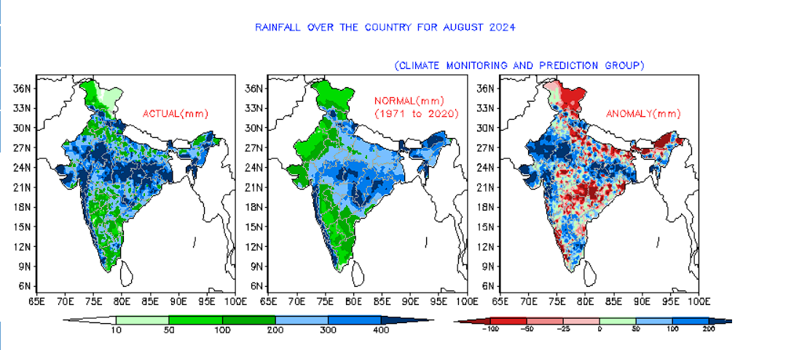
Figure 8. IMD rainfall over the country for August 2024: actual, normal (1971–2020) and anomaly (mm)
Source: IMD, South-West Monsoon Season 2024 (https://imdpune.gov.in/swmonsoon24.php).
The August anomaly map in Figure 8 has a more mixed appearance. Blue departures cover much of the northwest and Gujarat, with extensive areas across north and east-central India. Red patches are visible over parts of the central peninsula, the far north, the northeast and pockets of the southwest, so the spatial pattern differs markedly from that of June.

7.5 September 2024
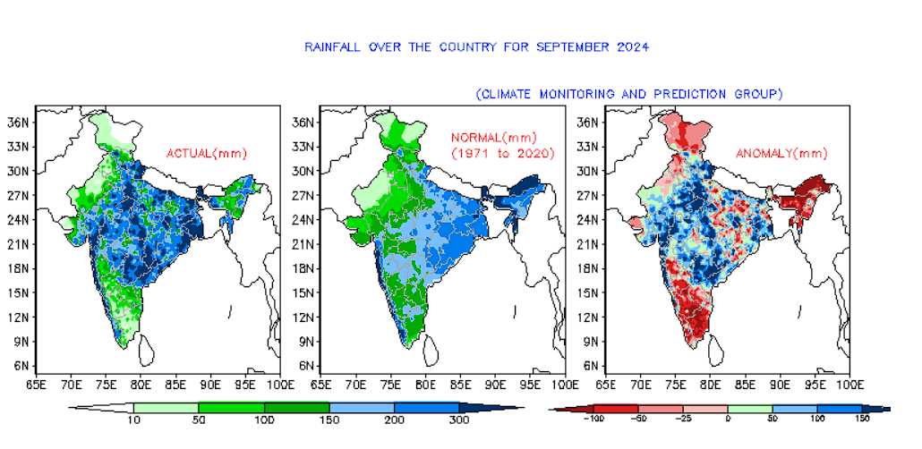
Figure 9. IMD rainfall over the country for September 2024: actual, normal (1971–2020) and anomaly (mm)
Source: IMD, South-West Monsoon Season 2024 (https://imdpune.gov.in/swmonsoon24.php).
In Figure 9, the September blue departures cover a broad central belt of the country, while red dominates the southern peninsula, the northeast and the far north. The sign of the departure over the south has therefore reversed relative to June.

7.6 Seasonal rainfall, 1 June–30 September 2024
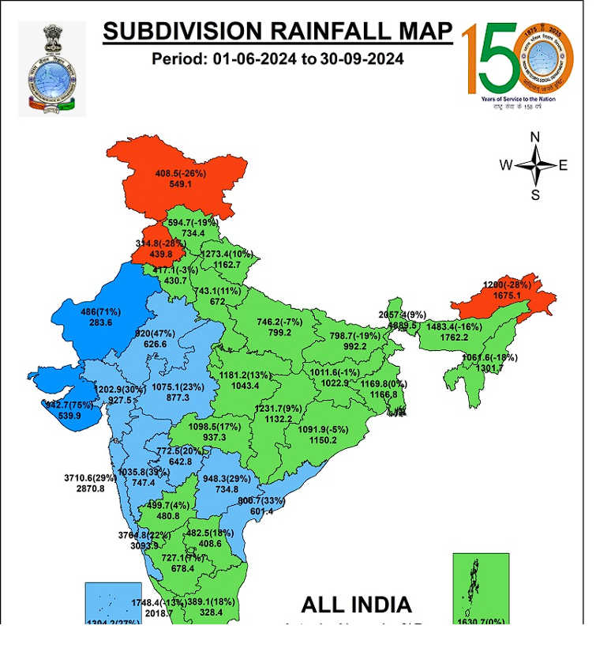
Figure 10. IMD subdivision rainfall map for 1 June–30 September 2024
Source: IMD, South-West Monsoon Season 2024 (https://imdpune.gov.in/swmonsoon24.php). The supplied image is cropped at the bottom; the legend and all-India summary are not visible.
The seasonal map in Figure 10 is coloured by meteorological subdivision, with each subdivision labelled with actual rainfall, the departure from normal in percent, and normal rainfall. Orange-red subdivisions are in deficit, green are near normal, and light and dark blue indicate excess rainfall. Deficit subdivisions appear in the far north, in the northwest near Punjab and in the northeast, while excess subdivisions are concentrated in the west (parts of Gujarat, Rajasthan, Maharashtra and the peninsula), where dark blue marks the largest excesses. Among the legible subdivision labels, departures range from roughly −28 percent to about +75 percent. The colour classes described here follow IMD's usual categories but the legend and the all-India summary at the bottom of the image are not visible in the supplied crop, so they have not been quoted (see Appendix D).

7.7 Why spatial variability matters, and limits of the maps
Seasonal rainfall totals can hide the month-to-month pattern. Across the four months the anomaly maps shift between deficit and excess in several regions, and the seasonal map averages those shifts into a single subdivision value. For agricultural research this matters because the effect of rainfall depends on where a crop is grown and when it is sown, flowering or harvested. A deficit in June may matter most for sowing of Kharif crops, whereas an excess in September may matter more near harvest.
The maps also have clear limits for analysis. They are images, not data, so exact values for individual districts cannot be recovered. The colour scales differ between months, and subdivision averages are coarser than districts. They are also silent on irrigation, soil moisture and rabi-season rainfall, and they cover only the monsoon months while the crop data cover the whole 2024–25 year.

8. Integrated Interpretation of Crop and Climate Findings
Rainfall timing and regional distribution are plausible influences on crop production and yield, particularly for rainfed Kharif crops. The 2024 maps show that the monsoon delivered very different conditions to different regions and months, and that a region's departure from normal could change sign during the season. These are useful reasons to expect that yield variation within a crop could be partly climatic.
The present work, however, did not join the crop dataset to numerical rainfall observations at any district or time level. It therefore establishes no statistical relationship between rainfall and any crop outcome, and the climate maps should not be taken to explain, or to have caused, the production rankings in Section 6. State rankings are driven by area, crop mix, irrigation and the number of records, none of which were controlled for here.
The exploratory work does suggest specific, testable questions for later phases:
- Do district-level rainfall departures during the sowing and growing months correspond to differences in yield for the same crop and season?
- Do Kharif crops in districts in deficit in June show lower yields than those in districts near normal, once crop and state are held fixed?
- Is the wide spread of production at larger areas, visible in Figure 4, associated with crop type, season or region?
- Are rainfall-yield associations different for irrigated states such as Punjab and Haryana than for largely rainfed regions?
Answering them needs numerical gridded or district-level rainfall data and a defensible mapping of rainfall periods to crop seasons.

9. Key Findings and Agribusiness Relevance
Table 6 lists the main findings of the Week 1 analysis, the type of evidence behind each, and its current status.
Table 6. Summary of verified findings and their status
Finding | Type | Status
25,239 rows, 7 columns; 47 missing production and yield values; no exact duplicates | Observed dataset property | Verified
Aggregate and individual crop categories coexist in one column | Observed dataset property | Verified; hierarchy not established
UP and MP lead recorded state totals (1,333.60 and 1,006.27 lakh tonnes) | Calculated result | Exploratory; aggregates may remain
Kharif 1,822.67; Rabi 1,710.57; Summer 201.42 lakh tonnes | Calculated result | Exploratory; aggregates may remain
Area–production Pearson r = 0.823 (n = 10,134) | Calculated result | Association among pooled records only
Mean yield: Maize 3,494.75 > Wheat > Rice > Gram > Tur 979.79 kg/ha | Calculated result | Unweighted record-level means
Monsoon anomalies changed pattern month to month in 2024 | Visual map observation | Qualitative only

For further agricultural data analysis, the most valuable outcome of Week 1 is a clearer picture of what the dataset can support. The records are rich enough for crop-, state- and season-level comparison, but they need a documented treatment of aggregate categories before any totals are quoted. The strong area–production association and the contrast between cereal and pulse yields are in line with general expectations and offer a limited plausibility check on the data.
Production and yield alone do not indicate profitability, market demand, farmer income or price trends, and none of these are inferred here. Investigating them would need mandi price and arrival data, cost-of-cultivation estimates, procurement or minimum support price information, and demand-side data, matched to the same crops, places and periods.

10. Limitations and Data Interpretation Risks
- Overlapping crop categories. Total Food Grains, Cereals and Nutri/Coarse Cereals were excluded from apy, but Total Pulses, Other Pulses and Shree Anna /Nutri Cereals remain. If any of these overlap with individual crops, state, season and correlation results include double counting.
- Incomplete aggregate removal. The filter was based on inspecting the category list and not on a documented aggregation rule, so it may be too narrow or, for other analyses, too broad.
- Missing values. Forty-seven production and yield values are missing and were left as missing. Their effect is likely small in count but was not assessed.
- District names. The 723 distinct district-name strings may include spelling variants or districts that were split or renamed, so the count may not equal the number of unique administrative districts.
- Unweighted yields. Yield means weight every record equally and are not national yield estimates.
- Heterogeneous correlation. The 0.823 coefficient pools different crops, seasons and regions and may be influenced by overlapping categories and by large-area outliers. It says nothing about causation.
- Total season label. The Total rows do not equal the sum of Kharif, Rabi and Summer in this data, and the reason is unknown.
- No numerical rainfall data. The rainfall evidence consists of map images, with no district-level numerical linkage to the crop data and non-identical time coverage.
- No market analysis. No price, arrival or cost data were analysed, so no economic conclusions are drawn.
- Descriptive scope. No predictive or causal methods were applied and no statistical significance was tested.

11. Recommendations and Future Work

11.1 Immediate next steps
- Verify the dataset's metadata, units and aggregation rules with its official source, and document which categories are aggregates of which.
- Inspect the 47 rows with missing production and yield, and decide, with justification, how to treat them.
- Re-run the state and season summaries after the category issue is settled, and compare against the current exploratory totals.
- Conduct crop-specific and region-specific comparisons, and add area-weighted yields alongside the unweighted means.
- Improve reproducibility by recording the filters, categories and random or version details in the notebook, with explanatory comments.

11.2 Longer-term possibilities
- Obtain numerical historical rainfall data at district or grid level from official sources, where available.
- Match rainfall and crop observations only where geographic and temporal definitions are compatible, for example by aligning monsoon months to Kharif sowing and growth stages.
- Explore official agricultural market-price and arrivals data in a later phase.
- Only after these steps, consider whether modelling is appropriate, with a clearly defined target and validation approach.

12. Conclusion
In Week 1 the crop production dataset for 2024–25 was loaded, inspected and summarised, and the IMD monsoon rainfall maps for June–September 2024 were reviewed for context. The notebook established the dataset's size and completeness, produced exploratory rankings of states and seasons, found a strong positive association (r = 0.823) between area and production, and showed clear differences in mean yield between cereals and pulses.
These results indicate where recorded production is concentrated and how output scales with area, but they cannot yet be treated as validated totals. The central unresolved issue is the mixture of individual and aggregate crop categories, which affects every grouped sum. The analysis also cannot say anything about the influence of rainfall, because the maps were not linked numerically to crop records, and nothing about prices or profitability.
This is the reason the report separates observed properties, calculated results and visual interpretation, and keeps caveats beside the results they qualify. The next phase can build on the work by confirming category definitions, treating missing records, adding numerical rainfall data and testing specific questions at district and season level.

References
India Meteorological Department. (2024). South-West Monsoon Season 2024 [Web page with rainfall maps]. Ministry of Earth Sciences, Government of India. https://imdpune.gov.in/swmonsoon24.php
India Meteorological Department. (2024). Monsoon report 2024 [Report]. Ministry of Earth Sciences, Government of India. https://mausam.imd.gov.in/imd_latest/monsoonreport2024.pdf (listed as the official report; no statistics were extracted from it for this report).
Crop Data 24-25.csv [Data set]. (n.d.). Crop production data for 2024–25 supplied for the internship. [Publisher, catalogue title and URL to be confirmed; see Appendix D.]

Appendix A: Reproducibility and Calculation Notes
Source file: Crop Data 24-25.csv (analysed as Crop_Data_24-25.csv in the report-preparation environment). Environment: Google Colab, Python 3, NumPy, pandas, Matplotlib; library versions were not recorded in the supplied materials.
Step | Definition
Analysis copy | apy = Df[~Df['Crop'].isin(['Total Food Grains','Cereals','Nutri/Coarse Cereals'])].copy() (17,823 rows)
Grouped sums | groupby(...)['Production-2024-25'].sum(min_count=1)
Correlation rows | Area and production non-missing, Area > 0, Production ≥ 0 (10,134 rows)
Yield statistics | apy filtered to Rice, Wheat, Maize, Gram, Tur with non-missing yield; count, mean, median
Figure 1 data | Df (full dataset), not apy

The Pearson correlation coefficient is r = covariance(X, Y) / (standard deviation(X) × standard deviation(Y)), where X is area and Y is production. The reported value of 0.823 applies only to the 10,134 included observations.

Appendix B: Data-Quality Notes
- Missing values: 47 in Production-2024-25 and 47 in Yield-2024-25; none elsewhere.
- Exact duplicate rows: 0.
- Aggregate-category limitation: three aggregates excluded; other potentially overlapping categories remain; hierarchy not established.
- Original dataset preserved; no imputation or deletion applied to it.

Appendix C: Figure Inventory
Figure | Content | Origin | Location
1 | Top 10 crops by recorded production | Notebook cell [56], regenerated from CSV | Section 6.1
2 | Top 10 states by production | Notebook cell [59], regenerated | Section 6.2
3 | Production by season | Notebook cell [60], regenerated | Section 6.3
4 | Area vs production scatter | Notebook cell [61], regenerated | Section 6.4
5 | Mean yield, selected crops | Notebook cell [62], regenerated | Section 6.5
6–9 | IMD monthly maps, June–September | Supplied IMD images | Sections 7.2–7.5
10 | IMD seasonal subdivision map | Supplied IMD image (cropped at bottom) | Section 7.6

Appendix D: Outstanding Verification Items
- Resolved discrepancy (retained for transparency): the final notebook output and the CSV give 2,026 Maize and 1,014 Gram records, while the project brief listed 2,005 and 1,054. The notebook values are used; the origin of the brief's values is unknown.
- Dataset publisher, catalogue entry, and official unit definitions are not in the supplied materials.
- The aggregation relationships among crop categories, and the reason the Total season label exceeds the sum of the three seasons.
- The seasonal IMD map image (Figure 10) is cropped at the bottom, and no complete version was among the supplied files, so its legend and the all-India figure are not visible. The map has not been reconstructed. Colour categories described in Section 7.6 should be checked against the IMD report.
- Library versions and the notebook's exact run date were not recorded.
- The Agricultural Statistics at a Glance 2024–25 PDF was supplied but not used, since no analysis in the notebook relied on it.

