**Declarative Jenkins Pipeline**

**1. To create a declarative pipeline, you need to have a Jenkinsfile in place. Since I will be using the project from my Github account, I have already placed the Jenkinsfile in my project.**

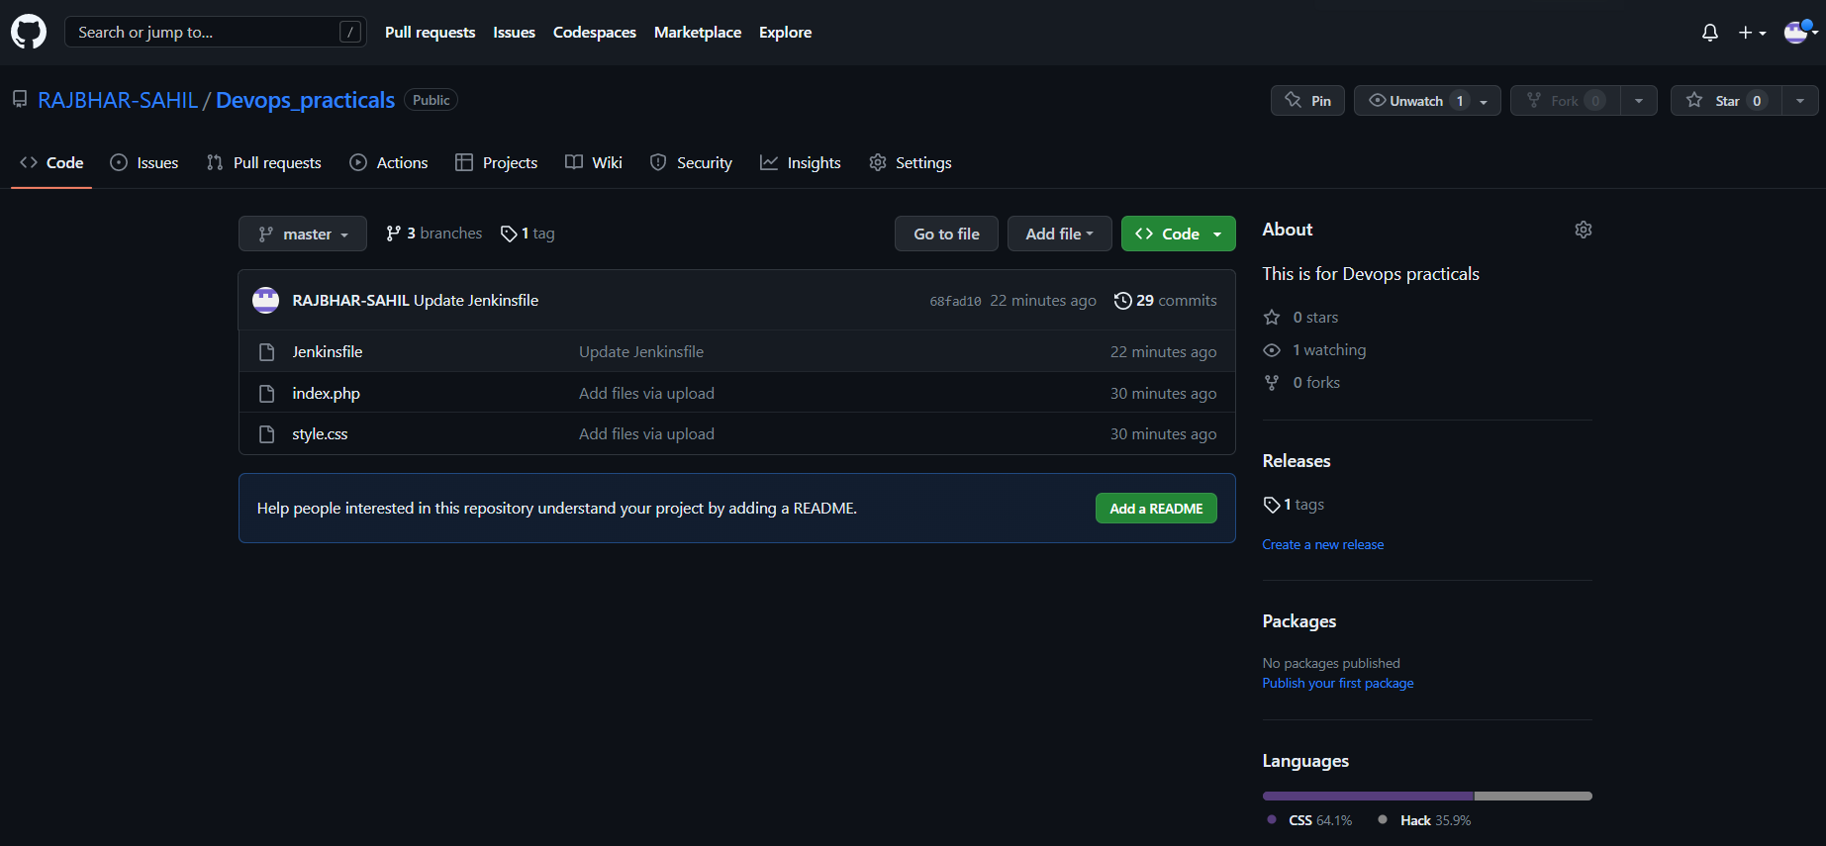

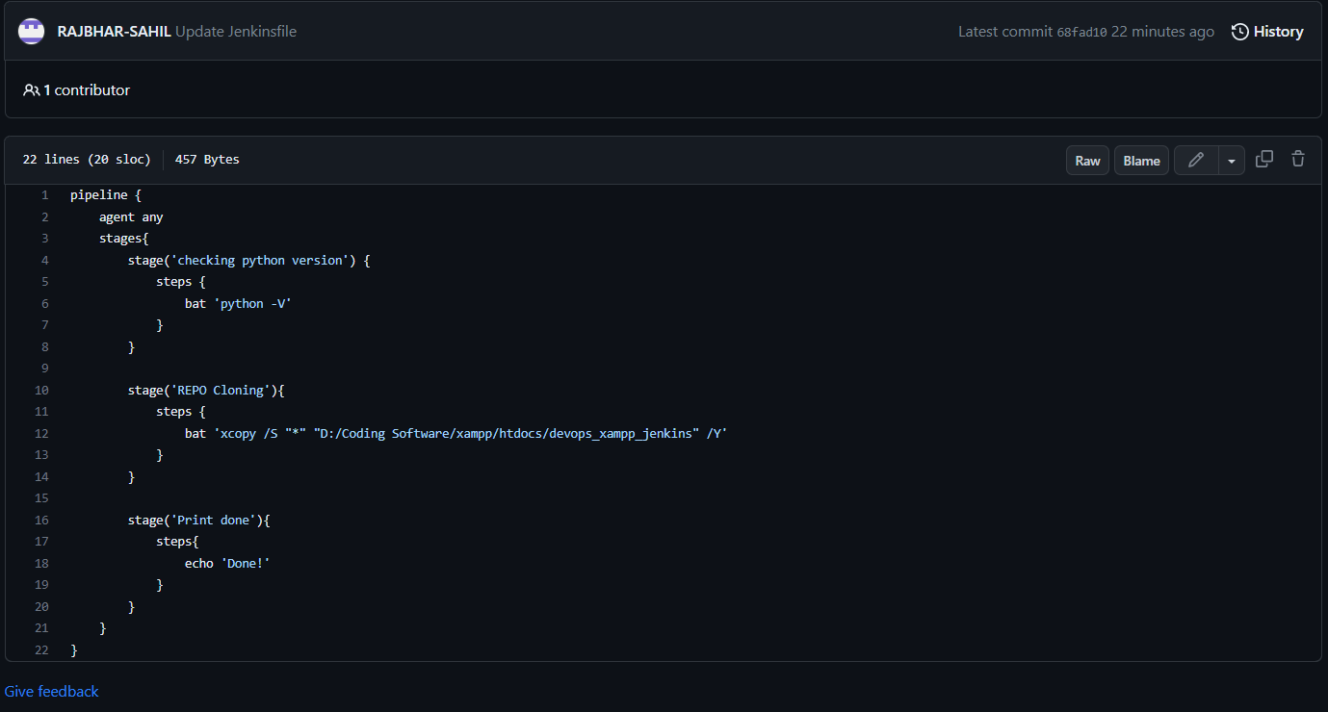

**2. For creating a Declarative Pipeline, you may follow step#1 and Step#2 from the scripted pipeline creation steps stated above and then follow the below stepsGo to the Pipeline tab, and from the Definition, the dropdown selects the Pipeline script from SCM**

**3. Go to the Pipeline tab, and from the Definition, the dropdown selects the Pipeline script from SCM**

**4. Now, you will get an option to input your Repository URL and credentials.**

**5. 4. Next, you may set the branch or let it be blank for any branch. In the script path, you need to write the Jenkinsfile name that exists in your repository. Click on Save, and there you go, your declarative pipeline is ready for use.**

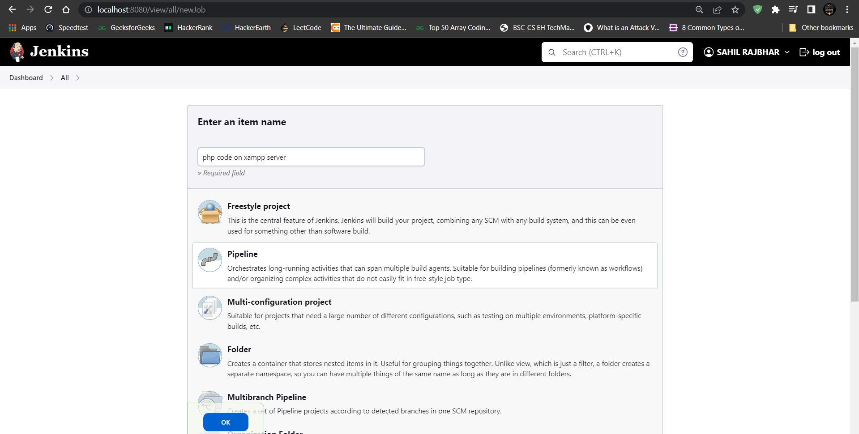

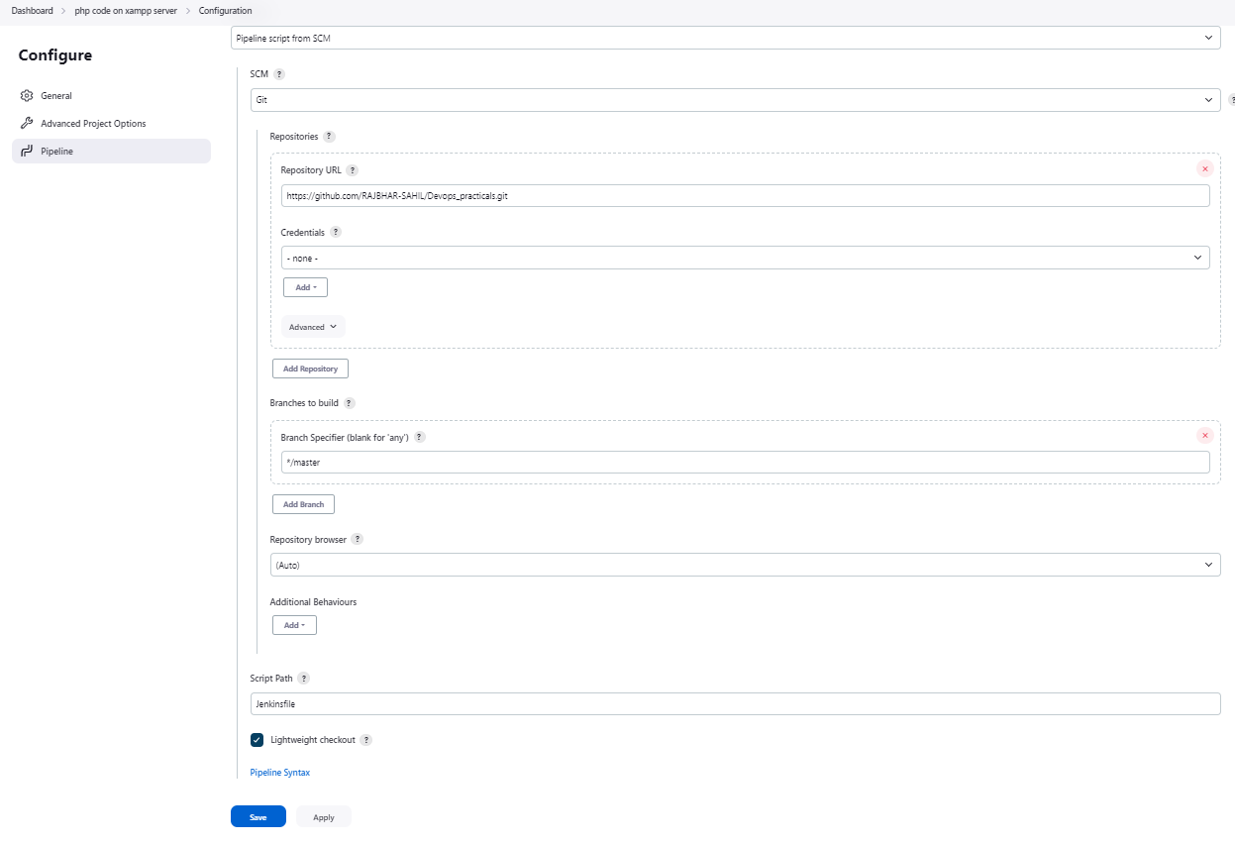

**6. Now that you are all set with your pipelines, you can execute the same from your Jenkins UI. All you need to do is select your pipeline and click on Build Now link on the left panel.**

**7. Once you run the pipeline, you will see the results displayed on the stage view as shown below**

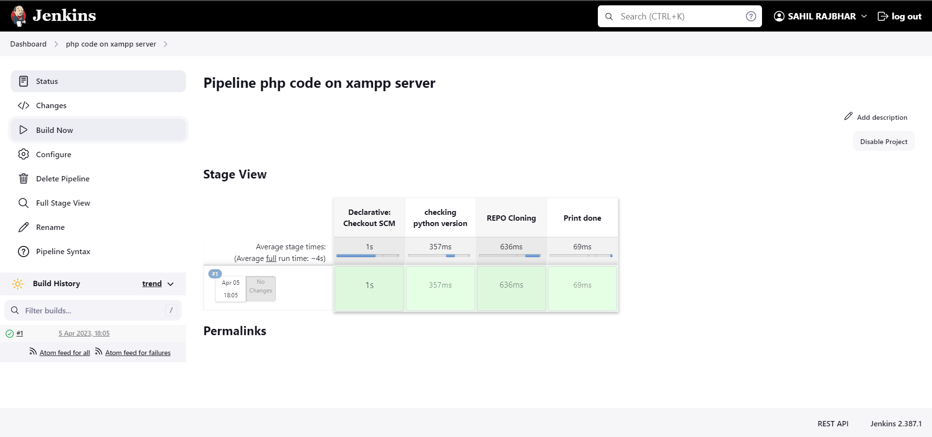

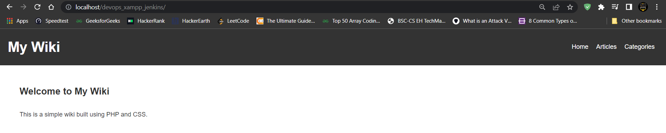

8.After some changes is para , rebuild it .

