Atharv Arya

1BM18CS020

PROGRAM TITLE: PIR SENSOR

## Aim: DEMONSTRATE AND SHOW THE WORKING OF PIR SENSOR

Hardware Required:

* Arduino Board
* LED
* Photoresistor
* Resistor

Circuit Diagram:

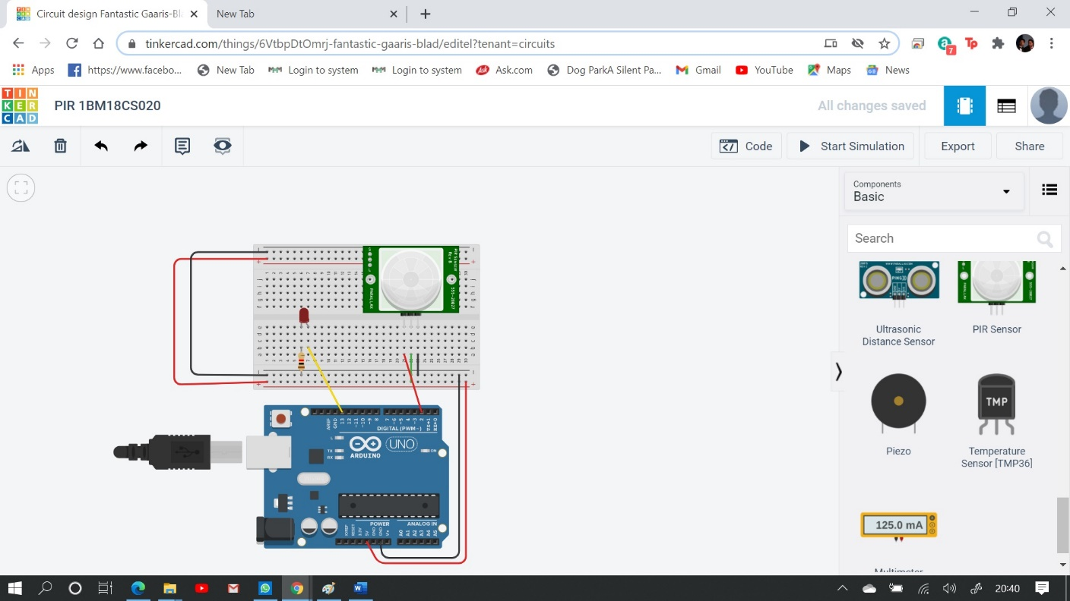

Write-Up:



CODE:

int sensorState = 0; void setup()

{

pinMode(2, INPUT); pinMode(13, OUTPUT); Serial.begin(9600);

}

void loop()

{

// read the state of the sensor/digital input sensorState = digitalRead(2);

// check if sensor pin is HIGH. if it is, set the

// LED on.

if (sensorState == HIGH)

{

digitalWrite(13, HIGH); Serial.println("Sensor activated!");

} else

{

digitalWrite(13, LOW); Serial.println("Sensor Deactivated!");

}

delay(10); // Delay a little bit to improve simulation performance

}

## OUTPUT/OBSERVATION:

Sensor is activated.