Atharv Arya

1BM18CS020

PROGRAM TITLE: TILT SENSOR

Aim: DESIGN A SMART PACKAGE HANDLING SYSTEM(TILT SENSOR AND LED)

Hardware Required:

* Tilt Sensor
* Resistor
* LED
* Breadboard
* Arduino UNO Circuit Diagram:

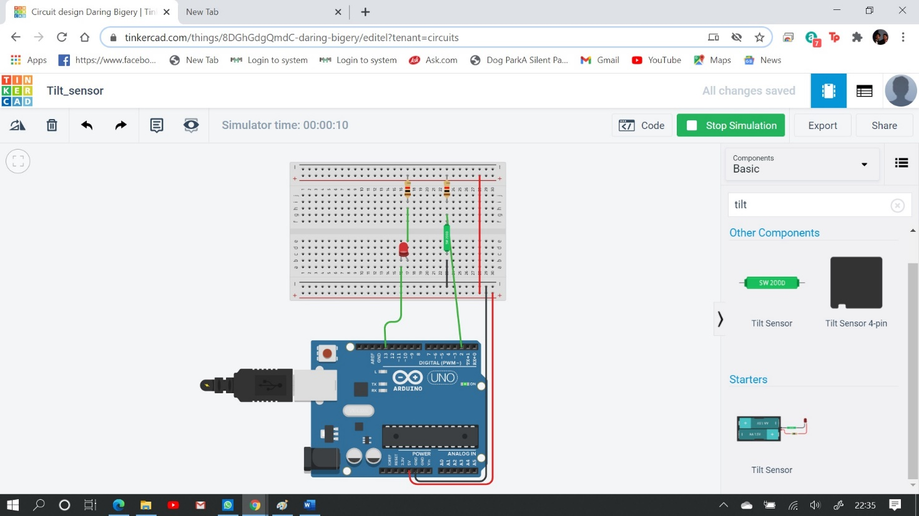

Write-Up:

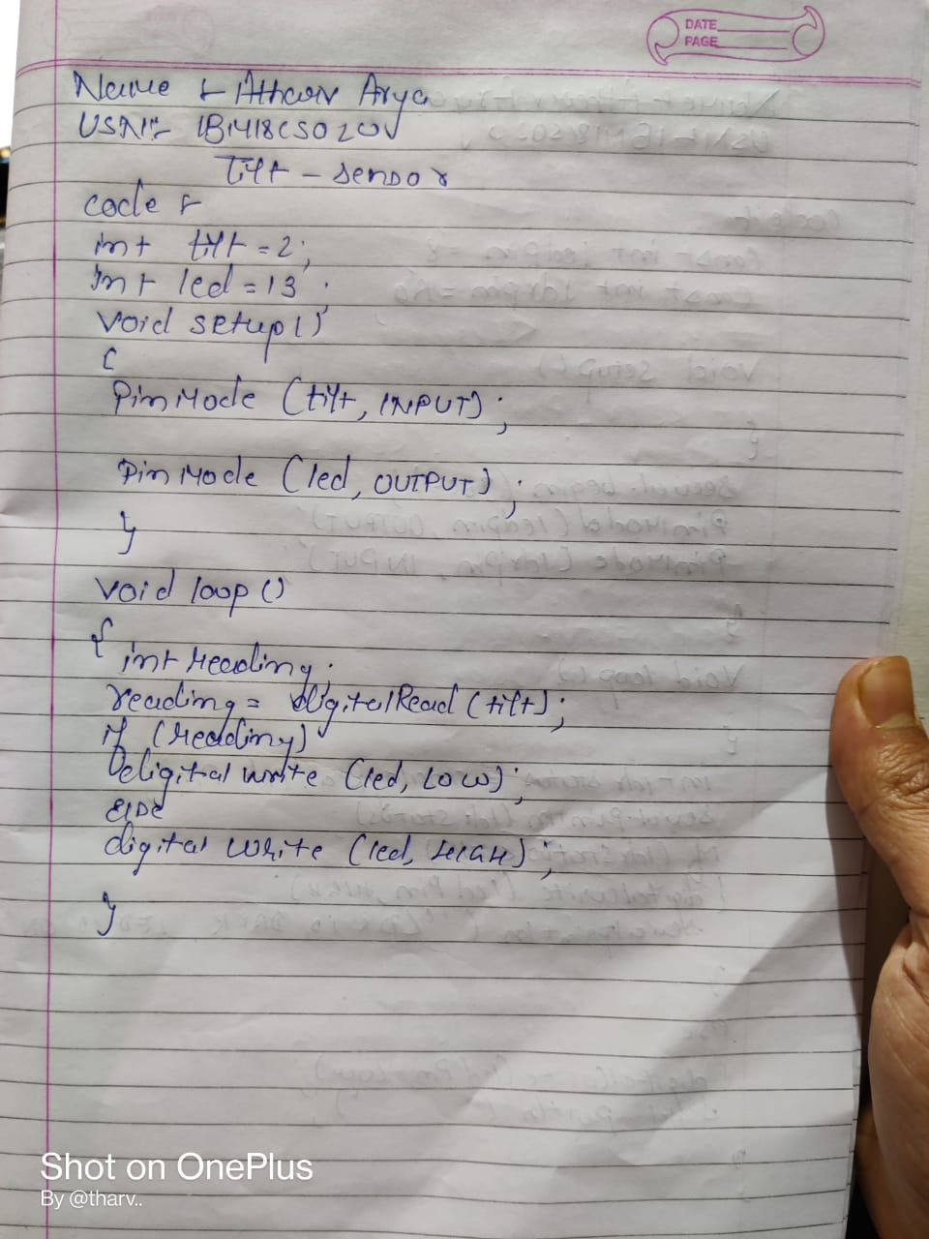

CODE:

int tilt=2; int led=13; void setup()

{

pinMode(tilt,INPUT);

pinMode(led,OUTPUT);

}

void loop()

{

int reading; reading=digitalRead(tilt); if(reading) digitalWrite(led, LOW); else

digitalWrite(led, HIGH);

}

Output/Observation:

The LED light glows accordingly.