Atharv Arya

1BM18CS020

PROGRAM TITLE: VIBRATOR MOTOR

Aim: DESIGN AUTOMATED DAY INDICATOR SYSTEM(VIBRATOR MOTOR AND LDR)

Hardware Required:

* Photoresistor
* Resistor, LED
* Breadboard, Arduino UNO
* Multimeter
* npn resistor, Vibrator Motor Circuit Diagram:

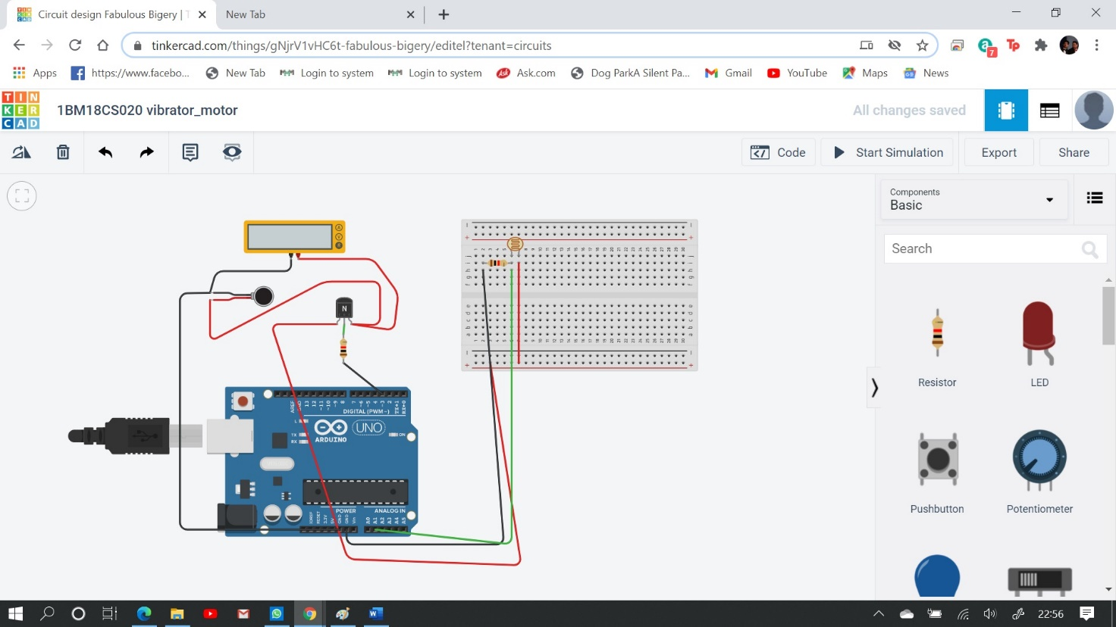

Write-Up:

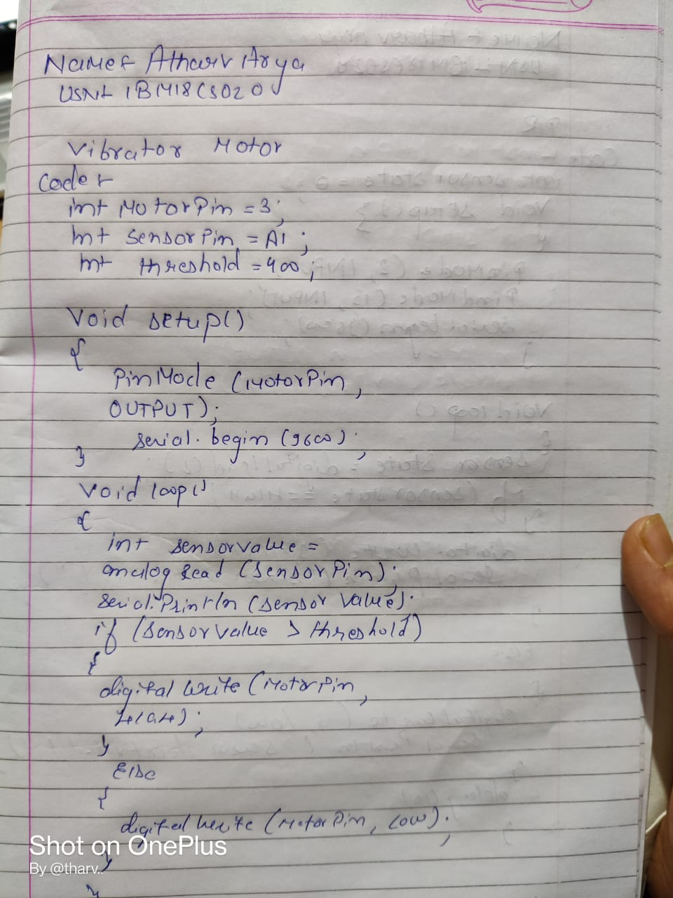

CODE:

int motorPin = 3; int sensorPin = A1; int threshold = 400;

void setup()

{

pinMode(motorPin, OUTPUT);

Serial.begin(9600);

}

void loop()

{

int sensorValue = analogRead(sensorPin); Serial.println(sensorValue); if(sensorValue > threshold)

{

digitalWrite(motorPin, HIGH);

}

else

{

digitalWrite(motorPin,LOW);

}

}

OBSERVATION/OUTPUT:

If sensor value>threshold it displays HIGH else LOW.