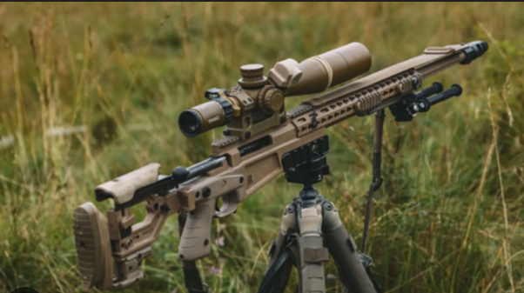
Assignment 6:- Create a text-to-image generation pipeline using a pre-trained model like DALL-E.

Output:-

