**Assessment-01**

**Problem Statement:**

To design and implement a program that performs basic arithmetic operations such as addition, subtraction, multiplication, and division. The program should handle user input, process the data accurately, and display the results efficiently.

**Aim:**

To write a program that takes two numbers as input and performs addition, subtraction, multiplication, and division using arithmetic operators.

**Algorithm:**

**Step 1:** Start

**Step 2:** Input Values for A and B

**Step 3:** Calculate SUM=A+B

**Step 4:** Calculate SUB=A-B

**Step 5:** Calculate PRODUCT=A*B

**Step 6:** Calculate DIV=A/B

**Step 7:** Display all results

**Step 8:** End

**Flowchart:**

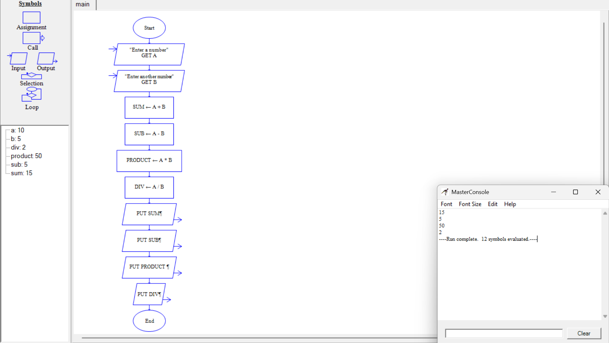

**Sample Program:**

A = int(input("Enter first number: "))

B = int(input("Enter second number: "))

# Processing of operations:

addition = A + B

subtraction = A - B

multiplication = A * B

# Check division by zero:

if B != 0:

division = A / B

else:

division = "Undefined (division by zero not possible)"

# Output:

print("\nResults:")

print("Addition:", addition)

print("Subtraction:", subtraction)

print("Multiplication:", multiplication)

print("Division:", division)

**Sample Input/Output:**

