**Assessment-02**

**Objectives**

* Understand the different types of operators in a programming language (arithmetic, relational,  
  logical, assignment, etc.).
* Explore how operator precedence and associativity govern the evaluation of complex expressions.
* Practice writing, predicting, and debugging expressions containing multiple operators.

**Task-01: Basic Operator Usage**

**Aim:**

Write a program that accepts two integer values and demonstrates the use of basic arithmetic operators like (+, −, ∗∗, //, ) by displaying the result of each operation.

**Sample Code:**

a=int(input("Enter a number: "))

b=int(input("Enter another number: "))

print("Addition:",a,"+",b,"=",a+b)

print("Subtraction: ",a,"-",b,"=",a-b)

print("Multiplication: ",a,"*",b,"=",a*b)

print("Exponentiation: ",a,"**",b,"=",a**b)

print("Floor division: ",a,"//",b,"=",a//b)

**Sample Output:**

**Task-02: Complex Expressions and Precedence**

**Aim:**

Ask the user to input three integer values (a, b, c) and evaluate and print the result of expressions.

**Sample Code:**

a=int(input("Enter a number: "))

b=int(input("Enter another number: "))

c=int(input("Enter one more number: "))

print("1st expression: ", a+b*c-a+b*c)

print("2nd expression: ", (a+b)*c-(a/b)*c)

print("3rd expression: ", a*b/c+a*b/c)

print("4th expression: ", a+b-c*a/b-a+b-c*a/b)

**Sample Output:**

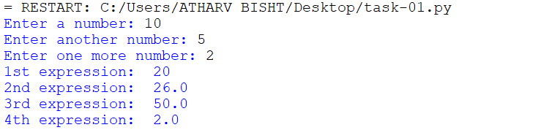

**Task-03: Predict and Verify Output**

**Aim:**

Provide a set of code snippets containing complex expressions with mixed operators.

**Sample Code:**

# Snippet 1

# Predict: 10 + 3 * 2 -> multiplication first -> 10 + 6 = 16

print("Snippet 1:", 10 + 3 * 2)

# Snippet 2

# Predict: (10 + 3) * 2 -> parentheses first -> 13 * 2 = 26

print("Snippet 2:", (10 + 3) * 2)

# Snippet 3

# Predict: 20 / 2 ** 2 -> exponent first -> 20 / 4 = 5.0

print("Snippet 3:", 20 / 2 ** 2)

# Snippet 4

# Predict: 15 // 4 % 3 -> floor division first -> 15 // 4 = 3, then 3 % 3 = 0

print("Snippet 4:", 15 // 4 % 3)

**Sample Output:**

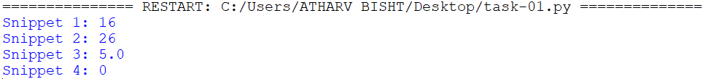

**Task 4: Parentheses to control Precedence**

**Aim:**

Demonstrate how inserting parentheses can change the result of expressions.

**Sample Code:**

a=float(input("Enter a number: "))

b=float(input("Enter another number: "))

c=float(input("Enter one more number: "))

print("1st expression: ", (a+b)*c/(a+b)**c)

print("2nd expression: ", a+(b-c)/a*(b/c))

print("3rd expression: ", a*(b/c)+(a+b)/c)

print("4th expression: ", a-(b+c)*c-(a+c))

**Sample Output:**

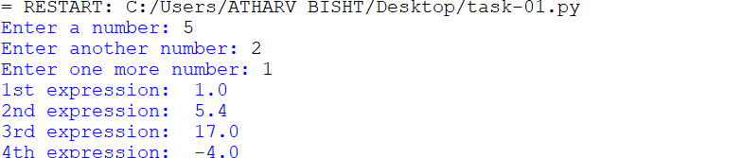

**Sample Output (Without Parentheses):**

