Project Synopsis
HCLTech Career Shaper Programme | III Year Industry Project | 2025-26

Field | Details (Learner to complete)
Project Title | Customer Lifetime Value (CLV) Prediction
Project No. | 54
Domain | Data Science / Python
Difficulty | Advanced
Duration | 4 Weeks
Format | Individual Project
Learner Name | Atharv Dhiman
Roll Number | 2300320130071
College / Campus | [FILL IN]
Mentor Name | [FILL IN]
Submission Date | [FILL IN]

1. Problem Statement
Marketing and CRM teams in retail and subscription businesses do not know which of their customers will be worth the most over the long term, so retention and marketing budgets are spread evenly instead of being focused where they matter. This happens every time a campaign is planned: valuable customers who are slipping away are noticed too late, and low-value customers receive costly offers. This project builds a CLV prediction pipeline that estimates each customer's value from purchase frequency, recency and order value, groups customers into segments, and recommends a retention action for each group.

2. Proposed Solution & Approach
I built a Python solution in two parts. Part 1 (clv_pipeline.py) audits and cleans the 500-customer dataset, explores it with six charts and builds RFM and regression models. The audit found that the file is synthetic: total_spend equals frequency x recency_days in every row and the segment label is random. Part 2 (clv_bgnbd.py) generates 5,000 customers and 31,256 transactions over three years (3% labelled anomalies, detected and removed), fits BG/NBD (Lifetimes) and Gamma-Gamma, validates them on a held-out final year, and compares them with gradient boosting. Customers are grouped into five retention actions using the probability of being active and 12-month CLV. Technology: Pandas, Scikit-learn, Lifetimes, Matplotlib; experiments tracked in MLflow.

3. System Architecture
Figure 1: Data Flow Diagram, Level 0
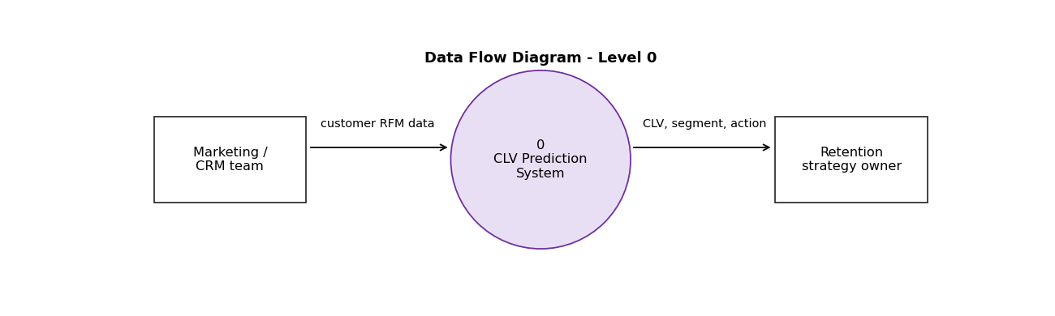
Figure 2: System block diagram
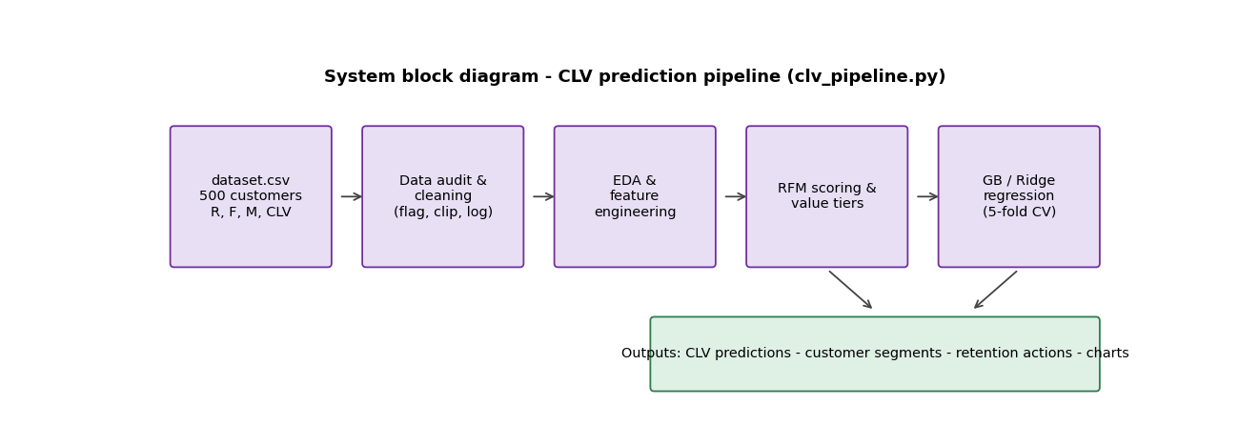

4. Technology Stack
Frontend / UI: Python scripts run locally (no interface; results are charts and CSV files)
Backend / Logic: Python 3.13: Pandas, NumPy, SciPy, Scikit-learn
Database: CSV files (dataset.csv, transactions.csv, customer_clv_bgnbd.csv)
AI/ML Framework: Lifetimes (BG/NBD, Gamma-Gamma); Scikit-learn gradient boosting and Ridge regression; MLflow for experiment tracking
Visualisation: Matplotlib
Hardware: Not applicable

5. Dataset Used
Dataset file name: dataset.csv (provided in project folder) plus transactions.csv (generated)
Number of rows: 500 customers in dataset.csv; 31,256 transactions (5,000 customers) in transactions.csv
Number of columns: 8 in dataset.csv; 5 in transactions.csv
Key columns (list 5): frequency, recency_days, avg_order_value, total_spend, clv_predicted (transactions.csv: customer_id, purchase_ts, order_value, is_anomaly, anomaly_detected)
Any additional data collected: Simulated transaction data (3 years, 3% labelled anomalies, from the Dataset Generation Prompt); both datasets are synthetic

6. Key Results & Metrics
Metric 1: Holdout accuracy BG/NBD predicted 10,765 repeat purchases in the held-out year against 10,432 actual (+3.2%); correlation per customer 0.75. Gamma-Gamma order value 1,534 predicted vs 1,498 actual (+2.5%).
Metric 2: CLV prediction R-squared 0.606 and MAE 2,444 for BG/NBD + Gamma-Gamma, against 0.513 and 2,748 for gradient boosting on RFM features, predicting holdout-year spend.
Metric 3: Targeting The top 10% of customers ranked by BG/NBD CLV capture 52.2% of next-year spend (47.1% for gradient boosting; about 10% at random).
Business value achieved: Total predicted 12-month CLV is about 12.0 million; the top 5% (250 customers) hold 42.4%. 1,236 customers (25%) are probably lapsed but hold only 2% of value, so only cheap reactivation is justified. Caution: the data are simulated from the same model family, so results validate the method and code, not performance on real customers. On the 500-row file, gradient boosting R-squared is 0.947, but this comes from the synthetic formula in that file.

7. Challenges Faced & How Resolved
Challenge 1: In dataset.csv, total_spend equals frequency x recency_days in all 500 rows (correlation 0.92 with CLV), the segment label is random and 39 dates are in the future. Resolution: excluded total_spend from the model, replaced the label with RFM and CLV-tier segments, used recency_days, and documented the issues.
Challenge 2: BG/NBD needs transaction-level data, which dataset.csv does not have. Resolution: generated simulated transactions for 5,000 customers (with 3% labelled anomalies that a label-free rule detected and removed) and used a time-based split (two years to fit, last year to test).
Challenge 3: Fitted BG/NBD dropout parameters (a, b) and Gamma-Gamma parameters differ from the simulation values although predictions are accurate. Resolution: judged the models on holdout predictions and not on individual parameters, and stated this in the report.

8. References
1. Fader, P. S., Hardie, B. G. S. and Lee, K. L. (2005). Counting Your Customers the Easy Way: An Alternative to the Pareto/NBD Model. Marketing Science, 24(2), 275-284. doi:10.1287/mksc.1040.0098
2. Fader, P. S. and Hardie, B. G. S. (2013). The Gamma-Gamma Model of Monetary Value. Technical note, brucehardie.com/notes/025.
3. Pedregosa, F. et al. (2011). Scikit-learn: Machine Learning in Python. Journal of Machine Learning Research, 12, 2825-2830. jmlr.org/papers/v12/pedregosa11a.html
4. Davidson-Pilon, C. Lifetimes documentation, lifetimes.readthedocs.io.

9. Ethical Compliance Declaration
I confirm that:
☐ All dataset usage complies with the source licence.
☐ No personally identifiable information (PII) is stored without consent.
☐ AI tools used for code/writing are disclosed in the Appendix.
☐ This project complies with the DPDP Act 2023 where applicable.
Learner Signature: _________________________ Date: ________________

Submit this file as 'Project_Synopsis_[YourName]_[RollNo].docx' | HCLTech Career Shaper Programme 2025-26

