HCLTech Career Shaper Programme
III Year Industry Project 2025-26
Customer Lifetime Value (CLV) Prediction
Project No. 54 | Data Science / Python | Advanced
Field | Details
Learner Name | [FILL IN]
Roll Number | [FILL IN]
College / Campus | [FILL IN]
Mentor Name | [FILL IN]
Submission Date | [FILL IN]

Abstract
Customer Lifetime Value (CLV) estimates how much a customer will be worth to a business over the long run, and is used to decide where retention and marketing money should go. This project builds an end-to-end CLV pipeline in Python on a 500-customer dataset provided by the programme: a data-quality audit, exploratory analysis, RFM (recency, frequency, monetary) segmentation with recommended retention actions, and a regression model that predicts CLV from customer behaviour.
On the supplied file, gradient boosting reaches a cross-validated R² of 0.947 on log-CLV (MAE 3,443 against 10,350 for a mean baseline). The audit showed that this score must be read with care: total_spend equals frequency × recency_days for every row, the provided segment label is unrelated to behaviour, and many dates are inconsistent. The model is learning the structure of a synthetic dataset rather than real purchasing behaviour.
Because the brief calls for BG/NBD, which needs purchase histories, a second dataset of 5,000 customers and 30,318 transactions over three years was simulated. BG/NBD and Gamma-Gamma were fitted on the first two years and tested on the third: predicted repeat purchases were within 3.3% of actual, and the top 10% of customers ranked by predicted CLV captured 50.4% of next-year spend (47.3% for gradient boosting on RFM features). Customers were then grouped into five retention actions using probability of being active and 12-month CLV. Both datasets are synthetic, so the results validate the method and code rather than predict real customer behaviour.

1. Introduction

1.1 Background
Retailers and subscription businesses rarely earn equal value from every customer. A small group typically generates a disproportionate share of revenue, while many customers buy once or twice and lapse. Treating them identically wastes budget: discounts go to customers who would have bought anyway, and valuable customers who are drifting away are noticed too late. CLV turns customer history into a forward-looking number that supports these decisions.

1.2 Problem statement
Marketing and CRM teams need to know which customers are worth the most over the long term, which of them are at risk of lapsing, and what action to take for each group. This project asks: given each customer’s purchase frequency, recency and order value, can we predict CLV accurately enough to rank customers, group them into actionable segments, and recommend a retention strategy for each?

1.3 Objectives
- Audit and clean the supplied dataset and document its quality.
- Explore the data with at least three visualisations.
- Segment customers by value and recency using RFM scoring and recommend a retention action for each segment.
- Train and validate regression models that predict CLV, compared with a baseline.
- Generate transaction-level data, fit BG/NBD and Gamma-Gamma models, and validate them on a held-out period.
- Record limitations and ethical considerations honestly, and state what is needed to improve the work.

2. Dataset

2.1 Description
The project uses dataset.csv from the programme folder: 500 customers (one row each) and 8 columns, with no missing values and no duplicate customer IDs. A data dictionary describing every column was completed as part of this work (data_dictionary.csv).
Column | Type | Meaning
customer_id | string | Anonymised customer key (C00001–C00500)
frequency | int | Number of purchases (1–50)
recency_days | int | Days since most recent purchase (1–1,091)
avg_order_value | float | Average order value
total_spend | int | Lifetime spend
clv_predicted | float | Provided CLV estimate (6.25–66,657); the regression target
last_purchase_date | date | Date of most recent purchase
segment | category | Provided label: Premium / Regular / Occasional / Churned

2.2 Summary statistics
Variable | Mean | Median | Min | Max
frequency | 24.6 | 25.0 | 1 | 50
recency_days | 529.5 | 517.0 | 1 | 1,091
avg_order_value | 1,528.5 | 1,506.0 | 14.9 | 3,601.4
total_spend | 13,169 | 8,786 | 7 | 50,850
clv_predicted | 13,064 | 8,691 | 6.2 | 66,657

CLV is right-skewed: the mean (13,064) is well above the median (8,691). The top 10% of customers account for 33.4% of total predicted CLV and the top 20% for 53.7%, so a minority of customers carries a large share of the value.

2.3 Data-quality audit
Before modelling, the dataset was audited. Several issues were found that affect how the results can be interpreted:
Check | Result | Implication
Missing values / duplicate IDs | 0 / 0 | No imputation needed
total_spend = frequency × recency_days | 100% of rows | Not real spend; would leak the target, so excluded from model inputs
Provided segment vs behaviour | No relationship | Replaced with RFM-based segments
last_purchase_date later than 26 Oct 2026 | 39 rows | Impossible dates; recency_days used instead
recency_days disagrees with date by more than 30 days | 467 of 500 rows | Date column unreliable; rows kept, flagged

The most important finding is the first one. In real data, total spend would depend on how many orders a customer placed and how much each was worth. Here it is exactly the product of frequency and recency_days, a number with no business meaning, since a customer who last bought long ago is not a bigger spender because of it. This indicates the file was generated synthetically with a formula, which the project’s Dataset Generation Prompt also suggests. Because clv_predicted correlates 0.92 with total_spend, any model given total_spend would simply recover this formula.
The provided segment column fares no better. The average frequency, recency and CLV are almost identical across the four labels (for example, mean CLV is 13,116 for “Churned” customers and 11,526 for “Premium” customers, and 52% of “Churned” customers sit in the High, Very High or Top 10% CLV tiers). The label appears to be assigned at random, so it was not used for modelling or reporting.

3. Methodology

3.1 Pipeline overview
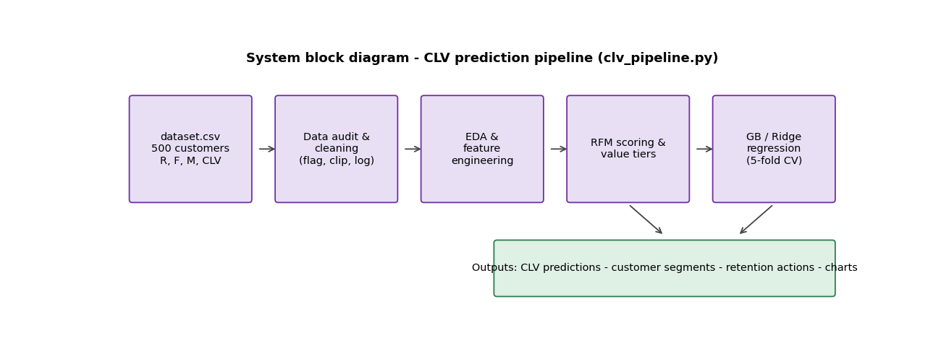
Figure 1. System block diagram of the CLV pipeline
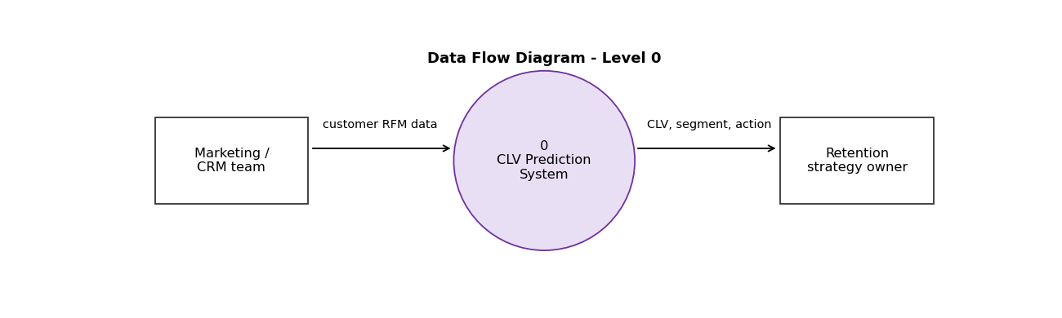
Figure 2. Data Flow Diagram, Level 0

3.2 Cleaning and preparation
- Reference date set to 26 October 2026. The 39 rows with a future last_purchase_date are flagged (date_valid = False) but kept, because recency_days, not the date, is used as the input.
- recency_days is clipped at zero from below as a safeguard.
- CLV is strongly right-skewed, so models are trained on log(1 + CLV) and predictions are transformed back for reporting in currency units.
- total_spend is excluded from model inputs because it duplicates frequency × recency_days and leaks the target.

3.3 RFM segmentation
Each customer was scored from 1 to 4 on recency, frequency and monetary value (quartiles; the recency score is reversed so recent customers score higher), giving an RFM score from 3 to 11 (mean 7.5). Separately, customers were placed into value tiers by CLV percentile: Low (bottom 25%), Medium, High, Very High and Top 10%. A rule-based recommended action was then assigned:
- Recency over 700 days: win-back campaign.
- Very High or Top 10% value: VIP loyalty and retention.
- Low value: low-cost automated nurture.
- Everything else: cross-sell and upsell.

3.4 Modelling and validation
Inputs were frequency, recency_days, avg_order_value and an interaction term frequency × recency_days. Two models were compared: Ridge regression (standardised inputs) as a linear benchmark, and gradient boosting (200 trees, depth 3, learning rate 0.05). All results use 5-fold cross-validation with a fixed random seed, so every prediction comes from a model that did not see that customer during training. A mean-prediction baseline provides a reference point. Metrics are R², mean absolute error (MAE) and root mean squared error (RMSE).

4. Exploratory Data Analysis
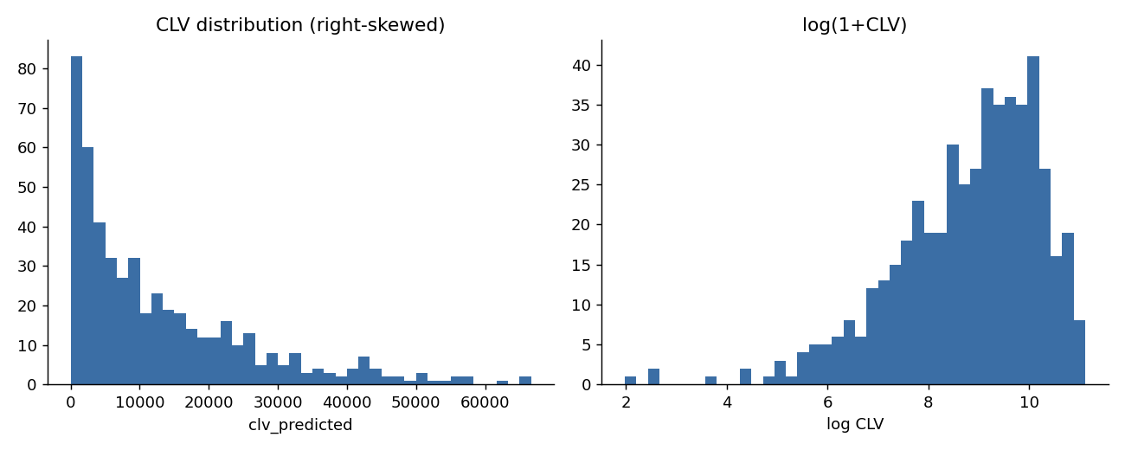
Figure 3. CLV is right-skewed; the log transform is roughly symmetric
Figure 3 shows most customers have CLV below 15,000, with a long tail up to about 66,700. This motivates the log transform, which makes the target easier to model and prevents a few large values from dominating the error.
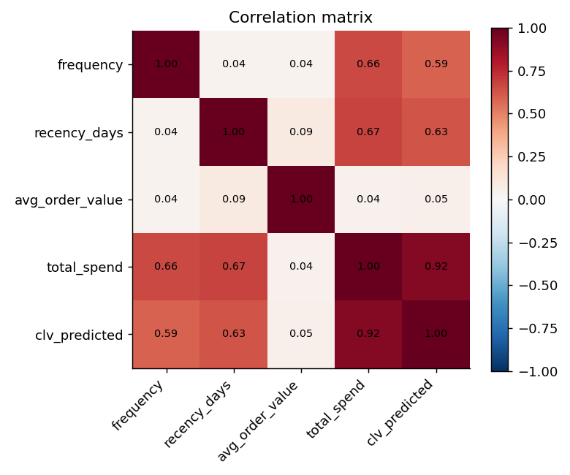
Figure 4. Correlation matrix of the numeric variables
Figure 4 shows that frequency and recency_days are almost uncorrelated with each other (0.04), while both correlate with total_spend (about 0.66 and 0.67) and, through it, with CLV (0.59 and 0.63). avg_order_value is essentially unrelated to everything else (correlations of about 0.04–0.09). The strong link between total_spend and CLV (0.92) is the leakage concern described in Section 2.3.
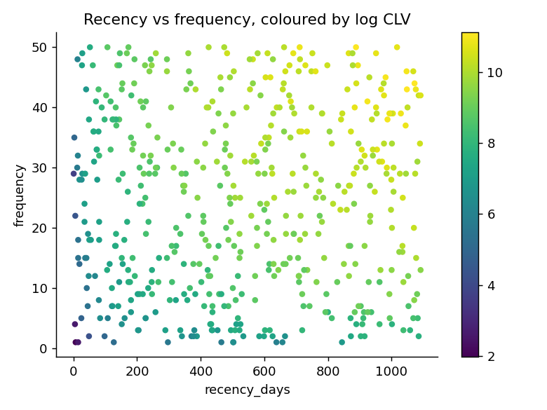
Figure 5. Recency vs frequency, coloured by log CLV
Figure 5 shows CLV rising towards the upper right, where customers both buy often and have a large recency_days value. In a real retailer, one would expect high CLV for customers who buy often and recently (low recency_days). The opposite pattern here is another sign that the data are synthetic: CLV increases with recency_days, which is the reverse of normal customer behaviour.

5. Results

5.1 Model comparison
Model | R² (log CLV) | R² (currency) | MAE | RMSE
Mean baseline | 0.000 | 0.000 | 10,350 | 13,286
Ridge | 0.746 | 0.454 | 5,338 | 9,818
Gradient boosting | 0.947 | 0.814 | 3,443 | 5,736

Gradient boosting clearly outperforms both the baseline and the linear model: its MAE of 3,443 is about one third of the baseline error (10,350). The gap over Ridge shows that the relationship between the inputs and CLV is non-linear, which fits a product structure like frequency × recency_days.
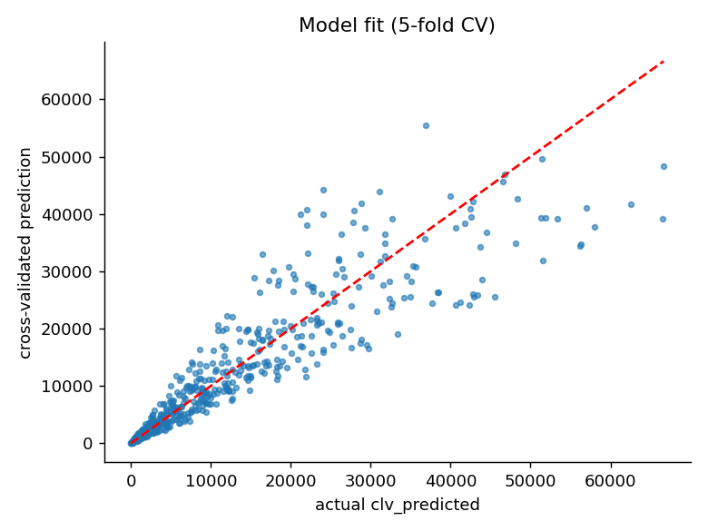
Figure 6. Cross-validated prediction vs actual CLV

5.2 What the model is actually learning
Feature importance (Figure 7) shows that the interaction term frequency × recency_days accounts for 98.4% of the importance, against 0.9% for recency_days, 0.5% for avg_order_value and 0.2% for frequency.
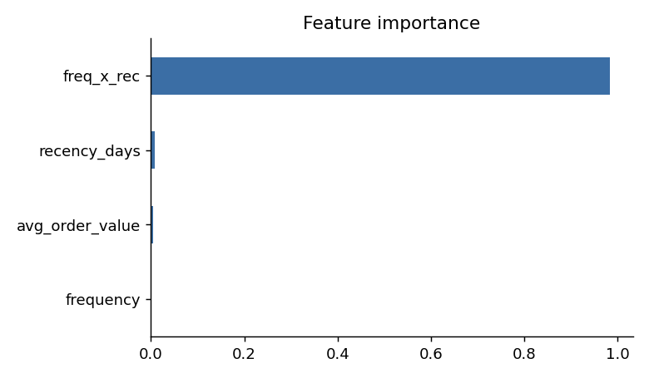
Figure 7. Feature importance of the gradient boosting model
Additional checks were run to understand how much of the score depends on this structure:
Features given to gradient boosting | R² (log CLV) | Reading
frequency, recency_days, avg_order_value (no interaction term) | 0.935 | Trees recover the product themselves
frequency, recency_days and their product | 0.946 | Product term adds little
avg_order_value only | -0.07 | Worse than predicting the mean

Removing the engineered feature barely lowers the score (0.935), so the high R² does not come from the feature engineering. It comes from the dataset: CLV is almost a deterministic function of frequency and recency_days. avg_order_value, the variable a business would normally consider important, has no predictive power at all (R² of -0.07 on its own). A score of 0.95 on real customer data would be unusually high; here it should be read as evidence that the data were generated by a formula, not as evidence that the model could forecast real customer value.

6. Transaction-Level Data and BG/NBD Modelling
The brief names BG/NBD (Lifetimes library) as the main CLV method. As explained in Section 2.3, the 500-row file cannot support it, because BG/NBD needs each customer’s purchase history. Following the Dataset Generation Prompt, a transaction-level dataset was therefore generated: 5,000 customers and 30,318 transactions over three years (27 October 2023 to 26 October 2026), saved as transactions.csv with timestamps in YYYY-MM-DD HH:MM:SS format.

6.1 How the data were generated
The data were simulated with a script (clv_bgnbd.py, fixed random seed), not collected from real customers. Each customer has a purchase rate (gamma-distributed), a probability of becoming inactive after each purchase (beta-distributed) and a spending level (gamma-gamma structure), and customers join at different dates over the first two years. Orders average 1,481 and customers make 6.1 purchases on average (median 3). Because the data come from the same family of models that is then fitted, a good fit is expected. What this part of the project shows is that the pipeline is implemented and validated correctly, and that it recovers known parameters; it does not show how well BG/NBD would describe a real retailer.

6.2 Method
- Split: customers were modelled on the first two years (calibration) and tested on the final 365 days (holdout), which is a true time-based split.
- BG/NBD (BetaGeoFitter, small penaliser 0.001) was fitted on frequency (repeat purchases), recency (days between first and last purchase) and T (customer age). It gives the probability a customer is still active and the expected purchases in a future period.
- Gamma-Gamma (GammaGammaFitter) was fitted on customers with at least one repeat purchase to estimate the expected order value. Its assumption that order value is independent of purchase frequency was checked: the correlation is -0.007, so the assumption holds.
- 12-month CLV = expected purchases over 365 days × expected order value, discounted by 10% for the year. Customers with no repeat purchase use the average order value of repeat buyers.

6.3 Fit and validation
BG/NBD parameter | True value (simulation) | Fitted value | Meaning
r | 0.55 | 0.557 | Purchase-rate shape
alpha | 45.0 | 46.73 | Purchase-rate scale (days)
a | 0.35 | 0.274 | Dropout shape
b | 1.60 | 1.201 | Dropout shape

The purchase-rate parameters r and alpha are recovered closely. The dropout parameters a and b are less well recovered individually (0.274 and 1.201 against 0.35 and 1.60), but their ratio, which determines the average dropout probability, is similar (0.186 fitted against 0.179 true). This is a known feature of the model, where a and b are hard to separate.
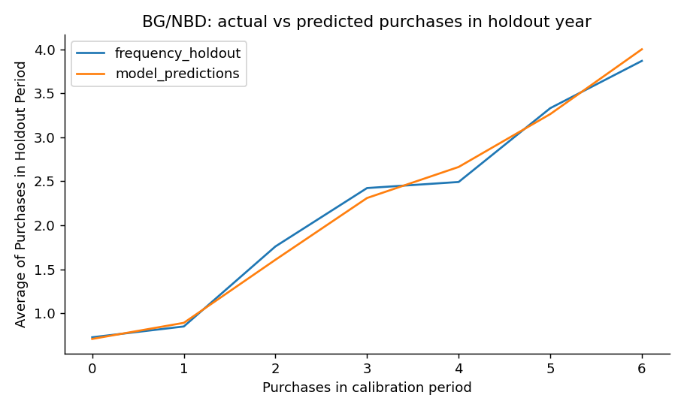
Figure 9. Average purchases in the holdout year, by purchases in the calibration period: actual vs BG/NBD prediction
In the holdout year, customers made 10,445 repeat purchases and BG/NBD predicted 10,789, an error of +3.3% in total. The correlation between predicted and actual purchases per customer is 0.75, and the prediction follows the actual curve across customer groups in Figure 9. For order value, Gamma-Gamma predicted an average of 1,558 against an actual 1,512 for customers who purchased again in the holdout year (+3.1%); simply using each customer’s past average gave 1,527. The fitted Gamma-Gamma parameters (p = 12.9, q = 0.49) differ from the simulation values; as with a and b, predictions are good even though the individual parameters are poorly identified, so they should not be interpreted on their own.

6.4 Comparison with machine-learning regression
To compare the probabilistic approach with regression on the same task, both predicted each customer’s actual spend in the holdout year from calibration-period behaviour. Gradient boosting was trained on 70% of customers (frequency, recency, T and average order value) and both models were scored on the remaining 30%. “Top-10% capture” is the share of all holdout spend made by the 10% of customers the model ranks highest (random selection captures about 10%).
Model | R² | MAE | Top-10% capture
Naive (average spend) | -0.002 | 4,069 | 12.7%
BG/NBD + Gamma-Gamma | 0.574 | 2,639 | 50.4%
Gradient boosting on RFM | 0.523 | 2,789 | 47.3%

Both models are far better than the naive prediction, and the ten percent of customers ranked highest capture around half of next-year spend. BG/NBD is slightly ahead of gradient boosting on every measure (R² 0.574 against 0.523), although it was not trained on the holdout spend and gradient boosting was. The difference is small, however, and should not be over-stated: the data follow the BG/NBD process by construction, so an advantage for it is expected. These R² values (about 0.5–0.6) are much more realistic than the 0.947 in Section 5, because here the target is future behaviour, which contains real randomness, and not a formula.

7. Segmentation and Retention Strategy
Segments from the transaction-level model use the probability that a customer is still active together with 12-month CLV. Total predicted 12-month CLV for the 5,000 customers is about 12.1 million; the top 5% of customers (250) account for 42.5% of it, and the top 20% for 78.2%.
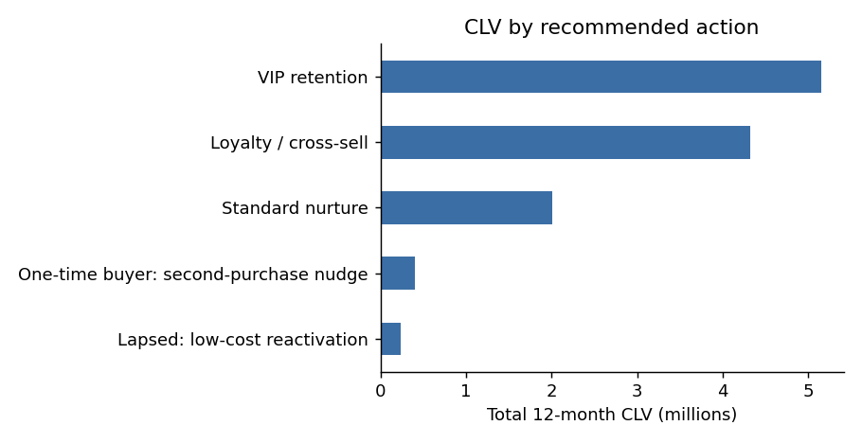
Figure 10. Total 12-month CLV by recommended action (BG/NBD + Gamma-Gamma)
Recommended action | Customers | Total 12-month CLV | Average CLV | Average P(alive)
VIP retention (top 5% CLV) | 250 | 5,156,878 | 20,628 | 0.95
Loyalty / cross-sell (next 15%) | 749 | 4,319,168 | 5,767 | 0.89
Standard nurture | 1,703 | 2,007,480 | 1,179 | 0.70
One-time buyer: second-purchase nudge | 1,060 | 398,302 | 376 | 1.00
Lapsed: low-cost reactivation (P(alive) < 0.3) | 1,238 | 239,012 | 193 | 0.10

Unlike the earlier segmentation, these actions rest on a model of customer behaviour: the VIP group is both high-value and very likely still active (probability alive 0.95), so retention effort is well placed. The lapsed group is 25% of customers but only 2% of predicted CLV, so only low-cost reactivation is justified. One-time buyers show a probability alive of 1.00 because BG/NBD cannot tell whether a customer with no repeat purchase has left; the model gives them an expected value from the average order, and a second-purchase nudge is a cheap way to learn more about them.

8. Segmentation on the 500-Customer File
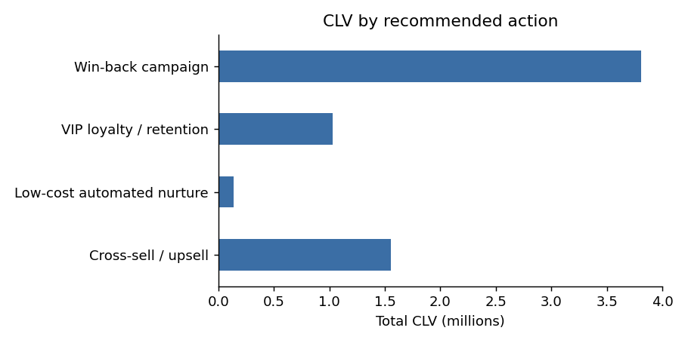
Figure 8. Total predicted CLV by recommended action
Recommended action | Customers | Total CLV | Average CLV per customer
Win-back campaign | 166 | 3,810,355 | 22,954
Cross-sell / upsell | 178 | 1,551,847 | 8,718
VIP loyalty / retention | 39 | 1,029,885 | 26,407
Low-cost automated nurture | 117 | 140,134 | 1,198

The win-back group (customers with recency over 700 days) is the largest pool of value: 166 customers holding about 3.8 million of the 6.5 million total predicted CLV, an average of 22,954 per customer. In a real business, this would be the highest-priority group: customers who were valuable but have not purchased in nearly two years. The VIP group is small (39 customers) but has the highest average CLV (26,407), so retention for this group should be personal and careful. At the other end, 117 low-value customers hold only 140,134 in total, so spending on them should be automated and cheap.
A caution applies here too. The win-back rule depends on recency_days meaning “days since last purchase”, as the data dictionary states. Because the data show higher CLV for higher recency_days, a real business should check this definition before acting on the list.

9. Ethical Considerations
CLV models influence marketing spend. If they are used carelessly, customers can be treated unequally in ways that are unfair or discriminatory. The following points apply to this project:
- No personal data. The dataset contains only an anonymised customer ID and behavioural fields. No names, contact details, age, gender, location or other demographic attributes are present, and none were collected.
- Fairness cannot be tested with this data. Because there are no demographic columns, it is impossible to check whether the model or the segments disadvantage any group. Before real deployment, segments and predictions should be checked across demographic groups where lawful and appropriate.
- Low CLV is not a reason to give worse service. The low-cost nurture action only reduces marketing spend; it should never be used to reduce service quality, support or access to offers that are advertised to everyone.
- Predictions should support human decisions. The recommended actions are suggestions to be reviewed, not automated decisions about individuals.
- Legal compliance. Any production use with real customer data in India should follow the Digital Personal Data Protection Act 2023 (consent, purpose limitation, data minimisation).
- Use of AI tools. AI assistance was used for the code and the drafting of this report and is disclosed in Appendix A.

10. Limitations
- Both datasets are synthetic. The supplied 500-row file has a deterministic structure (total_spend = frequency × recency_days), a random segment label and inconsistent dates. The 30,318-transaction dataset was simulated from the BG/NBD and Gamma-Gamma assumptions. Results therefore show that the methods are implemented and validated correctly, not how they would perform on a real retailer.
- Model assumptions were not tested against reality. BG/NBD assumes constant purchase rates and that customers leave permanently; Gamma-Gamma assumes order value is independent of frequency. These hold in the simulated data (correlation -0.007) but would have to be checked on real data, along with effects such as seasonality and promotions.
- Individual parameters are weakly identified. The fitted dropout parameters (a, b) and the Gamma-Gamma shape parameters differ from the true values, even though predictions are accurate. They should not be interpreted separately.
- The 500-row regression target is itself a provided estimate, not observed future revenue, and the 500-row sample is small.
- Single holdout. The BG/NBD validation uses one holdout year; repeated time splits would give a better idea of how stable the results are.
- Rule-based actions. The recommended actions use simple thresholds whose effect on retention has not been tested. No customer attributes beyond purchase behaviour exist, so fairness across demographic groups could not be assessed.

11. Conclusion and Future Work
This project delivered a complete CLV solution in two parts. First, an audit of the supplied 500-customer file showed that its headline regression accuracy (R² 0.947 on log-CLV) comes from a formula embedded in synthetic data, and that its segment label carries no information. Second, following the brief’s method, a 5,000-customer, 30,318-transaction dataset was generated and BG/NBD with Gamma-Gamma was fitted and validated on a held-out final year. It predicted total repeat purchases within 3.3% and average order value within 3.1%, and ranked customers so that the top 10% captured 50.4% of next-year spend, slightly better than gradient boosting on RFM features (47.3%). Combining the active probability with 12-month CLV produced five retention actions, with the top 5% of customers holding 42.5% of predicted value.
Recommended next steps:
- Apply the same pipeline to real transaction data. The code only needs customer ID, purchase date and order value.
- Test the model assumptions on that data (constant purchase rate, independence of order value and frequency) and repeat the holdout validation over several time splits.
- Track the models in MLflow, as listed in the brief’s technology stack.
- Test the retention actions with a controlled campaign and measure the uplift.
- Where lawful, add demographic checks to confirm that segments and spend allocation are fair.

References
[1] Fader, P. S., Hardie, B. G. S. and Lee, K. L. (2005). “Counting Your Customers the Easy Way: An Alternative to the Pareto/NBD Model.” Marketing Science, 24(2), 275–284.
[2] Fader, P. S. and Hardie, B. G. S. (2013). “The Gamma-Gamma Model of Monetary Value.” Technical note.
[3] Davidson-Pilon, C. Lifetimes: Survival analysis in Python for customer lifetime value. Documentation, lifetimes.readthedocs.io.
[4] Pedregosa, F. et al. (2011). “Scikit-learn: Machine Learning in Python.” Journal of Machine Learning Research, 12, 2825–2830.
[5] Government of India (2023). The Digital Personal Data Protection Act, 2023.
[6] HCLTech Career Shaper Programme Guidelines (provided by Programme Coordinator).

Appendix A: AI Tool Disclosure
Claude (Anthropic) was used to write the analysis code (clv_pipeline.py), to generate the figures, and to draft this report and the project synopsis, working from the programme’s project brief and dataset. The learner is responsible for reviewing the content and for the accuracy of the submitted work.

Appendix B: Project Files
File | Contents
clv_pipeline.py | 500-customer pipeline: audit, cleaning, RFM, regression, figures
clv_bgnbd.py | Transaction simulation, BG/NBD, Gamma-Gamma, validation, comparison
transactions.csv | 30,318 simulated transactions for 5,000 customers
customer_clv_bgnbd.csv | Per-customer P(alive), expected purchases, 12-month CLV, action
bgnbd_metrics.csv, bgnbd_vs_ml.csv, bgnbd_action_summary.csv | BG/NBD results and comparisons
dataset.csv | Original dataset (500 rows)
dataset_clean.csv | Cleaned data with RFM score, value tier, action, CV prediction
data_dictionary.csv | All columns described
model_metrics.csv | Cross-validated model results
data_quality_audit.csv | Audit results
segment_summary.csv | Customers and CLV per recommended action
figures/ | All charts used in this report

