Name: Atharv A Dugani
Roll No.: 2601056
Q1) Write a program to read a file and count how many vowels are present in its content.
Code:
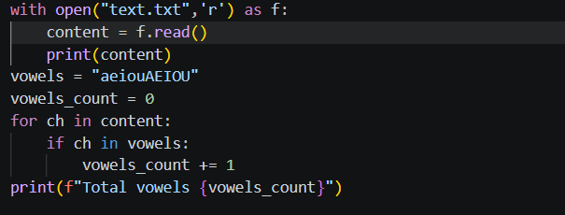
Output:
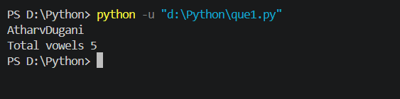
Q2) Read all lines from a file into a list. Print the total number of lines and display the 2nd and 4th line
Code:
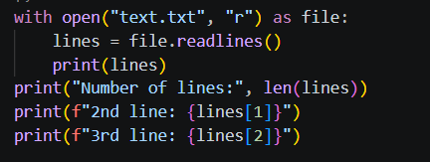
Output:
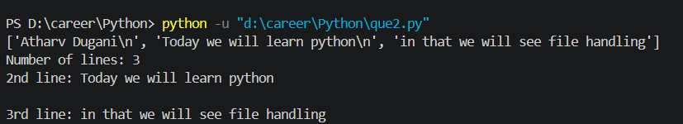

Q3) Take a sentence from the user, split it into words, and store them in a list. Print the longest word.
Code:
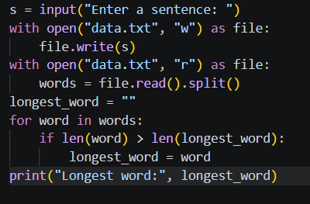
Output:
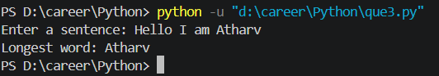

Q4) Read a file, split its content into words, and store them in a list.
- Print the total number of words.
- Print all unique words.
Code:
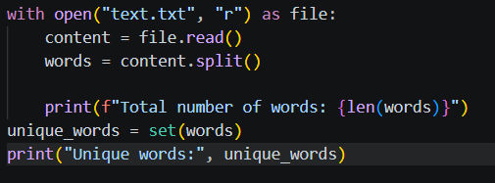
Output:
