📘 LITERATURE REVIEW
Scalable Retrieval-Augmented Generation and Graph-Based Architectures for Industrial Chatbots

🧠 1. INTRODUCTION
Modern chatbot systems designed for industrial deployment must handle extremely large, dynamic, and heterogeneous datasets such as financial records, logs, APIs, and user-generated data. Traditional large language models (LLMs), although powerful in language understanding and generation, are fundamentally limited in their ability to store, update, and reason over such large-scale datasets.
These limitations arise because LLMs rely on parametric memory, meaning knowledge is embedded in model weights during training. This approach makes it difficult to update knowledge in real-time, restricts scalability, and often leads to hallucinations when answering domain-specific queries.
To overcome these challenges, modern systems adopt Retrieval-Augmented Generation (RAG) and its advanced variants such as GraphRAG, which separate knowledge storage from reasoning and enable scalable, accurate, and efficient query processing.

🧠 2. RETRIEVAL-AUGMENTED GENERATION (RAG)
Retrieval-Augmented Generation introduces a hybrid architecture that combines two types of memory:
- Parametric Memory: The language model responsible for reasoning and response generation
- Non-Parametric Memory: An external knowledge base used for storing large-scale data
Instead of relying solely on internal knowledge, the system retrieves relevant information from external sources at query time.

🔷 Working Mechanism
- A user submits a query
- The query is converted into a vector representation
- The system retrieves the most relevant documents from a vector database
- Retrieved documents are passed to the language model
- The model generates a response using both the query and retrieved data

🔷 Advantages
- Enables real-time knowledge updates without retraining
- Improves factual accuracy
- Scales beyond model memory limitations

🚨 Limitations of RAG
Despite its advantages, RAG faces several critical challenges:
❌ Fragmentation of Information
Large documents are divided into smaller chunks for indexing, which breaks contextual relationships between pieces of information.
❌ Lack of Relational Understanding
RAG retrieves documents based on similarity but cannot understand relationships between different pieces of information.
❌ Context Window Limitation
Language models can only process a limited number of tokens, making it difficult to handle large datasets in a single query.
❌ Inefficient Retrieval for Complex Queries
Multi-step reasoning queries requiring connections across multiple documents are often poorly handled.

🧠 3. NEED FOR GRAPH-BASED RETRIEVAL (GRAPHRAG)
To overcome the limitations of traditional RAG, advanced systems introduce graph-based retrieval mechanisms.
Instead of storing data as independent text chunks, GraphRAG represents knowledge as a structured graph:
- Nodes represent entities (e.g., stocks, users, transactions)
- Edges represent relationships (e.g., ownership, correlation, dependency)

🔷 Key Concept
The core idea is:
Knowledge is not isolated; it is interconnected. Therefore, retrieval should preserve relationships.

🔷 GraphRAG Architecture
- Convert raw data into a knowledge graph
- Store entities and relationships in a graph database
- Process user query and identify relevant entities
- Retrieve a subgraph instead of isolated documents
- Pass structured information to the language model
- Generate a context-aware response

🔷 Advantages of GraphRAG
✅ Multi-Hop Reasoning
Supports queries requiring indirect relationships across multiple entities.
✅ Context Preservation
Maintains connections between data points instead of breaking them into independent chunks.
✅ Efficient Representation
Graph structures compress information while preserving meaning.
✅ Improved Accuracy
Reduces hallucinations by grounding responses in structured data.

🧠 4. ADVANCED GRAPH RETRIEVAL (GRAG)
A key challenge in GraphRAG is that retrieving the optimal subgraph is computationally expensive due to the large number of possible node combinations.
To address this, advanced methods introduce optimized retrieval strategies:

🔷 Divide-and-Conquer Strategy
Instead of searching the entire graph:
- Identify small local neighborhoods (ego graphs)
- Combine relevant subgraphs
- Prune irrelevant nodes
- Construct an approximate optimal subgraph

🔷 Dual Representation
The system provides two types of input to the language model:
- Textual View: Semantic information
- Graph View: Structural relationships
This allows the model to understand both meaning and structure simultaneously.

🔷 Impact
- Reduces computational complexity
- Improves retrieval efficiency
- Enhances reasoning capability

🧠 5. SCALING TO LARGE DATASETS
Handling extremely large datasets requires additional architectural innovations beyond basic RAG and GraphRAG.

🔷 Hierarchical Knowledge Representation
Data is organized into multiple levels:
- Entity Level: Individual data points
- Community Level: Groups of related entities
- Global Level: High-level summaries

🔷 Map-Reduce Query Processing
For large-scale queries:
- Map Phase: Generate partial answers from different parts of the dataset
- Reduce Phase: Combine partial answers into a final response

🔷 Benefits
- Enables processing of datasets with millions of tokens
- Supports global queries across entire datasets
- Improves scalability and parallel processing

🧠 6. ENTERPRISE OPTIMIZATION TECHNIQUES
Industrial systems introduce additional optimizations to ensure real-time performance and reliability.

🔷 Hybrid Retrieval
Combines two approaches:
- Dense Retrieval (semantic similarity)
- Sparse Retrieval (keyword matching)
This improves both recall and precision.

🔷 Semantic Caching
- Stores results of previous queries
- Retrieves cached answers for similar queries
- Significantly reduces latency

🔷 Adaptive Query Routing
- Simple queries → direct retrieval
- Complex queries → multi-step processing
This ensures efficient use of resources.

🔷 Corrective Retrieval Mechanisms
- Validate retrieved data before generation
- Reduce hallucinations and incorrect outputs

🧠 7. REAL-WORLD SYSTEM DESIGN
Modern industrial chatbot systems follow a multi-layer architecture:

🔷 Data Layer
- Raw data from APIs, logs, and databases
- Stored in distributed storage systems

🔷 Processing Layer
- Data cleaning and transformation
- Chunking and graph construction

🔷 Storage Layer
- Vector databases for embeddings
- Graph databases for relationships
- Cache systems for fast access

🔷 Retrieval Layer
- Hybrid search mechanisms
- Graph traversal algorithms

🔷 Intelligence Layer
- Language model for reasoning
- Agent-based systems for task orchestration

🔷 Optimization Layer
- Caching
- Routing
- Parallel processing

🧠 8. HOW LARGE DATA IS MANAGED
A critical principle in scalable systems is:
The system never processes the entire dataset; it only retrieves the most relevant subset.

🔷 Key Techniques
1. Indexing
Preprocessing data into searchable structures such as vectors and graphs.
2. Partitioning
Breaking data into manageable chunks or communities.
3. Parallel Processing
Handling multiple retrieval operations simultaneously.
4. Approximation Algorithms
Avoiding expensive computations by using efficient approximations.
5. Caching
Reusing previously computed results.

🧠 9. COMPARATIVE ANALYSIS
Feature | Traditional RAG | GraphRAG | Enterprise Systems
Data Representation | Flat text | Structured graph | Hybrid
Retrieval Method | Vector similarity | Graph traversal | Hybrid
Reasoning Capability | Limited | Advanced | Adaptive
Scalability | Moderate | High | Very high
Latency | Medium | Medium | Low

🧠 10. CONCLUSION
Modern chatbot systems designed for large-scale industrial deployment require a shift from simple document retrieval to intelligent knowledge retrieval.
Retrieval-Augmented Generation provides a scalable foundation by separating knowledge storage from reasoning. However, its limitations in handling relationships and complex queries necessitate the use of graph-based approaches.
GraphRAG enhances retrieval by incorporating structured knowledge, enabling multi-hop reasoning and preserving context. Advanced systems further improve performance through hierarchical indexing, hybrid retrieval, caching, and adaptive routing.
Ultimately, scalable AI systems operate by intelligently retrieving and processing only the most relevant portions of data, rather than attempting to process entire datasets. This paradigm enables efficient, accurate, and real-time responses even in environments with massive and continuously evolving data.

- Architecture
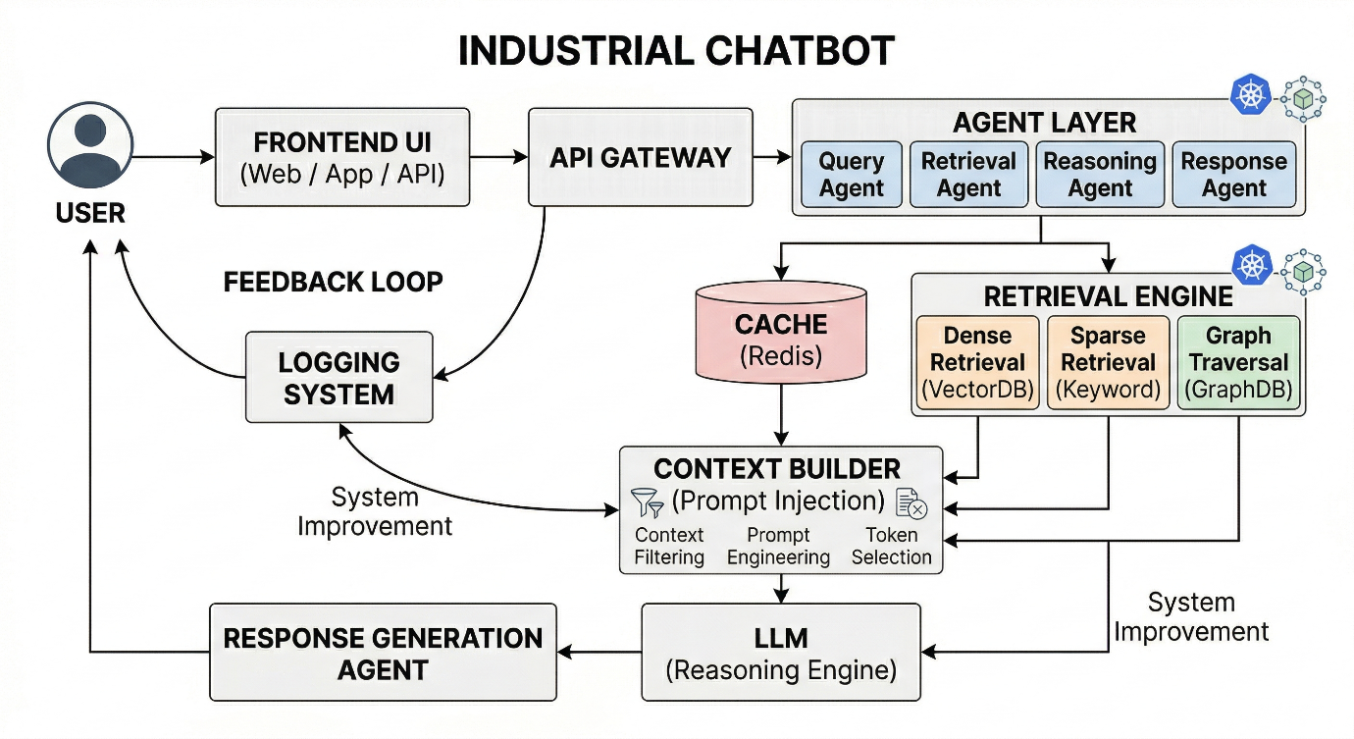

- Data Flow Pipeline
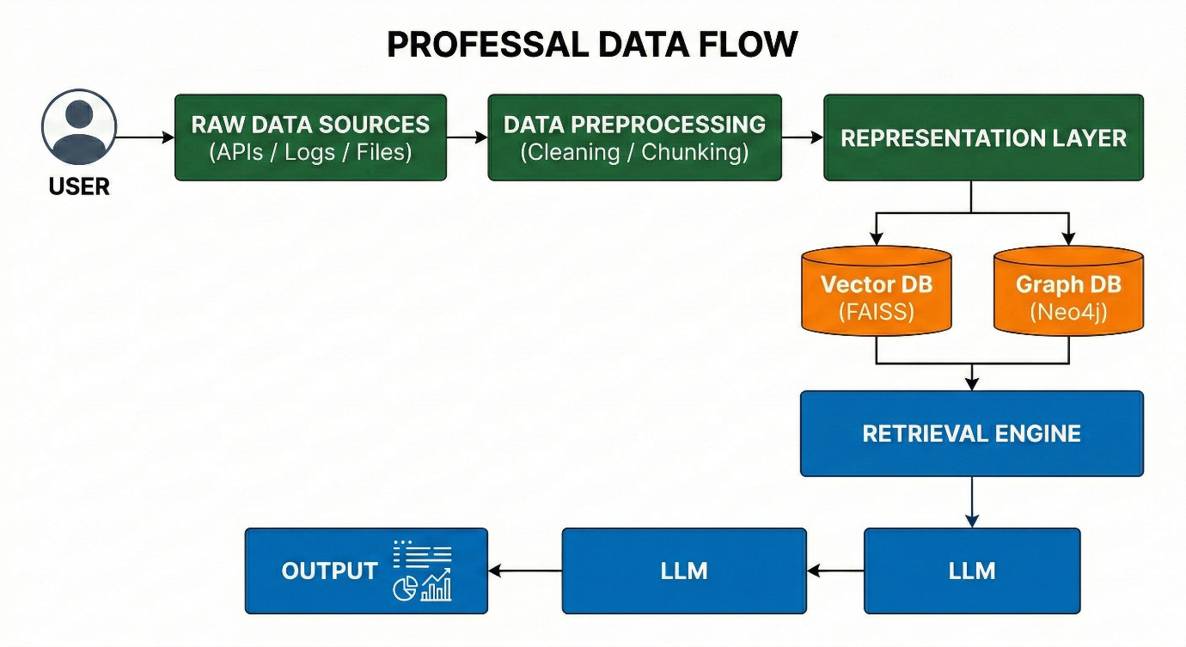
Comparison
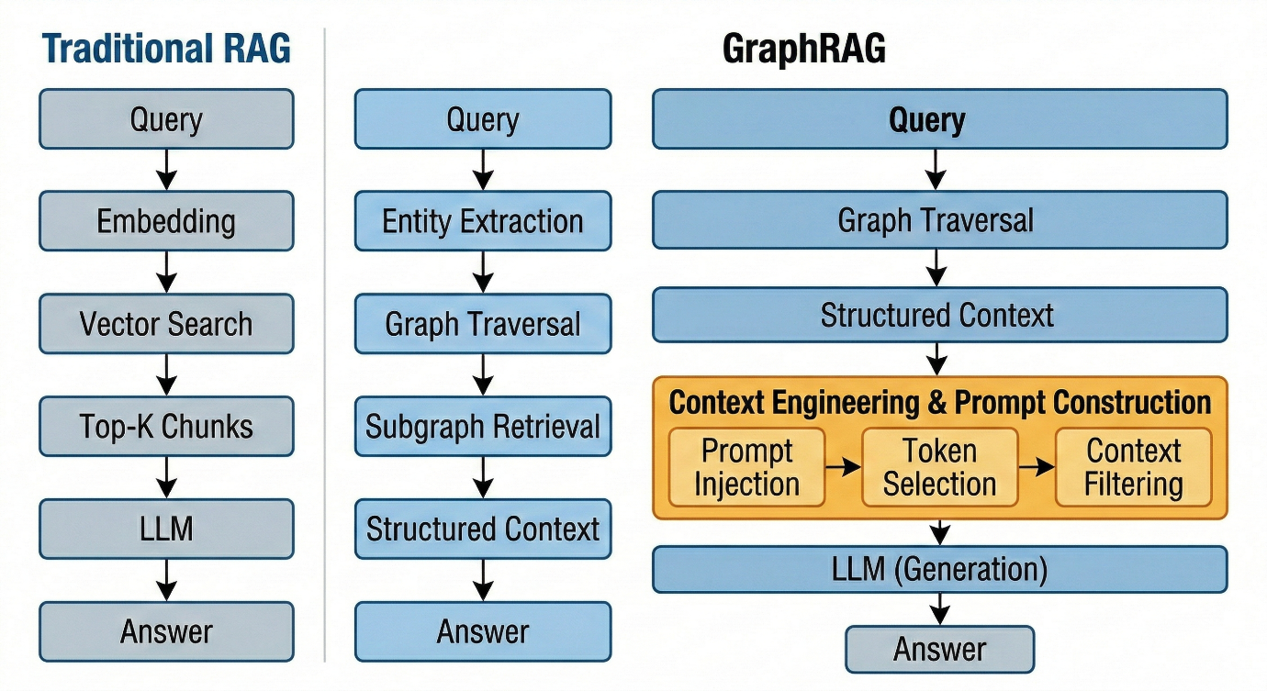
Hierarchical Graph Processing (Large Data)
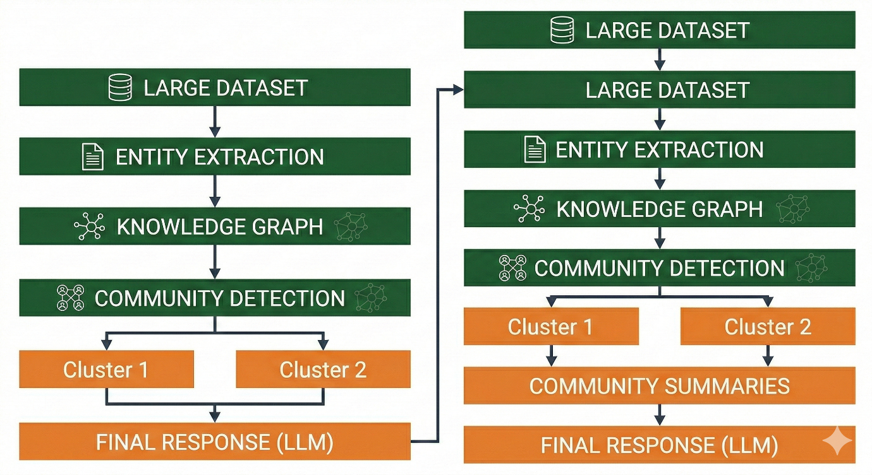
Pipeline
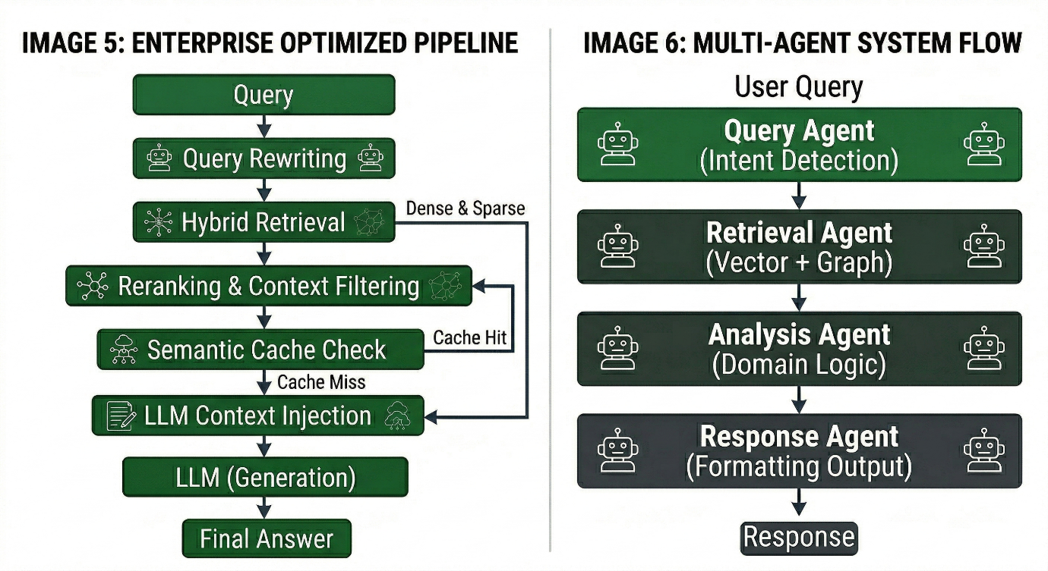
Multi-Agent System Flow

