Predicting In Vehicle Coupon Acceptance
A Predictive Analytics Project Using the KDD Process

Course Predictive Analytics
Assessment CA3 End to End Predictive Model Development
Student Atharv Deepak Jaiswal
PRN 23070521023
Academic year 2026

This report studies how a driver’s context and coupon characteristics relate to a survey response about accepting an in-vehicle coupon. It documents data selection, preparation, model comparison, held-out evaluation, and interpretation. All reported performance values are generated by the accompanying Jupyter Notebook.

Contents
1 Introduction
2 Literature Review
3 Workflow and Predictive Modelling Process
4 Results and Discussion
5 Conclusion
6 References

Abstract
Context-aware coupon recommendation asks whether a particular offer suits a person’s immediate situation. This study frames the UCI In-Vehicle Coupon Recommendation survey as a binary classification task: predict whether a respondent says they would accept a presented coupon. The work follows Knowledge Discovery in Databases (KDD), from data understanding and preparation to model evaluation and interpretation. A majority-class baseline, Logistic Regression, Decision Tree, and Random Forest are compared under a reproducible validation protocol. The final discussion explains the measured performance, important predictors, error patterns, and the limits of survey-based evidence. It does not equate stated acceptance with a completed purchase or redemption.

Keywords
predictive analytics; KDD; coupon acceptance; binary classification; contextual recommendation; model evaluation

1 Introduction

1 1 Problem context
A recommendation is useful only when the offer fits the recipient and the moment. An in-vehicle coupon may arrive while a driver is travelling to work, going home, or heading to no urgent destination. The weather, time, passengers, coupon category, expiry period, and the driver’s habits could all relate to the response. Predictive analytics can summarize these relationships and estimate the likelihood that a respondent will accept a coupon in a stated scenario.
The source data records answers to hypothetical driving situations in an Amazon Mechanical Turk survey. The outcome is therefore a stated intention. It is not an observed visit, purchase, or redeemed coupon. This distinction governs every interpretation in the report: the model predicts a survey response under the dataset’s conditions, and additional real-world validation would be needed before using it as a marketing decision system [1, 2].

1 2 Problem statement and objectives
The problem is to classify a coupon scenario as accepted or declined using information available in the survey. The target variable Y is 1 for acceptance and 0 for rejection. Each row is a scenario-response record. The work has four objectives: prepare the mixed categorical and numeric data without information leakage; compare simple and more flexible classification methods; estimate performance on unseen records; and interpret which observed fields the selected model uses most strongly.

1 3 Scope and research questions
The analysis uses only the published UCI dataset and its recorded predictors. It does not link to live location, personal identities, transaction histories, campaign costs, or redemption logs. The study asks: How much better is a trained classifier than a majority-class prediction? Which model gives the strongest validation F1-score? How does the selected model perform on a held-out set? Which input fields matter most to its predictions, and where do its mistakes concentrate?

1 4 Practical significance
A reliable prediction could help prioritize which combinations of context and coupon type deserve testing in a real campaign. Accuracy alone would not establish business value: sending an unwanted offer has a cost, and failing to present an offer has an opportunity cost. Because those costs are not supplied, this academic experiment evaluates statistical classification and leaves any operational threshold or campaign policy for a later study.

1 5 Organization of the report
Chapter 2 reviews the dataset’s original study and the methodological sources. Chapter 3 maps the work to KDD stages and describes the reproducible modelling process. Chapter 4 reports the notebook’s experimental results. Chapter 5 states the supported conclusions and limitations, followed by references in Chapter 6.

2 Literature Review

2 1 Context aware coupon recommendation
Wang and colleagues studied interpretable classification for context-aware in-vehicle recommendation [2]. Their Bayesian rule-set approach sought small groups of short rules that a human can inspect. The paper’s example uses an offer for a nearby coffee house, and its application concerns user behaviour in an in-vehicle recommender system. This project shares the coupon-response domain but asks a narrower course-level question: can commonly taught classifiers predict the survey label under a transparent evaluation protocol? It does not reproduce their Bayesian algorithm or claim comparable performance because the experimental setups differ.
The public UCI record describes the survey source, scenario variables, binary acceptance outcome, missing values, and reuse terms [1]. It lists 12,684 instances and 25 features. The data includes destination, passenger, weather, temperature, time, coupon type, expiry, demographic bands, and visit-frequency fields. These are suitable for demonstrating mixed-type preprocessing. The survey design also limits inference: a person’s answer to a hypothetical coupon is a proxy for intent, and the public release does not provide a respondent identifier for checking dependence among repeated answers.

2 2 Knowledge Discovery in Databases
Fayyad, Piatetsky-Shapiro, and Smyth describe knowledge discovery as a process that includes selecting relevant data, preparing it, applying data mining methods, and interpreting the resulting patterns [3]. The central lesson for this project is that fitting a classifier is only one stage. Data quality checks, defensible validation, and a careful account of what the results mean are necessary to turn a score into useful knowledge.
The KDD framing also makes the sequence important. Selection defines the target and available predictors. Preparation handles missing entries and categorical labels. Transformation converts survey categories into model inputs. Mining trains candidate classifiers. Evaluation checks whether those classifiers generalize beyond the training examples. Interpretation translates measured patterns into qualified statements about coupon acceptance. Feedback from later real campaigns could support a new iteration, but such feedback is unavailable here.

2 3 Validation and leakage
The scikit-learn cross-validation guide warns that fitting and assessing a model on the same observations yields overoptimistic results [4]. A held-out test set is therefore reserved until model choice is complete. The same source explains that tuning repeatedly against the test set can itself overfit the evaluation. In this project, training folds support model and parameter selection; the final test set is used once for the selected model.
The scikit-learn pipeline guide states that transformations should be learned on the fitting subset within each cross-validation fold [5]. A pipeline lets imputation and encoding follow that rule automatically. It also makes the saved model usable on new data, because the same preprocessing steps are applied at prediction time. These safeguards are particularly relevant when categories are numerous and some survey fields have missing values.

2 4 Interpretation of predictors
Permutation importance measures the change in a chosen score after one feature is shuffled while a fitted model is held fixed [6]. It answers a model-specific question: how much does this fitted model rely on that field for its tested predictions? It cannot prove that changing the field would change a person’s behaviour. Correlated inputs may share importance, and importance values depend on the data and scoring metric. The interpretation in Chapter 4 therefore remains descriptive, not causal.

2 5 Position of this project
The project combines the original dataset with a classroom comparison of Logistic Regression, Decision Tree, and Random Forest. Logistic Regression offers an interpretable linear baseline, a Decision Tree provides human-readable decision paths, and Random Forest tests whether combining trees improves generalization. A majority-class classifier anchors the comparison. The value of the experiment lies in an end-to-end and reproducible workflow, not in claiming a new recommendation algorithm.

3 Workflow and Predictive Modelling Process

3 1 KDD process map
KDD stage | Action in this study | Evidence produced
Selection | Define Y and choose UCI survey predictors | Problem statement and data source
Cleaning | Inspect missingness, categories and duplicates | Audit tables and documented decisions
Transformation | Impute, encode and scale inside pipelines | Reproducible preprocessing
Data mining | Tune and compare four classifier families | Cross-validation comparison
Evaluation | Use held-out test metrics and error analysis | Metrics, curves and confusion matrix
Interpretation | Discuss model reliance and limits | Feature importance and limitations
The accompanying notebook executes these stages in order. A fixed random seed makes sampling and model comparisons repeatable. The data source and software dependencies are retained in the project folder so the numerical results can be regenerated.

3 2 Data selection and target
The UCI In-Vehicle Coupon Recommendation dataset is the sole data source [1]. Each observation combines a hypothetical driving context, a proposed coupon, and the respondent’s stated decision. The target Y is removed from the predictor table before any feature preparation. No text from the target is used to create other inputs. The public source contains no respondent-level key, so this project cannot directly separate all answers from the same individual across evaluation partitions.
Dataset field | Value
Source | UCI Machine Learning Repository, DOI 10.24432/C5GS4P
Original observations | 12,684
Outcome | Y: 1 accepted, 0 declined
Published variables | 25 features in UCI metadata
Data type | Survey scenarios with categorical and numeric fields

3 3 Initial data audit
The audit checks file dimensions, target counts, column types, missing entries, repeated rows, and unexpected category labels. A duplicate record does not automatically prove a duplicate person: two respondents can receive identical scenarios and give the same answer. The notebook records how duplicates are defined and handled. The audit also distinguishes missing values from literal categories that resemble missingness, which prevents accidental conversion of a meaningful label into an empty cell.
The survey features include demographic bands such as age and income. Those bands are treated as categories because their labels are not measured numbers at a uniform scale. Scenario fields such as temperature may be numeric. The method does not convert categories into arbitrary ordinal codes, since that could suggest distances or ordering the survey did not establish.

3 4 Partitioning and validation
The notebook creates a training partition for exploration, preprocessing, tuning, and model selection, and a test partition for final evaluation. Identical predictor profiles are kept in the same partition where possible, so a scenario does not appear on both sides of the final split. Class proportions are kept approximately similar. The remaining training data is evaluated through five-fold cross-validation with the same grouping principle. The exact sample counts and checks are reported in Chapter 4.
Grouping by the complete predictor profile addresses exact scenario overlap. It cannot guarantee person-level independence because the released dataset has no respondent identifier. This matters when judging whether the measured performance would hold for entirely new individuals or a later campaign.

3 5 Exploratory analysis
Exploratory charts are computed on the training portion only. The notebook examines acceptance by coupon category, destination, passengers, time, weather, and relevant visit-frequency variables. Counts accompany rates so a high acceptance fraction from a small category is not treated as equally reliable as one supported by many records. Exploration identifies possible patterns for discussion; it does not control the final test-set outcomes.

3 6 Data preparation
Categorical inputs receive a missing-value label and one-hot encoding that can ignore an unseen category at prediction time. Numeric inputs receive median imputation, and scaling is used where it benefits the linear model. Columns with excessive missingness or no variation may be removed according to decisions learned from the training data. The fitted transformations are part of each classifier pipeline, so a validation fold never supplies imputation values or category vocabularies to the model trained for that fold [5].
The pipeline design makes preprocessing part of the estimated model rather than a separate manual step. It also provides a single saved object for inference. This reduces the chance that a new scenario is encoded differently from the examples used in training.

3 7 Models and selection
Candidate | Reason for inclusion | Main behaviour
Majority class | Reference point | Always predicts the most common training outcome
Logistic Regression | Linear benchmark | Combines encoded features in a regularized linear model
Decision Tree | Readable structure | Splits feature space into decision regions
Random Forest | Flexible ensemble | Aggregates many trees to reduce single-tree instability
Candidate settings are compared by mean cross-validation F1-score for the accepted class. ROC-AUC is used as a secondary measure when needed. F1 balances precision, the share of predicted acceptances that were accepted, and recall, the share of actual acceptances found. The selection rule is fixed before looking at the test results. The decision threshold remains 0.5; adjusting it to match business costs would require an explicit cost model or a separate tuning exercise.

3 8 Evaluation and interpretation
The selected model is fit on all training data and evaluated on the untouched test set. Accuracy shows the overall fraction correct; precision and recall distinguish the two types of positive-class error; F1 summarizes their balance. ROC-AUC measures ranking quality across thresholds. A confusion matrix makes false positives and false negatives visible, while ROC and precision-recall curves show how ranking behaves over a range of thresholds.
Permutation importance is then computed for the selected fitted pipeline on original input columns [6]. The analysis describes which fields matter to the model on this sample. Error counts or rates by coupon category help reveal whether a global score hides uneven performance. Three clearly hypothetical scenarios demonstrate how the model responds to different inputs; they are examples of inference, not observed participants.

4 Results and Discussion

4 1 Data audit and split
Measure | Observed result
Records used | 12,684
Training records | 10,148
Test records | 2,536
Train and test group overlap | 0
Positive class share | 56.84%
Exact duplicate rows retained | 74
Predictor profile groups | 12,587
The split counts above come from the notebook output. An overlap value of zero would mean no identical predictor profile occurs in both partitions. These checks assess exact profile separation; they do not identify all responses from the same person. The target balance and missing-value summary in the notebook provide the context for interpreting accuracy and imputation choices.
The 12,684 source rows include 74 exact duplicate records. They were retained because identical answers to identical scenarios can be valid survey observations. Grouping identical predictor profiles prevents those scenarios from crossing the hold-out split. The train and test acceptance shares are nearly the same, at 56.84% and 56.86% respectively. There are 12,587 distinct predictor profiles, and the recorded overlap is zero.
The car field exceeded 90% missingness and was dropped. The toCoupon_GEQ5min field was constant in training and was also dropped, leaving 23 predictor fields. Other missing categorical values were handled within the fitted preprocessing pipeline.
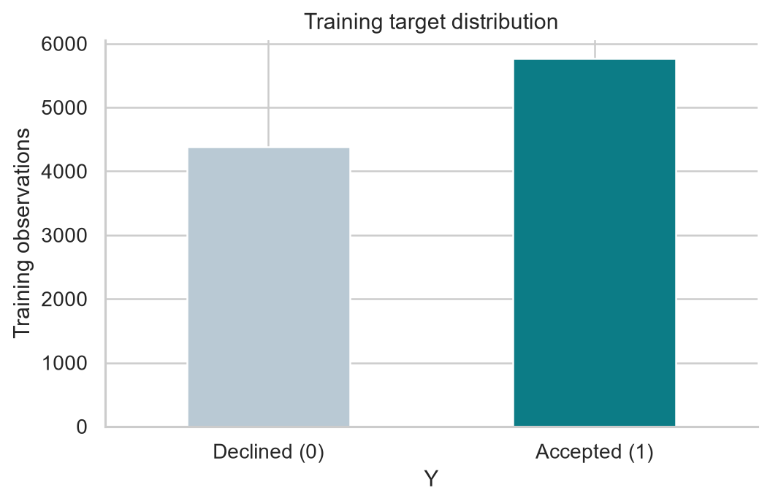
Figure 1 Coupon acceptance distribution
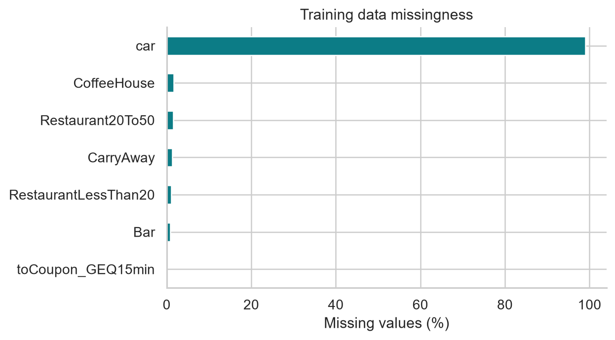
Figure 2 Missing values by input field

4 2 Exploratory findings
Acceptance rates can differ across coupon and journey categories because the offer and context change together. The exploratory figures report descriptive rates and counts from the training partition. A difference between groups does not by itself establish that changing one field would cause a different decision. The data was obtained through hypothetical survey prompts rather than a randomized coupon campaign.
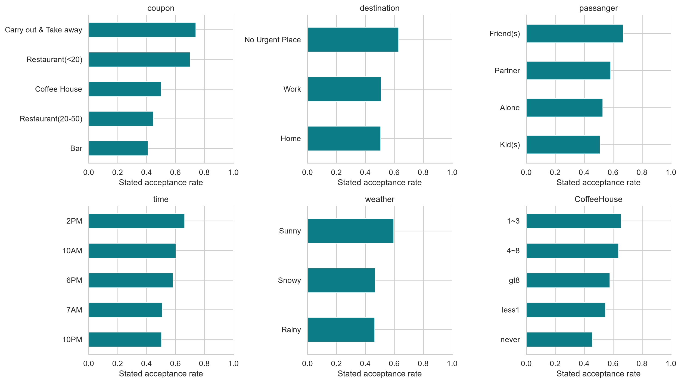
Figure 3 Training data acceptance patterns

4 3 Model comparison
Model | Mean validation F1 | Mean validation ROC-AUC
Majority baseline | 0.725 | 0.500
Logistic Regression | 0.734 | 0.734
Decision Tree | 0.742 | 0.676
Random Forest | 0.791 | 0.818
The selected classifier is Random Forest. The notebook applies the stated validation F1 selection rule; the test result is not used to choose among models. The comparison with the majority-class baseline indicates whether the trained methods add predictive information beyond the most frequent survey response. Cross-validation scores are estimates from the training partition, not the final held-out performance.
Random Forest achieved a mean validation F1 of 0.791, compared with 0.725 for the majority baseline, 0.734 for Logistic Regression, and 0.742 for the Decision Tree. Its mean validation ROC-AUC was 0.818. The selected forest used 200 trees, no maximum depth, and a minimum leaf size of 2. Its training F1 was 0.963, substantially above its cross-validation F1 of 0.791. That 0.171 gap signals overfitting to training records; the held-out test score below is the more relevant estimate of generalization to this survey sample.
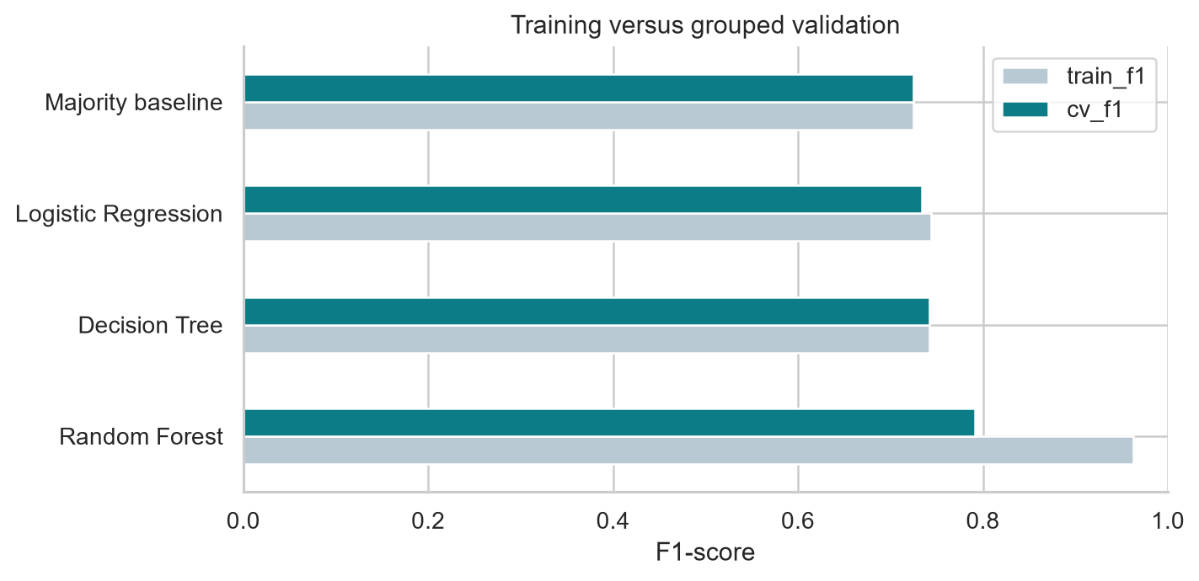
Figure 4 Cross-validation model comparison

4 4 Held out test performance
Metric | Selected model
Accuracy | 0.767
Precision for acceptance | 0.764
Recall for acceptance | 0.854
F1 for acceptance | 0.806
ROC-AUC | 0.837
The selected forest correctly classified 1,944 of 2,536 held-out records, yielding 76.66% accuracy. The majority baseline reached 56.86% accuracy and F1 0.725; the forest reached F1 0.806. Its recall of 0.854 exceeds its precision of 0.764, meaning it finds most acceptance responses while producing some extra positive predictions.
Actual outcome | Predicted decline | Predicted accept
Declined | 713 | 381
Accepted | 211 | 1,231
The confusion matrix contains 713 correct declines, 1,231 correct acceptances, 381 false positives, and 211 false negatives. False positives are more common than false negatives at the chosen threshold. In an actual campaign, the preferred balance would depend on the cost of sending unwanted coupons and the value of missed acceptances; this dataset does not quantify either.
These figures are calculated from the held-out records after the selected pipeline was fitted on the training partition. Precision and recall should be read together: a model can increase one by changing its decision threshold at the expense of the other. The 0.5 threshold used here is an experimental default, not an optimized campaign decision rule. ROC-AUC addresses ranking, so it provides a different view from threshold-based accuracy or F1.
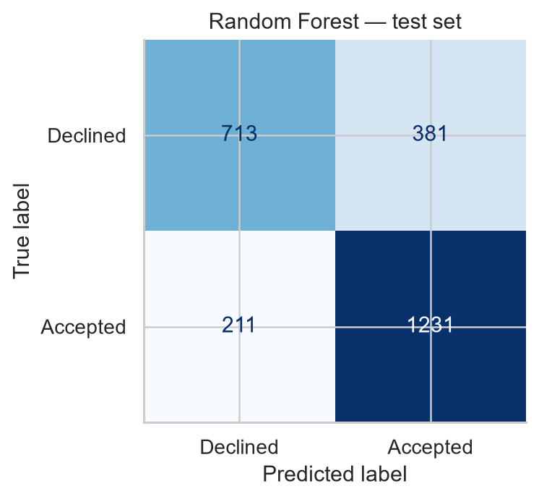
Figure 5 Confusion matrix for held-out predictions
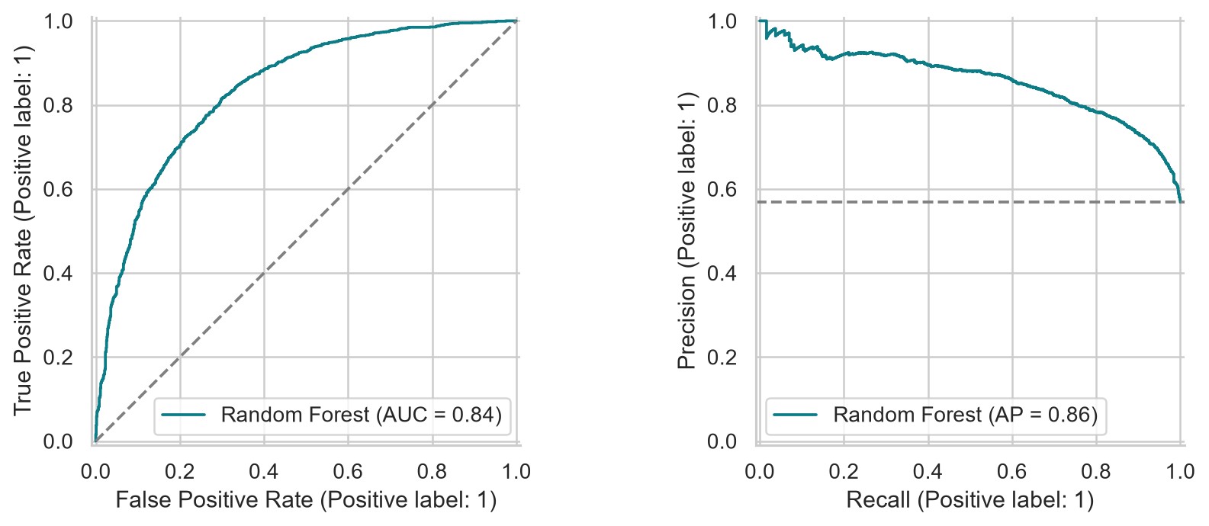
Figure 6 ROC and precision recall curves

4 5 What the model uses
Original input field | Permutation importance
coupon | 0.086
CoffeeHouse | 0.043
expiration | 0.027
Bar | 0.023
maritalStatus | 0.013
income | 0.012
CarryAway | 0.011
Restaurant20To50 | 0.010
destination | 0.008
occupation | 0.008
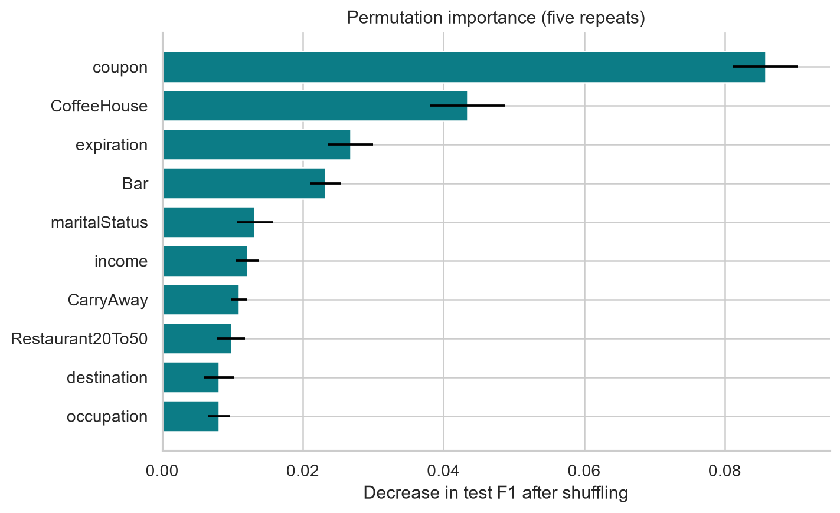
Figure 7 Model reliance on original input fields
Coupon type had the largest measured permutation importance: shuffling it lowered held-out F1 by an average of 0.086. CoffeeHouse visit frequency followed at 0.043 and coupon expiration at 0.027. These values concern the fitted Random Forest and its held-out data; they are not causal effect sizes. They also depend on correlated fields and the selected scoring metric.
Permutation importance quantifies the decrease in a chosen score when one original field is shuffled. A large value suggests that the selected pipeline relied on that field for this sample. A small value does not prove that the field is irrelevant in other models or populations, especially when related predictors carry similar information. The figures therefore support a description of model behaviour, not a causal claim about coupon responses [6].

4 6 Error patterns and limitations
Coupon category | Test rows | Error rate
Bar | 408 | 21.8%
Carry out & Take away | 489 | 24.3%
Coffee House | 788 | 22.1%
Restaurant(20-50) | 282 | 34.4%
Restaurant(<20) | 569 | 19.9%
The highest category error rate was 34.4% for Restaurant(20-50), based on 282 test rows. The lowest was 19.9% for Restaurant(<20), based on 569 rows. Carry out and take away coupons had a 24.3% error rate and were predicted accepted in 93.9% of test cases, although 72.0% were actually accepted. This suggests positive predictions in that category are especially common at the 0.5 threshold.

4 7 Example predictions
Coupon | Destination | Prediction | Accept probability
Coffee House | No Urgent Place | Accept | 64.7%
Bar | Work | Decline | 29.4%
Carry out & Take away | Home | Accept | 78.9%
These are hypothetical rows passed through the saved pipeline. They illustrate the mechanics of a prediction; the probabilities have not been calibrated against real coupon redemptions. The full input fields for each row are retained in the notebook.
An overall score can conceal uneven errors among coupon categories. The notebook’s category-level comparison should be considered alongside category counts: small groups produce less stable percentages. False positives could prompt a coupon for a respondent who said they would decline it; false negatives could withhold an offer from someone who said they would accept it. The available data does not specify the business cost of either outcome.
- Survey intention is not observed purchase or redemption.
- Respondent IDs are unavailable; identical-profile grouping does not guarantee independent people.
- No external or temporal validation; no causal interpretation.
- Probabilities are uncalibrated; demographic inputs require review before practical use.
The chief external-validity limit is the survey outcome. Respondents evaluated described situations, and their stated choices may differ from behaviour during actual travel. The dataset does not provide a time-based deployment sample, respondent identifiers, marketing costs, or observed redemption. These omissions prevent conclusions about live conversion, return on investment, and future drift. The project also uses one public dataset, so its model comparison should not be treated as a universal ranking of algorithms.

5 Conclusion
This project completed the KDD sequence for the UCI in-vehicle coupon survey. It selected a binary target, audited and prepared the data, compared a majority baseline with three common classifiers, selected a model through cross-validation, and tested Random Forest on held-out survey records. Its measured F1 for acceptance was 0.806, with ROC-AUC 0.837. Those numbers describe prediction of stated acceptance under the study’s evaluation conditions.
The experiment shows how preprocessing, validation, and interpretation belong together. Its saved pipeline can reproduce the same transformations for new scenario rows. The feature analysis helps explain what the fitted model used, while the error analysis shows where a single overall score needs qualification. These are descriptive findings, and they do not establish that altering a driver’s context would change an individual’s decision.
A practical next study would collect actual coupon impressions and redemptions with consent, retain an anonymous respondent or session identifier, and assess performance over time and across user groups. It could then choose a decision threshold using campaign costs and test it prospectively. Until such evidence exists, the model is best viewed as a reproducible academic analysis of survey responses.

6 References
[1] UCI Machine Learning Repository. In-Vehicle Coupon Recommendation [Dataset]. DOI: 10.24432/C5GS4P. https://archive.ics.uci.edu/dataset/603/in%2Bvehicle%2Bcoupon%2Brecommendation. Accessed 1 October 2026. Licensed CC BY 4.0.
[2] Wang, T., Rudin, C., Doshi-Velez, F., Liu, Y., Klampfl, E., and MacNeille, P. (2017). A Bayesian Framework for Learning Rule Sets for Interpretable Classification. Journal of Machine Learning Research, 18(70), 1-37. https://www.jmlr.org/papers/v18/16-003.html.
[3] Fayyad, U., Piatetsky-Shapiro, G., and Smyth, P. (1996). From Data Mining to Knowledge Discovery in Databases. AI Magazine, 17(3), 37-54. https://doi.org/10.1609/aimag.v17i3.1230.
[4] scikit-learn developers. Cross-validation: evaluating estimator performance. https://scikit-learn.org/stable/modules/cross_validation.html. Accessed 1 October 2026.
[5] scikit-learn developers. Pipelines and composite estimators. https://scikit-learn.org/stable/modules/compose.html. Accessed 1 October 2026.
[6] scikit-learn developers. Permutation feature importance. https://scikit-learn.org/stable/modules/permutation_importance.html. Accessed 1 October 2026.

Dataset attribution and reuse
The project package includes the UCI dataset under Creative Commons Attribution 4.0. The UCI record and DOI above provide the required source credit. The analysis, report, and figures were prepared for the named student’s CA3 submission.

