A Mini Project Report On
CONNECT-FOUR GAME

Submitted in partial fulfilment of the requirement of
University of Mumbai
For the Degree of
Bachelor of Engineering (SE)
in
COMPUTER ENGINEERING

Submitted by
Reuben Brian D’silva
Jeevan Kunder
Aryan Hirlekar
Atharv Kadam

Supervised by
Mrs. Prachi Verma (Guide)


Department of Computer Engineering
Fr. Conceicao Rodrigues Institute of Technology
Sector 9A, Vashi, Navi Mumbai - 400703

UNIVERSITY OF MUMBAI
2022-2023
APPROVAL SHEET

This is to certify that the Mini project entitled
“CONNECT-FOUR GAME”

Submitted by :-

Reuben Brian D’silva 1021135
Jeevan Kunder 1021163
Aryan Hirlekar 1021148
Atharv Kadam 1021156

Supervisors : Mrs.Prachi Verma

Project Coordinator: Mrs. Kavita Shelke

Examiners : 1.

2.

Head of Department: Dr.Lata Ragha

Date :
Place : Vashi ,Navi Mumbai

i
Declaration
We declare that this written submission for S.E. Mini Project entitled “CONNECT FOUR GAME” represent our ideas in our own words and where others’ ideas or words have been included. We have adequately cited and referenced the original sources. We also declared that we have adhere to all principles of academic honesty and integrity and have not misrepresented or fabricated or falsified any ideas / data / fact / source in our submission. We understand that any violation of the above will cause for disciplinary action by institute and also evoke penal action from the sources which have thus not been properly cited or from whom paper permission have not been taken when needed.

Project Group Members:

Reuben Brian D’silva, 1021135

Jeevan Kunder, 1021163

Aryan Hirlekar, 1021148

Atharv Kadam, 1021156

ii
Abstract

Trying to develop games where a human player is matched against a computer has been in development for decades. Along with this development, efforts have also been made to make the games enjoyable for longer periods of time. One method that can be employed is by providing a sense of randomness. For a two-player game as simple as Connect Four, there will hardly be anything that can prove to be a surprise during a regular game. It can help to include events that can occur at any time, supposedly at random. Having a player play against the computer can be the best way to implement randomness if properly executed. Algorithms such as the Minimax algorithm could provide the best move to perform to minimize the chances of the player winning. But seeing as the calculations are done from the point of view of both the computer and the player, and knowing that the human player won’t be able to compete, finding ways to handicap the computer could be a solution. The Alpha-Beta algorithm will prune out options that provide worse results than the ones already determined. This could also be used to omit certain possibilities to make sure the computer doesn’t always win. To add to the aspect of making the game experience engaging, features such as three-player games, time-based modes, and a high score leaderboard can be added.

iii

Contents

Abstract |  |  |  |  |  | iii
List of Figures |  |  |  |  |  | vi
List of Tables |  |  |  |  |  | vii
1 | Introduction |  |  |  |  | 9
 | 1.1 | Background |  |  |  | 10
 | 1.2 | Motivation |  |  |  | 10
 | 1.3 | Aim and Objective |  |  |  | 10
 | 1.4 | Report Outline |  |  |  | 10
2 | Study Of the System |  |  |  |  | 11
 | 2.1 | Literature Review |  |  |  | 12
 |  | 2.1.1 Real Time Connect 4 Game Using Artificial Intelligence |  |  |  | 12
 |  | 2.1.2Alpha-Beta Pruning in Min-MaxAlgorithm |  |  |  | 12
 |  | 2.1.3 Bridging the Blank: A Defining from Property Uncertainty to Felt Uncertainty in Games |  |  |  | 13
 |  | 2.1.4 Questioning Wizard of Oz: Effects of Revealing the Wizard behind the Robot |  |  |  | 14
 | 2. | Existing System |  |  |  | 15
 |  | 2.2.1 Helpfulgames.com Connect Four Game |  |  |  | 15
 |  | 2.2.2 CBC Kids Connect4 Game |  |  |  | 15
 |  | 2.2.3 Papergames.io’s connecct4 game |  |  |  | 16
3 | Proposed System |  |  |  |  | 17
 | 222 | 3.1 Problem Statement |  |  |  | 18
 | 3.2 | 3.2 Scope |  |  |  | 18
 | 3.3 | 3.3 Hardware and Software Requirements |  |  |  | 18
4 | Design Of the System |  |  |  |  | 19
 | 4.1 | 4.1 Approach |  |  |  | 20
 |  | 4.1.1 | Flow Chart |  |  | 21
 |  | 4.2 Technology Stack |  |  |  | 22
4.2.1 Front End
Back End
5 | Result and Discussion  5.1 Observations |  |  |  |  | 23  24
 | 5.1 | 5.2 Implementation
 |  | 5.2.1 |  | Registration |  | 24
 |  | 5.2.2 |  | Step-by-step working |  | 28
 | 5.2 | 5.3 Important Code Snippets |  |  |  | 29
 |  | 5.3.1 |  | Menu |  | 29
 |  | 5.3.2 |  | Game Algorithm |  | 31
6 | Conclusion & Future Scope |  |  |  |  | 33
 | References |  |  |  |  | 35
 | Appendix A: Timeline Chart

v

List of Figures
2.1.2 Final Game Tree Without Alpha-Beta Pruning 12
Final Game Tree with Alpha-Beta Pruning 12
2.1.3 Final average analysis of the collected data 14
Trust in the robot for the 3 experimental conditions 15
Intelligence perception for the 3 experimental conditions 15
Likeability perception for the 3 experimental conditions 15
4.1.1 Flow chart . . . 21
5.2.1 Registration 23
2 player (red winning screen) 24
3 player screen 25

vi
List of Tables
2.1.2 Comparison between Two Algorithms. . . . . . . . 13

vii

Chapter 1
Introduction

  - Background
Connect Four is a two-player connection board game, in which the players choose a color and then take turns dropping colored tokens into a seven-column, six-row vertically suspended grid. The pieces fall straight down, occupying the lowest available space within the column. A player wins if they manage to get four consecutive tokens of their color within the grid.
1.2 Motivation
The game, while seemingly easy, actually has 4,531,985,219,092 possible tokens configurations. Creating a program with respect to all those possibilities is difficult. So, finding ways to make it easy to for computer is a major motive. As beginners implementing features like creating a good scoring system, having time-based modes, the ability to customize the in-game color themes is a good starting point. This process will include concept generation, proper design, development and testing.

1.3 Aim and Objective
The main aim is to about various methods and algorithms deployed to create games. Implementing those methods, mainly to create a computer bot to play against. To improve upon the simple playstyle of the game by adding some factors of uncertainty and randomness, as games where the computer performs the same predefined steps, people will find it boring. To learn more about the challenges and difficulties faced within game development and trying to overcome the same.
1.4 Report Outline
This report presents our attempt at making a playable game on a single device regardless the number of players. We have provided our approach to make the program suitable for taking multiple user inputs as well as for a single user and a machine learning algorithm.

Chapter 2
Study of the System

2.1 Literature Survey
2.1.1 Real Time Connect 4 Game Using Artificial Intelligence ^{[1]}
To help the AI play Connect Four using heuristics with influence mapping. The different types of AI implemented were: Random, Defensive and Aggressive. The different modes were: Two players, with and w/o a timer, Against the AI, with and w/o a timer. The scoring system worked by checking the immediate up, down, left, right tokens of the same color. If more than one was present, it kept counting till required number of tokens were reached. The algorithms mentioned were: Minimax without Alpha-Beta, Minimax with Alpha-Beta, A* algorithm, A* finds the shortest path to reach the destination by creating trees for each path. Though it was not used because high memory consumption. Programs used while testing: VICTOR, Velena.
The program was implemented in C Lab Windows/CVI by National Instruments written for a Windows environment

2.1.2 Alpha-Beta Pruning in Min-Max Algorithm ^{[2]}
Using Minimax algorithm with and without Alpha-beta pruning and showing the distinction between programs running with above-mentioned methods
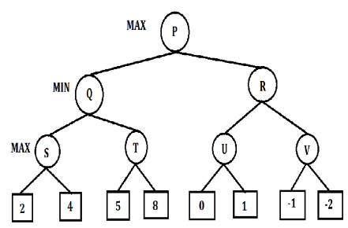 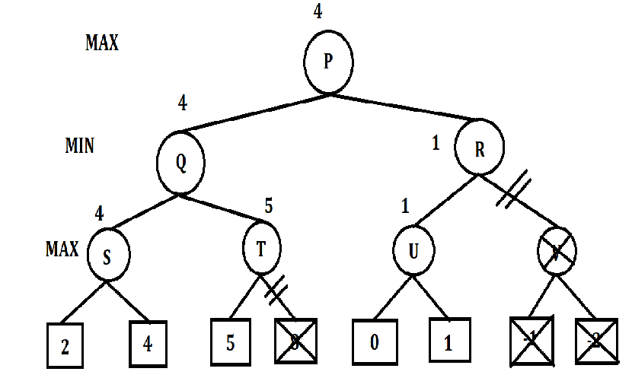 Final Game Tree Without Alpha-Beta Pruning Final Game Tree with Alpha-Beta Pruning

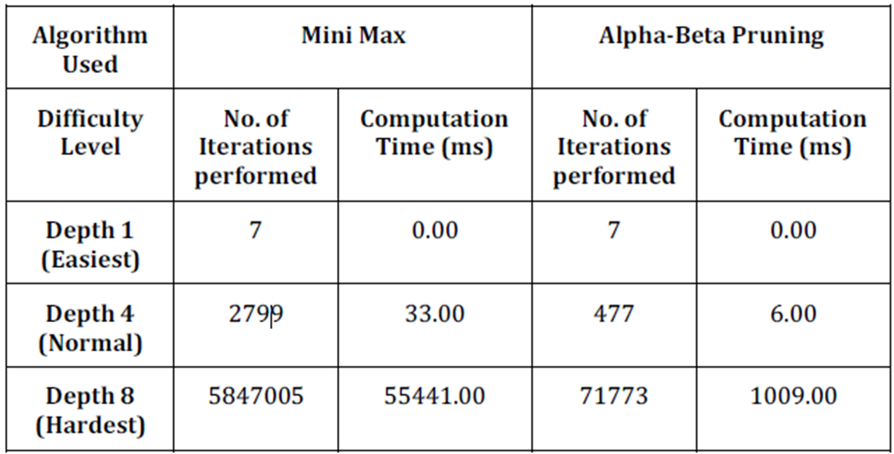
Comparison between Two Algorithms

2.1.3 Bridging the Blank: A Defining from Property Uncertainty to Felt Uncertainty in Games ^{[3]}
Importance of striking a balance of uncertainty in algorithms and in turn videogames. Having less randomness, the format becomes predictable and eventually boring. Having to much randomness causes difficulties in to learn patterns, and maybe even frustration
Different iterations of Connect Four developed were:
- FairGame7x6
- FairGame5x6
- FairGame9x6
- FairGameWithMCTS
- FairGameWithMCTSResultTold
Each participant was required to finish a total of seven games, and each game variant was played seven times.

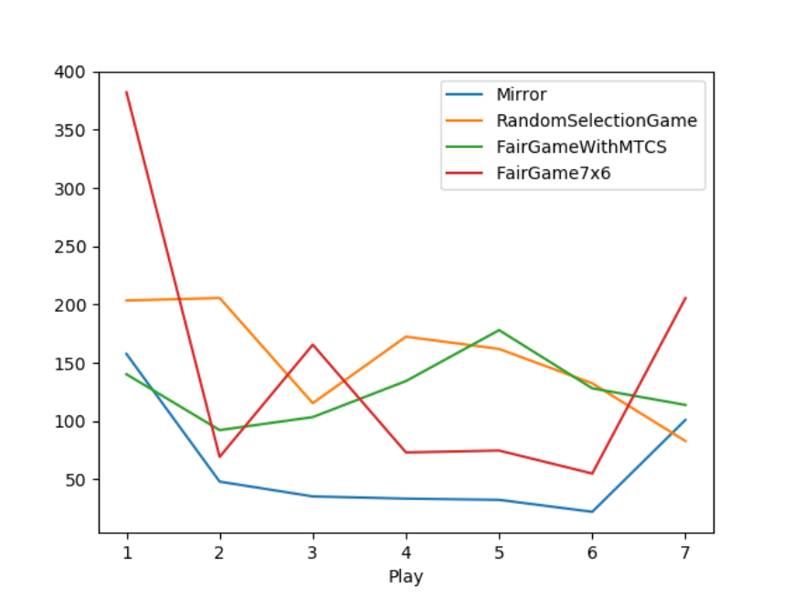
Final average analysis of the collected data

2.1.4 Questioning Wizard of Oz: Effects of Revealing the Wizard behind the Robot ^{[4]}
Wizard of Oz: A humans pretending to be AI behind the system till the AI gets properly implemented. A robot and the participant cooperate to beat a computer AI. The robot provides suggestions to the human about the next best move. While at the end of the game the robot engages the participant in a short conversation. Criticism: Users made to believe they are interacting with a fully AI integrated system and the secret is revealed only at the end of the experiment. For the purposes of our study, the game selected was Connect 4 and probability AI, based on Monte Carlo tree search (MCTS), that can predict the probability of winning the round associated with a move was selected. As the focus is on the interactions between the game and the player factors such as the case in which the robot reveals to be controlled by a human, the case in which it declares to be fully autonomous and the case in which it says nothing. The conditions were defined as: Where it lies about being an AI, the robot truthfully reveals that it is being controlled by a human, The robot does not reveal anything. The analysis was done on the following data: How frequently the participants accept the suggestions of the robot, how much did the player trust the robot to give the correct option? Feedback from the players on if the robot was entirely controlled by humans or entirely autonomous
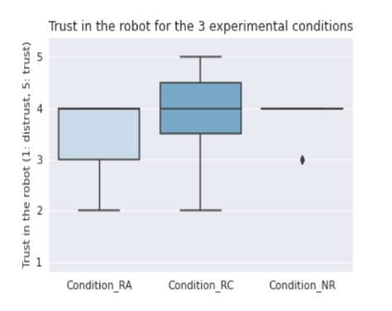 | 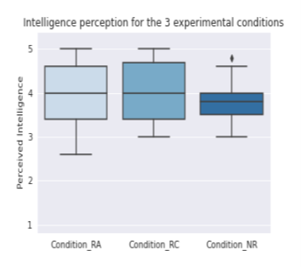  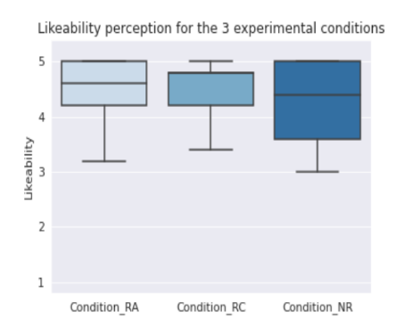
2.2 Existing System
2.2.1 Helpfulgames.com Connect Four Game ^{[5]}

It has a very ordinary yet concise interface. 14 difficulty levels are available which range from “EASY” all the way up to “EXCEPTIONALLY HARD”. It displays a bar which shows the player’s knowledge points (exp points). The bottom of the screen has a tab which stores the player’s statistics (rounds played, levels cleared, accuracy) alongside the recent activities in the game. The mode in which the player starts first the computer sometimes goes faster and skips some of the players placement. The player always has to face the computers AI, also no other game modes are available. It has a bug in which if we click really fast more than one chip is deployed.
2.2.2 CBC Kids Connect4 Game:^{[6]}
The graphics were very well designed. It only has 2 modes i.e., User vs AI & User vs User. Game is designed in such a way that it is easy to play. The board had a 7x6 ratio. The game doesn't show any leaderboard. Only 2 modes are available.

2.2.3 Papergames.io’s connecct4 game:^{[7]}
The front end of this site is very well designed with a user-friendly interface. It has 4 different game mode play online play with a friend play vs robot create a tournament. It has a feature of ranked matches as well which is missing in most online connect 4 games. It also has an interactive leaderboard. Rules of the game were not explained in the beginning. A lot of bots in online matches as well. You cannot play this game without signing in.

Chapter 3
Proposed System

3.1 Problem Statement
The topic chosen for this project isn’t a new idea by any means and various implementations with varying degrees of complexity are already being made. The complexity comes in the algorithm chosen for the computer. Having a fully functioning application with the projected requirements is the final goal.
3.2 Scope
Playing a game such as this develops the skill of noticing patterns. To some extent it can also develop fine motor skills. As some amount of planning is required on playing the next move it can boost strategic thinking capabilities. Creates a quick-thinking mindset. It teaches competitiveness and how to handle associated feelings/emotions. And probably the most important of all it provides fun and entertainment
3.3 Hardware and Software Requirements
We have chosen to create the game in the programming language Python. The reason was it extremely popular, simple, easy to follow and flexible to use. In python we will require the Numpy, Pygame, Sys, math libraries. From existing systems, it was observed the games utilized about 150 MB of Memory. Our first implementation was in Jupyter Notebook and the game was CPU heavy and the RAM usage was similar as above. On later versions we ran the game on Vscode, and the game as a python file on its own.

Chapter 4
Design of the System

4.1 Approach
Features to be implemented:
- A proper menu system
- Support to play against both real players and AI
- Support for up to 3 real players
- Having a good amount of game modes
- Rewarding scoring system
- Leaderboards for multiple modes

4.1.1 Flow Chart
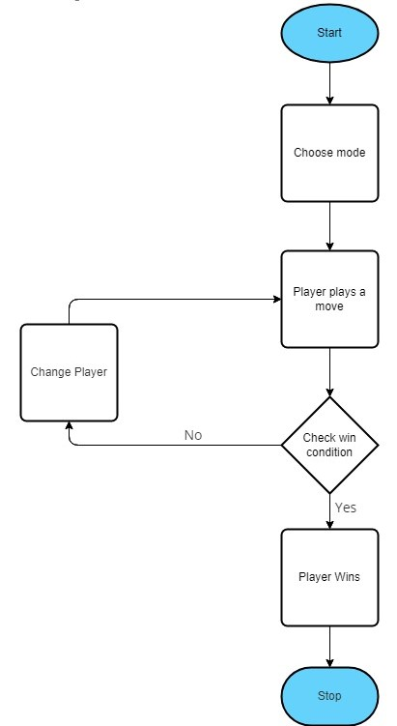
The above flowchart shows the barebones of the functioning of the program. The user will be prompted with a mode selection page after which the game will begin. Players will take in turns to play. The win condition is checked after each move. If it is satisfied, the current player wins and the game ends. If not the play continues till a player wins.

4.2 Technology Stack
4.2.1 Front End
For creating the menu, we have used DearPyGui. DPG is a simple, bloat-free, and powerful Python GUI framework. It is easy to work with to provide a good interface for selecting game modes as well as for account creation.

4.2.2 Back End
All data regarding the match, i.e. score, points, will go through DPG to locally connected database on MySQL. Leaderboard information can be displayed by fetching from the database and user account details can also be viewed.

Chapter 5
Result and Discussion

5.1 Observations
Checking stats through the task manager, the python program running through Jupyter notebook was CPU heavy average 150 MB RAM throughout the multiple instances. The exit button doesn’t perform it’s intended operation and the entire program crashes and needs to be restarted. Same stats observed while running through Vscode and as a python file on its own.
5.2.1 Registration (screen shots of each step)

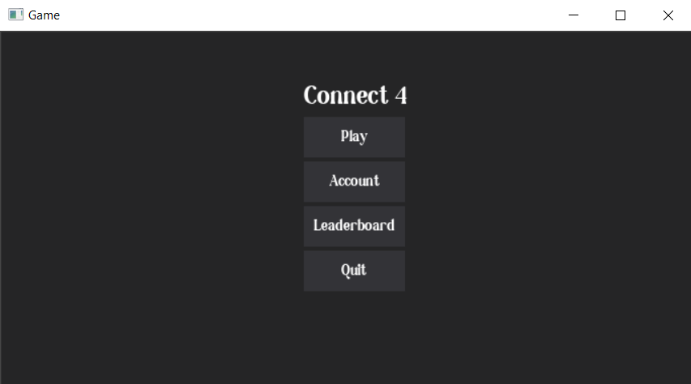
Landing page

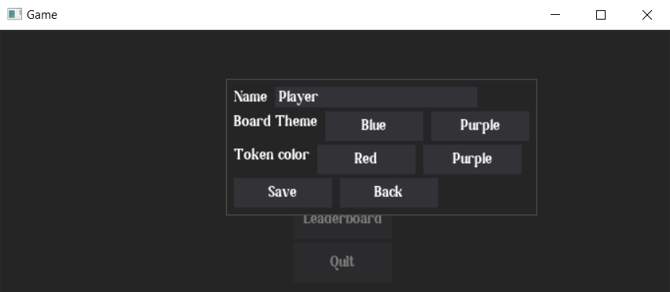
Registration page

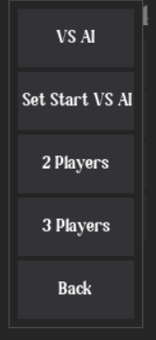
Mode Select
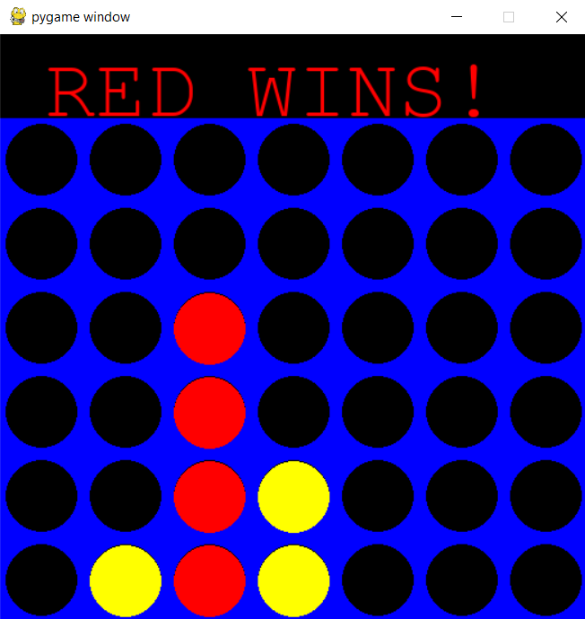
2 players (red winning)

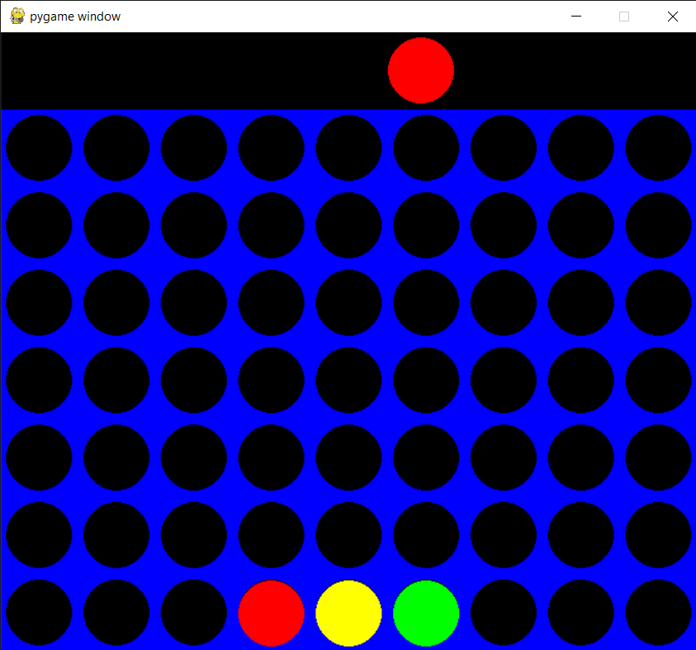
3 players

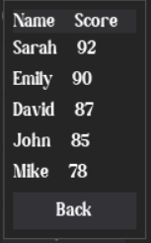
Leaderboard display

5.2.2 Step-by-step working
Step 1:
First, we import the NumPy package as np. Then create a python function named create_board(). np.zeros( ) function is used to create a matrix full of zeroes.6 rows and 7 columns are the dimensions. Then we return the board. We will begin writing the main game loop as while not game-over. Our loop is going to run as long as this game_over variable is false. The only time its going to switch to true is if someone gets 4 circles in a row. To increase the turn by 1 we will use turn += 1.
Step 2:
In the step 02, we make a few updates to the previous code. We want the selection variable to actually drop a piece on the board. For that, we will create another three functions as def drop_piece( ), def is_valid_location( ), def get_next_open_row( ). How these functions are going to Work together is as follows, the (0-6) in the code represents the column where they want to drop their piece. Hence we update the name of selection variable to column variable (col).Then we will take this col in the current board that we have and pass it as parameters in all the three functions with board. We will initialize global variables called ROW_COUNT and COLUMN_COUNT. The np.flip( ) function reverses the order of array elements along the specified axis, preserving the shape of the array.
Step 3:
In step 03, we will create a game with a GUI. With the new modifications that we do will make the game look like an actual board game. First we will import all the necessary libraries. Next we will define the colours blue, black, red and yellow as global static variables. These values are going to be rgb values. We will initialize global variables called ROW_COUNT and COLUMN_COUNT. Number of rows are 6 and number of columns are 7.Then we create 5 functions named create_board( ), drop_piece( ), is_valid_location( ), get_next_open_row( ) and print_board( ).Then we create a function called winning_move() and we check for horizontal locations to win, vertical locations to win, positively and negatively sloped diagonals to win. In horizontal and vertical locations, we create a nested for loop for the rows and columns and check an if condition statement to see if the piece has been dropped to that location on the board. If the if condition is satisfied, it will return TRUE. We will repeat the same procedure for vertical locations, positively and negatively sloped diagonals as well. the function def draw_board( ), pygame.draw is a module for drawing shapes.pygame.draw.rect is used to draw a rectangle. Now we will define the triangle. Define the height and width and the position. So the position is going to be, c*SQUARESIZE and the position of the y-axis is going to be r*SQUARESIZE+SQUARESIZE. Height and width are going to be the other two parameters and thats just going to be SQUARESIZE, SQUARESIZE. We will repeat the same procedure for the circle.
5.3 Important Code Snippets
5.3.1 Menu
dpg.create_context()
dpg.create_viewport(title='Game', width=700, height=600)
dpg.setup_dearpygui()

def ModeValue(sender, app_data):
if app_data[1]=='1Play':
oneplay()
elif app_data[1]=='2Play':
twoplay()
elif app_data[1]=='3Play':
threeplay()
else:
ssoneplay()

with dpg.window(label='Select Mode', modal=True, show=False, tag='b0', no_title_bar=True,pos=(280,50)):
dpg.add_button(label="VS AI", tag='1Play',width=100, height=50)
dpg.add_button(label="Set Start VS AI", tag='SS1Play',width=100, height=50)
dpg.add_button(label="2 Players", tag='2Play',width=100, height=50)
dpg.add_button(label="3 Players", tag='3Play',width=100, height=50)
dpg.add_button(label="Back", callback=lambda: dpg.configure_item("b0", show=False),width=100, height=50)

with dpg.window(label='Account', modal=True, show=False, tag='b1', no_title_bar=True,pos=(230, 50)):
with dpg.group(horizontal=True):
dpg.add_text("Name")
InName=dpg.add_input_text(default_value="Player", tag="Pname")

with dpg.group(horizontal=True):
dpg.add_text("Board Theme")
dpg.add_button(label="Blue", tag="BColBl", width=100, height=30)
dpg.add_button(label="Purple", tag="BColPurp", width=100, height=30)

with dpg.group(horizontal=True):
dpg.add_text("Token color")
dpg.add_button(label="Red", tag="TColRd",width=100, height=30)
dpg.add_button(label="Purple", tag="TColPurp",width=100, height=30)

with dpg.group(horizontal=True):
dpg.add_button(label="Save", tag="SaveChanges",width=100, height=30)
dpg.add_button(label="Back", callback=lambda: dpg.configure_item("b1", show=False),width=100, height=30)
a
with dpg.window(label='Leaderboards', modal=True, show=False, tag='b2', no_title_bar=True, pos=(300, 50)):
with dpg.group():
with dpg.table(header_row=True):
dpg.add_table_column(label='Name Score')
rows=showldb()
for i in rows:
print(i)
with dpg.table_row():
dpg.add_text(f"{i[1]} {i[2]}")
dpg.add_button(label="Back", callback=lambda: dpg.configure_item("b2", show=False),width=100, height=30)
with dpg.window(tag="Primary Window", width=700, height=600):
with dpg.group(pos=(300,50)):
title=dpg.add_text("Connect 4")
dpg.bind_item_font(title, default_font)
dpg.add_button(label="Play", callback=lambda: dpg.configure_item('b0', show=True),width=100, height=40)
dpg.add_button(label="Account", callback=lambda: dpg.configure_item('b1', show=True),width=100, height=40)
dpg.add_button(label="Leaderboard", callback=lambda: dpg.configure_item('b2', show=True), width=100, height=40)
dpg.add_button(label="Quit", callback=lambda: dpg.configure_item('Primary Window', show=False),width=100, height=40)
dpg.bind_font(second_font)

#========binding item to registry=========
dpg.bind_item_handler_registry('1Play', "widget handler")
dpg.bind_item_handler_registry('SS1Play', "widget handler")
dpg.bind_item_handler_registry('2Play', "widget handler")
dpg.bind_item_handler_registry('3Play', "widget handler")

dpg.bind_item_handler_registry('SaveChanges', "dbvalues")
dpg.bind_item_handler_registry('BColBl', "dbvalues")
dpg.bind_item_handler_registry('BColPurp', "dbvalues")

dpg.bind_item_handler_registry('TColRd', "dbvalues")
dpg.bind_item_handler_registry('TColPurp', "dbvalues")

dpg.show_viewport()
dpg.set_primary_window("Primary Window", True)
dpg.start_dearpygui()
dpg.destroy_context()

5.3.2 Game algorithm
while not game_over:

for event in pygame.event.get():
if event.type == pygame.QUIT:
sys.exit()

if event.type == pygame.MOUSEMOTION:
pygame.draw.rect(screen, BLACK, (0,0, width, SQUARESIZE))
posx = event.pos[0]
if turn == 0:
pygame.draw.circle(screen, RED, (posx, int(SQUARESIZE/2)), RADIUS)
else:
pygame.draw.circle(screen, YELLOW, (posx, int(SQUARESIZE/2)), RADIUS)
pygame.display.update()

if event.type == pygame.MOUSEBUTTONDOWN:
pygame.draw.rect(screen, BLACK, (0,0, width, SQUARESIZE))

if turn == 0: #RED
posx = event.pos[0]
col = int(math.floor(posx/SQUARESIZE))

if is_valid_location(board, col):
row = get_next_open_row(board, col)
drop_piece(board, row, col, 1)

if winning_move(board, 1):
label = myfont.render("RED WINS!", 1, RED)
screen.blit(label, (40,10))
game_over = True

else : #YELLOW
posx = event.pos[0]
col = int(math.floor(posx/SQUARESIZE))

if is_valid_location(board, col):
row = get_next_open_row(board, col)
drop_piece(board, row, col, 2)

if winning_move(board, 2):
label = myfont.render("YELLOW WINS!", 1, YELLOW)
screen.blit(label, (40,10))
game_over = True

print_board(board)
draw_board(board)

turn += 1
turn = turn % 2

if game_over:
pygame.time.wait(3000)

Chapter 6
Conclusion and Future Scope

6.1 Conclusion
In this project for Connect 4 we are going to design game which will be more engaging with more challenging levels also we will be focusing on increasing the game’s approachability by providing quick access and easy user-friendly interface.
In Connect 4 game we will be developing proficient enough AI that feels challenging enough for players. Adding randomness not only in the playstyle of the computer but also while the match is in play.

References
- Real-Time Connect 4 Game Using Artificial Intelligence, 2009, Ahmad M. Sarhan, Adnan Shaout and Michele Shock
- Alpha-Beta Pruning in Mini-Max Algorithm –An Optimized Approach for a Connect-4 Game, 2018, Rijul Nasa, Rishabh Didwania, Shubhranil Maji, Vipul Kumar
- Questioning Wizard of Oz: Effects of Revealing the Wizard behind the Robot, 2022, Shano Liang
- Bridging the Blank: A Defining from Property Uncertainty to Felt Uncertainty in Game, 2022, Jauwairia Nasir, Pierre Oppliger, Barbara Bruno, and Pierre Dillenbourg)
- helpfulgames.com ’s connect 4 game
- CBC kids
- https://papergames.io/en/connect4

Acknowledgement

Success of a project like this involving high technical expertise, patience and massive support of guides, is possible when team members work to-gather. We take this opportunity to express our gratitude to those who have been instrumental in the successful completion of this project. We would like to appreciate the constant interest and support of our mentor guide in our project and aiding us in developing a flair for the field of Your Domain. We would always cherish the journey of transforming the idea of our project into reality. We would like to show our appreciation to Guide for his/her tremendous support and help, without whom this project would have reached nowhere. We would also like to thank our project coordinator Mrs. Kavita Shelke /Mrs. Dakshayani R for providing us with regular inputs about documentation and project timeline. A big thanks to our HOD Dr. Lata Ragha for all the encouragement given to our team. We would also like to thank our principal, Dr. S. M. Khot, and our college, Fr. C. Rodrigues Institute of Technology, Vashi, for giving us the opportunity and the environment to learn and grow.

Project Group Members:

Reuben Brian D’silva, 1021135

Jeevan Kunder, 1021163

Aryan Hirlekar, 1021148

Atharv Kadam, 1021156

Appendix A: Timeline Chart

