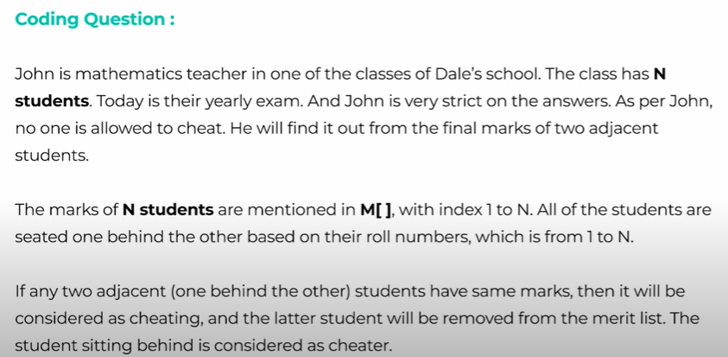

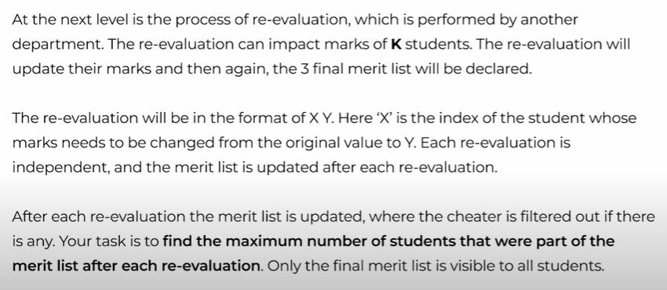

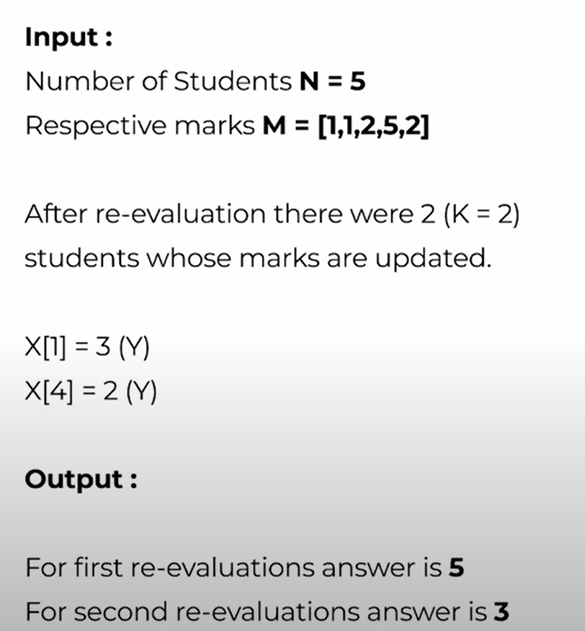

Code:

#include <iostream>

using namespace std;

int mrk[n];

int eval(int x, int y, int n){

mrk[x]=y;

int stud=1;

for(int i=1;i<n;i++){

if(mrk[i]!=mrl[i-1]){

stu++;

}

}

return stu;

}

int main() {

int x,y,n;

cin>>n; //no of students

int k;

cin>>k; //no of re evaluation

for{int j=0;j<n;j++}{

cin>>mrk[j];

}

for(int a=0;a<k;a++){

cin>>x; //index of student

cin>>y; //re evaluated marks

cout<<eval(x,y,n)<<endl;

}

return 0;

}