Game Design Document

Fill up the following document

1. Write the title of your project.

Space Shooter

1. What is the goal of the game?

To shoot as many asteroids as you can

1. Write a brief story of your game.

Asteroids are being knocked towards the Earth’s atmosphere and its our job to save our planet.

1. Which are the playing characters of this game?

* Playing characters are the ones who respond to the user based on the input from the user.
* Cars, monkeys, dinos, wizards, etc., are the playing characters in the game.

|  |  |  |
| --- | --- | --- |
| Number | Character Name | What can this character do? |
| 1 | Fighter Jet | This character serves us as the main character and the only character within our control. This characters purpose is to save the Earth by shooting down asteroids. |

1. Which are the Non-Playing Characters of this game?

* Non-Playing characters are the ones that don't have an action or behavior when the user interacts with the game.
* Hurdles, stones, bananas, coins, etc., are non-playing characters in the game.

|  |  |  |
| --- | --- | --- |
| Number | Character Name | What can this character do? |
| 1 | Asteroids | This object is the obstacle of our game. |
| 2 | Missiles | This is the item that saves us from the asteroids. It shoots the asteroids. |

Draw your imagination of this game. What does this game look like?

* Draw the game either on your computer or on paper.
* Add images of the game scenes to show each of the playing and non-playing characters at least once.

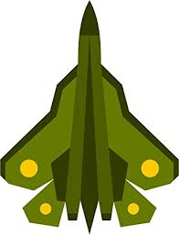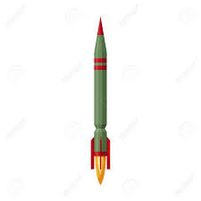

How do you plan to make your game engaging?

By using obstacles so you have to pay attention in order to play the game.