INTRODUCTION
1.1 Introduction to the Domain
Artificial Intelligence (AI) has transformed various sectors including education. In the educational domain, AI enables predictive analytics to analyze student data and derive meaningful insights. The integration of Large Language Models (LLMs) such as Google Gemini with messaging platforms has enabled development of intelligent chatbots that understand context and provide helpful responses.
Educational Data Mining uses machine learning techniques to predict student performance and identify at-risk students. These predictions help institutions take timely action to support struggling students before they drop out.
1.2 Narrowing Down to Student Dropout Prediction
Student dropout is a critical problem in engineering colleges. Research shows approximately 14.8% of students dropout during their first year. This project develops a dropout prediction system that uses a WhatsApp chatbot to interact with students, collect behavioral data, and predict dropout risk.
The system connects at-risk students with faculty mentors who can provide guidance and support. An admin panel allows administrators to monitor all students, while a mentor portal enables mentors to track and help their assigned students.
1.3 Problems in Wide Sense
- Late Detection: Institutions identify at-risk students only after academic failure, when intervention is too late.
- No Behavioral Data: Traditional systems only track marks and attendance, missing stress and emotional indicators.
- Communication Gap: Students hesitate to approach faculty due to fear of judgment.
- No Mentor Connection: No systematic way to connect struggling students with supportive mentors.
- Manual Monitoring: Administrators manually track students without any automated prediction system.

1.4 Solutions in Wide Sense
- Machine Learning Prediction: ML algorithms can predict dropout probability from student data.
- WhatsApp Chatbot: AI chatbot on WhatsApp can engage students and collect behavioral data naturally.
- Mentor Support System: Connect at-risk students with faculty mentors for guidance.
- Admin Dashboard: Centralized panel to monitor all students and predictions.
- Mentor Portal: Dedicated interface for mentors to track assigned students.
1.5 Applications
- Engineering Colleges
- Universities
- Online Learning Platforms
- Vocational Training Institutes

RELATED WORK
Paper 1: Student Dropout Prediction using Machine Learning
Citation: F. Del Bonifro, M. Gabbrielli, G. Lisanti, and S. P. Zingaro, "Student Dropout Prediction," in Artificial Intelligence in Education, Springer, 2020, pp. 129-140.
Summary:
The paper predicts university student dropout using ML techniques on data from 15,000 students. Features included gender, age, high school marks, and course credits. Using SVM and Random Forest, they achieved 87% accuracy.
Limitations:
- Uses only academic data, no behavioral indicators.
- No intervention or support mechanism.
- No student-mentor connection system.
Paper 2: Conversational AI for Student Support
Citation: A. K. Sharma and R. Gupta, "Intelligent Student Support System using Conversational AI," International Journal of Educational Technology, vol. 18, 2022, pp. 234-248.
How it Addresses Paper 1's Limitations:
Introduces chatbot to capture behavioral data through conversations with sentiment analysis.
Summary:
Developed web-based chatbot using rule-based responses and VADER sentiment analysis. Achieved 82% prediction accuracy by combining academic and sentiment data.
Limitations:
- Web-based chatbot has low adoption (students don't visit portal).
- Rule-based responses feel robotic.
- No mentor support system.
- No admin monitoring dashboard.

Paper 3: LangChain-based Educational Chatbots
Citation: P. Kumar and S. Singh, "Building Context-Aware Educational Chatbots using LangChain," IEEE AIED, 2023, pp. 156-165.
How it Addresses Paper 2's Limitations:
Uses LangChain with LLMs for natural conversations with memory.
Summary:
Developed chatbot using LangChain with GPT. Natural language understanding improved student engagement significantly.
Scope for Modification:
- Use WhatsApp instead of web portal for better adoption.
- Add mentor support system for at-risk students.
- Add admin dashboard for monitoring.
- Add mentor portal for tracking assigned students.
- Use Google Gemini (FREE) instead of OpenAI (PAID).
Our proposed system addresses all these gaps.
Comparison Table
Parameter | Paper 1 | Paper 2 | Paper 3 | Proposed System
Platform | Offline | Web | Web | WhatsApp
Chatbot | No | Rule-based | LLM | LangChain + Gemini
Mentor Support | No | No | No | Yes
Admin Panel | No | No | No | Yes
Mentor Portal | No | No | No | Yes
Cost | - | Paid | Paid | FREE

PROBLEM DESCRIPTION
3.1 Statement of the Problem
Student dropout in engineering colleges is a significant problem. Students face academic difficulties, stress, and personal issues that lead to dropout. Currently, there is no system to:
- Regularly check on student well-being.
- Identify at-risk students early.
- Connect them with mentors.
- Monitor student status systematically.
3.2 Current Situation
- Institutions learn about dropout only when student submits application.
- No proactive communication with students.
- Faculty cannot identify struggling students early.
- No systematic mentor assignment for at-risk students.
- Manual tracking without any prediction system.
3.3 Impact
- 14.8% first-year dropout rate.
- Students lose career opportunities.
- Institutions lose reputation and revenue.
- Society loses skilled professionals.
3.4 Proposed Solution
This project proposes a system with four main components:
- WhatsApp Chatbot: AI chatbot interacts with students, collects data, and identifies concerns.
- ML Prediction: Predicts dropout probability from academic and behavioral data.
- Mentor-Student Chat: Connects at-risk students with faculty mentors.
- Admin Panel & Mentor Portal: Dashboards for monitoring and managing students.
3.5 Expected Goals
- Predict dropout risk with 80%+ accuracy.
- Enable regular student interaction via WhatsApp.
- Connect at-risk students with mentors.
- Provide monitoring dashboards for admin and mentors.

PROBLEM STATEMENT
Design and develop a Student Dropout Prediction System with WhatsApp Chatbot using LangChain and Google Gemini for student interaction, Machine Learning for risk prediction, Mentor-Student Chat for support, Admin Panel for monitoring, and Mentor Portal for tracking assigned students.
OBJECTIVES
Functional Objectives:
1. To develop a WhatsApp chatbot using LangChain and Google Gemini API for student interaction and data collection.
2. To implement a Flask REST API backend for handling authentication, chatbot processing, and system services.
3. To design an Admin Dashboard and Mentor Portal for monitoring students and supporting at-risk learners.
Performance Objective:
4. To achieve 80% or higher dropout prediction accuracy using a Random Forest model.

METHODOLOGY
6.1 System Architecture
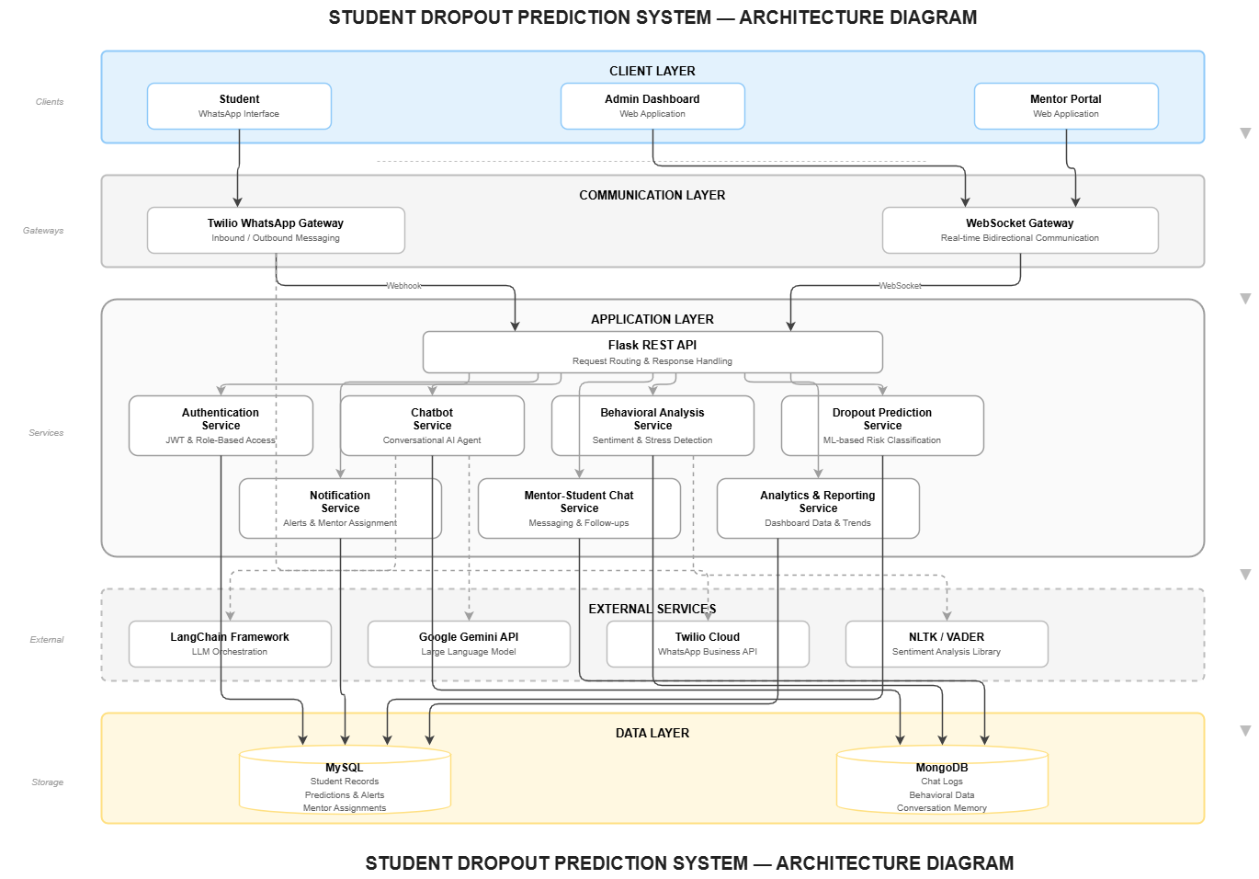
6.2 Module Descriptions
MODULE 1: DATA COLLECTION MODULE
Purpose:
To collect and store student academic data for dropout prediction.
Input:
- CSV file with student data (Roll No, Name, Gender, Age, 12th Marks, Semester Credits, etc.).
- Manual entry through admin panel.
Process:
- Admin uploads CSV file through web interface.
- System validates data (required fields, correct formats).
- Data stored in MySQL database.
- Students registered for WhatsApp chatbot.
Output:
- Student records in database.
- Students ready for chatbot interaction.

Technologies:
- Python, Pandas, Flask, MySQL

MODULE 2: WHATSAPP CHATBOT MODULE
Purpose:
To interact with students via WhatsApp, conduct check-ins, and collect behavioral data.
Input:
- Student messages via WhatsApp.
- Student profile from database.
Process:
- Student sends message on WhatsApp.
- Twilio receives message and sends to Flask server.
- LangChain processes message with conversation memory.
- Google Gemini generates appropriate response.
- System extracts sentiment and behavioral features.
- Response sent back to student via Twilio.

Output:
- Conversational responses to students.
- Behavioral data stored (sentiment, concerns mentioned).
- Alerts if student shows distress.
Technologies:
- Twilio WhatsApp API (Sandbox - FREE).
- LangChain Framework.
- Google Gemini API (FREE).
- Flask.
- MongoDB (for chat logs storage).

MODULE 3: BEHAVIORAL ANALYSIS MODULE
Purpose:
To analyze chatbot conversations and extract features for prediction.
Input:
- Chat messages from WhatsApp conversations.
Process:
- Extract text from conversations.
- Calculate sentiment score using VADER (-1 to +1).
- Count stress-related keywords.
- Calculate engagement metrics (message frequency, response rate).
- Detect dropout signals (mentions of leaving, quitting).
- Store features in database.
Output:
- Sentiment score.
- Stress level (Low/Medium/High).
- Engagement score.
- Dropout signal flag.
Features Extracted:
Feature | Description
avg_sentiment | Average sentiment of messages (-1 to +1).
stress_count | Number of stress keywords mentioned.
message_frequency | Messages per week.
engagement_score | How actively student responds.
dropout_signal | True if student mentioned leaving.

Technologies:
- VADER Sentiment Analysis
- Python, NLTK

MODULE 4: ML PREDICTION MODULE
Purpose:
To predict student dropout probability using machine learning.
Input:
- Academic features: Age, gender, marks, credits.
- Behavioral features: Sentiment, stress, engagement.
Process:
- Combine academic and behavioral features.
- Preprocess data (encode categories, scale numbers).
- Apply Random Forest classifier.
- Generate dropout probability (0-100%).
- Classify risk level (LOW/MEDIUM/HIGH).

Output:
- Dropout probability percentage.
- Risk category (LOW < 30%, MEDIUM 30-70%, HIGH > 70%).
Risk Classification:
RISK LEVEL | PROBABILITY | ACTION
LOW | 0% - 30% | Monitor
MEDIUM | 31% - 70% | Watch
HIGH | 71% - 100% | Assign
Technologies:
- Scikit-learn (Random Forest)
- Pandas, NumPy

MODULE 5: MENTOR-STUDENT CHAT MODULE
Purpose:
To enable real-time chat between students and assigned mentors.
Input:
- Student login.
- Mentor login.
- Chat messages.
Process:
- Student logs in to chat portal.
- Sees assigned mentor (if any).
- Can send messages in real-time.
- Mentor receives and responds.
- All messages stored for reference.
Output:
- Real-time chat between student and mentor.
- Chat history stored in database.
Technologies:
- Socket.io (real-time messaging)
- Flask-SocketIO
- React.js (chat interface)
- MongoDB (chat storage)

MODULE 6: ADMIN PANEL MODULE
Purpose:
To provide administrators a dashboard to monitor all students and manage the system.
Input:
- Student data from database.
- Predictions from ML module.
- Alerts from chatbot.
Features:
- Dashboard Overview:
  - Total students
  - Risk distribution (pie chart)
  - Recent alerts
- Student List:
  - All students with risk scores
  - Search and filter options
  - Sort by risk level
- Student Profile:
  - Academic information
  - Behavioral summary
  - Prediction details
  - Assigned mentor
- Mentor Management:
  - Add/remove mentors
  - View mentor workload
  - Assign mentor to student

- Alerts:
  - High-risk student alerts
  - Crisis alerts
  - Mark as resolved
Technologies:
- React.js
- Chart.js (for graphs)
- Material-UI (components)
- Flask REST API

MODULE 7: MENTOR PORTAL MODULE
Purpose:
To provide mentors a dedicated portal to view and support their assigned students.
Input:
- Mentor login.
- Assigned student data.

Features:
- My Students:
  - List of assigned students
  - Risk scores and levels
  - Quick view of concerns
- Student Details:
  - Academic information
  - Chat summary (concerns raised)
  - Behavioral trends
  - Prediction details
- Chat with Student:
  - Direct chat link
  - Chat history
- Notes:
  - Add notes about student
  - Track follow-ups
  - Record meeting outcomes
Technologies:
- React.js
- Flask REST API
- Material-UI

FACILITIES REQUIRED
7.1 Hardware Requirements
Component | Specification
Processor | Intel Core i5 or above
RAM | 8 GB (16 GB recommended)
Storage | 256 GB SSD
Internet | 10 Mbps Broadband
Mobile | Android/iOS with WhatsApp

7.2 Software Requirements
Category | Technology | Purpose
IDE | VS Code | Development
Backend | Python 3.10+, Flask | Server
AI | LangChain, Google Gemini | Chatbot
Frontend | React.js | Admin/Mentor Portal
Real-time | Socket.io | Chat
Database | MySQL, MongoDB | Storage

7.3 Python Libraries
Library | Purpose
langchain | LLM framework
langchain-google-genai | Gemini integration
flask | Web server
flask-socketio | Real-time chat
twilio | WhatsApp API
scikit-learn | ML prediction
pandas, numpy | Data processing
vaderSentiment | Sentiment analysis
pymysql, pymongo | Database

7.4 Dataset
Source | Description
College Data | Student records from exam section
Google Forms | Survey responses
UCI Repository | Public Students Dataset

REFERENCES
[1] F. Del Bonifro, M. Gabbrielli, G. Lisanti, and S. P. Zingaro, "Student Dropout Prediction," in Artificial Intelligence in Education, Springer, 2020, pp. 129-140.
[2] C. J. Hutto and E. Gilbert, "VADER: A Parsimonious Rule-Based Model for Sentiment Analysis," ICWSM, 2014.
[3] LangChain Documentation, https://python.langchain.com/docs/
[4] Google Gemini API Documentation, https://ai.google.dev/docs
[5] Twilio WhatsApp API Documentation, https://www.twilio.com/docs/whatsapp
[6] F. Pedregosa et al., "Scikit-learn: Machine Learning in Python," JMLR, vol. 12, 2011.
[7] Socket.IO Documentation, https://socket.io/docs/
[8] React Documentation, https://react.dev/

