GluNIR
Complete Technical Development Record
Stage 0 → Stage 5: Dataset, Signal Processing, ML, Hardware, Validation and Deployment Architecture

Item | Project record
Project | GluNIR non-invasive optical blood-glucose estimation
Controller | ESP32-C3
Optical channels | MAX30100 red/IR channels + external photodiode channel
External optical channel | 940 nm LED + BPW34 photodiode + MCP6002 TIA
Primary final computational model | 16 → 8 → 1 MLP, ReLU, Adam
Final locked Stage 4F inputs | I660 + I940
Final target | Glucose, mg/dL
Stage 4F test size | 6 sessions from 2 subjects
Stage 4F MAE | 19.282423 mg/dL
Stage 4F RMSE | 21.136196 mg/dL
Stage 4F R² | 0.150010
Stage 4F mean bias | +0.643786 mg/dL

This document is an expanded engineering record. It preserves the actual project decisions, measured results, dataset limitations, hardware decisions, model-selection history, and the interpretation of the Stage 5 figures supplied during development. It deliberately separates computational validation from physical-device validation.
Important terminology note: the STUBA public dataset does not provide a direct 880 nm feature. The project hardware architecture uses a separate 940 nm optical channel, while the final physical prototype is intended to contain the report-defined [I660, I880, I940, HR] feature vector. The public computational baseline therefore uses [I660, I940, HR], and Stage 4F ultimately locks I660 + I940. The STUBA red channel is approximately 655 nm, so the project shorthand I660 should be understood as a project-mapped red-channel label, not as a claim that the STUBA sensor is literally 660 nm.

1. Document Roadmap
- Project objective and system-level architecture.
- Stage 0: source dataset, WFDB decoding, calibration, glucose extraction, quality control and subject-independent partitioning.
- Stage 1: signal preprocessing, heart-rate extraction, windowing, session-level feature construction and normalization.
- Stage 2: exploratory analysis, correlations, distributions and data-integrity checks.
- Stage 3A: baseline model and feature ablation using Ridge, PLS and MLP.
- Stage 3B: Adam-trained MLP experiments and seed/configuration stability.
- Stage 4A: formal grouped cross-validation and model selection.
- Stage 4B: mean-predictor audit and split-distribution diagnosis.
- Stage 4C: robustness diagnosis, subject effects, within/between variance and glucose-range behavior.
- Stage 4E: final MLP configuration selection.
- Stage 4F: locked final model training and untouched test evaluation.
- Hardware architecture: ESP32-C3, MAX30100, BPW34, MCP6002, LED driver and biasing.
- Firmware acquisition architecture and signal-quality logic.
- Stage 5: visualization and performance analysis using the frozen Stage 4F model.
- Stage 6 deployment boundary: converting the frozen Stage 4F pipeline to embedded TinyML.
- Limitations, interpretation and recommended next engineering validation.

2. Project Objective and System Architecture
GluNIR is designed as a non-invasive optical blood-glucose estimation prototype. The central idea is to illuminate tissue with selected optical wavelengths, measure the resulting photodetector response, derive compact physiological/spectroscopic features, and pass those features through a lightweight regression model that can run locally on an ESP32-class microcontroller.
The intended system is not simply an ML model. It is a chain: optical emission → tissue interaction → photodetection → analog front end → ADC → digital preprocessing → feature extraction → normalization → MLP inference → glucose estimate. Every stage has to remain numerically compatible with the stage before it. Otherwise the machine-learning model becomes a beautifully optimized calculator for the wrong numbers.
Layer | Function | GluNIR implementation
Optical excitation | Provide known illumination wavelengths | MAX30100 internal red/IR emitters; external 940 nm LED
Photodetection | Measure returned/transmitted optical signal | MAX30100 photodetector; BPW34
Analog front end | Convert photodiode current into ADC voltage | MCP6002 transimpedance amplifier
Embedded controller | Sampling, preprocessing, inference and output | ESP32-C3
Digital preprocessing | Remove ambient/DC effects and stabilize signals | OFF/ON/OFF subtraction, smoothing, filtering
Feature extraction | Produce compact model inputs | Optical intensities/ratios + HR
Normalization | Map hardware feature scale to training scale | Frozen Stage 4F training scaler
Regression | Estimate glucose | 16→8→1 ReLU MLP
Output | Human-readable estimate | Glucose mg/dL + HR + quality information

2.1 Report-defined final physical feature vector
The controlling project report defines the intended physical-device feature vector as [I660, I880, I940, HR]. I660 and I880 are optical intensity-derived features, I940 is the external infrared channel, and HR is heart rate derived from the pulsatile PPG signal.
The public STUBA computational dataset does not contain a direct I880 channel. Therefore, fabricating an I880 column would contaminate the experiment. The public computational baseline was kept to the available channels. Stage 4F selected I660 + I940. The eventual physical system can still implement the report-defined four-feature architecture once the actual I880 hardware channel is measured and the model is retrained using genuine paired data containing that channel.

2.2 Signal-processing boundary
- Raw optical measurements are not sent directly to the MLP.
- Ambient/background optical contribution is estimated where the hardware permits an OFF measurement.
- The external BPW34 channel uses OFF → ON → OFF acquisition.
- The net optical response is calculated as ON − mean(OFF1, OFF2).
- PPG is processed to obtain heart rate.
- Signals are filtered and averaged before feature extraction.
- The feature vector is normalized using parameters learned from training data only.
- The frozen neural network then produces the glucose estimate.

3. Stage 0: Dataset Acquisition, Calibration and Quality Control
Stage 0 establishes the computational foundation. The uploaded STUBA PPG/BGL archive contained 125 WFDB records, 24 subjects and 3,000 samples per record at 100 Hz. This corresponds to 375,000 raw sample rows before record-level quality control.
Stage 0 quantity | Value
WFDB records | 125
Subjects | 24
Samples per record | 3,000
Sampling frequency | 100 Hz
Raw samples | 375,000
Initial channels | R1, IR1, G1, R2, IR2, G2
Glucose annotation source | WFDB annotation strings containing GLY ... mmol/L
Glucose conversion | mmol/L × 18.0182 = mg/dL
Strict-QC pass records | 100
Strict-QC fail records | 25
Model-ready sessions | 100
Windowed 5-s samples/features | 600 windows in the initial Stage 0 processing

3.1 WFDB decoding
The archive was decoded record-by-record. WFDB stores signal samples as integer values plus calibration metadata. Reading the integer samples alone is insufficient because the integer value is not necessarily the physical channel value used by the dataset documentation.
The processing therefore used the header calibration information for each channel. The resulting calibrated signal was then used for downstream feature extraction. This prevents an arbitrary ADC-code scale from being silently treated as a physical optical quantity.

3.2 Glucose annotation extraction
Glucose labels were obtained from the WFDB annotation stream. Annotation strings containing GLY followed by a glucose value were parsed. The source value was interpreted in mmol/L and converted to mg/dL using the project conversion factor 18.0182.
The conversion is a label-unit operation, not a model transformation. The model target throughout the final stages is Glucose_mg_dL.

3.3 Record quality control
- Optical ADC saturation was checked because a photodiode/TIA channel at the ADC rail carries little useful amplitude information.
- Records with excessive optical saturation were rejected under the strict threshold.
- Invalid or unusable HR/target values were rejected.
- Plausible extreme glucose values were retained rather than deleted merely because they were inconvenient.
- The absence of a dedicated dark-reference channel in the archive was recorded explicitly. No synthetic dark reference was invented.
- The archive did not provide a direct I880 feature, so no fabricated I880 was inserted.

3.4 Subject-independent splitting
Subject leakage is especially dangerous in physiological ML. Multiple records from the same person can share anatomy, sensor coupling, baseline optical properties and physiological characteristics. Randomly placing records from one person into both training and test sets can therefore make the model appear much better than it is on a genuinely unseen person.
The project therefore used subject-independent partitioning. The final Stage 1 development split contained 111 training sessions, 8 validation sessions and 6 test sessions, with no subject overlap between the partitions.
Partition | Sessions | Subjects | Mean glucose (mg/dL) | SD (mg/dL) | Range (mg/dL)
Train | 111 | 20 | 111.469 | 59.123 | 39.640–304.508
Validation | 8 | 2 | 108.334 | 17.692 | 90.091–136.938
Test | 6 | 2 | 114.115 | 25.114 | 79.280–140.542

3.5 Why the Stage 0 dataset structure matters
The glucose label is session-level. A 3,000-sample record is not 3,000 independent glucose measurements. Treating every raw sample as a separate independent target observation would create pseudo-replication and would allow the model to see nearly identical physiology repeatedly. The correct conceptual flow is therefore raw signal → preprocessing → session/window feature extraction → session-level ML.
This distinction becomes important later when interpreting the apparently large raw dataset. The 375,000 raw samples do not represent 375,000 independent glucose labels.

4. Stage 1: Signal Processing and Feature Construction
Stage 1 converts calibrated raw records into model-ready session-level features. The final baseline feature set contains optical channels corresponding to the available red and infrared information plus HR where applicable.

4.1 Processing chain
- Read calibrated optical channels from the Stage 0 output.
- Apply signal-quality checks.
- Apply moving-average smoothing to reduce high-frequency noise.
- Band-limit the PPG signal for heart-rate extraction.
- Detect pulse peaks and calculate heart rate.
- Use a fallback optical channel if the preferred PPG channel fails.
- Construct optical intensity and ratio features.
- Aggregate the processed signal over the appropriate session/window.
- Create the session-level target label.
- Fit the scaler on the training partition only.
- Apply the frozen scaler to validation and test features.

4.2 Five-second windows
Five-second windows were used for signal-processing and feature extraction. A window is not automatically an independent glucose observation. The purpose of the window is to stabilize the optical/PPG measurements and provide a defined interval over which the signal can be summarized.
The initial processed dataset contained 750 five-second windows in the Stage 1 workflow. The session-level feature file remains the correct level for the final subject-independent model evaluation.

4.3 Heart-rate extraction
HR was derived from the IR PPG signal using a physiological band approximately spanning 0.7–4 Hz, followed by peak detection. This corresponds to roughly 42–240 beats/min as a broad signal-processing band. The project then applies stricter physiological plausibility checks when storing the HR feature.
If the preferred IR channel was not usable, the red channel was available as a fallback for peak detection. The purpose of the HR feature is to encode pulsatile cardiovascular information, not to infer glucose directly from HR.

4.4 Optical ratio
An optical ratio feature was also examined during analysis. In the STUBA processing this was represented as a red-to-infrared ratio, written in the project shorthand as R_660_940. Ratio features can reduce some multiplicative effects, but they do not automatically solve subject-specific optical differences.
Feature | Meaning | Used in final Stage 4F?
I660 | Project-mapped red optical intensity feature | Yes
I940 | Infrared optical intensity feature | Yes
HR | Heart rate from PPG | No, not in locked Stage 4F
R_660_940 | Red/IR ratio examined in Stage 2 | No
I880 | Report-defined physical feature | Unavailable in STUBA

4.5 Normalization
The final Stage 4 pipeline used a median imputer followed by StandardScaler. The scaler was fit only on the development/training data available at the relevant stage. This matters because using the test distribution to calculate normalization parameters is a subtle form of leakage.
For a feature x, the conceptual standardization is z = (x − μ_train) / σ_train. The same μ_train and σ_train must be used by the embedded device at inference time. The ESP32 cannot simply invent a new mean and standard deviation every time it receives a measurement, because that would change the meaning of the trained network input.

5. Stage 2: Exploratory Data Analysis and Feature Diagnostics
Stage 2 checks whether the extracted features and target behave plausibly before spending computational effort on model selection.
Feature | Pearson r with glucose | Interpretation
I660 | -0.032 | Essentially no linear association in this dataset
I940 | -0.026 | Essentially no linear association
HR | -0.036 | Essentially no linear association
R_660_940 | +0.178 | Weak positive association; p≈0.047 in the Stage 2 analysis

These correlations do not establish whether a feature is useful in multivariate prediction. A nonlinear model can exploit relationships that a Pearson coefficient misses, and a feature can also be correlated with glucose while failing to improve subject-independent generalization. Therefore Stage 2 was treated as diagnosis, not model selection.

5.1 Target distribution
The processed glucose target spanned approximately 39.6 to 304.5 mg/dL. This is substantially broader than the final held-out test distribution, which covered only 79.28 to 140.54 mg/dL.
The training set contained the extreme values, while the test set did not. This becomes a major interpretive point in Stage 4C and Stage 5: the final test result cannot establish performance in hypoglycemic or hyperglycemic regimes because those regimes were not represented in the six test sessions.

5.2 Subject-level stability
Stage 2 and later Stage 4C analyses showed that optical features can vary strongly within subjects and between subjects. HR showed a comparatively larger between-subject fraction than the optical ratio, while the target glucose itself had relatively low between-subject variance in the aggregate decomposition.
This is consistent with a difficult physiological-regression setting: the model is not merely learning a clean one-dimensional optical response to glucose. It is seeing subject-dependent optical baselines, sensor coupling, tissue properties and temporal variation.

6. Stage 3A: Baseline Models and Feature Ablation
Stage 3A compared seven feature sets: I660; I940; HR; I660+I940; I660+HR; I940+HR; and I660+I940+HR. Three model families were evaluated: Ridge regression, PLS regression and a small 16→8 ReLU MLP.
Feature set | Ridge MAE | PLS MAE | MLP MAE
I660 | 15.2376 | 15.2395 | 20.9678
I940 | 15.9094 | 15.9289 | 30.6190
HR | 15.9655 | 15.9740 | 21.7228
I660+I940 | 15.9596 | 15.9758 | 34.0384
I660+HR | 16.2367 | 16.2482 | 26.6880
I940+HR | 16.9485 | 16.9675 | 27.4554
I660+I940+HR | 16.9427 | 16.9433 | 42.1601

The best Stage 3A validation result was Ridge using I660 alone: MAE 15.2376 mg/dL, RMSE 17.2262 mg/dL, R² −0.0835. The negative R² indicates that the model did not outperform the simple variance baseline on that validation split.
The key finding was not that a neural network is inherently unsuitable. Rather, this particular small dataset and training procedure did not make the MLP reliably superior at this stage. HR generally did not improve the linear baselines.

6.1 Stage 3B: Adam-trained MLP
Stage 3B separated model architecture from optimizer behavior. The MLP remained 16→8 ReLU, but training was performed with Adam over several learning-rate and regularization settings and seeds.
Best single configuration | Value
Feature set | I940
Learning rate | 3×10^-4
Alpha | 1×10^-4
Seed | 123
Validation MAE | 14.0928 mg/dL
Validation RMSE | 16.3853 mg/dL
Validation R² | 0.0197

Adam improved the MLP relative to several Stage 3A runs, but the results were seed-sensitive. Some low-learning-rate configurations were unstable or catastrophically poor. This motivated formal grouped cross-validation rather than selecting a model based on a single favorable validation run.

7. Stage 4A: Formal Subject-Grouped Cross-Validation
Stage 4A moved model selection to 5-fold GroupKFold using subject identity as the grouping variable. Hyperparameters were selected without touching the final test set.
The compared families were Ridge with alpha values [0.01, 0.1, 1, 10, 100], PLS with up to three components where valid, and the 16→8 MLP across the tested Adam configurations and seeds.
Feature set | Selected model | CV MAE | CV RMSE | CV R²
I660 | PLS, 1 component | 30.8493 | 37.3011 | -0.0506
I660+HR | Ridge, alpha 10 | 30.8952 | 37.1434 | +0.0011
HR | Ridge, alpha 100 | 30.9574 | 36.7141 | +0.0254
I660+I940 | Ridge, alpha 100 | 31.0034 | 37.0624 | -0.0502
All | Ridge, alpha 100 | 31.0116 | 36.9145 | +0.0033
I940 | Ridge, alpha 100 | 31.0479 | 37.0087 | -0.0470
I940+HR | Ridge, alpha 100 | 31.0613 | 36.8559 | +0.0078

The grouped CV results were dramatically worse than the earlier eight-session validation split. That discrepancy is not a contradiction. The validation split had only two subjects and a narrow glucose range. Grouped CV exposed the much larger subject-to-subject and glucose-range difficulty.

7.1 Stage 4B: Mean baseline audit
A constant predictor equal to the training glucose mean was evaluated under the same grouped CV. This is essential because a model should be judged against a trivial baseline.
Metric | Grouped CV mean baseline
MAE | 30.972524 ± 24.300704 mg/dL
RMSE | 36.889808 ± 27.606841 mg/dL
R² | -0.031348 ± 0.029046

The best grouped-CV model, I660 PLS1, improved MAE by only 0.123222 mg/dL over the mean baseline, or about 0.398%. This is effectively negligible from a practical modeling perspective.
The held-out validation mean predictor had MAE 15.02937 mg/dL because that validation set was unusually close to the training mean and contained only 8 sessions. This is why a single validation split can give a misleadingly favorable impression.

7.2 Stage 4C: Robustness diagnosis
Feature | Between-subject variance fraction
I660 | 0.092243
I940 | 0.211437
HR | 0.477439
R_660_940 | 0.001140
Glucose | 0.019816

Stage 4C also examined glucose-range performance. The models were relatively close to the target around 100–125 mg/dL, while errors became much larger at low and high glucose. The typical behavior was regression toward the training mean: low glucose was overpredicted and high glucose was underpredicted.
Glucose range | Typical I660-PLS signed error behavior
<70 mg/dL | Strong positive error, about +55 mg/dL
70–99 mg/dL | Positive error, about +25 mg/dL
100–125 mg/dL | Near zero, about +1.5 mg/dL
126–179 mg/dL | Negative error, about −43.8 mg/dL
180–249 mg/dL | Negative error, about −96.5 mg/dL
>=250 mg/dL | Very large negative error, about −163.9 mg/dL; n=3

8. Stage 4E: Final MLP Selection
After the robustness analysis, the MLP was re-evaluated under grouped CV using the fixed architecture and candidate configurations. The best configuration was not chosen from the six-session test set.
Locked parameter | Selected value
Feature set | I660 + I940
Hidden architecture | 16 → 8 → 1
Activation | ReLU
Optimizer | Adam
Learning rate | 0.0003
L2 regularization alpha | 0.0001
Seed | 42
Maximum iterations | 5000
Early stopping | False
Preprocessing | Median imputation + StandardScaler

The best Stage 4E grouped-CV configuration had CV MAE 31.717750 ± 21.263182 mg/dL, CV RMSE 38.942978 mg/dL and CV R² −0.107850. The test set remained untouched.

9. Stage 4F: Locked Final Training and Test Evaluation
Stage 4F is the final computational experiment. The selected architecture and hyperparameters were frozen. The 111 training sessions and 8 validation sessions were combined into a 119-session development set. The six-session test set was then used once for final evaluation.
Stage 4F item | Value
Development sessions | 119
Development subjects | 22
Test sessions | 6
Test subjects | 2
Inputs | I660 + I940
Target | Glucose_mg_dL
Architecture | 16 → 8 → 1
Optimizer | Adam
Learning rate | 0.0003
Alpha | 0.0001
Seed | 42
Max iterations | 5000
Iterations reached | 5000
Convergence | Maximum iterations reached; sklearn convergence warning

Final test metric | Result
MAE | 19.282423 mg/dL
RMSE | 21.136196 mg/dL
R² | 0.150010
Mean bias (predicted − actual) | +0.643786 mg/dL
Actual mean | 114.115267 mg/dL
Predicted mean | 114.759052 mg/dL
Actual glucose range | 79.28–140.54 mg/dL

The final training loss was approximately 1598.962402, and the optimizer reached the configured 5000-iteration ceiling. Therefore the final model was not declared mathematically converged. It is nevertheless the locked Stage 4F model because the experiment was frozen after the prescribed selection process.
The R² of 0.150 means that the six test observations show only modest explained variance. The result should not be presented as evidence of clinical-grade glucose estimation. The test set is too small and too narrow in glucose range to support that conclusion.

10. Hardware Architecture
The physical prototype is built around an ESP32-C3 with optical sensing, a photodiode analog front end, and a controlled external infrared emitter.
Component | Role
ESP32-C3 | Controller, ADC, GPIO control, I2C, signal processing and eventual TinyML inference
MAX30100 | Integrated red/IR optical PPG sensor and HR source
940 nm LED | External infrared illumination channel
BPW34 | External photodiode for optical intensity measurement
MCP6002 | Dual rail-to-rail op-amp; TIA + VBIAS buffer
Rf | TIA transimpedance feedback resistor, starting value 100 kΩ
Cf | TIA feedback capacitor, starting range 10–33 pF
10 kΩ + 10 kΩ | VBIAS divider at approximately half supply
NMOS | Low-side switching of external 940 nm LED

10.1 ESP32-C3 pin map
ESP32-C3 pin | Connected function
GPIO 8 | I2C SDA → MAX30100
GPIO 9 | I2C SCL → MAX30100
GPIO 10 | Optional MAX30100 interrupt
GPIO 0 | ADC input → MCP6002 TIA output
GPIO 4 | External 940 nm LED MOSFET gate

10.2 MCP6002 wiring
MCP6002 pin | Connection | Purpose
1 | OUT A → ESP32-C3 GPIO0 | TIA output
2 | IN A− → BPW34 cathode + feedback | Photocurrent summing node
3 | IN A+ → buffered VBIAS | TIA reference bias
4 | VSS → GND | Supply return
5 | IN B+ → raw VBIAS divider | Buffer input
6 | IN B− → pin 7 | Follower feedback
7 | OUT B → buffered VBIAS + pin 3 | VBIAS buffer output
8 | VDD → 3.3 V | Supply

A 100 nF bypass capacitor is placed between MCP6002 VDD and VSS. The VBIAS target is approximately 1.65 V from a 10 kΩ/10 kΩ divider, then buffered by the second op-amp channel.

10.3 BPW34 TIA
The BPW34 is used in a transimpedance configuration. Its anode is tied to ground and its cathode is connected to the MCP6002 inverting input. The feedback network from output to the inverting input consists of Rf and Cf. The non-inverting input is held at VBIAS, so the TIA output sits around the midpoint rather than trying to represent a bidirectional photocurrent around ground.
The initial Rf value is 100 kΩ. Cf in the 10–33 pF range provides compensation and helps control high-frequency noise and stability. The exact final values must be validated experimentally because photodiode capacitance, PCB parasitics and LED coupling affect the loop.

10.4 External 940 nm LED driver
The LED is not driven directly from an ESP32 GPIO. GPIO4 drives an NMOS gate through a 100 Ω series resistor, with a 10 kΩ gate pulldown. The LED anode connects to 3.3 V through its current-limiting resistor, while its cathode connects to the MOSFET drain. The MOSFET source is grounded.
The GPIO therefore controls illumination without forcing LED current through the microcontroller output stage. The exact LED resistor is determined from the selected LED forward voltage and desired current.

11. Firmware Acquisition Architecture
The acquisition firmware supplied during development uses the MAX30100 library for heart rate/SpO2 servicing and direct ADC acquisition for the BPW34 channel. The current logger is a data-acquisition firmware stage, not yet the complete final TinyML inference firmware.

11.1 Acquisition sequence
- Initialize Serial at 115200 baud.
- Configure GPIO4 as the external LED control.
- Configure GPIO0 as the ADC input.
- Set ADC resolution to 12 bits.
- Set ADC attenuation to 11 dB.
- Initialize I2C on GPIO8/GPIO9 at 400 kHz.
- Initialize the MAX30100.
- Set MAX30100 IR LED current to the selected 24 mA library setting.
- Register the beat callback.
- Every 100 ms, service the MAX30100 and collect one optical sample.
- Determine whether a recent heartbeat indicates a finger/valid PPG condition.
- Acquire BPW34 OFF1.
- Turn external LED ON and acquire BPW34 ON.
- Turn LED OFF and acquire BPW34 OFF2.
- Calculate ambient as mean(OFF1, OFF2).
- Calculate net optical response as ON − ambient.
- Evaluate saturation, signal strength and ambient stability.
- Output the acquisition row over Serial.

11.2 Current CSV structure
The acquisition logger produces the following fields:
Column | Meaning
sample | Sequential acquisition sample number
time_ms | ESP32 millis() timestamp
hr_bpm | Heart rate estimate
spo2_pct | MAX30100 SpO2 value, retained as an acquisition diagnostic
bpw_off_1 | First ambient/off ADC measurement
bpw_on | LED-on ADC measurement
bpw_off_2 | Second ambient/off ADC measurement
bpw_net | Ambient-corrected optical signal
bpw_mV | Calibrated ADC millivolt reading of LED-on channel
status | Signal-quality status code

11.3 Status codes
Code | Meaning | Action
0 | OK | Measurement accepted
1 | ADC saturated | Reject/check optical gain and LED intensity
2 | Signal too weak | Reject or reposition finger/optics
3 | Ambient unstable | Reject sample or wait for stable background

11.4 Important hardware/software wavelength correction
The supplied logger comments label GPIO4 as an 880 nm LED. The controlling GluNIR architecture, however, specifies the external LED as 940 nm. The final hardware documentation therefore treats GPIO4 as the 940 nm LED control. The firmware constant should be renamed from LED_880_PIN to LED_940_PIN in the final integrated code so the software cannot accidentally perpetuate the documentation mismatch.
This is not cosmetic. The wavelength is part of the physical meaning of the feature. A model trained on one spectral channel cannot be assumed valid for another wavelength merely because both are infrared.

12. Stage 5: Visualization and Performance Analysis
Stage 5 does not retrain or modify the Stage 4F model. It reads the frozen final test predictions and calculates diagnostic visualizations. The figures supplied for this report are therefore post-hoc analyses of the locked six-session test result.

12.1 Actual vs predicted glucose
The actual-versus-predicted figure plots each test session with actual glucose on the x-axis and predicted glucose on the y-axis. The dashed diagonal represents perfect prediction. The six predictions cluster around the middle of the test glucose range rather than tracking the diagonal tightly.
The figure reports MAE 19.28 mg/dL, RMSE 21.14 mg/dL and R² 0.150. The pattern is consistent with a model that has limited ability to distinguish the six unseen sessions and tends to compress predictions toward a central value.

12.2 Residuals vs actual glucose
Residual is defined as predicted − actual. Positive residual means overprediction; negative residual means underprediction.
The supplied residual plot shows positive errors for the lower-glucose test observations and negative errors for the higher-glucose observations. This is a classic regression-to-the-mean signature. It does not prove that the model will behave identically on a larger population, but it is a useful diagnostic warning.

12.3 Absolute error per test session
The supplied bar chart shows substantial session-to-session variation. The largest absolute error is approximately 33 mg/dL, while the smallest is below 10 mg/dL. Three sessions exceed the overall MAE line and three are below it.
Because the test set has only six sessions, a single observation changes the aggregate MAE substantially. The per-session chart is therefore more informative than the aggregate number alone.

12.4 Error distribution
The error histogram contains both positive and negative errors and is centered near the reported mean bias of +0.64 mg/dL. The distribution is not symmetric around zero, but the mean bias is small because positive and negative errors partially cancel.
A small mean bias does not imply small absolute error. This is exactly why MAE and RMSE are reported separately.

12.5 Per-subject performance
The test subjects were Subject_014 and Subject_021. The supplied chart shows a noticeably larger MAE for Subject_014 than Subject_021. This reinforces the central subject-independent validation issue: performance can depend strongly on the individual even when the model has never seen that person during training.

12.6 Bland-Altman analysis
The supplied Bland-Altman figure plots the mean of actual and predicted glucose on the x-axis against predicted − actual on the y-axis. The estimated bias is +0.64 mg/dL. The plotted limits are approximately +46.00 and −44.72 mg/dL, based on ±1.96 standard deviations of the six residuals.
With N=6, these limits are highly unstable. They are useful as a visual diagnostic, not as a clinical agreement claim. A clinically meaningful Bland-Altman assessment would require a much larger, prospectively collected paired dataset.
Stage 5 result | Value / observation
N | 6 test sessions
Subjects | 2
Actual range | 79.28–140.54 mg/dL
MAE | 19.28 mg/dL
RMSE | 21.14 mg/dL
R² | 0.150
Mean bias | +0.64 mg/dL
Bland-Altman upper limit | +46.00 mg/dL
Bland-Altman lower limit | −44.72 mg/dL
Clinical interpretation | Not established; dataset is too small and narrow

13. Stage 6: TinyML Deployment Boundary
Stage 6 is intended to be deployment only. The model should not be retrained on the ESP32. The microcontroller receives sensor measurements, performs the same preprocessing used during training, constructs the same features, applies the frozen training normalization, executes the frozen 16→8→1 network, and prints the glucose estimate.

13.1 Runtime chain
- Acquire MAX30100 optical data and external BPW34 data.
- Check signal quality.
- Acquire OFF1 → ON → OFF2 for the external channel.
- Calculate ambient-corrected optical response.
- Collect enough PPG samples for stable HR estimation.
- Apply the same filtering and averaging conventions used during training.
- Compute I660 and I940 in the exact numerical representation expected by the Stage 4F model.
- Apply the frozen Stage 4F imputation/scaling constants.
- Run the 16-neuron hidden layer with ReLU.
- Run the 8-neuron hidden layer with ReLU.
- Run the output neuron.
- Print glucose estimate in mg/dL.
- Print HR and signal-quality status alongside the estimate.

13.2 Embedded neural-network mathematics
For an input vector x after scaling, the first hidden layer is:
h1 = ReLU(W1 x + b1)
The second hidden layer is:
h2 = ReLU(W2 h1 + b2)
The final scalar glucose estimate is:
ŷ = W3 h2 + b3
The ESP32 implementation therefore needs the exact trained weights and biases plus the exact preprocessing constants. It does not need scikit-learn itself.

13.3 What must be exported from Stage 4F
- Final imputer values, if any feature can be missing.
- Training mean μ for I660 and I940.
- Training standard deviation σ for I660 and I940.
- W1 and b1 for the 16-neuron layer.
- W2 and b2 for the 8-neuron layer.
- W3 and b3 for the output layer.
- Feature ordering: [I660, I940].
- Any fixed feature transformations used before scaling.
- Model output convention and units: mg/dL.
- Quality thresholds used to decide whether an inference should be trusted.

13.4 Critical deployment warning
The ESP32 must not use arbitrary raw ADC counts if the model was trained on calibrated or transformed features. The embedded preprocessing must reproduce the training pipeline numerically. Otherwise the MLP sees a different coordinate system and the final glucose number has no defensible relationship to the training result.
Likewise, the Stage 4F model has only two inputs. The eventual physical four-feature model [I660, I880, I940, HR] would require a different trained network. The ESP32 cannot simply add HR and I880 at runtime to a two-input Stage 4F network.

14. Complete Stage-by-Stage Output Inventory
Stage | Primary outputs / purpose
Stage 0 | Calibrated raw CSV, record QC audit, clean baseline dataset, subject split manifest
Stage 1 | Session features, train/validation/test features, 5-s windowed features, scaler parameters
Stage 2 | Feature statistics, target statistics, correlation matrices, HR analysis, plots
Stage 3A | Seven feature-set ablations across Ridge, PLS and MLP
Stage 3B | Adam MLP configuration/seed stability study
Stage 4A | 5-fold subject-grouped CV and model selection
Stage 4B | Mean baseline and distribution audit
Stage 4C | Robustness, subject effects, glucose-range diagnostics
Stage 4E | Locked MLP configuration selection
Stage 4F | Final development training, untouched six-session test prediction
Stage 5 | Visualization and diagnostic analysis of final predictions
Stage 6 | Embedded implementation of the frozen model and preprocessing

15. Files and Artifact Map
Artifact | Purpose
01_stuba_raw_calibrated.csv | Calibrated raw STUBA samples
02_record_quality_audit.csv | Record-level QC decisions
03_model_ready_baseline_clean.csv | Clean baseline computational data
04_train_subject_independent.csv | Training split
05_validation_subject_independent.csv | Validation split
06_test_subject_independent.csv | Final test split
07_windowed_features_5s.csv | Five-second window feature data
08_dataset_audit.csv | Dataset-level audit
09_subject_split_manifest.csv | Subject partition manifest
10_preprocessing_parameters.json | Stage 1 preprocessing parameters
Stage 4F 01_final_test_predictions.csv | Frozen final predictions used in Stage 5
Stage 5 01_actual_vs_predicted.png | Prediction agreement visualization
Stage 5 02_residuals_vs_actual.png | Residual diagnostic
Stage 5 03_absolute_error_per_session.png | Per-session error
Stage 5 04_error_distribution.png | Residual distribution
Stage 5 05_subject_MAE.png | Subject-level MAE
Stage 5 05_subject_performance.csv | Subject-level statistics
Stage 5 06_glucose_range_performance.csv | Range-specific performance
Stage 5 07_bland_altman.png | Agreement diagnostic
Stage 5 08_actual_vs_predicted_table.csv | Prediction table
Stage 5 09_final_metrics.csv | Final metric table
Stage 5 10_STAGE5_SUMMARY.txt | Stage 5 textual summary

16. Limitations and What the Results Actually Prove
The project has several distinct evidence levels. Keeping them separate is essential.
Evidence level | What is supported | What is not supported
Dataset processing | STUBA can be decoded, calibrated, cleaned and split subject-independently. | That STUBA alone represents the final physical sensor.
ML baseline | Small models can be trained and evaluated reproducibly on the processed dataset. | That the model is clinically accurate.
Grouped CV | Subject-independent generalization is difficult; models are close to the mean baseline. | That the final architecture has failed universally.
Stage 4F test | Six held-out sessions produced MAE 19.28 mg/dL and RMSE 21.14 mg/dL. | That 19.28 mg/dL is a stable population-level accuracy.
Hardware | A physically coherent optical acquisition chain has been designed. | That the assembled device has already achieved the Stage 4F computational accuracy.
Stage 6 | The frozen model can in principle be embedded. | That embedded inference will be correct until calibration and numerical equivalence are verified.

16.1 The test-set limitation
The most important limitation is the final test size: six sessions from two subjects. The glucose range is 79.28–140.54 mg/dL, meaning the final test does not challenge the model on the low and high extremes that were present in training. Consequently, the Stage 4F test metrics should be described as preliminary held-out computational performance.
The result is useful because the test subjects were unseen during development. It is not sufficient because N=6 is far too small for stable population-level conclusions.

16.2 The convergence limitation
The MLP reached the 5000-iteration limit and produced a convergence warning. This was intentionally not followed by another model modification because Stage 4F was locked. The warning belongs in the scientific record rather than being quietly removed.

16.3 The hardware-to-dataset domain gap
The STUBA data are not identical to measurements from the custom GluNIR hardware. The eventual device has its own LED spectrum, photodiode response, analog gain, ADC quantization, ambient-light behavior, mechanical coupling and sensor placement. Therefore the public dataset model is a computational baseline and deployment starting point, not proof that the physical prototype will immediately predict glucose accurately.
The next serious experimental step is paired physical data collection in which every optical feature used by the final model is acquired by the actual device and paired with a reference glucometer measurement.

17. Stage 6 Engineering Checklist
- Correct firmware naming from LED_880_PIN to LED_940_PIN.
- Confirm MAX30100 raw red/IR acquisition rather than relying only on the high-level PulseOximeter API if raw intensities are required.
- Verify GPIO0 ADC electrical range with the MCP6002 output under all expected optical conditions.
- Verify the 1.65 V VBIAS under load and confirm the op-amp remains within its common-mode/output limits.
- Characterize BPW34 dark current and ambient response with the LED physically blocked.
- Measure LED-on response without tissue to verify ADC headroom.
- Verify OFF1/ON/OFF2 timing and settling time experimentally.
- Confirm the net optical feature is stable across repeated measurements.
- Collect the actual physical I660/I940/HR measurements from the device.
- If the report-defined I880 channel is retained, collect genuine I880 data rather than synthesizing it.
- Export the exact Stage 4F scaler and MLP parameters.
- Implement the scaler numerically in C/C++.
- Implement the 16→8→1 ReLU network.
- Compare ESP32 predictions against a desktop reference using identical feature vectors.
- Only after numerical equivalence is confirmed should real sensor inference be evaluated.
- Pair each device inference with a reference glucometer value for physical validation.
- Maintain subject-independent splits in the physical dataset.
- Increase the number of subjects substantially before making clinical-performance claims.

18. Final Technical Summary
GluNIR has progressed from a public physiological dataset through calibrated signal processing, exploratory analysis, feature ablation, subject-grouped model selection, a locked final MLP, held-out testing and a defined embedded deployment architecture.
The most scientifically important finding is not the isolated Stage 4F MAE. The grouped cross-validation analysis showed that subject-independent generalization is difficult and that the current optical features provide only a small advantage over a constant mean predictor on the STUBA computational dataset. This prevents the project from overclaiming performance.
The most useful engineering outcome is that the pipeline is now explicit: what enters the model, how it is normalized, which model is frozen, how the hardware measures its optical channels, and what must be reproduced on the ESP32 are all defined. Stage 6 therefore becomes a numerical-equivalence and physical-validation task rather than another round of uncontrolled model experimentation.
The Stage 5 plots support the same conclusion. The final six predictions have small mean bias but appreciable absolute errors, with visible regression toward the middle of the test range and subject-to-subject performance differences. The correct next step is physical paired-data acquisition and rigorous validation, not changing the reported Stage 4F result after seeing the test set.

Appendix A. Core Equations
Glucose_mg/dL = Glucose_mmol/L × 18.0182
Ambient = (OFF1 + OFF2) / 2
Net optical signal = ON − Ambient
z = (x − μ_train) / σ_train
h1 = ReLU(W1x + b1)
h2 = ReLU(W2h1 + b2)
ŷ = W3h2 + b3
MAE = mean(|ŷ − y|)
RMSE = sqrt(mean((ŷ − y)^2))
R² = 1 − Σ(y − ŷ)^2 / Σ(y − ȳ)^2
Bias = mean(ŷ − y)

Appendix B. Interpretation of the Stage 5 Figures
- Figure 1: actual versus predicted values lie substantially away from the identity line, particularly at the lower and upper portions of the six-session range.
- Figure 2: residuals change sign across the glucose range, showing regression toward the center.
- Figure 3: session-level absolute errors range from below 10 mg/dL to approximately 33 mg/dL.
- Figure 4: residuals contain both positive and negative values and average to only +0.64 mg/dL bias.
- Figure 5: Subject_014 has substantially higher MAE than Subject_021 in the supplied test data.
- Figure 6: Bland-Altman limits are very wide relative to the six observations and must not be interpreted as clinical agreement limits.

Appendix C. Terminology Discipline
- Use 'computational baseline' for the STUBA-based ML result.
- Use 'physical prototype' for the ESP32-C3 + optical hardware system.
- Use 'held-out test result' for Stage 4F, not 'clinical accuracy'.
- Use 'project-mapped I660' or 'approximately 655 nm red channel' when describing STUBA.
- Do not claim an I880 measurement exists in STUBA.
- Do not claim the six-session test proves population-level accuracy.
- Do not silently retrain the model after seeing Stage 4F test predictions.
- Do not use the Stage 4F two-input model with an additional HR or I880 input unless the network is retrained.

Stage 5 Visualisation Results
This section contains the exact visualisations generated from the final Stage 4F test predictions. The figures are reproduced directly from the project outputs so that the report retains both the numerical results and their visual interpretation.

Stage 4F Actual vs Predicted Glucose
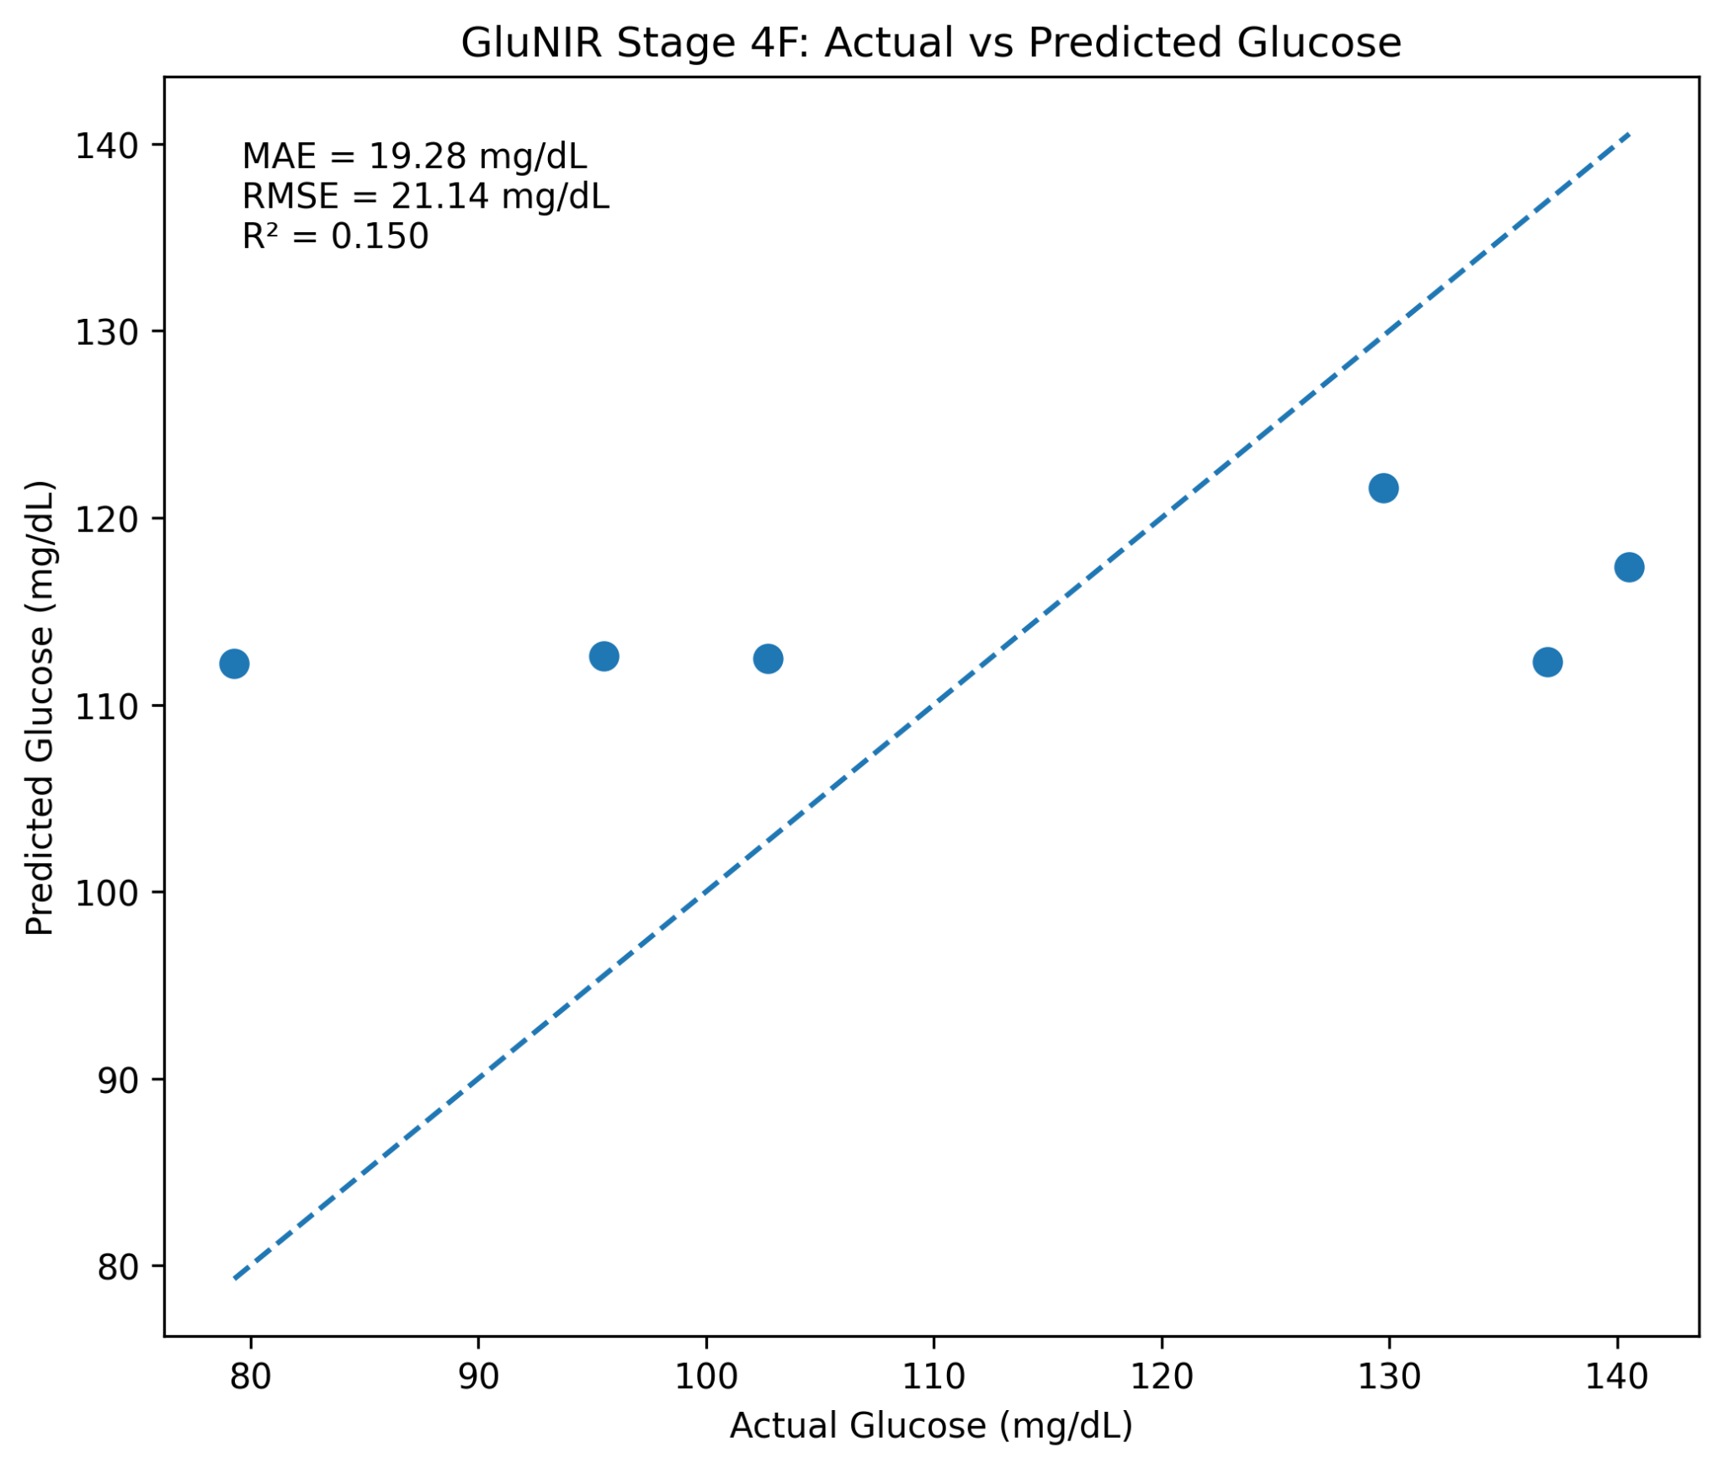
Figure 1. Stage 4F Actual vs Predicted Glucose

Stage 5 Residuals vs Actual Glucose
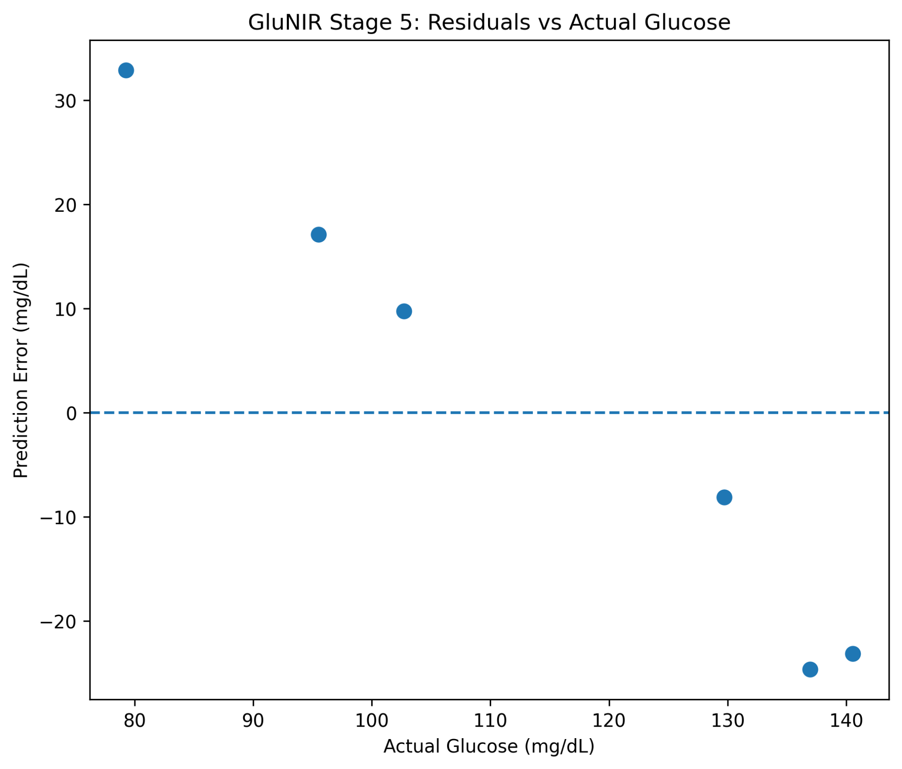
Figure 2. Stage 5 Residuals vs Actual Glucose

Stage 5 Absolute Error per Test Session
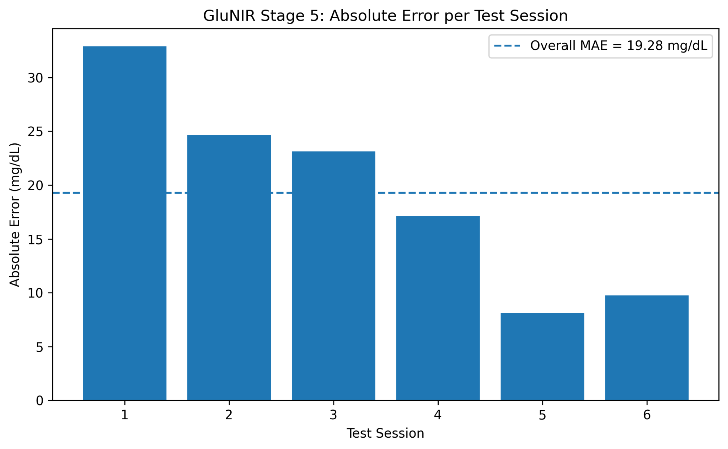
Figure 3. Stage 5 Absolute Error per Test Session

Stage 5 Prediction Error Distribution
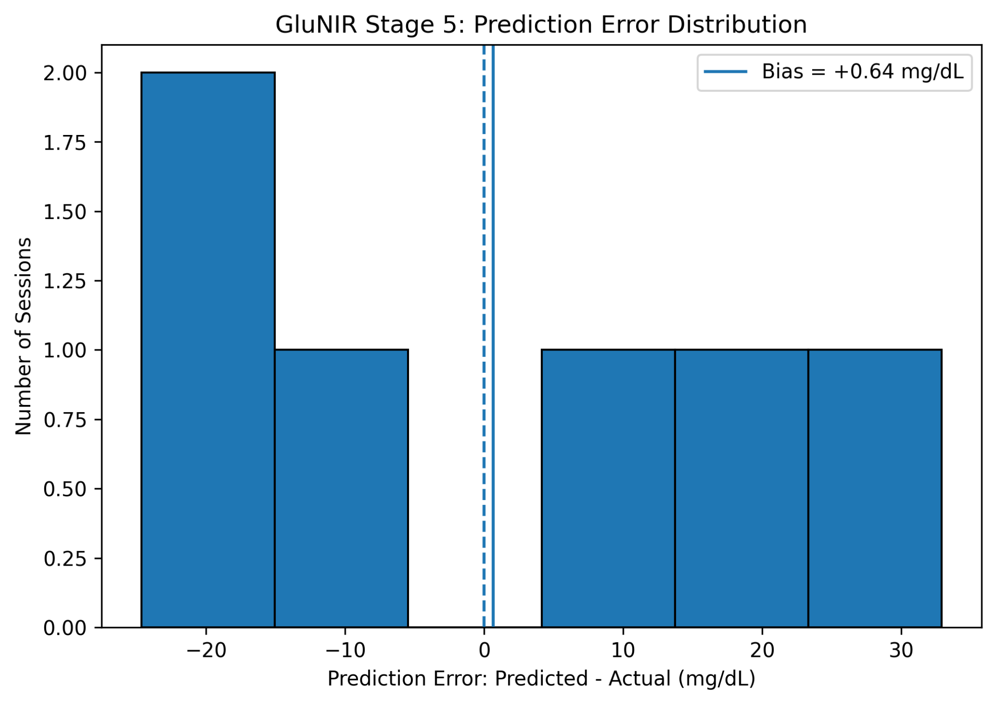
Figure 4. Stage 5 Prediction Error Distribution

Stage 5 Test MAE by Subject
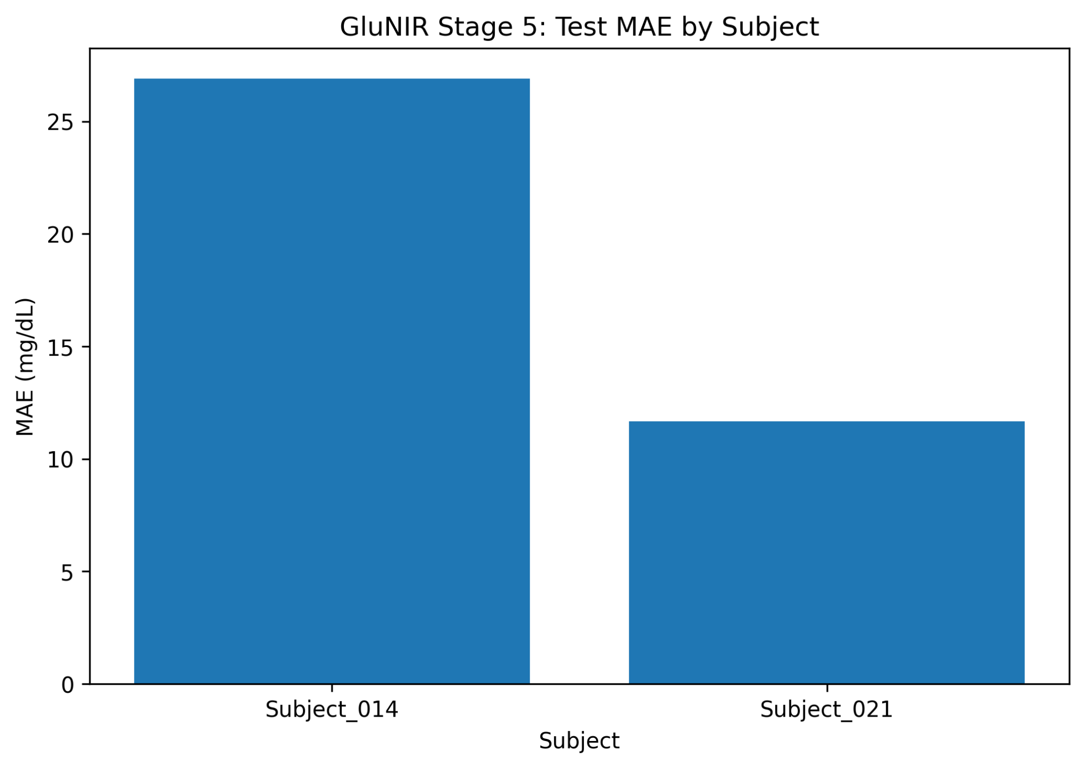
Figure 5. Stage 5 Test MAE by Subject

Stage 5 Bland-Altman Analysis
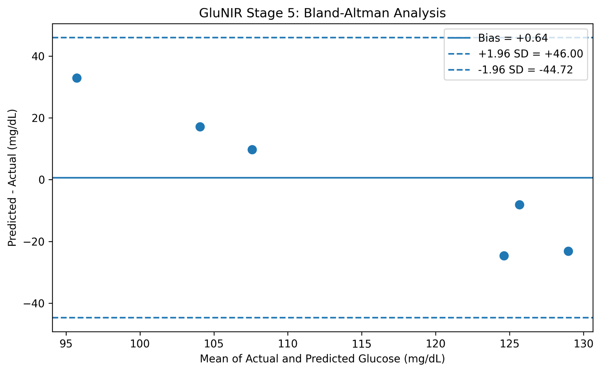
Figure 6. Stage 5 Bland-Altman Analysis

Visualisation Interpretation Summary
- Actual vs predicted: the predictions cluster around the middle of the observed test range rather than following the identity line closely. This is consistent with the modest R² of 0.150 and the small six-session test set.
- Residuals vs actual: positive residuals occur at the lower actual-glucose observations, while negative residuals dominate at the higher observations. This is the visual signature of regression toward the mean.
- Absolute error per session: the six session errors are heterogeneous, with the largest error occurring in the lowest-glucose test session and several smaller errors at higher glucose values.
- Error distribution: the prediction errors span both positive and negative values. The mean bias is approximately +0.64 mg/dL, so there is little overall average bias even though individual errors can be substantial.
- Subject MAE: performance differs between the two held-out subjects, demonstrating subject dependence and reinforcing the need for a larger subject-independent hardware validation study.
- Bland-Altman: the mean bias is close to zero, but the limits of agreement are wide. Therefore, low mean bias must not be interpreted as tight individual-level agreement.

End of Stage 0 to Stage 5 Record
This document now contains the complete written engineering record and the final Stage 5 visualisation outputs. The Stage 4F model remains a research prototype and the six-session, two-subject test result is descriptive rather than clinical validation.

