 Invention Disclosure Format (IDF)-B | Document No. | 02-IPR-R003
 | Issue No/Date | 2/01.02.2024
 | Amd. No/Date | 0/00.00.0000

- Title of the invention:

- Field /Area of invention:

- Prior Patents and Publications from literature (provide a table summarizing the prior art)

- Summary and background of the invention (Address the gap / Novelty)

- Objective(s) of Invention

- Working principle of the invent (in brief)
Draft-1
{
The proposed invention relates to an Artificial Intelligence-based computational system for automatically estimating the proportional contribution of musical instruments present in a digital audio recording. The invention transforms an input audio signal into a structured representation from which the relative presence of multiple instruments is determined. The complete workflow comprises five principal stages: Audio Preprocessing, Feature Extraction, Instrument Representation, Percentage Estimation, and Result Generation.
The working principle begins with receiving an input music file in a supported digital audio format. Since audio recordings may vary in sampling frequency, duration, recording quality, compression format, and signal intensity, the input audio is first subjected to preprocessing. During this stage, the audio signal is standardized through resampling, normalization, and temporal alignment to produce a consistent representation suitable for subsequent analysis while minimizing variations introduced during recording.
Following preprocessing, the standardized audio signal undergoes feature extraction to capture the acoustic characteristics associated with different musical instruments. The extracted features represent both temporal and spectral information of the audio signal, enabling identification of instrument-specific patterns present within the recording. These features collectively provide a comprehensive representation of the musical content while preserving the relationships between simultaneously occurring instruments.
The extracted representations are subsequently processed by an Artificial Intelligence model configured to analyze the contribution of individual instruments within the audio signal. Rather than performing single-label classification, the model estimates the relative dominance of each detected instrument by evaluating its contribution throughout the duration of the recording. The computational framework is capable of identifying multiple instruments simultaneously and determining their proportional presence within the overall musical composition.
The estimated contributions are then normalized to generate percentage values representing the relative participation of each detected instrument. The resulting percentages collectively describe the instrumental composition of the uploaded music and provide a quantitative distribution of the instruments contributing to the audio signal.
Finally, the invention generates an output comprising the detected instruments along with their respective percentage contributions. The generated instrument distribution enables objective analysis of musical compositions and may be utilized in applications including music information retrieval, audio content analysis, music production, digital archiving, educational systems, and intelligent music analytics. The proposed invention therefore provides an automated and scalable framework for transforming raw audio recordings into interpretable quantitative representations of instrumental composition using Artificial Intelligence.

}

Draft-2
{

The proposed invention is an Artificial Intelligence (AI)-based computational system for automatically identifying musical instruments present in a digital audio recording and estimating their relative percentage contribution within the overall composition. The invention transforms an input audio signal into a structured feature representation from which the proportional presence of multiple instruments is determined. The complete workflow comprises five principal stages, namely Audio Preprocessing, Feature Extraction, Instrument Analysis, Percentage Estimation, and Output Generation.
The working principle begins with receiving an input music file in a supported digital audio format. Since audio recordings may differ in sampling frequency, duration, recording quality, loudness, and compression characteristics, the input audio first undergoes a preprocessing stage. During preprocessing, the audio signal is standardized to produce a uniform representation suitable for computational analysis, thereby reducing variations introduced during recording and ensuring consistent processing for subsequent stages.
Following preprocessing, the standardized audio is processed to extract representative acoustic features describing both the temporal and spectral characteristics of the musical content. These features capture the distinctive properties associated with different musical instruments and provide a comprehensive representation of the audio signal while preserving information from multiple instruments occurring simultaneously.
The extracted feature representation is subsequently processed by an Artificial Intelligence model configured to identify the instruments present within the recording. Unlike conventional single-label classification systems, the proposed invention performs multi-instrument analysis by independently evaluating the contribution of each detected instrument throughout the duration of the audio. This enables simultaneous recognition of multiple instruments contained within a single musical composition.
The detected instrument responses are further processed to estimate the relative contribution of each instrument. The estimated contributions are normalized to generate percentage values representing the proportional presence of every identified instrument in the music. The normalized percentages collectively describe the instrumental composition of the uploaded audio while maintaining a consistent quantitative representation suitable for analysis and interpretation.
Finally, the invention generates an output comprising the detected musical instruments along with their corresponding percentage contributions. The generated instrument distribution provides an objective representation of the instrumental composition of the audio recording and may be utilized in applications including music information retrieval, digital music analysis, music production, educational platforms, audio content indexing, and intelligent multimedia analysis. The proposed invention therefore provides an automated and scalable framework for transforming raw music recordings into quantitative instrument contribution distributions using Artificial Intelligence.

}

- Description of the invention in detail (Include drawing and or photograph as needed)

DRAFT-1
{

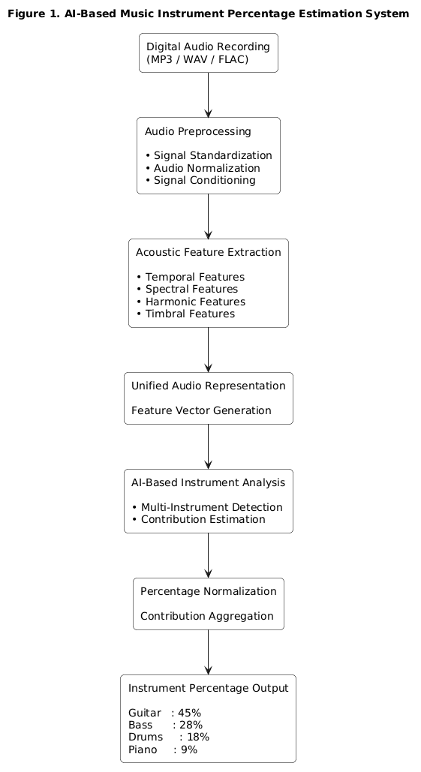

Figure 1 illustrates the overall architecture of the proposed Artificial Intelligence-based Music Instrument Percentage Estimation System. The invention provides an automated computational framework capable of transforming a digital music recording into a quantitative representation of its instrumental composition. The architecture consists of interconnected functional modules that sequentially process the input audio, extract representative musical information, estimate the contribution of individual instruments, and generate an interpretable percentage-based output.
The process begins when a digital audio recording is received by the system. Since music recordings may originate from different recording environments and exhibit variations in sampling frequency, signal amplitude, compression characteristics, duration, and recording quality, the audio is initially processed by an audio preprocessing module. This module standardizes the input signal by performing operations that produce a consistent representation suitable for computational analysis while minimizing variations introduced during recording. The standardized audio serves as the common input for all subsequent processing stages.
The standardized audio is subsequently supplied to a feature representation module configured to derive a multidimensional description of the musical content. Rather than relying on a single acoustic property, the proposed invention extracts complementary temporal, spectral, harmonic, and timbral characteristics that collectively describe the instrumental structure of the recording. These characteristics are integrated into a unified feature representation that preserves the acoustic signatures associated with simultaneously occurring musical instruments while reducing redundancy within the raw audio signal.
The unified feature representation is then processed by an Artificial Intelligence-based instrument analysis engine configured to perform multi-instrument estimation. Unlike conventional systems that identify only the presence or absence of instruments, the proposed invention evaluates the relative contribution of each detected instrument throughout the complete audio recording. The computational model independently analyzes multiple instrument signatures and determines their respective influence within the overall musical composition without restricting the analysis to a single dominant instrument.
The estimated instrument responses are subsequently transferred to a contribution estimation module, which computes quantitative contribution values for every detected instrument. These values are further processed by a normalization module that converts the estimated contributions into percentage distributions representing the proportional participation of each instrument within the music recording. The normalization process ensures that the generated percentages collectively provide a standardized and interpretable representation of the instrumental composition, enabling consistent comparison across different audio recordings irrespective of duration or recording conditions.
The normalized percentage distribution is then supplied to the output generation module, which produces a structured representation of the detected instruments together with their corresponding percentage contributions. The generated output may additionally be presented in graphical or tabular form to facilitate interpretation by end users while preserving the quantitative relationship among all detected instruments.
The modular architecture enables each functional component to operate independently while collectively forming an integrated Artificial Intelligence framework for automated instrument contribution estimation. The invention thereby converts raw digital audio into a standardized quantitative representation of instrumental composition, enabling efficient music content analysis, digital music indexing, music information retrieval, production analytics, educational applications, intelligent multimedia processing, and other computational music analysis systems.
The proposed architecture is scalable and extensible, allowing additional analytical modules to be incorporated without modifying the fundamental processing pipeline. Consequently, the invention establishes a generalized framework for Artificial Intelligence-based quantitative music analysis in which instrument contribution estimation serves as the primary computational output.

}

- Experimental validation results:

- What aspect(s) of the invention need(s) protection?

Invention Disclosure Format (IDF)-B | Document No. | 02-IPR-R003
 | Issue No/Date | 2/01.02.2024
 | Amd. No/Date | 0/00.00.0000

- What is Technology readiness level of your invention? (Tick the appropriate TRL)

Research |  |  | Development |  |  | Deployment
TRL 1 | TRL 2 | TRL 3 | TRL 4 | TRL 5 | TRL 6 | TRL 7 | TRL 8 | TRL 9
Basic | Technology | Experimental | Technology | Technology | Technology | System | System | Actual system
Principles | concept | proof of | validated in | validated in a | demonstrated | prototype | complete | proven in an
observed | formulated | concept | a lab | relevant | in a relevant | demonstration | and | operational
 |  |  |  | environment | environment | in an | qualified | environment
 |  |  |  | (industrially | (industrially | operational |  | (competitive
 |  |  |  | relevant in | relevant in | environment |  | manufacturing
 |  |  |  | case of key | case of key |  |  | in case of key
 |  |  |  | enabling | enabling |  |  | enabling
 |  |  |  | technologies) | technologies) |  |  | technologies,
 |  |  |  |  |  |  |  | or in space )

----------------------END OF THE DOCUMENT-----------------------------

