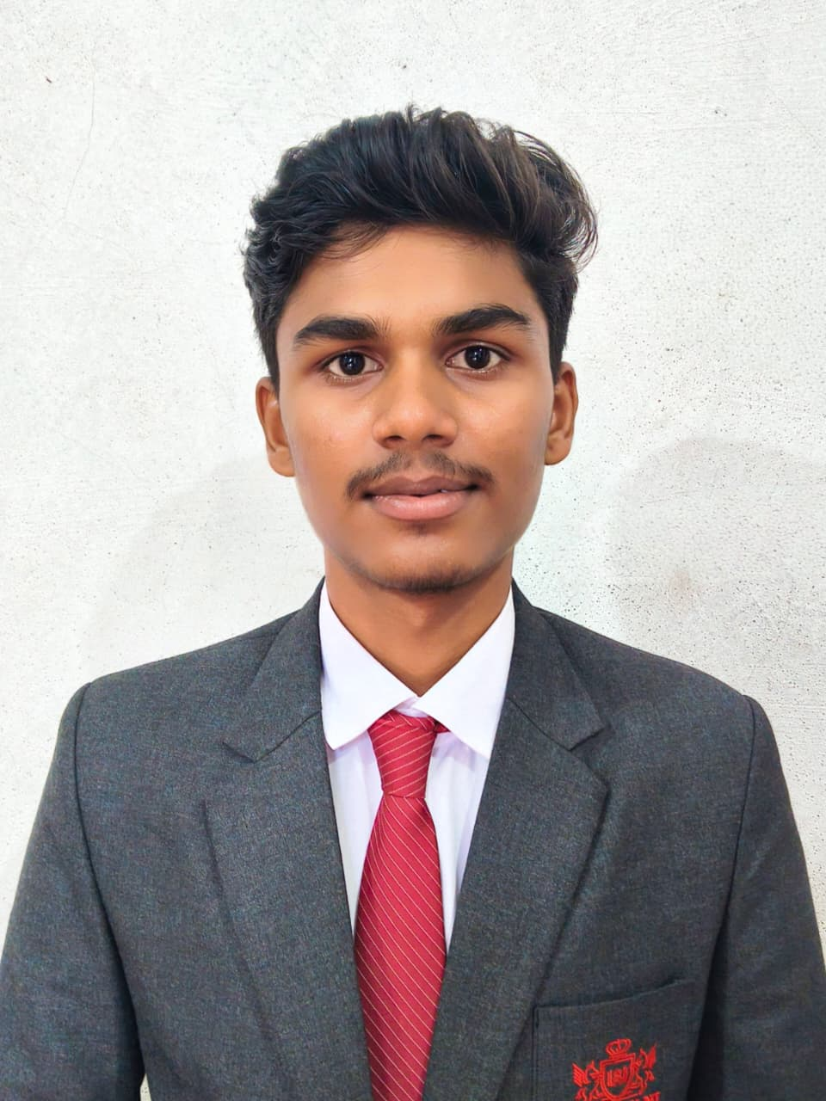
Resume

Atharv Tambe
EMAIL ID: atharvtambe2007@gmail.com
PHONE NO.:+918668828916

- SCOE: Sanjivani College of Engineering
- Attending from 2025 to 2029
- Pursuing Electrical Engineering at SCOE

- Skills:
- Driving: Valid driving license with a clean driving record.
- Computer Skills: Microsoft Excel (Data entry, table , and formulas), Microsoft Word (Document Creation, and formatting), Microsoft PowerPoint (Presentation design).
- Management: Team leadership, Project management, Time management.
- Soft Skills: Communication, Problem-solving.

- EDUCATION-
Sr. No. | Qualification | School/  college | Name of Institution | Year of Passing | Percentage
1. | SSC | RAYAT | SPPU | 2023 | 85.60%
2. | MSC-IT | HI-TECH |  | 2023 | 97%
3. | HSC | P.V.P | SPPU | 2025 | 69.83%
4. | MHT-CET |  | CETCELL | 2025 | 83.88%tile

