Presented by Atharv Tambe

Transformer Accessories…

Common Transformer Accessories and Their Meanings :
- Buchholz Relay :
A safety device that detects internal faults (like oil leaks or gas formation) in oil-filled transformers and triggers an alarm or disconnect switch.
- Breather :
A device containing a drying agent (usually silica gel) that absorbs moisture from the air entering the conservator tank as the oil level fluctuates.
- Conservator Tank :
A storage tank mounted above the main tank provides space for the insulating oil to expand and contract with temperature changes, preventing excessive pressure buildup.
- Cooling Fans/Systems :
Fans, pumps, and radiators used to dissipate heat generated during operation, keeping the transformer within a safe temperature range.
- Gauges (Oil Level, Temperature, Pressure) :
Instruments used to monitor critical operating conditions like the level of the insulating oil, the temperature of the oil and windings, and the internal pressure of the tank.
- Bushings :
Insulated terminals that allow the electrical connections to pass safely through the grounded transformer tank wall without making electrical contact with it.
- Tap Changer :
A mechanism (either de-energized or on-load) used to adjust the voltage ratio of the transformer by changing the number of winding turns to maintain the correct secondary voltage.
- Pressure Relief Device :
A safety mechanism designed to release excess pressure from within the tank in abnormal conditions, preventing a rupture or explosion.
- Lightning Arresters :
Devices that protect the transformer from high voltage surges caused by lightning strikes by diverting the excess current to the ground.

Application :

Diagram :
- Buchholz Relay :

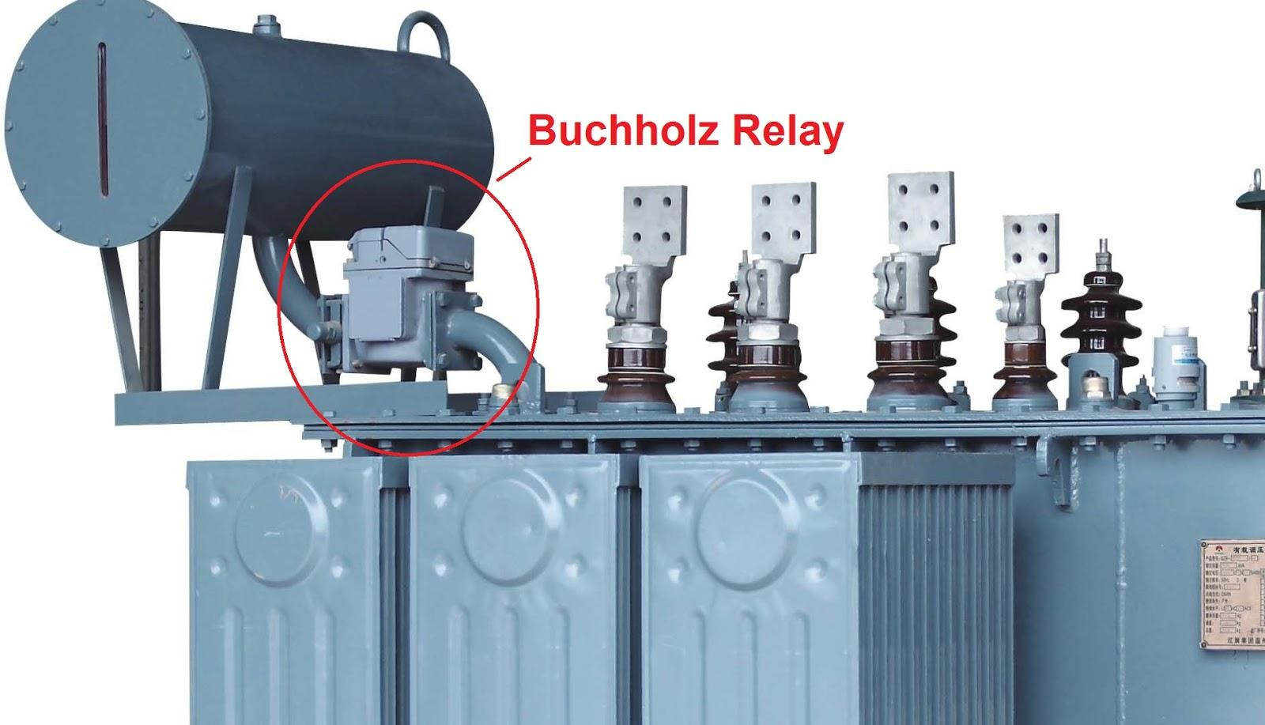
- Breather :
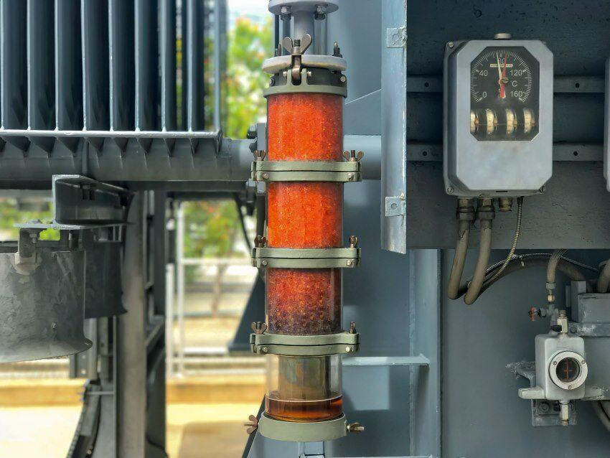
- Conservator Tank :
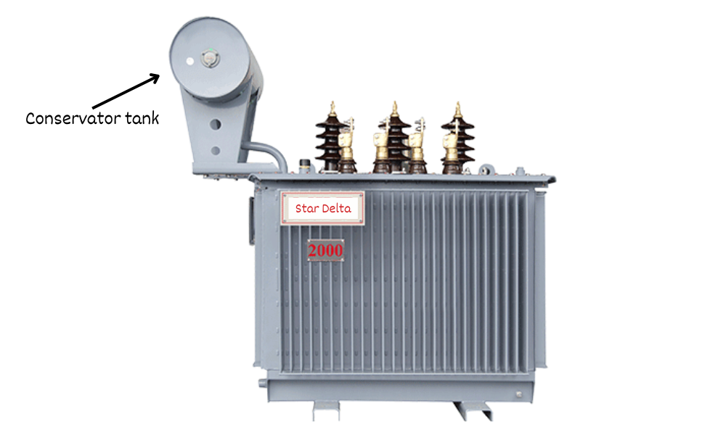
- Cooling Fans/Systems :

- Bushings :
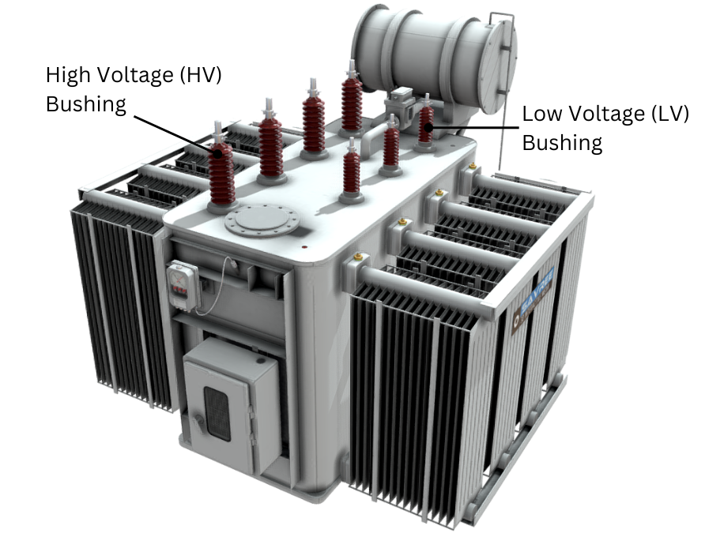
- Pressure Relief Device :
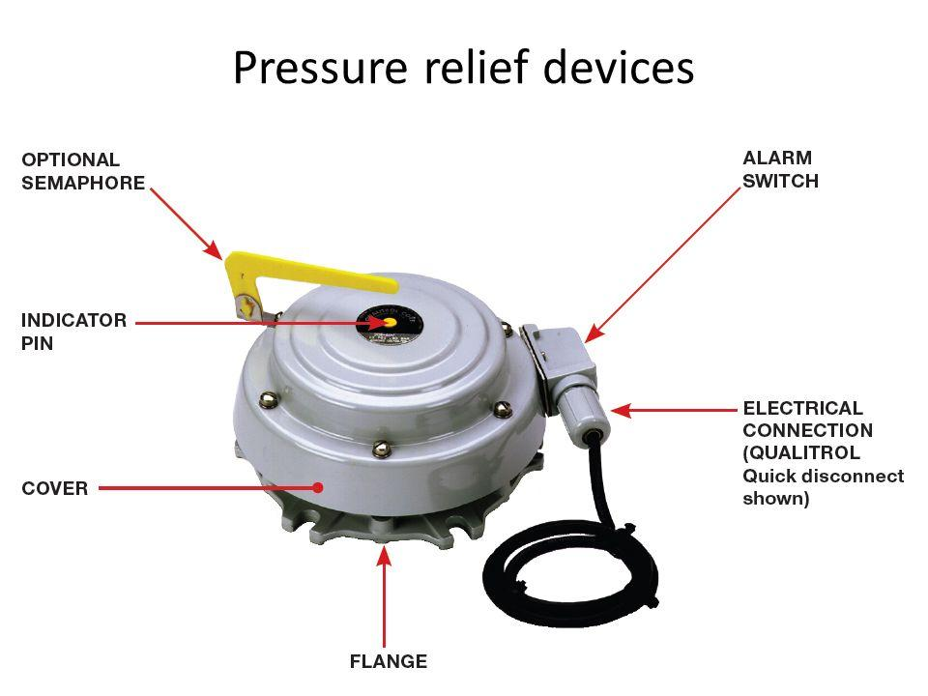
- Lightning Arresters :
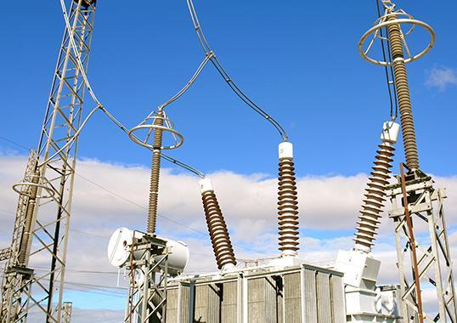

ONBOARDING TASKLIST

Advantages
- Improved safety
- Enhanced performance
- Increased versatility
- Extended lifespan

Disadvantages
- Higher costs
- Increased complexity
- Increased Maintenance
- Increased in size and weight

Conclusion :
Transformer accessories are crucial for safety, reliability, and extended lifespan (e.g., Buchholz Relay, Breather). While they lead to higher cost and maintenance, their functions are indispensable for ensuring the transformer operates efficiently and safely within the power system.
RESOURCE
Google
Gemini
Prof. B. B. Kadam sir

