SAP PROJECT REPORT

Order-to-Cash (O2C) Process in SAP SD
SAP Business Technology Platform (BTP)
Modules: SD | MM | FI
Stream: B. Tech — Computer Science & Engineering
Academic Year: 2024 – 2025
System: SAP ERP — ECC 6.0 / S/4HANA

Name | Atharva Gupta
Roll Number | 2305286
Program | SAP BTP
Branch | B. Tech
Stream | CSE
Course | Computer Science & Engineering
Date of Submission | 18th April 2025

1. Title & Introduction
This report documents the study and practical understanding of the Order-to-Cash (O2C) process as implemented in SAP Sales and Distribution (SAP SD), completed as part of the SAP Business Technology Platform (BTP) academic program. The O2C process describes the complete sequence of business activities that begin when a customer places an order and end when the company receives and records the payment for that order.
SAP SD addresses this by bringing all of these functions into a single integrated system. Every action taken in the O2C process, from confirming a sales order to clearing a payment, is recorded in SAP and immediately visible to anyone with the appropriate access. The O2C process is the most central use case of SAP SD, and understanding it in depth is the primary objective of this project.

2. Problem Statement
Before integrated ERP systems became standard practice, most companies managed their sales operations through a combination of spreadsheets, email, telephone calls, and standalone software. Each department maintained its own records, and sharing information across teams was a manual, time-consuming process.
Core operational pain points observed in pre-SAP environments include:
Order Management Gaps
Without a centralised order management system, sales orders can be entered incorrectly, duplicated across teams, or lost entirely. There is no automatic check to confirm whether a customer's requested delivery date is achievable given the current state of inventory.
Inventory Mismatches
In the absence of real-time inventory visibility, a sales team might confirm an order for goods that are no longer in stock. By the time the warehouse flags the shortage, the customer has already been given a delivery commitment.
Billing Errors and Revenue Leakage
Generating invoices manually is inherently error-prone. Incorrect pricing, missing line items, wrong tax amounts, or invoices sent to the wrong contact are all common occurrences.
3. Solution / Features
The O2C process in SAP SD is carried out through a sequence of linked transactions. Each transaction generates a document, and each document references the one that came before it. This chain of documents forms a complete, traceable record of the entire sales event. The steps are as follows.
Customer Master — Transaction VD01
The customer master record is created before any sales transaction can take place. It holds all the information SAP needs to process a sale for a particular customer: the customer's name and address, the payment terms agreed with them (such as payment due within 30 days of invoice), which plant should deliver to them by default, and how their invoices should be transmitted
Material Master — Transaction MM01
The material master holds all product-level information. The sales-relevant views specify how a product is sold, what unit of measure applies, from which plant it is shipped, and what pricing conditions govern it.
Sales Order — Transaction VA01
The sales order is the central document of the O2C cycle. When a sales order is created in VA01, the system carries out two automatic checks before the order is saved. First, an availability check confirms whether the requested quantity can be delivered on the date the customer has asked for. If not, the system proposes the earliest date on which the quantity will be available. Second, a credit check compares the customer's current outstanding balance against their credit limit. If the limit would be breached, the order is flagged or blocked for review by a credit manager.
Outbound Delivery — Transaction VL01N
With the sales order confirmed, the next step is to create an outbound delivery in VL01N. This document is the instruction to the warehouse to prepare the goods for shipment. It carries the shipping information, the quantities to be picked, and the storage location from which the goods should be retrieved. Warehouse staff use this document to carry out the physical picking and packing. As each step is completed, the delivery document is updated so that the current status of the shipment is always visible in the system.
Post Goods Issue — Transaction VL02N
Post Goods Issue, commonly abbreviated as PGI, is the step that records the physical transfer of goods from the company to the customer. When PGI is executed in VL02N, two things happen simultaneously and automatically. In Materials Management, the inventory quantity is reduced by the amount shipped. In Financial Accounting, an accounting entry is posted that debits the Cost of Goods Sold account and credits the Inventory account. From this point, the goods are legally the property of the customer, and the company has recognised its cost of sale.
Billing Document — Transaction VF01
Once PGI has been posted, the billing document is created in VF01 with reference to the completed delivery. The system copies the customer details, line items, quantities, and pricing conditions from the sales order and delivery into the invoice.
Payment Receipt — Transaction F-28
The final step is recording the customer's incoming payment. When payment is received, it is posted in SAP via transaction F-28 against the open invoice. The system clears the open receivable, meaning the invoice is no longer outstanding in the customer's account.
4. Screenshots
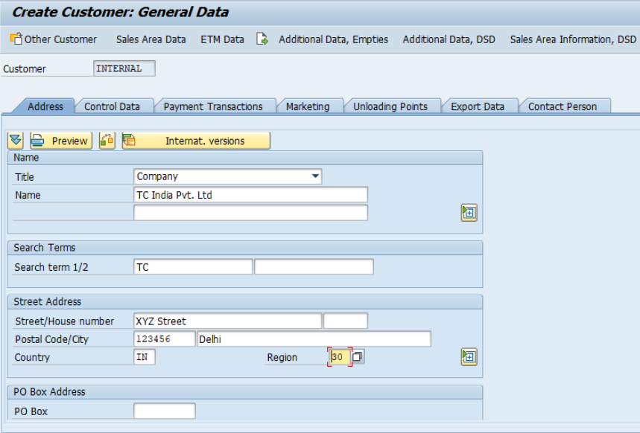
Figure 1: Customer Master creation screen in VD01, showing General Data, Company Code Data, and Sales Area Data tabs
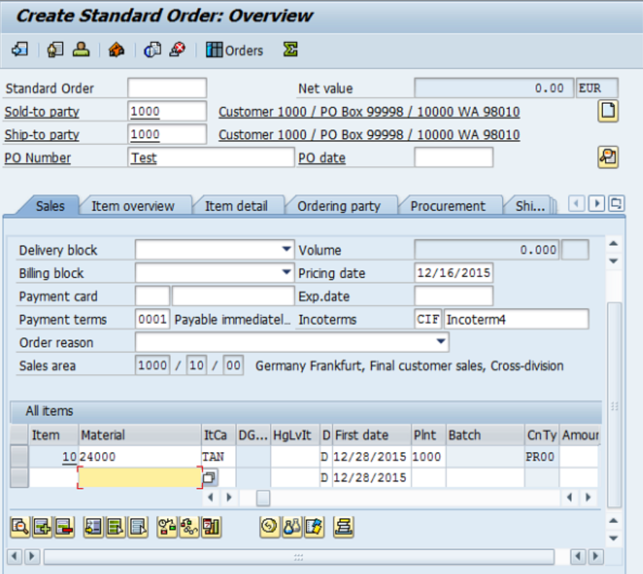
Figure 2: Sales Order entry screen in VA01 with customer details, material line items, and system-determined pricing conditions
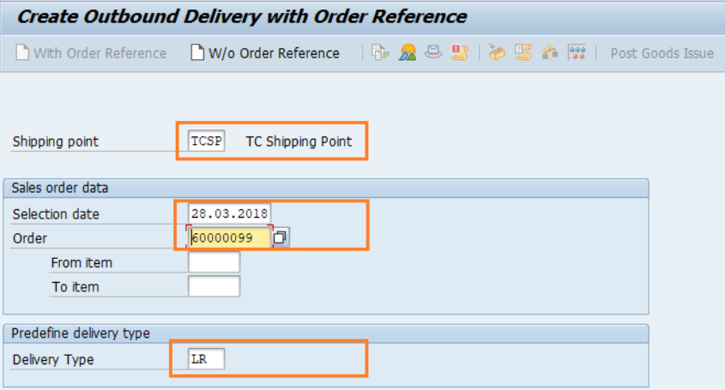
Figure 4: Outbound Delivery document in VL01N showing picking quantities and storage location
5. Tech Stack
SAP ERP — ECC 6.0 and S/4HANA
SAP ECC is the traditional on-premise ERP platform that has been the backbone of enterprise operations for decades. SAP S/4HANA is its successor, built on the in-memory HANA database.
SAP SD — Sales and Distribution
The primary module through which the O2C process is executed. SAP SD governs sales order management, pricing determination, delivery processing, and billing. It integrates directly with SAP FI for financial postings and SAP MM for inventory management, ensuring that every sales event is reflected accurately across all relevant areas of the business.
SAP FI — Financial Accounting
Financial Accounting handles the accounting consequences of every step in the O2C process. The PGI posting, the billing document, and the incoming payment all trigger entries in SAP FI without any manual intervention from the finance team. The Accounts Receivable sub-module within FI manages the open items and their clearing.
SAP MM — Materials Management
Materials Management is responsible for inventory. It provides the stock data that drives the availability check at sales order creation, and it records the physical movement of goods when PGI is executed. The valuation data in MM also determines the value of the COGS entry posted to FI.
SAP GUI
SAP GUI is the desktop client through which users access and interact with the SAP system. All the transactions covered in this project are executed through SAP GUI. It remains the standard interface for SAP ECC environments and is still widely used alongside Fiori in S/4HANA deployments.
SAP HANA
SAP HANA is the in-memory, column-oriented database that powers SAP S/4HANA. Its architecture enables large volumes of transactional data to be processed and queried in real time, which is what makes features like live availability checks and real-time financial reporting possible without the need for separate reporting layers.
SAP Business Technology Platform
SAP BTP is the cloud platform that allows organisations to extend and integrate their SAP systems without modifying the core system. In the context of O2C, it enables custom order portals, third-party integrations, and API-based connections to external applications. It is also the platform context within which this academic program is structured.
Modules integrated:
- SAP SD (Sales and Distribution) — Core O2C process orchestration
- SAP MM (Materials Management) — Inventory management, ATP, and goods movement
- SAP FI (Financial Accounting) — Accounts Receivable, General Ledger, and tax posting
6. Unique Points
Several characteristics of the O2C process in SAP SD stand out as particularly significant, both in terms of how the system is designed and in terms of the practical value it delivers to the business.
The Document Flow
Every transaction in the O2C cycle generates a document, and every document references the one before it. The billing document references the delivery, which references the sales order. This chain is always accessible within the system. Any user with the relevant authorisation can open a billing document and navigate all the way back to the original sales order, or forward to the payment posting. During an audit or a customer dispute, this traceability is invaluable. There is no need to search across multiple systems or ask different departments for their records.
Automatic Financial Postings
In many organisations, the operations and finance teams work from separate systems and reconcile their records periodically. In SAP SD, the financial impact of every logistical event is posted to Financial Accounting automatically. When goods are issued, the cost entry appears in FI without anyone in the finance department doing anything. When an invoice is saved, the revenue entry posts instantly. This real-time synchronisation eliminates the reconciliation burden and ensures that financial statements always reflect the current state of operations.
Availability-to-Promise Logic
The availability check in SAP SD does more than simply look at the current stock level. It considers existing sales commitments already made to other customers, expected stock arrivals from open purchase orders, safety stock buffers defined in the system, and the lead times involved in moving goods from the warehouse to the customer. The result is a realistic, defensible delivery date rather than an optimistic estimate based on incomplete information.
Pricing Through the Condition Technique
SAP's pricing framework allows very complex pricing structures to be configured without any custom code. A company can define that a specific customer always receives a 10 percent discount, that freight charges apply above a certain order weight, that a minimum order surcharge applies below a certain value, and that all of these conditions interact in a defined sequence. All of this is managed through configuration in the system. When conditions change, the configuration is updated and the new pricing takes effect immediately for all subsequent orders.
Built-In Credit Management
At the point of sales order creation, the system checks the customer's current credit exposure against a limit defined in the customer master. If the new order would push the customer beyond their limit, the order can be blocked automatically, preventing fulfilment until a credit manager reviews and releases it. This mechanism protects the business from shipping goods that may not be paid for, without requiring a credit team member to manually review every order.
7. Future Improvements
While the standard SAP SD O2C process is mature and well-established, there are areas where organisations are actively working to make it more efficient, more intelligent, and better connected to modern technology.
Migration to SAP S/4HANA
A large number of organisations still running SAP ECC are currently planning or executing a migration to S/4HANA. The newer platform simplifies the underlying data model, which reduces storage requirements and improves processing speed. For the O2C process specifically, S/4HANA introduces real-time billing, an improved available-to-promise engine, and embedded analytics that allow sales managers to monitor pipeline and fulfilment metrics without leaving the transactional system.
SAP Fiori Applications
SAP Fiori provides a modern browser-based interface for S/4HANA that works on desktop, tablet, and mobile. Fiori applications for the O2C process allow sales representatives to create and manage orders from a mobile device, and can provide customers with a self-service portal to check their own order status, download invoices, and raise queries. This reduces inbound calls to customer service teams and gives customers a faster and more convenient experience.
AI-Assisted Demand Forecasting
Integrating machine learning into the pre-sales planning process can improve inventory positioning before orders are even received. By analysing historical order patterns, seasonal trends, and other signals, AI models can predict which products a given customer is likely to order and in what volumes. This allows the warehouse to position stock proactively, reducing the frequency of availability check failures at order entry.
8. Conclusion
The Order-to-Cash process in SAP SD is, at its core, a straightforward concept: take an order, deliver the goods, raise an invoice, and collect the payment. What makes it interesting, and what gives it lasting relevance in enterprise software, is the depth of integration and automation that sits beneath that simple description.
Every step in the process touches a different part of the business. The sales order involves the customer, the stock, the pricing rules, and the credit position. The delivery involves the warehouse and the logistics team. The billing document involves the finance team and the customer's accounts payable department. The payment clearing closes the loop back to finance. In a manual or loosely integrated environment, coordinating all of these touches is slow, error-prone, and heavily dependent on individual effort. In SAP SD, the system handles the coordination. Each step triggers the next automatically, and the financial consequences of every operational event are recorded in real time.

