Resume Screening Pipeline Architecture
This document explains the end-to-end flow of the resume parsing and screening system.
__________________________________________________

Pipeline Overview (Data Flow)
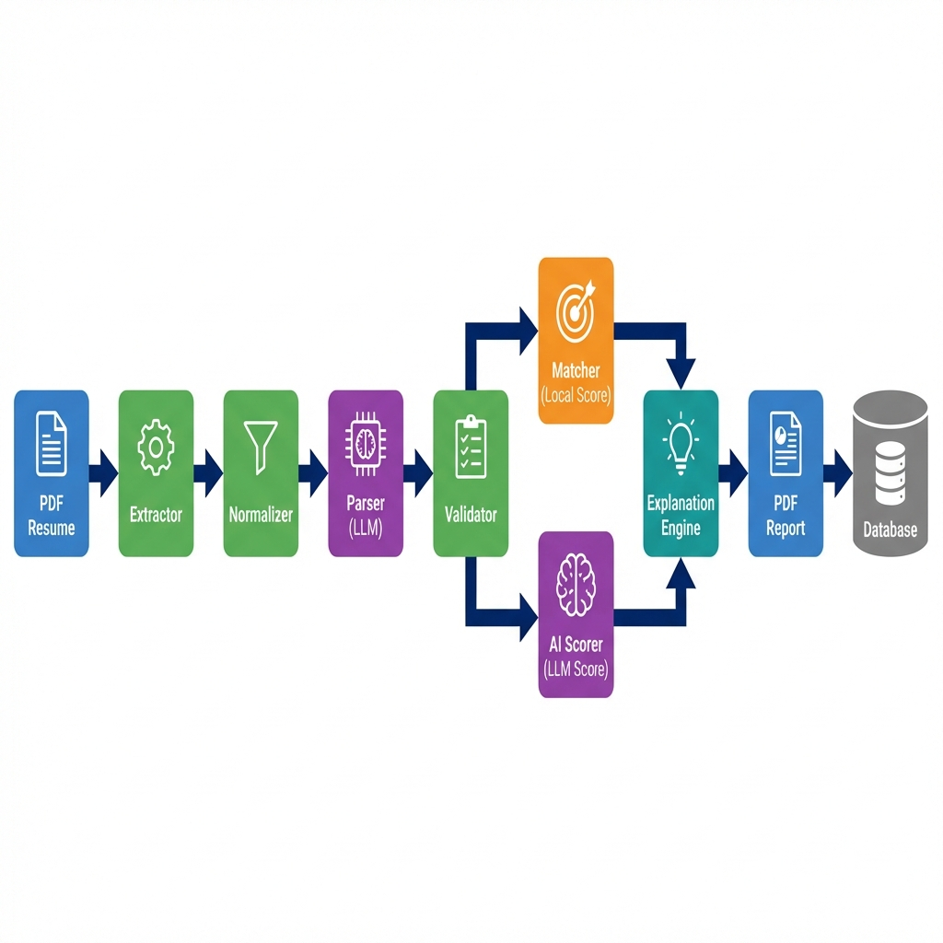
__________________________________________________

Stage 1: Extraction
File: extractor.py
Purpose: Extract raw text from PDF resumes.
Input | Output
PDF file path | Raw text string

What it does:
- Detects if PDF is **digital** (text-layer) or **scanned** (image).
- Uses `pdfplumber` for digital PDFs.
- Uses `PaddleOCR` for scanned/image PDFs.
What it does NOT do:
- Does not clean or structure the text.
- Does not extract metadata (author, creation date).
Why it exists: Different PDF types require different extraction methods. This ensures we can handle both machine-generated and scanned resumes.
__________________________________________________

Stage 2: Normalization
File: normalizer.py
Purpose: Clean and structure raw text for downstream processing.
Input | Output
Raw text | Cleaned, section-marked text (Markdown-like)

What it does:
- Removes extra whitespace, non-ASCII characters.
- Fixes broken words (e.g., `devel-\nopment` → `development`).
- Inserts Markdown headers (`## Skills`, `## Experience`).
- Extracts **CGPA/Percentage** and **Salary** into separate JSON files.
What it does NOT do:
- Does not identify specific entities (names, emails).
- Does not evaluate content quality.
Why it exists: Clean input improves LLM parsing accuracy. Section markers help the parser identify structure.
__________________________________________________

Stage 3: Parsing (LLM)
File: parser.py
Prompt: system_prompt.txt
Purpose: Convert normalized text into structured JSON using Azure OpenAI (Phi-4).
Input | Output
Normalized text | Structured JSON with `name`, `email`, `skills`, `experience`, etc.

What it does:
- Sends text to Azure OpenAI API with a strict system prompt.
- Enforces **zero hallucination** — only extracts explicitly stated information.
- Handles code fences and malformed JSON from model output.
- Retries with higher `max_tokens` on failure.
What it does NOT do:
- Does not infer missing information.
- Does not correct typos in the resume.
- Does not score or rank the candidate.
Why it exists: LLMs excel at understanding natural language structure. The strict prompt ensures deterministic, auditable output.
__________________________________________________

Stage 4: Validation
File: validator.py
Purpose: Clean, normalize, and enrich the parsed JSON.
Input | Output
Parsed JSON | Validated JSON with normalized dates, skills, durations

What it does:
- Normalizes dates to `YYYY-MM` format.
- Calculates `total_experience_years` from role timelines.
- Extracts salary from raw text if missing.
- Normalizes role titles (`sde intern` → `Software Development Intern`).
- Cleans company names.
- Extracts courses and projects from raw text.
What it does NOT do:
- Does not evaluate truthfulness of claims.
- Does not score the candidate.
Why it exists: Raw LLM output varies. Validation ensures consistent downstream schema.
__________________________________________________

Stage 5: Scoring

5A: Local Matcher
File: matcher.py
Purpose: Deterministic, rule-based scoring against Job Description (JD).
Input | Output
Validated resume JSON + JD JSON | Score breakdown (0-100 per category)

What it does:
- **Skills matching:** Exact + semantic similarity (SentenceTransformers).
- **Experience scoring:** Years vs. JD requirements.
- **Qualification/Education matching.**
- **Project keyword matching.**
- **Salary fit scoring.**
- Returns `matched_items`, `missing_items`, and component scores.
What it does NOT do:
- Does not understand context or nuance (e.g., "led a team" vs "was on a team").
- Does not penalize red flags subjectively.
Why it exists: Provides fast, explainable, auditable baseline scores.
__________________________________________________

5B: AI Scorer
File: ai_scorer.py
Prompt: system_prompt.txt
Purpose: LLM-based qualitative scoring with reasoning.
Input | Output
Resume + JD + Weights | AI scores (0-100) + notes

What it does:
- Sends resume facts + JD requirements to LLM.
- LLM returns component scores and natural language notes.
- Applies **evidence rules** (from `config/evidence_rules.json`) to inject constraints.
- Applies **guardrails** to cap scores when evidence is missing.
What it does NOT do:
- Does not replace local scorer (used as supplementary signal).
- Does not make hiring decisions.
Why it exists: Captures nuance that rule-based matching misses.
__________________________________________________

Stage 6: Guardrails
Files:
- [guardrails.py](file:///c:/Users/asr26/OneDrive/Desktop/Reaper/Work_101/RaiyaRecuritment_Parser/phi%204/app/guardrails.py) — Explanation validation
- [ai_guardrails.py](file:///c:/Users/asr26/OneDrive/Desktop/Reaper/Work_101/RaiyaRecuritment_Parser/phi%204/app/ai_guardrails.py) — Score correction
Purpose: Prevent hallucinated or inflated scores.
What it does:
- **Evidence rules:** If no skills → `skills_score = 0`.
- **Consistency checks:** If LLM says "5 years" but facts show 2 → flag.
- **Leakage checks:** Missing skills should not appear in "strengths".
- **Generic rules:** Configurable via `config/evidence_rules.json`.
What it does NOT do:
- Does not block pipeline on failure (fails open, logs warning).
Why it exists: LLMs can hallucinate. Guardrails enforce factual grounding.
__________________________________________________

Stage 7: Explanation Engine
File: explanation_engine.py
Purpose: Generate human-readable summaries and structured feedback.
Input | Output
Matcher output | Recruiter summary, candidate feedback, visual payloads

What it does:
- **Recruiter summary:** 1-3 sentence factual overview.
- **Candidate feedback:** Actionable improvement suggestions.
- **Structured JSON:** Strengths, improvements, skill gaps.
- **Visual payload:** Radar charts, coverage bars, salary gauge data.
What it does NOT do:
- Does not call external APIs.
- Does not make subjective judgments.
Why it exists: Scores alone are not user-friendly. Explanations build trust.
__________________________________________________

Stage 8: PDF Report
File: pdf_report.py
Purpose: Generate polished PDF reports for recruiters.
Input | Output
Matcher output | Corporate Blue PDF with charts and tables

What it does:
- Renders radar chart (component scores).
- Renders coverage bar chart.
- Lists matched/missing skills, experience, projects.
- Displays recruiter summary and candidate feedback.
- Paginated, branded layout.
What it does NOT do:
- Does not store to database (separate step).
Why it exists: Recruiters need shareable documents, not JSON.
__________________________________________________

Orchestration
File: main.py
Purpose: Coordinates all stages into a single pipeline run.
Flow:
- Load JD from `uploads/job_description.json`
2. Extract → Normalize → Parse → Validate → Score → Explain → PDF
3. Optionally save to database (`saas_db.py`)
__________________________________________________

Prompt Versioning
Directory: `prompts/v1/`
Module | Prompt File
Parser | `prompts/v1/parser/system_prompt.txt`
AI Scorer | `prompts/v1/ai_scorer/system_prompt.txt`
Explainer | `prompts/v1/explainer/system_prompt.txt`

Active version configured in `config/system_config.json`.
__________________________________________________

Key Design Decisions
- **Zero Hallucination Prompts:** LLMs are instructed to extract only explicit information.
2. Dual Scoring: Local (fast, explainable) + AI (nuanced). Neither is sole authority.
3. Guardrails: Post-processing rules ensure scores match evidence.
4. Deterministic Validation: All dates, roles, salaries normalized before scoring.
5. Modular Architecture: Each stage is independently testable.
__________________________________________________

Limitations
- **OCR Quality:** Scanned PDFs depend on PaddleOCR accuracy.
- **LLM Latency:** Azure API calls add ~2-5 seconds per resume.
- **Schema Rigidity:** Fixed output schema may miss non-standard resume sections.
- **Single JD:** Currently one JD at a time; multi-JD ranking is separate.

