CHAPTER 1
INTRODUCTION
The process of buying property involves the examination of multiple legal and ownership records. Documents such as sale deeds, RTC/Pahani records, mutation extracts, encumbrance certificates, khata certificates, and tax receipts must be checked together to establish whether the available information is consistent and whether important risks are present. In practice, this verification is often manual, document-heavy, and dependent on repeated cross-checking by buyers, lawyers, banks, and other stakeholders.
Artificial intelligence and document intelligence provide an opportunity to assist this process by extracting information from documents, understanding their contents, and comparing related facts across a complete property document set. Modern language models and information-extraction methods can convert unstructured legal documents into structured information that can be searched, compared, and reviewed more efficiently.
The proposed TrustVerify by Proplox is an AI-powered property verification platform designed to reduce the time and effort required for first-pass property document verification. It accepts a set of property documents, reads and cross-verifies relevant information, identifies mismatches or missing records, assigns risk severity, and generates a professional verification report for review by the appropriate stakeholder.

1.1 Problem Statement
Property verification is currently fragmented across multiple documents and stakeholders. Manual comparison can take days or weeks and may involve repeated checking of names, ownership history, property extent, encumbrances, and supporting records. Errors, omissions, forged documents, and inconsistencies may be overlooked during a manual first-pass review. There is therefore a need for a secure AI-assisted system that can organize documents, cross-verify their contents, highlight potential risks, and provide an explainable summary for human review.

1.2 Objective
- To design an AI-powered property document verification system for analysing and validating property-related documents.
- To develop an intelligent system that extracts relevant information and cross-verifies ownership, property extent, encumbrances, and other key details across multiple documents.
- To implement a risk detection and reporting mechanism that identifies missing information, mismatches, and potential risk indicators with severity levels and generates a structured verification report.

1.3 Proposed Solution
The proposed solution, TrustVerify by Proplox, provides a single platform in which users can upload the available property document set together. The system processes each document using document intelligence techniques and extracts relevant entities and attributes. The extracted information is then normalized and compared across documents so that inconsistencies can be detected systematically.
The AI verification engine focuses on first-pass analysis rather than replacing a qualified legal professional. It flags issues such as conflicting owner names, inconsistent property extent, gaps in ownership information, unexpected encumbrance information, missing supporting documents, and other patterns defined by the verification rules. Each finding is presented with a severity level and an explanation so that the user can understand why the issue was flagged.
After analysis, the platform produces a professional verification report containing document status, cross-document findings, risk indicators, and recommended areas for further review. Secure OTP-based login and role-based access are incorporated so that users only access information relevant to their role. The platform therefore combines AI document analysis with security and controlled information sharing in a single workflow.

Core capabilities
- Bulk upload of sale deeds, RTC/Pahani, mutation extracts, encumbrance certificates, khata records, and tax receipts.
- AI-based reading and extraction of important property and ownership information.
- Cross-document comparison to identify mismatches and missing information.
- Risk flagging with severity and explanation.
- Automatic generation of a shareable verification report.
- OTP-based authentication and role-based access control.
- Centralized transaction and document status for buyers, builders, banks, and legal teams.

CHAPTER 2
LITERATURE REVIEW
1. Premasiri, Damith et al. (2025)
Title: Survey on Legal Information Extraction: Current Status and Open Challenges
This survey reviews information extraction from legal documents, including named-entity recognition, relationship extraction, and event detection. It highlights that legal documents are often lengthy, unstructured, and difficult to process manually.

2. Adhikary, Subinay et al. (2024)
Title: A Case Study for Automated Attribute Extraction from Legal Documents Using Large Language Models
This work investigates the extraction of structured attributes from legal documents using large language models. It demonstrates the potential of LLMs to identify relevant information from complex legal text and convert it into a form suitable for downstream processing. The study is relevant to TrustVerify because property verification requires extraction of names, dates, parties, property details, and other attributes before cross-document validation.

3. Nagaraja, S. R. & Shushma, R. (2025)
Title: A Hybrid AI-Blockchain Framework with OCR, NER, and Anomaly Detection for Secure Land Record Management
This research proposes combining OCR, named-entity recognition, and anomaly detection for land-record validation, with blockchain-based storage for integrity. The work demonstrates the relevance of combining document extraction with anomaly detection when dealing with land records and forgery risks. TrustVerify adopts the AI validation aspect while focusing on secure document handling and cross-document verification.

4. Shen, Jiyuan et al. (2026)
Title: OCR or Not ? Rethinking Document Information Extraction in the MLLMs Era with Real-World Large-Scale Datasets
This study evaluates multimodal large language models for document information extraction and examines OCR-based and image-based approaches. It highlights the potential of multimodal models for extracting structured information from documents while also identifying failure modes that require careful evaluation.

CHAPTER 3
SYSTEM REQUIREMENTS
3.1 Hardware Requirements:
- Laptop/desktop with minimum 8 GB RAM.
- Stable internet connection for secure document processing and AI services.
- Scanner or mobile camera for digitizing physical property documents when required.
- Server/cloud environment with sufficient CPU/GPU resources for document and AI processing.

3.2 Software Requirements:
- Programming Languages: Python, JavaScript
- Frontend: React.js / HTML, CSS, JavaScript
- Backend: Python-based API framework such as FastAPI
- Document Processing: OCR and document parsing libraries
- AI/ML: NLP, transformer/LLM or multimodal document-intelligence model
- Database: Structured database such as MongoDB or MySQL
- Authentication: OTP-based mobile verification and role-based access control
- Development Tools: VS Code, Git, API testing tools
- Deployment: Cloud/server environment with secure storage and controlled access

CHAPTER 4
SYSTEM ARCHITECTURE
4.1 Architecture Design
The system follows a layered architecture consisting of the following major components:
- User Interface Layer – Provides interfaces for buyers, builders, banks, and legal teams to authenticate, upload documents, view verification status, and access reports.
- Application/Backend Layer – Manages authentication, document workflows, APIs, validation rules, report generation, and communication between the user interface and AI services.
- AI Verification Layer – Performs document understanding, information extraction, normalization, cross-document comparison, and risk detection.
- Data Layer – Stores user, property, document metadata, extracted information, findings, and verification history in a structured and controlled manner.
- Security Layer – Applies OTP verification, role-based authorization, controlled document access, and secure handling of sensitive property information.

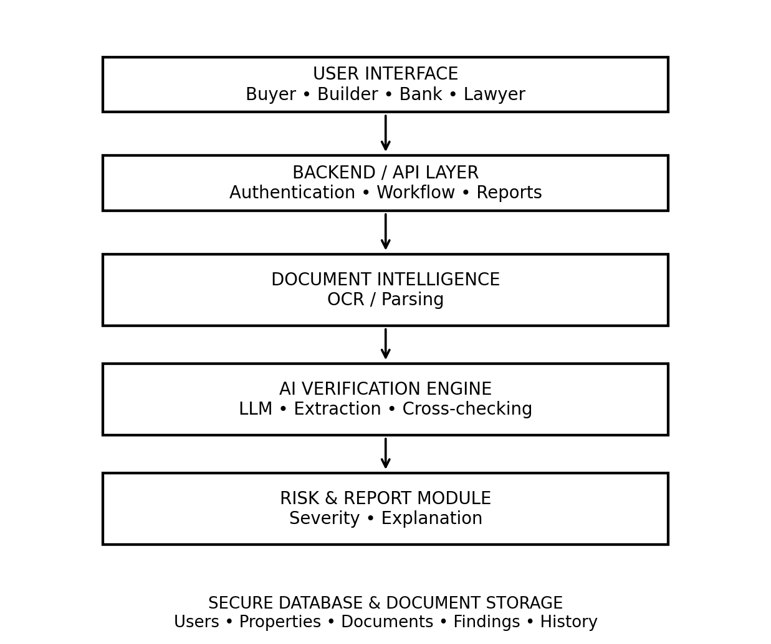
Fig 4.1 System Architecture

Workflow
1. User registers and completes OTP-based mobile verification.
2. User creates/selects a property verification case.
3. All available property documents are uploaded together.
4. Document intelligence extracts relevant text, entities, and attributes.
5. The AI verification engine normalizes and cross-references extracted information.
6. Risk rules and AI analysis identify mismatches, missing records, and potential legal/document risks.
7. Findings are assigned severity and accompanied by an explanation or recommended action.
8. A structured verification report is generated and made available according to the user's role.

4.2 Frontend Implementation
- Provides a simple upload and verification dashboard for different user roles.
- Displays document status, verification progress, risk findings, and generated reports.
- Provides controlled access to property information according to the authenticated role.

4.3 Backend Implementation
- Handles user authentication, document upload, processing requests, and verification workflows.
- Coordinates AI services, database operations, risk rules, and report generation.
- Maintains transaction and verification history for traceability.

CHAPTER 5
EXPECTED OUTCOMES
The expected outcome of TrustVerify by Proplox is a functional and scalable AI-assisted property verification platform capable of processing a collection of property documents and presenting the results in a clear and structured manner. The system is expected to reduce the effort involved in first-pass document review by automatically extracting and comparing information that would otherwise have to be checked manually.
The platform is expected to identify important inconsistencies such as differences in owner names, property extent, dates, ownership-chain information, encumbrance details, and missing supporting documents. Instead of presenting only a binary result, the system will provide severity-based findings and explanations so that users can understand which areas require additional attention.
Another expected outcome is the generation of a professional verification report that can be shared with relevant stakeholders. Buyers can use the report to identify questions before proceeding with a transaction, while lawyers and financial institutions can use it as an AI-assisted first pass review before detailed professional verification.
The system is also expected to improve information security through OTP-based authentication and role-based access. Property documents contain sensitive personal and financial information; therefore, controlled access and secure storage are important parts of the proposed platform rather than optional features.
In future versions, the platform can be extended with multilingual document processing, stronger document authenticity checks, integration with authorized land-record sources, property-specific knowledge bases, improved explainability, and human-in-the-loop review for difficult or ambiguous documents.

CHAPTER 6
CONCLUSION
TrustVerify by Proplox provides an AI-assisted approach to one of the most intensive document stages of a property transaction: verification of the available property records. By bringing multiple documents into a single workflow, extracting relevant information, and cross-checking related facts, the system aims to reduce repetitive manual effort and make potential inconsistencies easier to identify.
The integration of document intelligence, natural language processing, large language model capabilities, and rule-based risk analysis provides a practical foundation for automated first-pass verification. Rather than treating AI output as a final legal decision, the system is designed to highlight areas that deserve attention and support professionals with organized, explainable evidence.
Security is a central part of the proposed platform because property documents contain sensitive information. OTP-based authentication, role-based access, secure document management, and controlled report access help reduce unauthorized exposure of transaction data.
Overall, Proplox aims to make property verification faster, more consistent, and easier to understand while keeping human legal expertise in the verification loop. With further development and validation on real-world document sets, the platform can evolve into a broader property due-diligence assistant for buyers, builders, banks, and legal teams.

REFERENCES
1. Premeasure, Damith, Tharindu Ranasinghe, Ruslan Mitkov, Mo El-Haj, et al. (2025). Survey on Legal Information Extraction: Current Status and Open Challenges. Knowledge and Information Systems, 67, 11287–11358.
2. Adhikary, Subinay, Procheta Sen, Dwaipayan Roy, et al. (2024). A Case Study for Automated Attribute Extraction from Legal Documents Using Large Language Models. Artificial Intelligenceand Law, 34, 245–266.
3. Nagaraja, S. R. & Shushma, R. (2025). A Hybrid AI-Blockchain Framework with OCR, NER, and Anomaly Detection for Secure Land Record Management. Engineering, Technology & Applied Science Research, 15(6), 30252–30259. DOI: 10.48084/etasr.15223.
4. Shen, Jiyuan, Yuan Peiyue, Atin Ghosh, Yifan Mai & Daniel Dahlmeier. (2026). OCR or Not? Rethinking Document Information Extraction in the MLLMs Era with Real-World Large-Scale Datasets. Proceedings of the 19th Conference of the European Chapter of the Association for Computational Linguistics (EACL 2026), 385–396. DOI: 10.18653/v1/2026.eacl-industry.28.

