
K J SOMAIYA INSTITUTE OF TECHNOLOGY, SION, MUMBAI
DEPARTMENT OF COMPUTER ENGINEERING
AgriSense: AI-Driven Crop Type, Phenology,
Moisture Stress Detection and Irrigation Advisory
TY Mini Project Report
Submitted in partial fulfillment of the requirements
of the Subject Project Based Learning: Mini Project Lab-I (Sem V)
by
[Student Name 1] ([Roll No.])
[Student Name 2] ([Roll No.])
[Student Name 3] ([Roll No.])
[Student Name 4] ([Roll No.])
Supervisor
[Project Guide Name]

Department of Computer Engineering
K J Somaiya Institute of Technology
Ayurvihar, Sion Mumbai-400022
2026-27

CERTIFICATE
This is to certify that the project entitled “AgriSense: AI-Driven Crop Type, Phenology, Moisture Stress Detection and Irrigation Advisory” is bonafide work of [Student Name 1], [Student Name 2], [Student Name 3], and [Student Name 4], submitted as a Third Year Semester V Mini Project in the subject of Project Based Learning: Mini Project Lab-I, Computer Engineering, for the academic year 2026-27.
[Project Guide Name] | [Head of Department] | [Principal]
Project Guide  Department of Computer Engineering | Head of Department  Department of Computer Engineering | Principal  KJSIT, Sion
Place: Sion, Mumbai-400022 Date:

PROJECT APPROVAL FOR T. Y.
This project report entitled “AgriSense: AI-Driven Crop Type, Phenology, Moisture Stress Detection and Irrigation Advisory”
[Student Name 1] ([Roll No.])
[Student Name 2] ([Roll No.])
[Student Name 3] ([Roll No.])
[Student Name 4] ([Roll No.])
is an approved Third Year Mini Project in Computer Engineering.
EXAMINER:
1. ____________________________________
External Examiner Name and Sign
2. ____________________________________
Internal Examiner Name and Sign

DECLARATION
We declare that this written submission represents our ideas in our own words and where others' ideas or words have been included, we have adequately cited and referenced the original sources. We also declare that we have adhered to all principles of academic honesty and integrity and have not misrepresented or fabricated or falsified any idea, data, fact, result, or source in our submission. We understand that any violation of the above will be cause for disciplinary action by the Institute and may also invoke action from the sources whose work has not been properly cited or for which permission has not been obtained where required.
[Student Name 1]
(sign of student)
[Student Name 2]
(sign of student)
[Student Name 3]
(sign of student)
[Student Name 4]
(sign of student)
Date:

ACKNOWLEDGEMENT
Before presenting our TY project work entitled “AgriSense: AI-Driven Crop Type, Phenology, Moisture Stress Detection and Irrigation Advisory”, we would like to convey our sincere thanks to the people who guided and supported us throughout the course of this project.
We would like to express our gratitude towards our project guide [Project Guide Name] for the constant encouragement, technical guidance, review of the research methodology, and support during implementation and report preparation.
We would also like to express our sincere thanks to the Head of the Department, Department of Computer Engineering, for the encouragement, co-operation, and suggestions provided during the progressive stages of the project.
We are grateful to the Principal and the institute for providing the academic environment and facilities required to carry out this work. We also acknowledge the European Space Agency Copernicus programme, Google Earth Engine, ECMWF/Copernicus Climate Data Store, FAO publications, and open remote-sensing research literature that enabled the data and methodological components of this project.
Finally, we thank all teaching and non-teaching staff, classmates, friends, and family members for their direct and indirect support during the course of the project.
Place: Sion, Mumbai-400022
Date:

ABSTRACT
AgriSense is a remote-sensing and artificial-intelligence decision-support platform developed for crop monitoring and irrigation advisory over Karnal District, Haryana. The project integrates optical and microwave satellite observations, weather reanalysis, static soil properties, machine-learning models, a FAO-style crop-water-balance engine, and a role-specific web application. The current implementation uses real Sentinel-2-derived spectral indices and Sentinel-1 VV/VH backscatter from ten approximately 16-day satellite periods during the Kharif 2025 season. Sampling at 4,311 fixed Karnal locations produced a 43,110-row temporal table. Optical coverage varies substantially because of cloud contamination, including two dates with no valid optical observations, while Sentinel-1 SAR coverage remains 100% over all ten satellite periods. This characteristic motivated the explicit fusion of optical and radar data and independent fresh/carried observation tracking in the application.
A second data stream consists of nineteen real 8-day weather GeoTIFFs from 1 June to 23 October 2025 containing rainfall, air temperature, dew point, wind speed, surface pressure, solar radiation, potential evaporation, and validity information. A 24-band static soil stack represents texture, bulk density, organic carbon, and field capacity at six depth levels. These sources are combined through a 19-step 8-day master timeline: weather updates every eight days, while the latest valid optical and SAR observations are retained independently without inventing missing satellite images.
Four analytical engines are implemented. The Crop Engine compares Random Forest, XGBoost and RBF-SVM; the Phenology Engine compares Random Forest, XGBoost and a sequence-based LSTM; the Stress Engine compares Logistic Regression, Random Forest and XGBoost; and the Irrigation Engine applies a transparent FAO-56-style reference evapotranspiration and crop-coefficient water balance followed by priority rules. The LSTM operates on three-step sequences of NDVI, NDMI, NDWI, EVI, SAVI, VV, VH, the corrected VV-VH dB difference, observation-validity masks, and season day. The application exposes a 19-step seasonal timeline, live model inference, map layers, confusion matrices, and role-specific interfaces for agriculture officers, irrigation officers, Water User Associations, farmers, administrators, GIS analysts, and policy/research users.
The current model evaluation is explicitly treated as prototype evaluation because crop, stress, and phenology targets are derived or pseudo labels rather than independent field-survey ground truth. Therefore, the present work demonstrates a reproducible, app-ready multi-sensor architecture and realistic seasonal data integration rather than claiming fully validated agronomic accuracy. The report documents the literature basis, requirements, architecture, UML design, methodology, implementation, results, limitations, and future validation roadmap for AgriSense.

CONTENTS
TITLE | Page no.
LIST OF FIGURES | viii
LIST OF TABLES | x
LIST OF ABBREVIATION | xi
Chapter No. | TITLE / SECTION
1 | INTRODUCTION
 | 1.1 Problem Definition ............................................................ 1
 | 1.2 Aim and Objective ............................................................. 1
 | 1.3 Organization of the Report ................................................... 2
2 | REVIEW OF LITERATURE
 | 2.1 Introduction ........................................................................ 3
 | 2.2 Literature Survey .................................................................. 4
 | 2.3 Limitations of Existing Systems .............................................. 8
3 | REQUIREMENT SPECIFICATION
 | 3.1 Introduction ........................................................................ 9
 | 3.2 Functional Requirements ..................................................... 10
 | 3.3 Non-Functional Requirements ............................................... 11
 | 3.4 Hardware Requirements ...................................................... 12
 | 3.5 Software Requirements ...................................................... 12

CONTENTS (CONTINUED)
Chapter No. | TITLE / SECTION
4 | PROJECT ANALYSIS & DESIGN
 | 4.1 Introduction ...................................................................... 13
 | 4.2 System Architecture ........................................................ 14
 | 4.3 System Flow Diagram ........................................................ 15
 | 4.4 UML Diagrams ..................................................................... 16
 | 4.5 Project Timeline .................................................................. 20
5 | METHODOLOGY
 | 5.1 Introduction ...................................................................... 21
 | 5.2 Proposed Methodology ........................................................ 21
 | 5.3 Data and API Schema .......................................................... 24
6 | PROJECT IMPLEMENTATION AND RESULT
 | 6.1 Introduction ...................................................................... 25
 | 6.2 System Implementation ....................................................... 25
 | 6.3 Performance Evaluation ...................................................... 29
7 | CONCLUSION & FUTURE SCOPE
 | 7.1 Conclusion .......................................................................... 32
 | 7.2 Limitations .......................................................................... 32
 | 7.3 Future Scope ......................................................................... 32
8 | REFERENCES ............................................................................ 34

LIST OF FIGURES

Figure No. | Title | Page No.
4.1 | System Architecture of AgriSense | 14
4.2 | System Flow Diagram | 15
4.3 | UML Use Case Diagram | 16
4.4 | UML Activity Diagram | 17
4.5 | UML Sequence Diagram | 18
4.6 | UML Class Diagram | 19
4.7 | Project Development Timeline | 20
5.1 | AI and Data-Fusion Pipeline | 22

LIST OF FIGURES (CONTINUED)

Figure No. | Title | Page No.
6.1 | Karnal Kharif 2025 Satellite Observation Coverage | 26
6.2 | 8-Day Weather Timeline | 26
6.3 | Crop Engine - Random Forest Confusion Matrix | 30
6.4 | Phenology Engine - LSTM Confusion Matrix | 30
6.5 | Stress Engine - XGBoost Confusion Matrix | 31
6.6 | Application Screenshot - Agriculture Officer Dashboard | 27
6.7 | Application Screenshot - Irrigation Officer Dashboard | 27
6.8 | Application Screenshot - Farmer View | 27
6.9 | Application Screenshot - AI Model Evaluation | 28

LIST OF TABLES

Table No. | Title | Page No.
2.1 | Summary of Literature Survey - Related Works | 4
2.2 | Limitations Identified from Existing Systems | 8
3.1 | Functional Requirements | 10
3.2 | Non-Functional Requirements | 11
3.3 | Hardware Requirements | 12
3.4 | Software Requirements | 12
4.1 | Project Development Timeline Summary | 20
5.1 | AgriSense Data Sources and Native Resolution | 21
5.2 | Real Satellite Temporal Table Schema | 24
5.3 | AI Engine Configuration | 24
5.4 | Data and API Endpoint Schema | 24
6.1 | Satellite Temporal Coverage by Period | 25
6.2 | Prototype Model Performance Summary | 29
6.3 | Result Interpretation and Validation Status | 31

LIST OF ABBREVIATIONS

Sr. No. | Abbreviation | Description
1 | AI | Artificial Intelligence
2 | API | Application Programming Interface
3 | AOI | Area of Interest
4 | CRS | Coordinate Reference System
5 | ET₀ | Reference Evapotranspiration
6 | ETc | Crop Evapotranspiration
7 | EVI | Enhanced Vegetation Index
8 | FAO | Food and Agriculture Organization
9 | GEE | Google Earth Engine
10 | Kc | Crop Coefficient
11 | LSTM | Long Short-Term Memory
12 | ML | Machine Learning
13 | MSI | Multispectral Instrument
14 | NDMI | Normalized Difference Moisture Index
15 | NDVI | Normalized Difference Vegetation Index
16 | NDWI | Normalized Difference Water Index
17 | PEV | Potential Evaporation
18 | RF | Random Forest
19 | SAR | Synthetic Aperture Radar
20 | SAVI | Soil Adjusted Vegetation Index
21 | S1 | Sentinel-1
22 | S2 | Sentinel-2
23 | SVM | Support Vector Machine
24 | UI | User Interface
25 | WUA | Water User Association
26 | XGB | Extreme Gradient Boosting / XGBoost

CHAPTER 1
INTRODUCTION
1.1 Problem Definition
Agriculture in Karnal requires timely information on crop type, seasonal growth stage, moisture stress and irrigation need. Field scouting is accurate but difficult to repeat frequently over large areas. Satellite remote sensing offers scalable monitoring, but optical and microwave sensors observe different aspects of the crop and have different limitations.
Sentinel-2 provides multispectral vegetation and moisture-sensitive information, while Sentinel-1 C-band SAR provides cloud-independent VV/VH observations. During the Kharif monsoon, cloud cover can remove most or all usable optical observations on some dates; therefore AgriSense fuses optical, SAR, weather and soil information rather than depending on a single sensor.
The implemented Karnal dataset contains 4,311 fixed locations across ten real satellite dates (43,110 temporal rows). SAR is valid across all ten dates, whereas optical coverage ranges from 0% to 100%. The system must preserve this missingness honestly, track the age of carried observations, and never fabricate an 8-day satellite image.

1.2 Aim and Objective
Aim
To design and implement AgriSense, an integrated satellite remote-sensing and AI decision-support platform for Karnal District that combines crop-type identification, phenology-aware moisture-stress monitoring and 8-day irrigation advisory using optical, microwave, weather and soil data.
Objectives
- Develop a reproducible data pipeline for Sentinel-2 optical indices and Sentinel-1 VV/VH SAR time series over Karnal.
- Create a real temporal feature table and preserve optical/SAR validity rather than replacing missing observations with fabricated satellite data.
- Compare Random Forest, XGBoost and SVM models for the Crop Engine.
- Compare Random Forest and XGBoost baselines with an LSTM temporal model for the Phenology Engine.
- Compare Logistic Regression, Random Forest and XGBoost for moisture-stress classification.
- Integrate 19 real 8-day weather periods and a 24-band soil stack with the satellite timeline.
- Implement a FAO-56-style crop-water-balance and irrigation-priority rule engine.
- Develop a role-specific web application with seasonal playback, map layers, field inspection, model evaluation and persistent Python inference.

1.3 Organization of the Report
The remainder of this report is organized as follows:

Chapter | Content Description
Chapter 2 | Review of Literature - reviews crop classification, SAR-optical fusion, field-scale phenology, moisture-stress monitoring, evapotranspiration and irrigation-scheduling research.
Chapter 3 | Requirement Specification - defines functional, non-functional, hardware and software requirements for the present prototype.
Chapter 4 | Project Analysis & Design - presents the system architecture, system flow, UML use case/activity/sequence/class diagrams and project timeline.
Chapter 5 | Methodology - explains data acquisition, temporal fusion, feature engineering, machine-learning engines, LSTM sequence preparation, water-balance logic and API/data schemas.
Chapter 6 | Project Implementation and Result - documents the real Karnal dataset, app implementation, live inference architecture, observation coverage and prototype model evaluation.
Chapter 7 | Conclusion & Future Scope - summarizes outcomes, identifies present limitations and defines the validation and production roadmap.
Chapter 8 | References - lists the scientific, methodological and technology sources cited throughout the report.

The project deliberately distinguishes between measured observations, algorithmically derived variables and prototype AI outputs. This distinction is carried throughout the report because the current crop, phenology and stress labels are not yet independent field-survey ground truth.

CHAPTER 2
REVIEW OF LITERATURE
2.1 Introduction
Remote-sensing-based agricultural monitoring has progressed from single-date crop mapping to dense multi-sensor time-series analysis. Sentinel-2 offers fine-resolution spectral information suited to vegetation and water-sensitive indices, while Sentinel-1 SAR provides cloud-independent temporal measurements. Modern studies increasingly combine these sensors with machine learning, phenological features, environmental data and cloud platforms such as Google Earth Engine. This literature review concentrates on research that directly informs the AgriSense design: crop type classification, phenology retrieval, SAR-optical fusion, moisture-stress detection, irrigation scheduling and scalable geospatial processing.
The relevance to Karnal is particularly strong because the monsoon season creates severe optical-data gaps. ESA reports a five-day revisit for the two-satellite Sentinel-2 constellation and 13 MSI spectral bands at 10-60 m resolution, but revisit frequency does not guarantee cloud-free observations [1]. Sentinel-1 time series have therefore become important for crop mapping and seasonal monitoring in cloudy agricultural regions. Haryana-specific studies have already demonstrated the value of Sentinel-1 for regional crop classification, while recent work around Karnal has reported strong Random Forest and SVM performance using dual-polarization SAR vegetation indices [5][6].
AgriSense extends these directions by combining a real Kharif 2025 Sentinel-1/Sentinel-2 temporal table with a separate 8-day weather timeline, soil context, three ML engines, a sequence-based phenology model and a transparent irrigation water-balance engine. The literature below is therefore evaluated not only for reported accuracy, but also for assumptions about ground truth, temporal density, cloud robustness, transferability and suitability for operational decision support.

2.2 Literature Survey
Crop Classification and Sentinel-1/Sentinel-2 Fusion
Mishra et al. investigated rainy-season crop classification near Karnal using time-series Sentinel-1 C-band SAR and dual-polarization vegetation indices derived from VV and VH. The study emphasized the ability of radar to penetrate thick cloud cover and reported classification accuracies of 93.77% for Random Forest and 93.50% for SVM [5]. This work is geographically significant for AgriSense and supports the decision to retain SAR as a continuous seasonal signal even when optical data are unavailable.
Ahlawat et al. mapped the Rabi cropping pattern of Hisar District, Haryana using multi-date Sentinel-1 observations and a multi-data approach [6]. Wheat, mustard, sugarcane and other crops were separated from multi-temporal radar behaviour. Although the study used a different season and classification procedure, it demonstrates the feasibility of regional crop mapping in Haryana from repeated SAR observations.
Cai, Lin and Zhang proposed an object-based Random Forest workflow for paddy rice mapping using time-series Sentinel-1 and Sentinel-2 data [7]. Their method combined optical NDVI, phenological parameters and SAR backscatter, achieving overall accuracy above 95% in their study area. The result reinforces the importance of temporal and multi-modal features rather than relying on a single image.
Blickensdörfer et al. combined Sentinel-1, Sentinel-2 and Landsat 8 time series for national-scale crop-type and crop-sequence mapping in Germany [8]. Their workflow used a Random Forest classifier and environmental context across 24 agricultural land-cover classes. The study is important to AgriSense because it shows that optical, radar and environmental features can jointly improve robustness under inter-annual variability.
Recent work on smallholder agriculture in Central and South Asia reported that Sentinel-1/2 fusion improves crop classification and that temporal aggregation and feature selection are especially important when fields are fragmented and labels are limited [14]. This aligns with the Karnal design, where real temporal signatures are prioritized and model evaluation must explicitly account for class imbalance and incomplete labels.

Crop Phenology from Optical and SAR Time Series
Woźniak et al. derived multi-temporal phenological indices from Sentinel-1 image time series for country-wide crop classification in Poland [9]. Their radar-based approach achieved regional overall accuracies of approximately 86-90%, and the proposed phenological indices improved individual crop F1 scores. The study shows that seasonal crop structure is encoded in SAR temporal behaviour even when optical observations are unavailable.
Meroni et al. compared crop-specific land-surface phenology derived from Sentinel-1 cross-polarization behaviour and Sentinel-2 NDVI for major European crops [10]. Their analysis found that Sentinel-1 and Sentinel-2 provide relevant and sometimes complementary phenology information. This is directly reflected in AgriSense's independent optical/SAR freshness logic: a SAR observation may be fresh even while NDVI must be carried from an earlier cloud-free optical date.
Liao et al. proposed near-real-time within-field phenology detection and forecasting for winter wheat and corn using Sentinel-2 time series [11]. Their framework estimated detailed BBCH stages and reported stage-date errors generally below four days for the studied crops. The work demonstrates that continuous growth-stage estimation requires temporal shape information rather than a static spectral snapshot.
Field-scale phenology research also highlights a central operational limitation: high spatial resolution is valuable for individual fields, but cloud-free temporal density may be insufficient. Fusion of high-spatial-resolution and high-temporal-resolution data has therefore been used to improve field-scale phenometrics [12]. AgriSense addresses the same issue conservatively by retaining the actual acquisition dates and marking carried-forward observations rather than synthesizing additional satellite images.

Moisture Stress, Evapotranspiration and Irrigation Scheduling
Moisture stress is difficult to infer from a single spectral index because canopy condition, crop stage, soil background, weather and management influence the signal. Veysi et al. evaluated a satellite-based crop water stress index for irrigation scheduling in sugarcane and validated satellite-derived stress against field measurements of canopy temperature and vegetation water content [13]. Their results demonstrate the value of satellite stress information for irrigation scheduling, but also emphasize the need for independent in-situ validation.
For AgriSense, optical moisture indicators such as NDMI and NDWI are combined with Sentinel-1 backscatter and phenological context. This strategy is motivated by the complementary sensitivity of optical reflectance and microwave backscatter to canopy and surface conditions. However, the present stress labels are derived/pseudo labels and are strongly imbalanced; therefore high prototype accuracy is not treated as independent evidence of agronomic stress-detection accuracy.
The irrigation engine is based on the FAO-56 crop evapotranspiration framework of Allen et al. [3]. FAO-56 computes reference evapotranspiration ET₀ from meteorological variables using the Penman-Monteith formulation and obtains crop evapotranspiration from ETc = Kc × ET₀, where Kc changes with crop and growth stage. AgriSense follows this transparent structure, combines it with effective rainfall, and converts the remaining deficit into a prototype irrigation-priority rule.
ERA5-Land provides globally consistent, hourly land variables at approximately 9 km native resolution and is widely used in hydrological and environmental applications [2]. The AgriSense weather exports are aggregated into 8-day rasters containing rainfall, mean/max/min temperature, dew point, wind, surface pressure, solar radiation and potential evaporation. These variables permit an 8-day advisory cadence even when satellite observations occur less frequently.

Machine Learning and Scalable Geospatial Processing
Random Forest is widely used in crop mapping because it handles nonlinear feature interactions, mixed feature scales and relatively small training datasets while providing robust performance [15]. XGBoost implements scalable gradient-boosted decision trees and is useful when complex decision boundaries can be learned from tabular remote-sensing features [16]. Support Vector Machines remain competitive in remote-sensing classification, particularly when class boundaries are well separated in feature space. AgriSense compares all three for crop classification rather than assuming one classifier a priori.
For temporal phenology, Long Short-Term Memory networks are designed to learn dependencies across sequential observations through gated recurrent units [17]. The AgriSense LSTM therefore uses ordered three-step sequences containing optical indices, VV/VH, validity masks and season day. The temporal split is performed by field identifier, preventing observations from the same location appearing in both training and test sets.
Google Earth Engine has become a common platform for large-scale geospatial preprocessing because it co-locates remote-sensing archives with cloud computation [4]. AgriSense used GEE to prepare optical, SAR, weather and soil exports, but the final prototype is deliberately capable of operating from downloaded local GeoTIFFs and CSV files. This was necessary because free-tier computational quotas limited repeated extraction of the complete corrected 8-day satellite stack.
Table 2.1: Summary of Literature Survey - Related Works
Study | Problem | Method / Data | Key Finding | Relevance / Limitation
Mishra et al., 2022 [5] | Karnal-region rainy-season crop classification | Sentinel-1 VV/VH + dual-pol indices; RF/SVM | RF 93.77%, SVM 93.50%; strong cloud robustness | Uses SAR-focused crop labels; does not integrate irrigation decision support
Ahlawat et al., 2020 [6] | Regional crop mapping in Hisar, Haryana | Multi-date Sentinel-1 | Mapped wheat, mustard, sugarcane and other crops | Different season and methodology; limited multi-sensor fusion
Cai et al., 2019 [7] | Paddy rice mapping | Sentinel-1 + Sentinel-2 + phenology + RF | Overall accuracy >95% | Specific to rice and study region
Blickensdörfer et al., 2022 [8] | Crop types and crop sequences | S1 + S2 + Landsat + RF | Large-area multi-year crop mapping | Requires extensive reference data
Woźniak et al., 2022 [9] | Phenological indices for crop classification | Sentinel-1 time series | Approx. 86-90% regional OA; phenology improves F1 | Radar phenology not directly equivalent to agronomic stages
Meroni et al., 2021 [10] | Crop land-surface phenology | S1 cross-ratio + S2 NDVI | Optical/SAR phenology can be complementary | Agreement varies by crop and stage
Liao et al., 2023 [11] | Near-real-time crop phenology | Sentinel-2 time series + shape models | Detailed BBCH stage estimation | Cloud-free S2 temporal density remains a constraint
Veysi et al., 2017 [13] | Water stress and irrigation scheduling | Landsat thermal CWSI + field validation | Demonstrated operational stress classes | Relies on thermal data and in-situ validation
Raab et al., 2026 [14] | Smallholder crop classification | Sentinel-1/2 fusion + RF | Fusion and temporal aggregation improve mapping | Ground truth and transferability remain central
Allen et al., 1998 [3] | Crop water requirements | FAO-56 Penman-Monteith + Kc | Standard transparent ET framework | Requires locally appropriate crop coefficients and weather

2.3 Limitations of Existing Systems
The reviewed literature establishes the technical feasibility of multi-temporal crop classification, phenology monitoring and satellite-supported irrigation management, but several limitations remain when these methods are transferred into a single operational application for an Indian command-area context.
Table 2.2: Limitations Identified from Existing Systems
Limitation | Effect | AgriSense Design Response
Optical cloud dependence | Sentinel-2 time series can lose critical monsoon observations. | Use Sentinel-1 as an independent all-weather temporal stream and expose validity/age.
Ground-truth dependence | High reported accuracy often relies on extensive parcel labels or field surveys. | Current AgriSense results are labelled prototype until independent Karnal field truth is collected.
Phenology interpretation | Remote-sensing phenometrics do not always correspond directly to agronomic growth stages. | Use temporal LSTM plus explicit pseudo-label warning; future work requires observed stage labels.
Single-task systems | Many studies focus only on crop mapping, phenology or water stress. | AgriSense integrates crop, stage, stress, weather, soil and advisory in one timeline.
Temporal mismatch | Different sensors and weather products operate at different cadences. | Use a 19-step 8-day master calendar while retaining native satellite dates and observation age.
Irrigation validation | Remote-sensing stress or ET estimates are often not tested against actual irrigation events. | Current advisory is rule-based prototype; future validation must use soil-moisture/irrigation records.
Transferability | Models trained in one region or season may degrade elsewhere. | Use grouped spatial/field evaluation and future multi-year validation.
Operational transparency | Black-box outputs can be difficult for officers and farmers to interpret. | Retain real/derived/prototype labels, source dates, confidence and role-specific views.

The main research gap addressed by the present prototype is therefore the engineering of an end-to-end, provenance-aware seasonal system rather than a claim that all agronomic prediction problems have already been solved. AgriSense treats data availability, temporal consistency and validation status as first-class system properties.

CHAPTER 3
REQUIREMENT SPECIFICATION
3.1 Introduction
AgriSense is implemented as a remote-sensing data pipeline, machine-learning inference service, irrigation decision engine and browser-based geospatial application. The requirement specification defines what the system must do, how reliably it should operate, the computing environment required for development, and the software technologies used by the current prototype.
The system is designed for multiple stakeholder roles. Agriculture Officers require broad regional crop-condition and model-evaluation views; Irrigation Officers and WUAs require water-deficit and advisory layers; Farmers require a simplified view restricted to assigned plots; GIS/RS Analysts require temporal and QA information; and Administrators or Researchers require access to pipeline and evaluation outputs.
Because the prototype uses real observations mixed with derived and prototype components, a critical requirement is provenance visibility. Every period should indicate whether optical and SAR data are fresh, carried from an earlier valid observation, or unavailable. The application must never imply that an interpolated or carried observation is a newly acquired satellite image.

3.2 Functional Requirements
Table 3.1: Functional Requirements
ID | Requirement | Description
FR-01 | Load Karnal satellite temporal data | System shall load the 4,311-location × 10-date real satellite temporal table.
FR-02 | Support variable-band periods | System shall handle full 14-band and SAR-only 3-band old GEE exports without failure.
FR-03 | Track sensor validity | System shall retain optical_valid and sar_valid masks and source dates.
FR-04 | Master seasonal timeline | System shall expose 19 8-day periods from 1 June to 23 October 2025.
FR-05 | Fresh/carried state | System shall carry optical and SAR independently and display observation age.
FR-06 | Crop Engine | System shall provide crop predictions using the selected Random Forest deployment model.
FR-07 | Phenology Engine | System shall provide stage predictions using the LSTM temporal model.
FR-08 | Stress Engine | System shall provide moisture-stress predictions using the selected XGBoost model.
FR-09 | Irrigation Engine | System shall estimate ET₀, ETc, effective rainfall, water deficit and irrigation priority.
FR-10 | Role-specific UI | System shall show different map layers and controls for Officer, Irrigation, WUA, Farmer and Policy roles.
FR-11 | Field Inspector | System shall display current satellite source dates, indices, weather, water balance and model outputs.
FR-12 | Model Evaluation | System shall display stored accuracy, macro metrics and confusion matrices.
FR-13 | Persistent inference | System shall load serialized model artifacts once and reuse them across API requests.
FR-14 | Export | System shall allow field-level output export and retain audit metadata.

3.3 Non-Functional Requirements
Table 3.2: Non-Functional Requirements
ID | Attribute | Requirement
NFR-01 | Transparency | Real observations, derived variables, carried states and prototype outputs shall be visibly distinguished.
NFR-02 | Reproducibility | Data-generation and temporal-fusion steps shall be scripted and deterministic.
NFR-03 | Scalability | The architecture shall separate preprocessing, period data serving and model inference so components can scale independently.
NFR-04 | Usability | Stakeholders shall see only the information relevant to their role in the demo interface.
NFR-05 | Maintainability | Frontend, Node API and Python inference shall remain modular and independently replaceable.
NFR-06 | Performance | Serialized ML artifacts shall be loaded once per inference-service process, avoiding model reload on every request.
NFR-07 | Robustness | Missing optical values shall not terminate the application; SAR-only periods shall remain usable.
NFR-08 | Data Integrity | VV/VH processing shall use the correct dB-domain difference VV - VH rather than the invalid direct quotient from the first script.
NFR-09 | Security | Model artifacts shall not be served as public static files. Production deployment will require server-side authentication/authorization.
NFR-10 | Scientific Caution | Prototype confusion matrices shall not be presented as independent field validation.

3.4 Hardware Requirements
Table 3.3: Hardware Requirements
Component | Specification | Purpose
Development CPU | 4-core 64-bit processor or better | Python raster processing, model inference and Node server
RAM | 8 GB minimum; 16 GB recommended | GeoTIFF sampling, Pandas temporal tables, TensorFlow LSTM
Storage | 20 GB free SSD minimum | Satellite TIFFs, temporal CSV/Parquet, model artifacts and app data
GPU | Optional NVIDIA CUDA-capable GPU | Speeds LSTM training; not required for inference/demo
Client | Modern desktop/laptop browser | Leaflet map, Chart.js charts and role-specific dashboard
Network | Stable internet during data acquisition | GEE/Copernicus access and package installation; local demo can run offline except basemap tiles

3.5 Software Requirements
Table 3.4: Software Requirements
Layer | Technology | Role
Geospatial preprocessing | Google Earth Engine; Rasterio; PyProj | GEE export and local GeoTIFF sampling/reprojection
Data processing | Python 3.x; Pandas; NumPy; PyArrow | Temporal tables, feature engineering and Parquet/CSV
ML - tabular | scikit-learn; XGBoost | RF, SVM, Logistic Regression and XGBoost
ML - sequence | TensorFlow / Keras | Phenology LSTM training and inference
Backend | Node.js + Express | Static app server, period API and inference proxy
Inference service | FastAPI + Uvicorn | Persistent Python model loading and prediction endpoints
Frontend | HTML/CSS/JavaScript; Leaflet; Chart.js | Maps, charts, seasonal timeline and role-specific UI
Version control | Git / GitHub | Source-code management and reproducible development

CHAPTER 4
PROJECT ANALYSIS & DESIGN
4.1 Introduction
The AgriSense design separates data preparation, temporal fusion, analytical engines, service APIs and the stakeholder-facing web interface. The architecture must support two different temporal cadences: real satellite observations at approximately 16-day dates from the existing download and real 8-day weather periods from the corrected GEE weather export. The master calendar therefore updates every eight days while preserving the true source date and age of optical and SAR observations.
A second design concern is validation provenance. The application contains real observed features, derived physical variables, pseudo labels used for prototype machine learning, and decision rules. These categories are kept separate in the UI and report. This avoids a common failure mode in prototype agricultural systems where derived labels are inadvertently described as independently validated truth.

4.2 System Architecture
Figure 4.1 shows the end-to-end architecture. Satellite observations are transformed into a real temporal table; the weather and soil streams are fused through the 19-step master timeline; analytical engines generate crop, stage, stress and irrigation outputs; a persistent FastAPI process holds selected serialized models in memory; Node/Express proxies the inference and period-data APIs; and the browser presents role-specific maps and analytics.
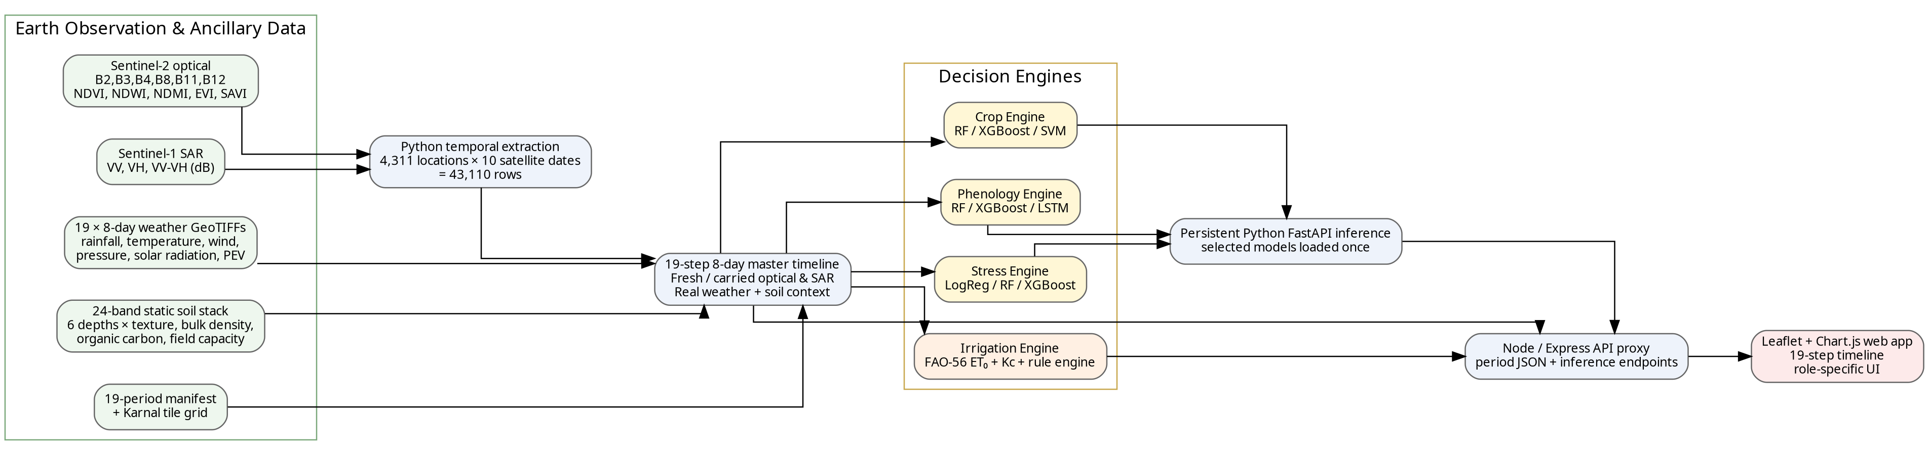
Figure 4.1: System Architecture of AgriSense
The architecture intentionally keeps large preprocessing tasks outside the live request path. Period JSON files and indexed temporal data are prepared in advance, while model inference loads only the required field history for a prediction. This design reduces repeated disk/model loading and supports future migration to PostGIS, object storage and tiled raster services without replacing the user interface.

4.3 System Flow Diagram
The operational flow begins with real data acquisition and preprocessing, followed by temporal-table generation and master-period construction. Model inference and irrigation computation are then executed for the selected field and period. The final stage is role-aware visualization and export.
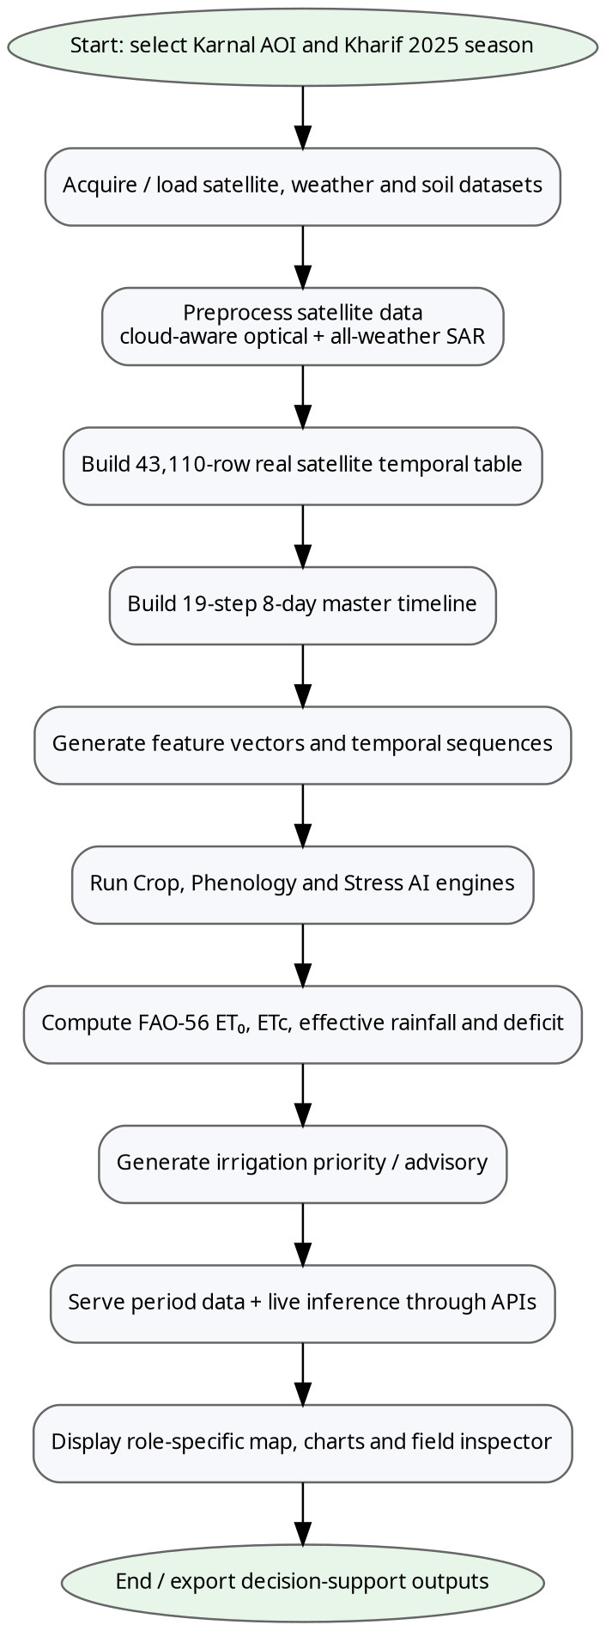
Figure 4.2: System Flow Diagram

4.4 UML Diagrams
4.4.1 Use Case Diagram
The use case diagram defines the interaction of seven stakeholder roles with the AgriSense platform. Farmers are intentionally restricted to assigned demo plots, whereas officers and analysts receive broader regional and technical views.
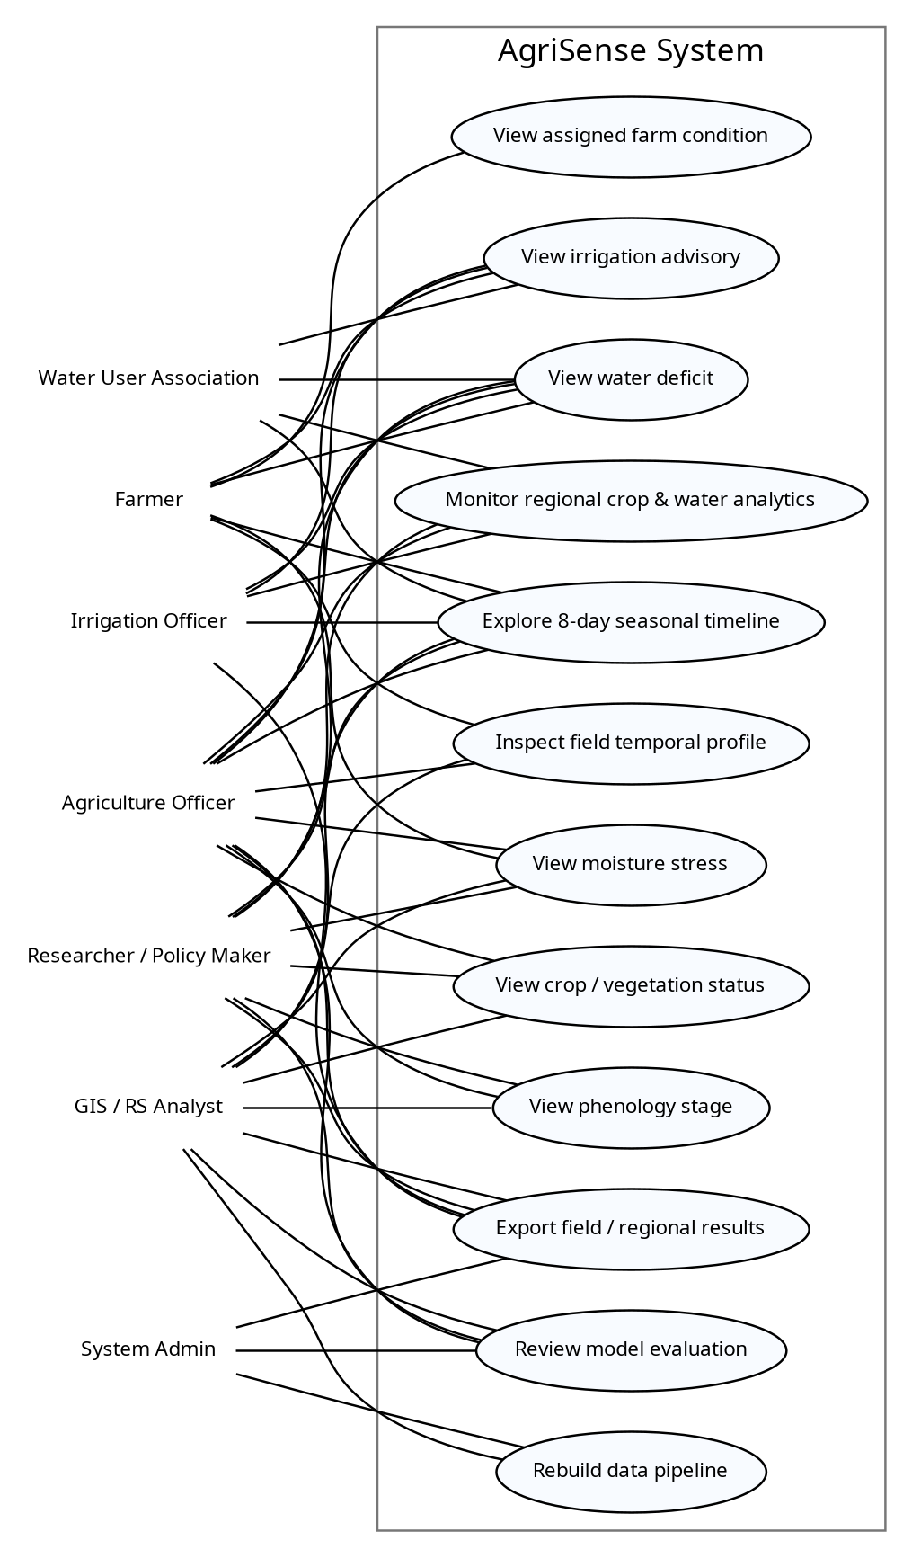
Figure 4.3: UML Use Case Diagram

4.4.2 Activity Diagram
The activity model captures the processing path for a selected master period. The key branch is satellite availability: current measurements are used when fresh, while optical and SAR streams are carried independently from their most recent valid source date when necessary.
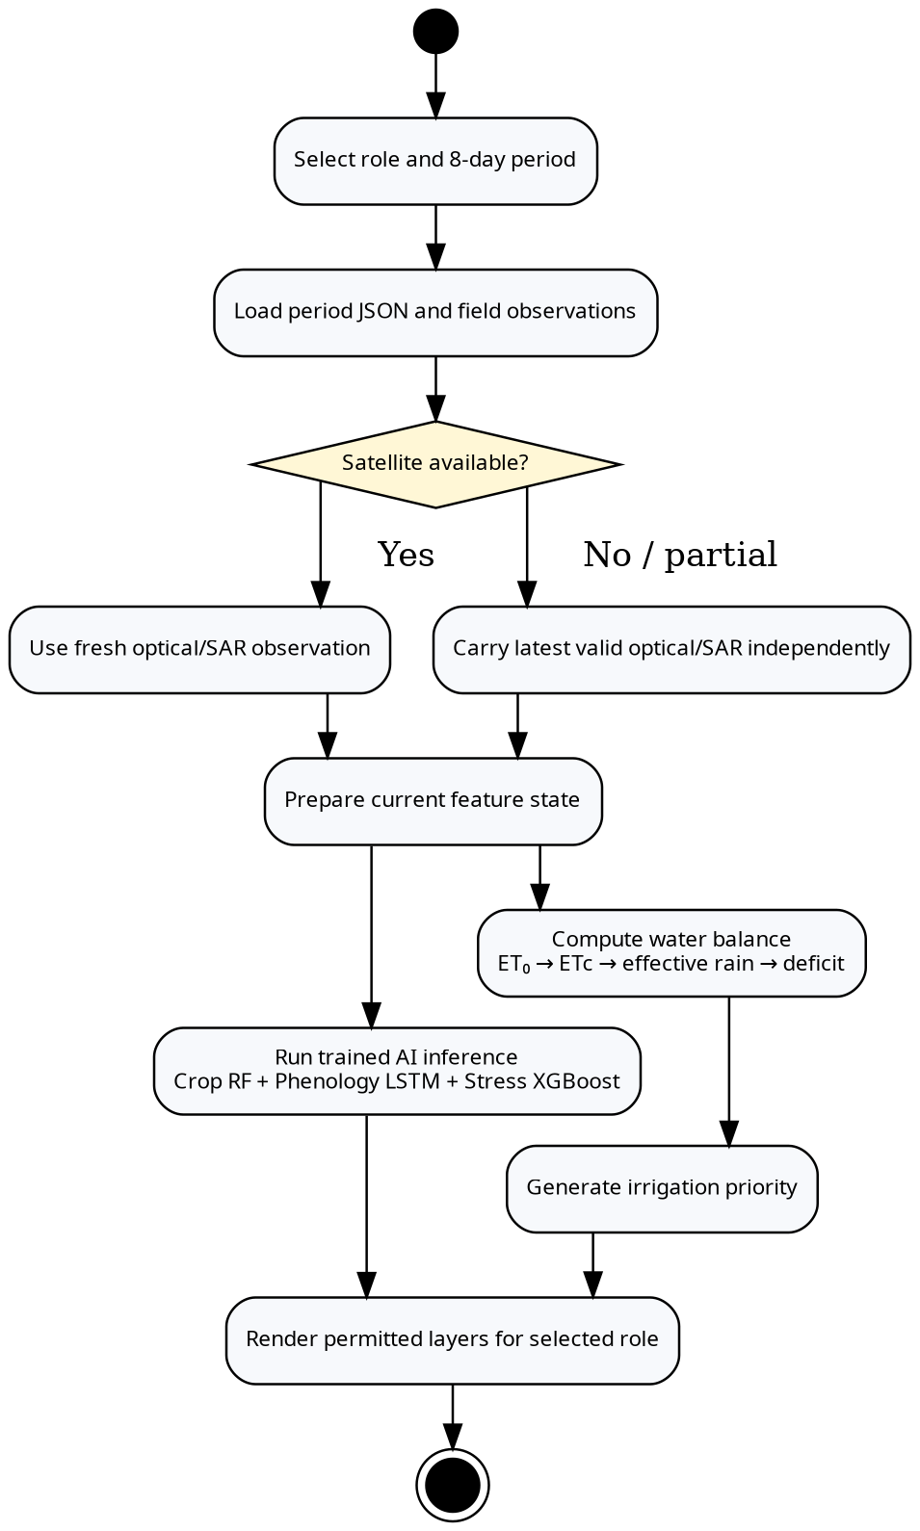
Figure 4.4: UML Activity Diagram

4.4.3 Sequence Diagram
The sequence diagram represents a live field-assessment request. The browser first loads the selected period from Node/Express, then requests model inference. Node proxies the request to the persistent Python service, which calls the in-memory Crop RF, Phenology LSTM and Stress XGBoost models and returns probabilities and labels.
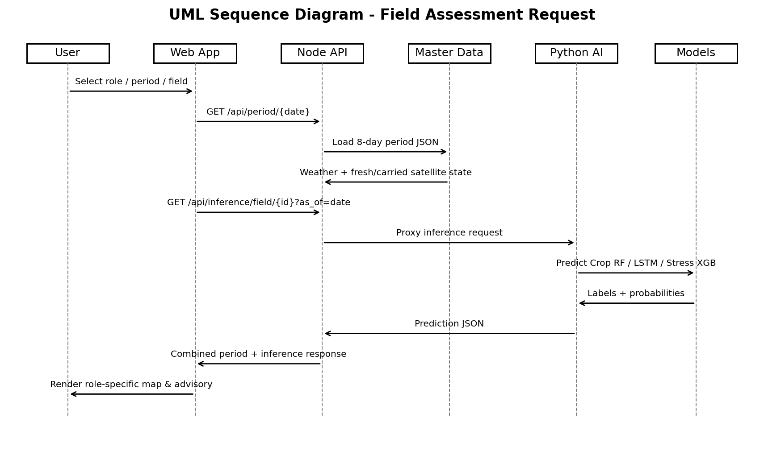
Figure 4.5: UML Sequence Diagram

4.4.4 Class Diagram
The class diagram presents the principal domain entities used by the implementation: a field/observation unit, master period, satellite observation, weather state, model prediction, irrigation advisory and user role. The implementation is file- and JSON-oriented rather than database-backed, but these classes provide a direct path to a future relational or spatial database schema.
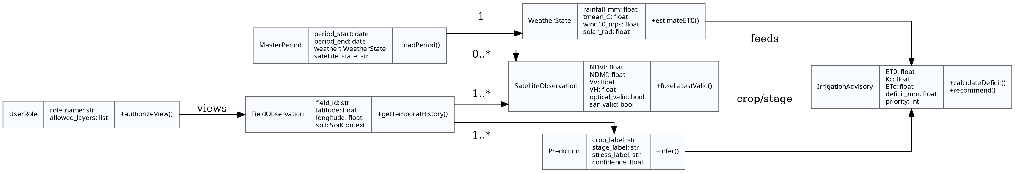
Figure 4.6: UML Class Diagram

4.5 Project Timeline
Table 4.1: Project Development Timeline Summary
Phase | Activity | Duration | Week No.
Phase 1 | Problem definition and literature review | 1 week | Weeks 1-2
Phase 2 | GEE data design and Karnal satellite extraction | 2 weeks | Weeks 2-4
Phase 3 | Real temporal table generation and QA | 1 week | Weeks 4-5
Phase 4 | Crop / phenology / stress model experiments | 2 weeks | Weeks 5-7
Phase 5 | 8-day weather and soil integration | 2 weeks | Weeks 6-8
Phase 6 | Web application and role-specific UI | 2 weeks | Weeks 7-9
Phase 7 | Persistent Python inference integration | 2 weeks | Weeks 8-10
Phase 8 | Testing, report preparation and presentation | 2 weeks | Weeks 10-12

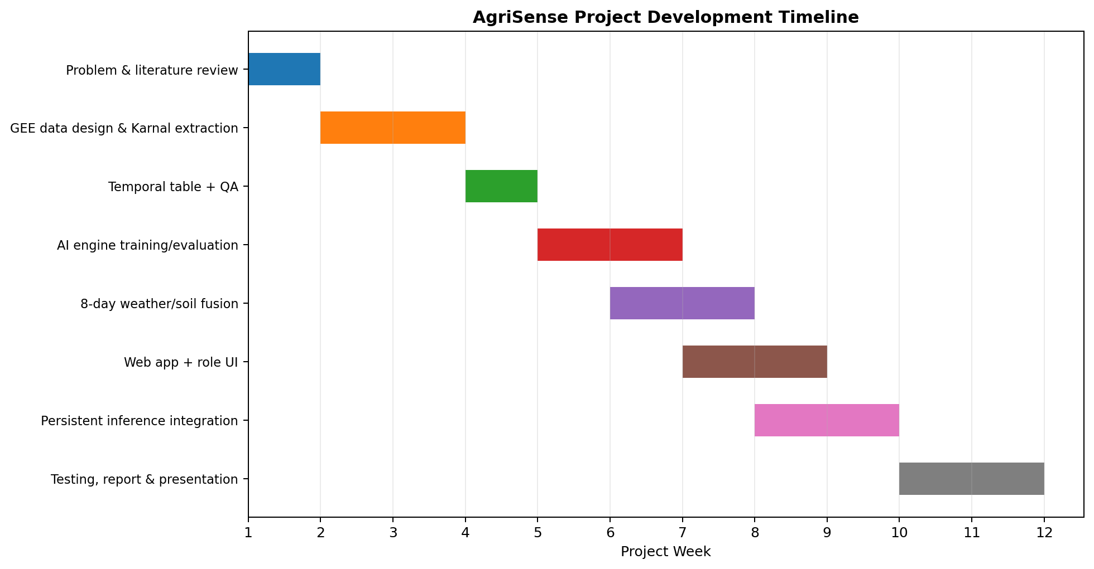
Figure 4.7: Project Development Timeline

CHAPTER 5
METHODOLOGY
5.1 Introduction
The AgriSense methodology is organized as a provenance-aware multi-source temporal pipeline. It begins with real satellite, weather and soil data, creates a consistent seasonal table, extracts tabular and sequence features, evaluates multiple machine-learning models, and connects the selected models to a persistent inference API. The irrigation engine remains physics/rule based so its assumptions are transparent.
5.2 Proposed Methodology
5.2.1 Study Area and Seasonal Window
Karnal District, Haryana is used as the pilot study area. The implemented demonstration focuses on the Kharif 2025 season. The old satellite download covers ten composite start dates: 1 June, 17 June, 3 July, 19 July, 4 August, 20 August, 5 September, 21 September, 7 October and 23 October 2025. A corrected weather export provides nineteen 8-day periods from 1 June to 23 October 2025.
5.2.2 Data Acquisition
Table 5.1: AgriSense Data Sources and Native Resolution
Source | Origin | Temporal / Spatial Context | Variables
Sentinel-2 optical | Old GEE export | ~16-day dates; pixel features at 10/20 m source scale | B2, B3, B4, B8, B11, B12, NDVI, NDWI, NDMI, EVI, SAVI
Sentinel-1 SAR | Old GEE export | ~16-day dates; C-band dual polarization | VV, VH, corrected VV-VH dB difference
Weather | New GEE export | 19 × 8-day periods; 5.5 km raster | Rainfall, Tmean/Tmax/Tmin, dew point, wind, pressure, solar radiation, ERA5 PEV, valid flag
Soil | New static stack | 250 m; six depth levels | Texture, bulk density, organic carbon, field capacity
Manifest / tile grid | New GEE export | 19 periods / 24-tile export grid | Period dates and export metadata

5.2.3 Satellite Temporal Table Construction
The old download contains 110 satellite GeoTIFFs spanning ten dates. Eighty-eight TIFFs contain the full 14-band optical+SAR layout and twenty-two contain only the three SAR bands. The temporal builder detects GeoTIFF band descriptions and supports both layouts. For each of the 4,311 fixed Karnal locations, it samples whichever tile contains the coordinate and writes a canonical row with missing optical variables left as NaN when they are not observed.
The original first-script ratio feature is not used for modelling because Sentinel-1 GRD values are in dB. The corrected polarization difference is therefore computed as:
VV_VH_ratio_dB = VV_dB - VH_dB
The resulting table contains 43,110 rows (4,311 locations × 10 dates). Sensor-validity masks are retained as explicit features. EVI values outside the plausible range [-1, 1] are converted to missing values before LSTM preprocessing because unstable denominators can produce extreme EVI outliers.
5.2.4 19-Step 8-Day Master Timeline
The application does not resample or invent satellite imagery at 8-day intervals. Instead, each 8-day master period loads real weather for that interval and identifies the most recent valid optical and SAR records on or before the period start. Optical and SAR are carried independently. Thus, a period can legitimately show 'OPT 16d OLD' and 'SAR FRESH'. The source date and age are shown in the user interface.
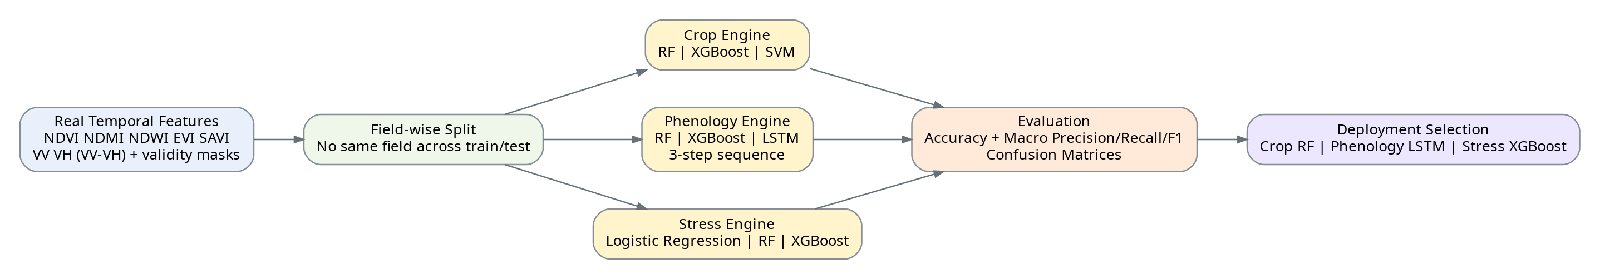
Figure 5.1: AI and Data-Fusion Pipeline
5.2.5 Crop Engine
The Crop Engine compares Random Forest, XGBoost and RBF-SVM using optical indices and corrected SAR features. The current labels are limited and derived, with the prototype classification task dominated by an Unclassified class and a smaller Paddy (Rice) class. Because of this label limitation, the confusion matrices demonstrate pipeline behaviour rather than a final multi-crop agronomic benchmark.
5.2.6 Phenology Engine
Two tabular baselines (Random Forest and XGBoost) are compared with a temporal LSTM. The corrected LSTM uses an 11-feature vector: NDVI, NDMI, NDWI, EVI, SAVI, VV, VH, VV-VH dB difference, optical_valid, sar_valid and season_day. Causal forward-fill is used only for previously observed optical values; no future back-fill is allowed. Missing values are imputed using a training-fitted median imputer, then standardized using a training-fitted scaler.
Three satellite steps form one LSTM input sequence. Fields are split by field_id into 3,017 training fields, 647 validation fields and 647 held-out test fields. Since independent stage labels are not yet available, presentation-only stage targets are derived from the real NDVI trajectory. The five output classes are Sowing/Planting, Vegetative, Flowering, Grain Filling and Maturity.
5.2.7 Moisture-Stress Engine
Logistic Regression, Random Forest and XGBoost are compared for moisture-stress classification. The input features use the same optical/SAR snapshot family as the Crop Engine. The current stress labels are highly imbalanced and derived, so macro metrics are reported alongside accuracy and the evaluation status is explicitly marked as prototype.
5.2.8 Irrigation Engine
The irrigation component uses a transparent FAO-style water balance rather than a black-box classifier. An 8-day reference evapotranspiration estimate is calculated from temperature, dew point, wind, surface pressure and solar radiation following the FAO-56 Penman-Monteith formulation [3]. Crop evapotranspiration is computed as ETc = Kc × ET₀. Effective rainfall is represented by a simple prototype fraction of period rainfall, and the irrigation deficit is calculated as the positive remainder after effective rainfall.
ETc = Kc × ET₀
Peff = 0.80 × Rainfall
Deficit = max(0, ETc - Peff)
The deficit is mapped to Low, Medium and High priority thresholds, with an escalation when the current NDMI-derived moisture signal is very low. This engine is intentionally labelled prototype until it is compared against observed irrigation events, root-zone soil moisture or trusted water-delivery records.
5.2.9 Persistent Model Inference
The deployment layer selects Random Forest for crop prediction, LSTM for temporal phenology and XGBoost for stress prediction. A FastAPI service loads the serialized model artifacts, encoders, LSTM imputer and scaler once during startup. The Node/Express server proxies browser requests to the Python service and blocks the private_models directory from public static access. This separates web delivery from Python ML execution and avoids reloading large model objects for every field click.
5.2.10 Role-Specific User Interface
The Agriculture Officer receives the complete crop, stage, stress, deficit, advisory, QA and model-evaluation interface. The Irrigation Officer and WUA views are limited to deficit and advisory functions. Farmer View displays only two assigned demo observation points and hides technical pipeline/model controls. Policy/Research views emphasize regional seasonal summaries. These restrictions are currently presentation-level controls; production use will require authenticated server-side authorization.

5.3 Data and API Schema
Table 5.2: Real Satellite Temporal Table Schema
Field | Type | Description
field_id | String | Stable observation / field identifier
period_start | Date | Real old-satellite composite start date
latitude, longitude | Float | WGS84 coordinate of sample location
NDVI, NDMI, NDWI, EVI, SAVI | Float | Optical vegetation/moisture indices; may be missing
VV, VH | Float dB | Sentinel-1 backscatter
VV_VH_ratio_dB | Float dB | Corrected polarization difference VV - VH
optical_valid | 0/1 | Whether valid optical data exist for this row
sar_valid | 0/1 | Whether valid SAR data exist for this row

Table 5.3: AI Engine Configuration
Engine | Models | Input | Deployment / Status
Crop Engine | RF / XGBoost / RBF-SVM | EVI, NDMI, NDVI, NDWI, SAVI, VV, VH, VV-VH dB | Selected deploy: Random Forest
Phenology Engine | RF / XGBoost / LSTM | LSTM: 11 features × 3 time steps | Selected deploy: LSTM
Stress Engine | Logistic Regression / RF / XGBoost | Optical indices + SAR features | Selected deploy: XGBoost
Irrigation Engine | FAO-style water balance + rules | Weather, crop/stage, Kc, rainfall | No confusion matrix; requires independent validation

Table 5.4: Data and API Endpoint Schema
Method | Endpoint | Purpose
GET | /api/data | Load master metadata, fields and GeoJSON
GET | /api/period/{periodStart} | Load one 8-day period and all field records
GET | /api/field-timeline/{fieldId} | Load complete 19-step field timeline
GET | /api/model-evaluation | Load evaluation metrics and confusion matrices
GET | /api/inference/health | Check persistent Python model readiness
GET | /api/inference/models | List selected deployment models
GET | /api/inference/field/{fieldId}?as_of=YYYY-MM-DD | Return Crop RF, Phenology LSTM and Stress XGBoost predictions
POST | /api/run-pipeline | Rebuild master period data from local inputs

CHAPTER 6
PROJECT IMPLEMENTATION AND RESULT
6.1 Introduction
This chapter documents the implemented Karnal prototype and reports only results supported by the current data artifacts. The system successfully integrates the complete 43,110-row real satellite temporal table, nineteen real 8-day weather files, a 24-band soil stack, model-evaluation artifacts, a seasonal web application and a persistent model-inference service. Results are divided into data-pipeline observations, application implementation and prototype ML evaluation.
6.2 System Implementation
6.2.1 Real Satellite and Weather Integration
The variable-band temporal builder processed 110 satellite TIFFs. Raster layout QA identified 88 full 14-band files and 22 three-band SAR-only files. This confirms that missing optical bands on specific dates are a property of sensor/scene availability rather than file corruption. The pipeline therefore standardizes every record to the same output schema and records missing optical values as NaN.
Table 6.1: Satellite Temporal Coverage by Period
Period Start | Locations | Optical Valid | SAR Valid
2025-06-01 | 4,311 | 100.00% | 100.00%
2025-06-17 | 4,311 | 31.18% | 100.00%
2025-07-03 | 4,311 | 1.62% | 100.00%
2025-07-19 | 4,311 | 0.00% | 100.00%
2025-08-04 | 4,311 | 0.00% | 100.00%
2025-08-20 | 4,311 | 25.68% | 100.00%
2025-09-05 | 4,311 | 99.98% | 100.00%
2025-09-21 | 4,311 | 100.00% | 100.00%
2025-10-07 | 4,311 | 100.00% | 100.00%
2025-10-23 | 4,311 | 41.89% | 100.00%

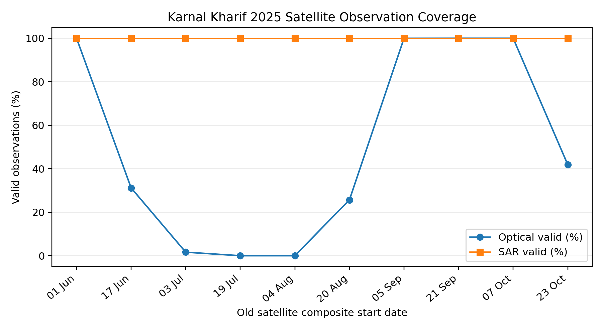
Figure 6.1: Karnal Kharif 2025 Satellite Observation Coverage
The coverage curve explains the value of SAR-optical fusion. On 19 July and 4 August, no valid optical observations are available for the sampled locations, while SAR remains fully available. On 3 July, optical validity is only 1.62%. The application therefore carries the most recent previous optical measurement where appropriate but still uses fresh Sentinel-1 VV/VH from the current satellite period.
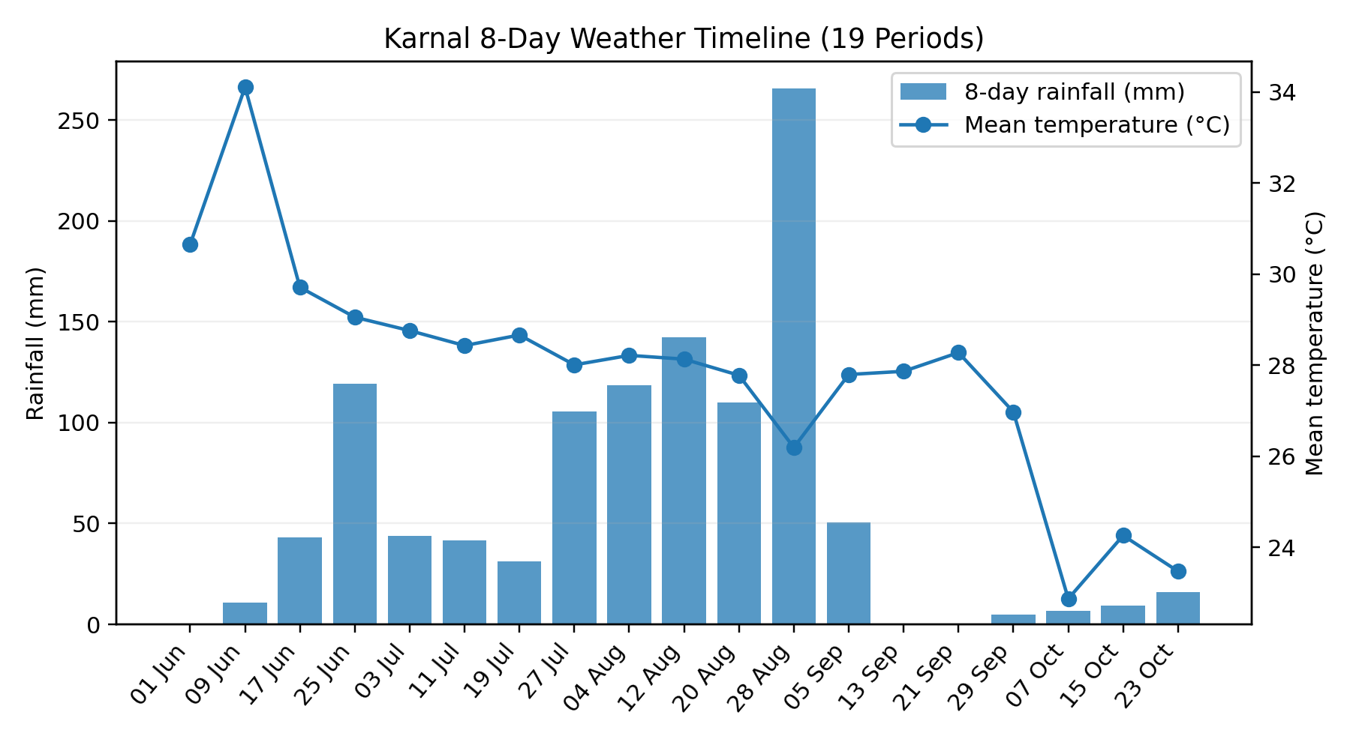
Figure 6.2: 8-Day Weather Timeline
All nineteen weather periods from 1 June through 23 October 2025 are present. The 8-day master timeline uses these files to update rainfall and atmospheric demand twice as frequently as the approximately 16-day satellite schedule. The soil stack remains static and contributes 24 bands across six depths.
6.2.2 Web Application and Role-Specific Interface
The browser application uses Leaflet for map interaction and Chart.js for temporal/summary graphics. A master-period control provides previous/next navigation, a slider, date selection and automatic seasonal playback. The satellite status chip distinguishes fresh, carried, mixed or unavailable conditions and tracks optical and SAR separately. Role-specific UI filtering reduces information overload and demonstrates how the same analytical backend can support multiple stakeholder workflows.
PLACEHOLDER - INSERT FINAL AGRICULTURE OFFICER DASHBOARD SCREENSHOT
Figure 6.6: Application Screenshot - Agriculture Officer Dashboard
PLACEHOLDER - INSERT FINAL IRRIGATION OFFICER DASHBOARD SCREENSHOT
Figure 6.7: Application Screenshot - Irrigation Officer Dashboard
PLACEHOLDER - INSERT FINAL FARMER VIEW SCREENSHOT
Figure 6.8: Application Screenshot - Farmer View
PLACEHOLDER - INSERT FINAL AI MODEL EVALUATION SCREENSHOT
Figure 6.9: Application Screenshot - AI Model Evaluation
6.2.3 Persistent AI Inference
The deployment package uses a local FastAPI service on a separate Python process. The service loads crop_engine__random_forest.joblib, stress_engine__xgboost.joblib, phenology_lstm.keras and their encoders/preprocessing artifacts once at startup. Field-level inference queries reconstruct the latest valid optical and SAR feature state as of the selected 8-day master date; the LSTM additionally consumes the causal field history up to that date. This replaces hard-coded display labels with actual serialized-model predictions while retaining the warning that the models were trained on prototype labels.

6.3 Performance Evaluation
Table 6.2: Prototype Model Performance Summary
Engine | Model | Accuracy | Macro Precision | Macro Recall | Macro F1 | Evaluation Status
Crop Engine | Random Forest | 100.00% | 1.000 | 1.000 | 1.000 | Prototype evaluation on derived/pseudo labels
Crop Engine | XGBoost | 100.00% | 1.000 | 1.000 | 1.000 | Prototype evaluation on derived/pseudo labels
Crop Engine | SVM RBF | 99.65% | 0.965 | 0.998 | 0.981 | Prototype evaluation on derived/pseudo labels
Phenology Engine | Random Forest | 100.00% | 1.000 | 1.000 | 1.000 | Prototype evaluation on derived/pseudo labels
Phenology Engine | XGBoost | 99.77% | 0.997 | 0.997 | 0.997 | Prototype evaluation on derived/pseudo labels
Phenology Engine | LSTM | 80.89% | 0.740 | 0.748 | 0.740 | Prototype field-group temporal evaluation on derived/pseudo NDVI labels
Stress Engine | Logistic Regression | 98.96% | 0.666 | 0.895 | 0.733 | Prototype evaluation on derived/pseudo labels
Stress Engine | Random Forest | 99.77% | 0.999 | 0.800 | 0.874 | Prototype evaluation on derived/pseudo labels
Stress Engine | XGBoost | 100.00% | 1.000 | 1.000 | 1.000 | Prototype evaluation on derived/pseudo labels

The tabular Crop and Phenology baselines achieve extremely high prototype scores because their targets are derived from the same limited feature/label process and are not independent field observations. These numbers therefore should not be interpreted as expected real-world agronomic accuracy. The temporal LSTM is a more demanding test because it uses grouped field splits and five trajectory-derived stage classes; it achieves 80.89% accuracy and a macro-F1 of 0.740 on 647 held-out fields.
The Stress Engine results are also affected by severe label imbalance: the current dataset contains very few Moderate Stress examples compared with Severe Stress. Accuracy can therefore appear high even when minority-class behaviour is weak. Macro-F1 and the confusion matrix are included to make this imbalance visible.
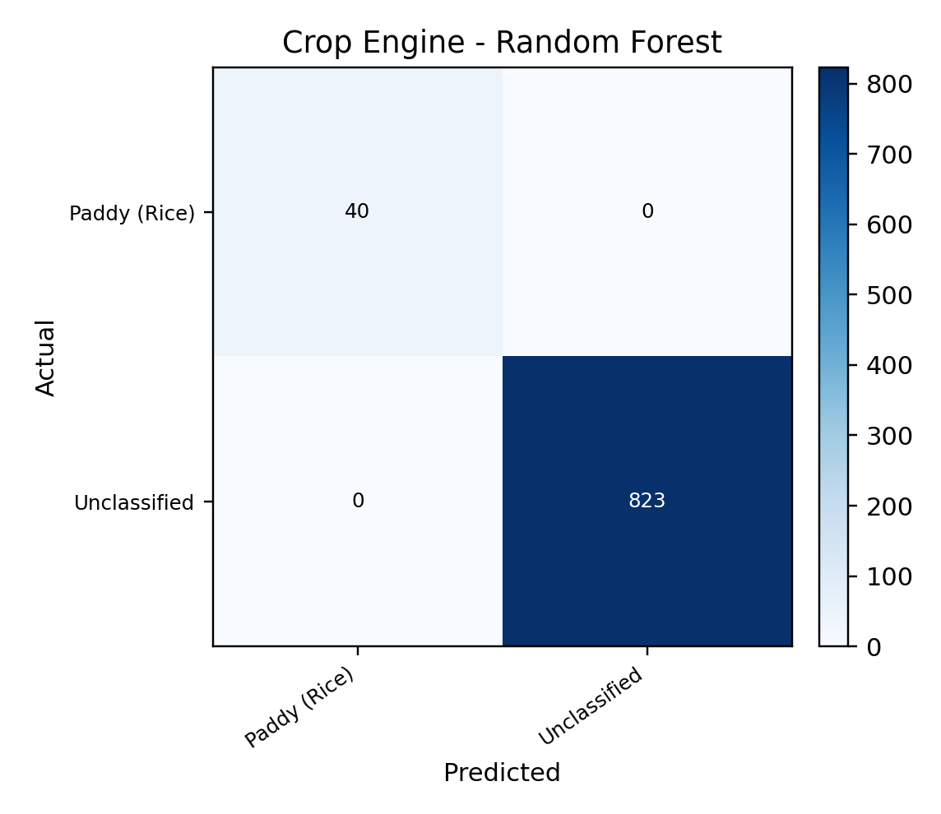
Figure 6.3: Crop Engine - Random Forest Confusion Matrix
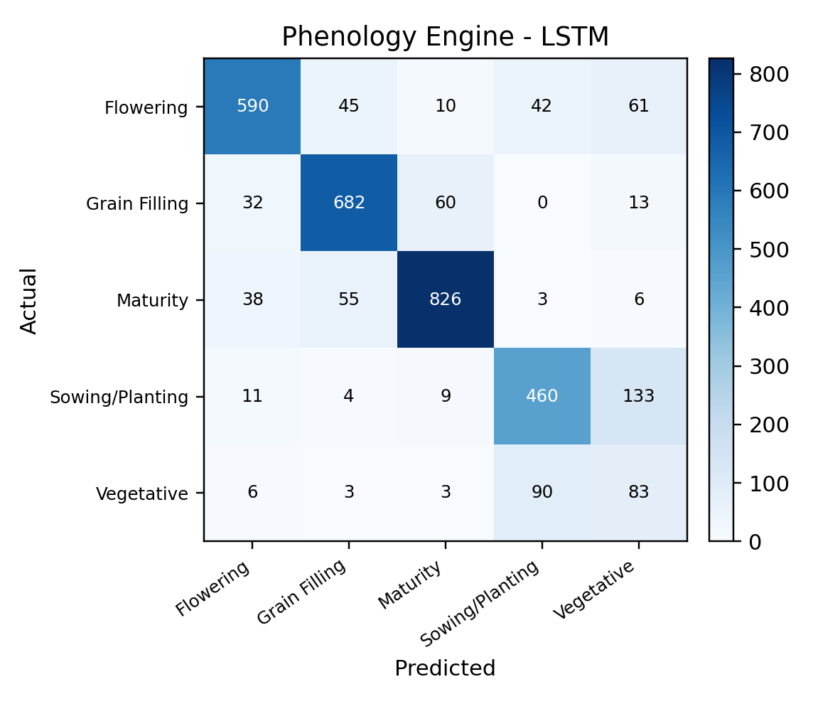
Figure 6.4: Phenology Engine - LSTM Confusion Matrix
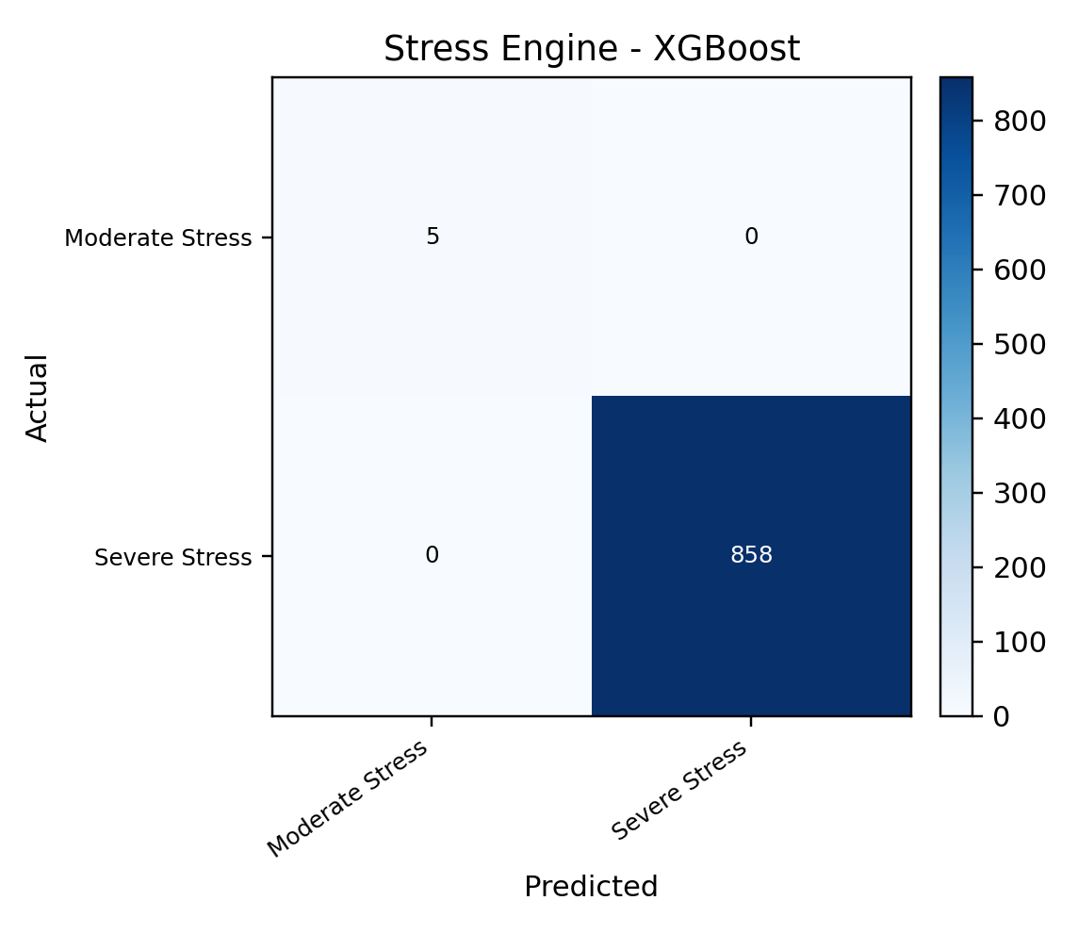
Figure 6.5: Stress Engine - XGBoost Confusion Matrix
Table 6.3: Result Interpretation and Validation Status
Component | Current Result | Interpretation
Satellite data | 43,110 real temporal rows; 100% SAR on all 10 dates | Real observation / QA result
Weather data | 19 of 19 required 8-day periods available | Real observation / QA result
Soil data | 24 bands at six depths | Real static ancillary data
Crop RF | 100% prototype accuracy on two derived classes | Implementation check only; not independent crop validation
Phenology LSTM | 80.89% accuracy; macro-F1 0.740; 647 held-out fields | Temporal prototype evaluation on NDVI-derived pseudo stages
Stress XGBoost | 100% prototype accuracy on highly imbalanced derived labels | Not evidence of independent stress-detection accuracy
Irrigation advisory | 8-day FAO-style deficit and priority generated | Prototype rule; no confusion matrix or field validation yet
Application performance | Interactive local demo and persistent model loading implemented | Formal latency/concurrency benchmarking not yet completed

The most defensible result of the current project is the completed, provenance-aware data and application pipeline. It correctly handles sensor gaps, retains real acquisition dates, combines 8-day weather with slower satellite observations, produces live model inference, and exposes validation caveats to users. Independent ground-truth collection is the primary requirement before the model scores can be converted into publishable agronomic performance claims.

CHAPTER 7
CONCLUSION & FUTURE SCOPE
7.1 Conclusion
AgriSense demonstrates an integrated approach to crop and irrigation intelligence for Karnal using real multi-source geospatial data and AI. The implemented system converts a difficult, irregular sensor archive into a consistent seasonal representation while preserving the provenance of every source. A 43,110-row real satellite temporal table, nineteen 8-day weather periods, and a 24-band soil stack are brought together in a 19-step master timeline. Optical and SAR are treated as independent observation streams, allowing the platform to remain useful during periods in which optical coverage is almost absent.
The project implements four decision engines: crop classification, temporal phenology, moisture-stress classification and irrigation advisory. Random Forest, XGBoost and SVM are compared for crop classification; RF, XGBoost and LSTM are compared for phenology; and Logistic Regression, RF and XGBoost are compared for stress. The selected deployment models are executed through a persistent Python service rather than hard-coded in the browser. The irrigation engine uses an interpretable FAO-style water balance instead of an unvalidated black-box classifier.
A major design contribution is the explicit separation of real observations, derived variables, pseudo labels and prototype advisories. Although several model evaluations show high numerical accuracy, the report does not claim these as independent agronomic validation because the current targets are derived and imbalanced. The present achievement is therefore a technically complete prototype and research pipeline that is ready for the next stage: field-labelled validation.
7.2 Limitations
- Independent ground-truth crop, phenology and moisture-stress labels are not yet available for the 4,311 Karnal locations. Current model labels are derived/pseudo labels.
- The observation units are fixed sample points rather than verified cadastral farm polygons; Farmer View therefore uses demo-assigned points rather than actual ownership boundaries.
- Optical coverage is extremely low or zero on several monsoon dates. Carry-forward preserves continuity but does not replace the information content of a fresh optical observation.
- Weather data are coarse relative to individual fields (approximately 5.5 km exported grid), and soil data are 250 m. These resolutions are appropriate as context but should not be interpreted as within-field measurements.
- The irrigation engine uses generic/prototype Kc and effective-rainfall assumptions and has not yet been validated against observed irrigation deliveries, soil moisture or crop water-use measurements.
- Stress labels are highly imbalanced, making simple accuracy misleading; independent stress measurements are required before operational use.
- Role filtering in the current demonstration is presentation-level. Secure production deployment requires authentication, authorization and server-side data filtering.
- Only one Kharif season is included. Inter-annual and multi-season generalization has not yet been established.
7.3 Future Scope
- Collect independent field labels for crop type, agronomic phenological stage, soil moisture, irrigation events and crop condition. These labels should be spatially separated from training data and used for true external validation.
- Replace point samples with verified field boundaries and compute parcel-level temporal statistics. Use spatial/group cross-validation to prevent neighbouring or repeated field observations from leaking across folds.
- Expand to multiple Kharif and Rabi seasons and evaluate transfer across years, crops and neighbouring districts in Haryana.
- Integrate higher-frequency cloud-robust features, including Sentinel-1 temporal derivatives and future Sentinel-2/Landsat fusion where scientifically justified, while retaining source provenance.
- Calibrate crop coefficients, root-zone properties and effective-rainfall rules for local crops and management practices. Validate irrigation recommendations against measured soil moisture and water-delivery records.
- Add uncertainty and Area-of-Applicability layers so officers can see where model predictions are outside the training domain.
- Move production storage to PostGIS/object storage and serve Cloud Optimized GeoTIFFs through a tile service for scalable regional deployment.
- Implement authenticated role-based access control for Farmer, Officer, WUA, GIS Analyst, Admin and Policy/Research users.
- Investigate advanced sequence architectures such as Temporal CNNs or attention-based temporal models only after sufficient independent labelled sequences are available.
- Link advisories with canal-command constraints, water availability and scheduling optimization so field demand can be aggregated into operational water-release planning.

CHAPTER 8
REFERENCES
[1] European Space Agency, “Sentinel-2 Facts and Figures,” Copernicus Sentinel-2 mission documentation. Sentinel-2 MSI provides 13 spectral bands with 10 m, 20 m and 60 m spatial resolutions and a five-day two-satellite revisit.
[2] J. Muñoz-Sabater et al., “ERA5-Land: a state-of-the-art global reanalysis dataset for land applications,” Earth System Science Data, vol. 13, pp. 4349-4383, 2021. doi: 10.5194/essd-13-4349-2021.
[3] R. G. Allen, L. S. Pereira, D. Raes, and M. Smith, Crop Evapotranspiration - Guidelines for Computing Crop Water Requirements, FAO Irrigation and Drainage Paper 56, FAO, Rome, 1998.
[4] N. Gorelick, M. Hancher, M. Dixon, S. Ilyushchenko, D. Thau, and R. Moore, “Google Earth Engine: Planetary-scale geospatial analysis for everyone,” Remote Sensing of Environment, vol. 202, pp. 18-27, 2017. doi: 10.1016/j.rse.2017.06.031.
[5] D. Mishra et al., “Crop classification by using dual-pol SAR vegetation indices derived from Sentinel-1 SAR-C data,” Environmental Monitoring and Assessment, vol. 195, 115, 2023 (online 2022). doi: 10.1007/s10661-022-10591-x.
[6] I. Ahlawat, H. S. Sheoran, Roohi, G. Dahiya, and P. Sihag, “Analysis of Sentinel-1 data for regional crop classification: a multi-data approach for rabi crops of district Hisar (Haryana),” Journal of Applied and Natural Science, vol. 12, no. 2, pp. 165-170, 2020. doi: 10.31018/jans.vi.2263.
[7] Y. Cai, H. Lin, and M. Zhang, “Mapping paddy rice by the object-based random forest method using time series Sentinel-1/Sentinel-2 data,” Advances in Space Research, vol. 64, no. 11, pp. 2233-2244, 2019. doi: 10.1016/j.asr.2019.08.042.
[8] L. Blickensdörfer et al., “Mapping of crop types and crop sequences with combined time series of Sentinel-1, Sentinel-2 and Landsat 8 data for Germany,” Remote Sensing of Environment, vol. 269, 112831, 2022. doi: 10.1016/j.rse.2021.112831.
[9] E. Woźniak et al., “Multi-temporal phenological indices derived from time series Sentinel-1 images to country-wide crop classification,” International Journal of Applied Earth Observation and Geoinformation, vol. 107, 102683, 2022. doi: 10.1016/j.jag.2022.102683.
[10] M. Meroni et al., “Comparing land surface phenology of major European crops as derived from SAR and multispectral data of Sentinel-1 and -2,” Remote Sensing of Environment, vol. 253, 112232, 2021. doi: 10.1016/j.rse.2020.112232.
[11] C. Liao, J. Wang, B. Shan, J. Shang, T. Dong, and Y. He, “Near real-time detection and forecasting of within-field phenology of winter wheat and corn using Sentinel-2 time-series data,” ISPRS Journal of Photogrammetry and Remote Sensing, vol. 196, pp. 105-119, 2023. doi: 10.1016/j.isprsjprs.2022.12.025.
[12] X. Zhang et al., “Mapping corn and soybean phenometrics at field scales over the United States Corn Belt by fusing time series of Landsat 8 and Sentinel-2 data with VIIRS data,” ISPRS Journal of Photogrammetry and Remote Sensing, vol. 186, pp. 55-69, 2022. doi: 10.1016/j.isprsjprs.2022.01.023.
[13] S. Veysi, A. A. Naseri, S. Hamzeh, and H. Bartholomeus, “A satellite based crop water stress index for irrigation scheduling in sugarcane fields,” Agricultural Water Management, vol. 189, pp. 70-86, 2017. doi: 10.1016/j.agwat.2017.04.016.
[14] C. Raab et al., “Crop type classification in smallholder agriculture of Central and South Asia using Sentinel-1/2 data fusion,” Remote Sensing Applications: Society and Environment, vol. 42, 102007, 2026. doi: 10.1016/j.rsase.2026.102007.
[15] L. Breiman, “Random Forests,” Machine Learning, vol. 45, pp. 5-32, 2001. doi: 10.1023/A:1010933404324.
[16] T. Chen and C. Guestrin, “XGBoost: A Scalable Tree Boosting System,” Proceedings of the 22nd ACM SIGKDD International Conference on Knowledge Discovery and Data Mining, pp. 785-794, 2016. doi: 10.1145/2939672.2939785.
[17] S. Hochreiter and J. Schmidhuber, “Long Short-Term Memory,” Neural Computation, vol. 9, no. 8, pp. 1735-1780, 1997. doi: 10.1162/neco.1997.9.8.1735.
[18] A. Savitzky and M. J. E. Golay, “Smoothing and Differentiation of Data by Simplified Least Squares Procedures,” Analytical Chemistry, vol. 36, no. 8, pp. 1627-1639, 1964. doi: 10.1021/ac60214a047.
[19] M. G. Maponya, A. van Niekerk, and Z. E. Mashimbye, “Pre-harvest classification of crop types using a Sentinel-2 time-series and machine learning,” Computers and Electronics in Agriculture, vol. 169, 105164, 2020. doi: 10.1016/j.compag.2019.105164.
[20] K. H. Tran, H. K. Zhang, J. T. McMaine, X. Zhang, and D. Luo, “10 m crop type mapping using Sentinel-2 reflectance and 30 m cropland data layer product,” International Journal of Applied Earth Observation and Geoinformation, vol. 107, 102692, 2022. doi: 10.1016/j.jag.2022.102692.

