Installation Procedure for MATLAB Software

**Redundant clients- LINUX/MAC systems:**

• Get administrator privileges for the system on which you plan to install MATLAB.

**Download:**

* MAC.dmg (for mac) and LINUX_dvd1.iso & LINUX_dvd2.iso (for LINUX)
* PLP
* License.dat from ***http://repo.iitd.ernet.in/matlab*** into Your Desired Folder (/usr/local/matlabR2017a).

**STEPS:**

To mount iso file to /mnt , run the following commands:

* Login as root (Super User)
* mkdir /mnt
* mount -o loop -t iso9660 LINUX_dvd1.iso first if ask for DVD 2 please mount LINUX_dvd2.iso /mnt or any desired folder
* On mac system just double click on MAC.dmg it will auto mount

**Step 1: Prepare to Install**

* cd /mnt

**Step 2: Start the installer:**

Start installer with given below

**LINUX**

. /install

or

**Macintosh**



**Step 3: Choose to Install Without Using the Internet**

When it starts, the installer displays the following dialog box. Select the Install without using the Internet option and Click OK to proceed with installation.

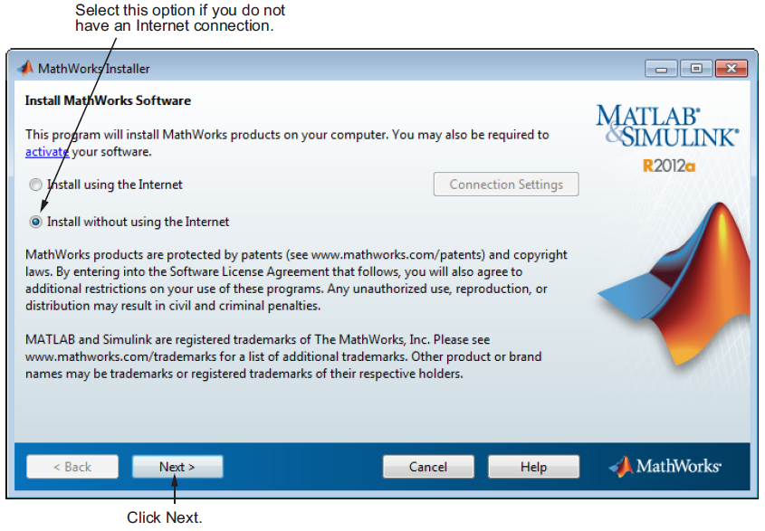

**Step 4: Review the License Agreement**

Review the software licensing agreement and, if you agree to its terms, click Yes.

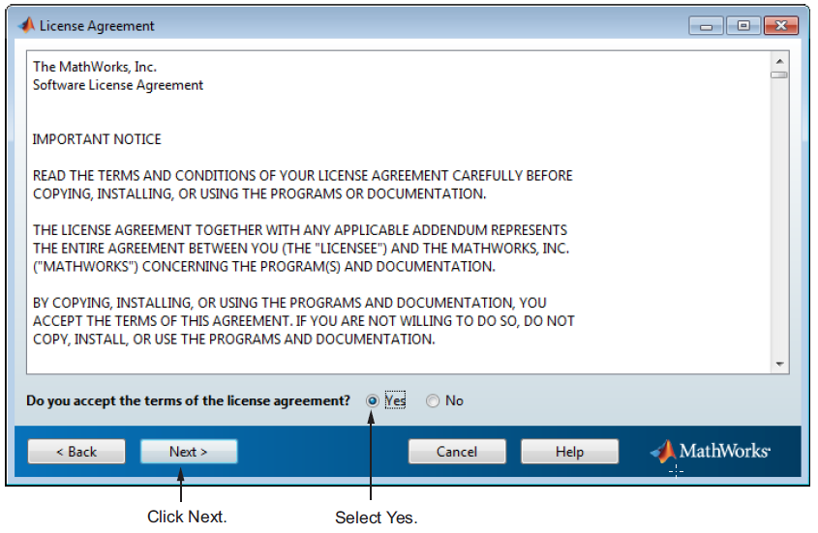

**Step 5: Enter the File Installation Key**

Enter your File Installation Key and Click OK.

13506-23454-49388-60751-28055-41203-30691-47605-16814-52487-16695-00505-31921-03650-32196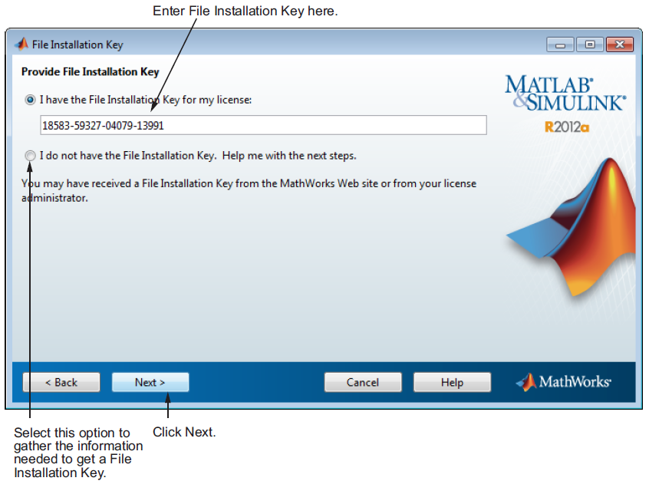

13506-23454-49388-60751-28055-41203-30691-47605-16814-52487-16695-00505-31921-03650-32196

**Step 5: Choose the Installation Type**

In the Installation Type dialog box, specify whether you want to perform a Custom installation and click **Next**.

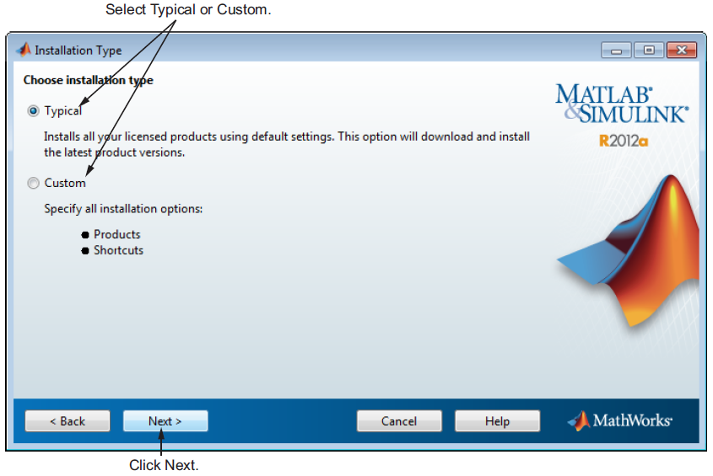

**Step 6: Specify the Installation Folder**

Specify the name of the folder where you want to install MathWorks products.

Accept the default installation folder or click Browse to select a different one.

If the folder doesn’t exist, the installer creates it.

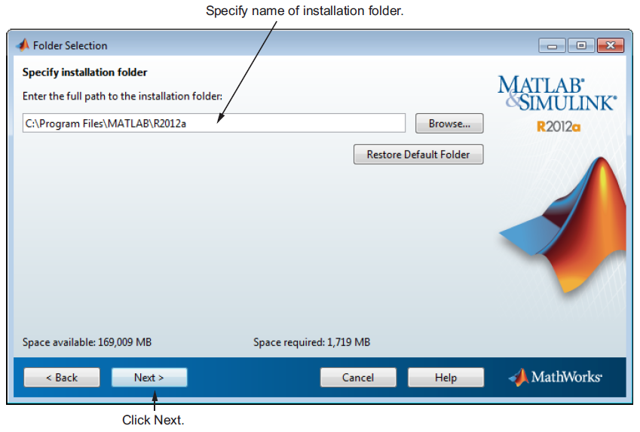

/usr/local/matlabr2017a

**Step 7: Specify Products to Install (Custom Only)**

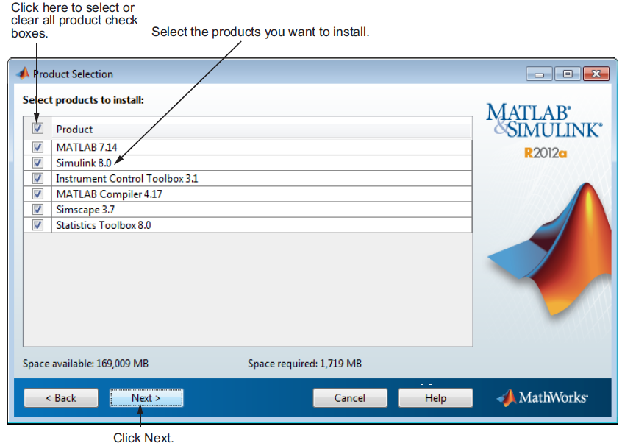

Leave it by default and continue.

**Step 8: Specify the Location of the License File**

Enter the full path of your License File in the text box (or drag and drop the file) and click **Next**.

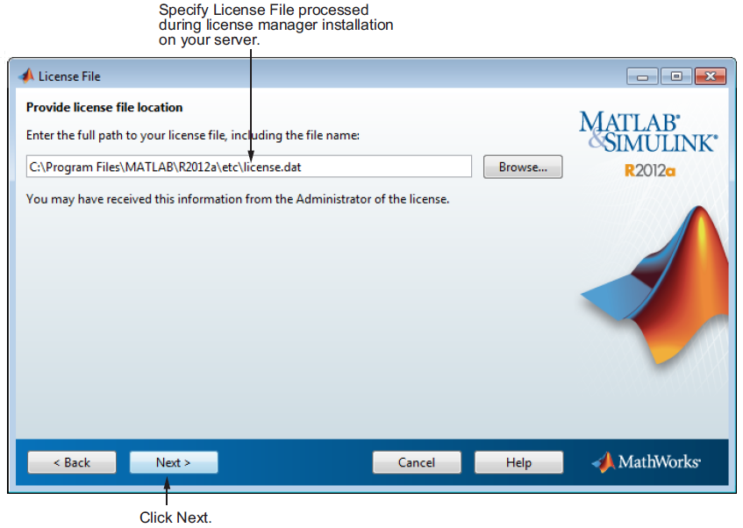

**Step 9: Specify Installation Options (Custom Only)**

**Linux Systems**

On Linux systems, you can specify whether you want to create symbolic links to the matlab and mex scripts. Specify a folder to which you have write access and that is common to all your user’s paths, such as /usr/local/bin .

After selecting installation options, click **Next** to proceed with the installation.

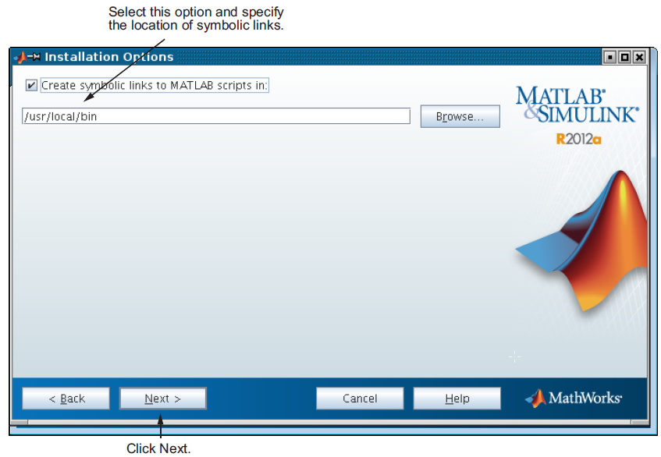

**Step 10: Confirm Your Choices and Begin Copying Files**

Before it begins copying files to your hard disk, the installer displays a summary of your installation choices. To change a setting, click **Back**. To proceed with the installation, click **Install**.

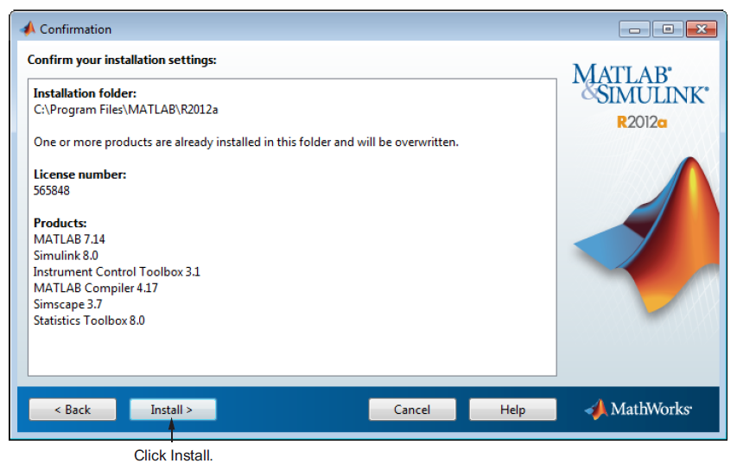

/usr/local/matlabr2017a

As it copies files to your hard drive, the installer displays a status dialog box to show the progress of the installation.

**Step 11: Complete the Installation**

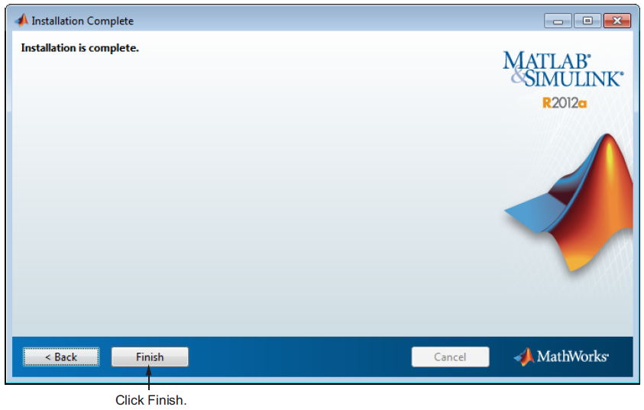

**Step 12: Set Environment Variables**

To edit .bashrc, you will need to open it up in a basic text editor and add the command (depending on your shell):

vi .bashrc

export MLM_LICENSE_FILE=27000@licmngr1.iitd.ernet.in, 27000@licmngr2.iitd.ernet.in,

27000@ licmanager.cse.iitd.ernet.in