Roll no. 31145

Assignment No. 10

Using same collection from assignment 9:
mongo --host 10.10.10.55 --port 27017 te31145_db

db.students.insertMany([
{ name: "Song Joong-ki", department: "CSE", marks: 85, city: "Seoul" },
{ name: "Kim Seon-ho", department: "CSE", marks: 92, city: "Busan" },
{ name: "Ji Chang-wook", department: "IT", marks: 78, city: "Busan" },
{ name: "Lee Do-hyun", department: "IT", marks: 88, city: "Jeju" },
{ name: "Park Hyung-shik", department: "ECE", marks: 95, city: "Seoul" }
]);

Aggregate:

1. Average
db.students.aggregate([{$group: {_id: "$department", avgmarks: {$avg: "$marks"}}}]);
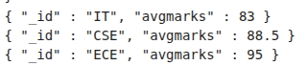

2. Sum
db.students.aggregate([{$group: {_id: "$city", totalstudents: {$sum: 1}}}]);
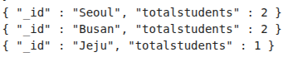

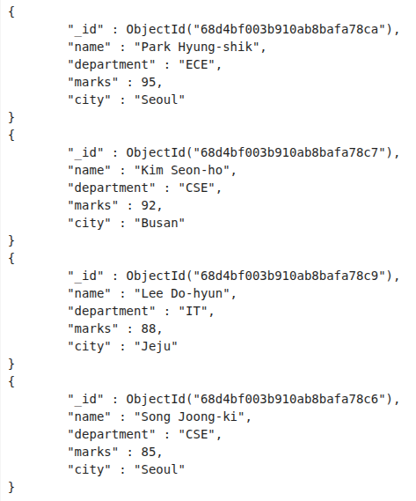
3. Sort
db.students.aggregate([{ $match: { marks: { $gt: 80 } } }, { $sort: { marks: -1 } }]).pretty();

Indexing:
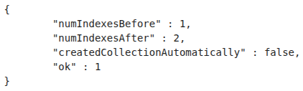

1. Single Field Index
db.students.createIndex({ department: 1 });

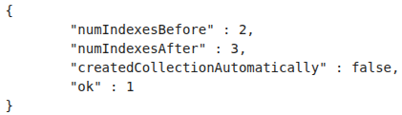
2. Compond Index
db.students.createIndex({ department: 1, marks: -1 });

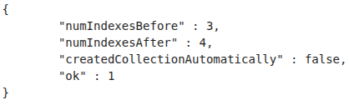
3. Unique Index
db.students.createIndex({ name: 1 }, { unique: true });

4. Checking all Indexes
db.students.getIndexes();

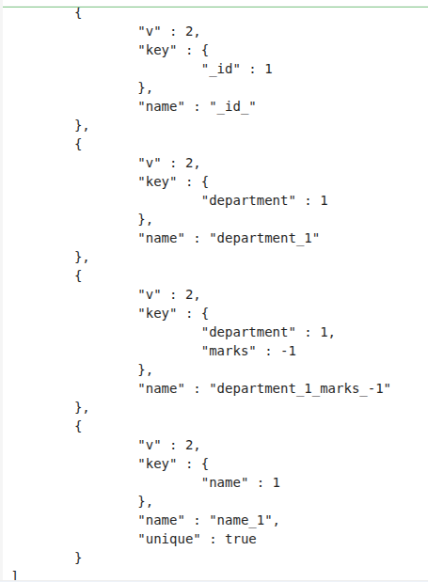

5. Query with index
db.students.find({ department: "CSE" }).explain("executionStats");

