Roll no. 31145

Assignment No. 11

mongo --host 10.10.8.119 --port 27017 te31145_db

db.orders.insertMany([
{_id: 1, customer: "Song Joong-ki", amount: 480},
{_id: 2, customer: "Kim Seon-ho", amount: 300},
{_id: 3, customer: "Kim Tae-hyung", amount: 700},
{_id: 4, customer: "Song Joong-ki", amount: 560},
{_id: 5, customer: "Kim Seon-ho", amount: 120},
]);

var mapFunction = function() {
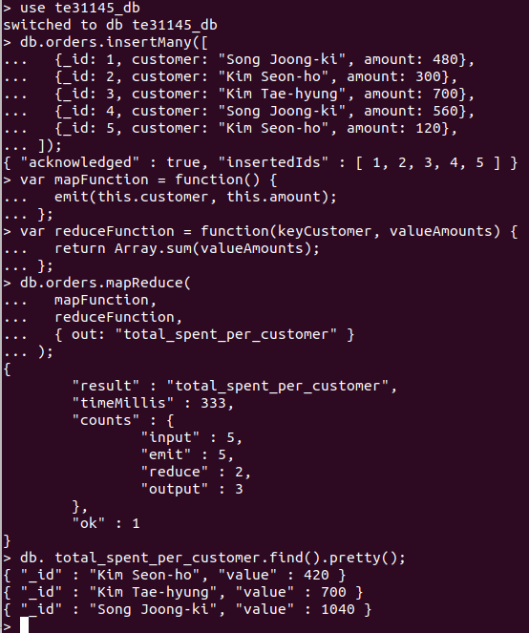
emit(this.customer, this.amount);
};

var reduceFunction = function(keyCustomer, valueAmounts) {
return Array.sum(valueAmounts);
};

db.orders.mapReduce(
mapFunction,
reduceFunction,
{ out: "total_spent_per_customer" }
);

db. total_spent_per_customer.find().pretty();

