Roll no.: 31145

Assignment no.: 2

USE te31145_db;

CREATE TABLE Dept (
dept_id INT PRIMARY KEY,
dept_name VARCHAR(50),
dept_location VARCHAR(20)
);

CREATE TABLE Project (
proj_id INT PRIMARY KEY,
dept_id INT,
proj_name VARCHAR(20),
proj_location VARCHAR(20),
proj_cost INT,
proj_year INT,
FOREIGN KEY (dept_id) REFERENCES dept(dept_id) ON DELETE CASCADE
);

CREATE TABLE Employee (
emp_id INT PRIMARY KEY,
dept_id INT,
emp_fname VARCHAR(20),
emp_lname VARCHAR(20),
emp_position VARCHAR(50),
emp_salary INT,
emp_joinDate DATE,
FOREIGN KEY (dept_id) REFERENCES dept(dept_id) ON DELETE CASCADE
);

1. Insert at least 10 records in the Employee table and insert other tables accordingly.

INSERT INTO Dept VALUES
(1, 'Computer', 'Mumbai'),
(2, 'IT', 'Pune'),
(3, 'HR', 'Delhi'),
(4, 'Marketing', 'Mumbai'),
(5, 'Finance', 'Bangalore')
;

INSERT INTO Employee (dept_id, emp_fname, emp_lname, emp_position, emp_salary, emp_joinDate) VALUES
(1, 'Peter', 'Parker', 'Developer', 55000, '1980-06-15'),
(2, 'Harry', 'Potter', 'Analyst', 60000, '1984-07-22'),
(1, 'Pamela', 'Anderson', 'Developer', 58000, '1983-04-19'),
(3, 'John', 'Doe', 'HR Manager', 75000, '1990-01-10'),
(4, 'Jessica', 'Jones', 'Accountant', 52000, '1987-12-05'),
(2, 'Paul', 'Smith', 'Analyst', 61000, '1986-09-17'),
(1, 'Helen', 'Mirren', 'Team Lead', 70000, '1982-03-20'),
(5, 'Peter', 'Quill', 'Marketing Executive', 48000, '1995-08-12'),
(2, 'Hannah', 'Montana', 'Support', 45000, '1981-11-30'),
(3, 'Philip', 'Fry', 'HR Executive', 50000, '1989-05-23')
;

INSERT INTO Project (proj_id, dept_id, proj_name, proj_location, proj_cost, proj_year) VALUES
(101, 1, 'Alpha', 'Pune', 200000, 2004),
(102, 2, 'Beta', 'Mumbai', 450000, 2005),
(103, 3, 'Gamma', 'Pune', 750000, 2007),
(104, 4, 'Delta', 'Delhi', 150000, 2004),
(105, 5, 'Epsilon', 'Bangalore', 1000000, 2006)
;

2. Display all Employee details with Department ‘Computer’ or ‘IT’ and Employee
first name starting with 'p' or 'h'.

// Method – I

SELECT * FROM Employee e
JOIN Dept d ON d.dept_id = e.dept_id
WHERE (d.dept_name = 'Computer' OR d.dept_name = 'IT') AND (e.emp_fname LIKE 'p%' OR e.emp_fname LIKE 'h%');

// Method – II

SELECT * FROM Employee e
JOIN Dept d ON d.dept_id = e.dept_id
WHERE (d.dept_name IN ('Computer', 'IT')) AND (e.emp_fname LIKE 'p%' OR e.emp_fname LIKE 'h%');

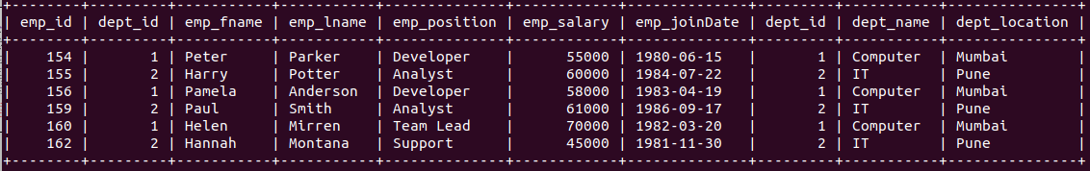

3. List the number of different Employee Positions.

SELECT DISTINCT emp_position FROM Employee;
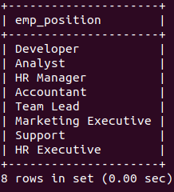

4. Give 10% increase in Salary of the Employee whose joining year is before 1985.

UPDATE Employee
SET emp_salary = emp_salary * 1.1
WHERE YEAR(emp_joinDate) < 1985;
5. Delete Department details which location is ‘Mumbai’.

DELETE FROM Dept
WHERE dept_location = 'Mumbai';

// Before:-
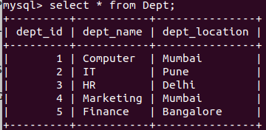

// After:-

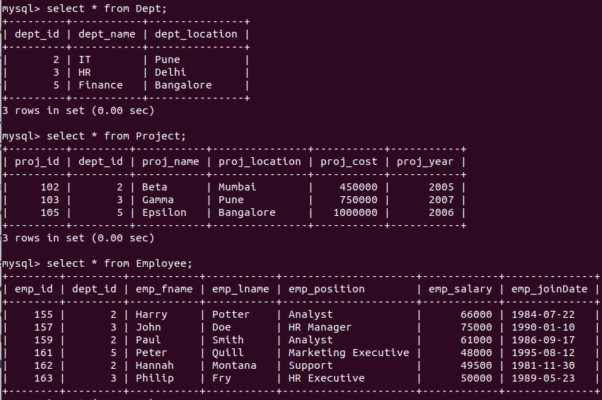

6. Find the names of Projects with location ‘pune’.

SELECT proj_name FROM Project
WHERE proj_location = 'pune' OR proj_location = 'Pune';
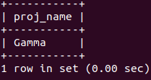

7. Find the project having cost in between 100000 to 500000.

SELECT * FROM Project
WHERE proj_cost >= 100000 AND proj_cost <= 500000;

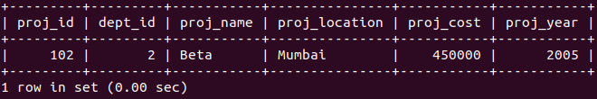
8. Find the project having maximum price and find average of Project cost.

SELECT * FROM Project
WHERE proj_cost = (SELECT MAX(proj_cost) FROM Project);

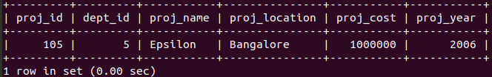

SELECT AVG(proj_cost) AS avg_proj_cost FROM Project;
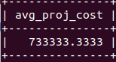

9. Display all employees with Emp _id and Emp name in decreasing order of
Emp_lname

SELECT emp_id, emp_fname, emp_lname
FROM Employee
ORDER BY emp_lname DESC;

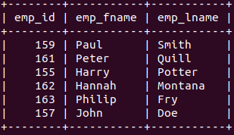

10. Display Proj_name,Proj_location ,Proj_cost of all project started in 2004,2005,2007

SELECT proj_name, proj_location, proj_cost
FROM Project
WHERE proj_year IN (2004, 2005, 2007);
