Roll no.: 31145

Assignment no.: 3

USE te31145_db;

CREATE TABLE Dept (
dept_id INT PRIMARY KEY,
dept_name VARCHAR(50),
dept_location VARCHAR(20)
);

CREATE TABLE Project (
proj_id INT PRIMARY KEY,
dept_id INT,
proj_name VARCHAR(20),
proj_location VARCHAR(20),
proj_cost INT,
proj_year INT,
FOREIGN KEY (dept_id) REFERENCES dept(dept_id) ON DELETE CASCADE
);

CREATE TABLE Employee (
emp_id INT PRIMARY KEY NOT NULL AUTO_INCREMENT,
dept_id INT,
emp_fname VARCHAR(20),
emp_lname VARCHAR(20),
emp_position VARCHAR(50),
emp_salary INT,
emp_joinDate DATE,
FOREIGN KEY (dept_id) REFERENCES dept(dept_id) ON DELETE CASCADE
);

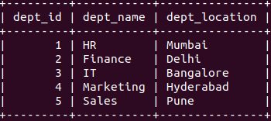

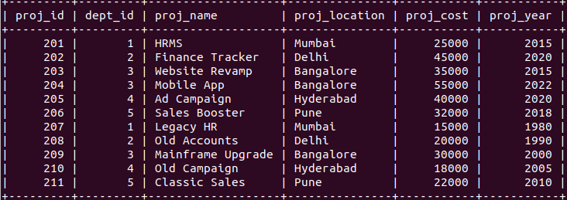
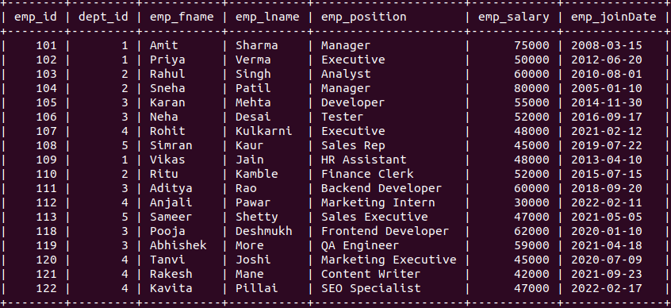

1. Find Employee details and Department details using NATURAL JOIN.

SELECT *
FROM Employee
NATURAL JOIN Dept;

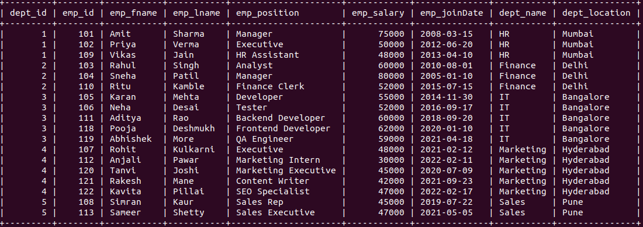

2. Find the emp_fname,Emp_position,location,Emp_JoinDate who have same Dept id.

SELECT E.emp_fname, E.emp_position, D.dept_location, E.emp_joinDate
FROM Employee E
INNER JOIN Dept D ON E.dept_id = D.dept_id;

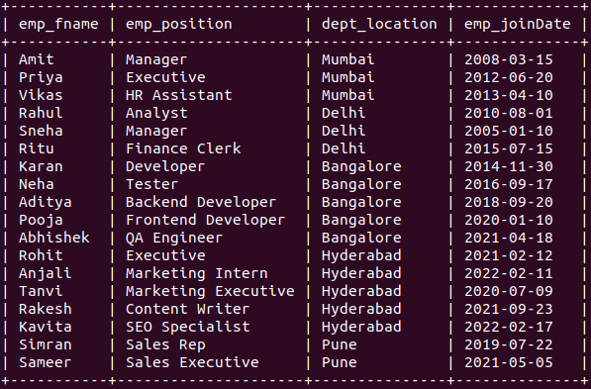

3. Find the Employee details ,Proj_id,Project cost who does not have Project location as
‘Hyderabad’.

SELECT E.*, P.proj_id, P.proj_cost
FROM Employee E
LEFT JOIN Project P ON E.dept_id = P.dept_id
WHERE P.Proj_location <> "Hyderabad";
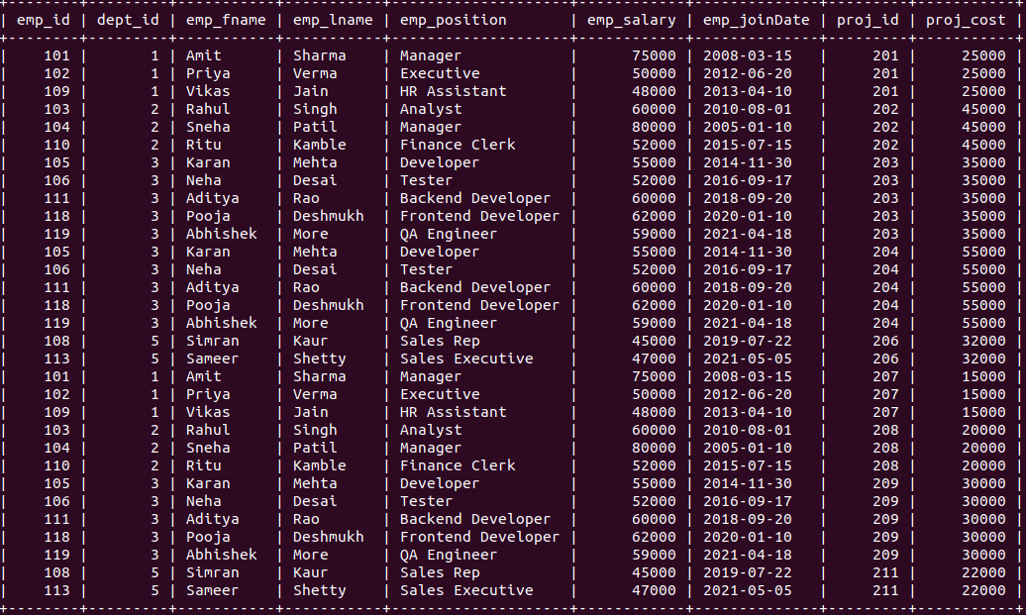
4. Find Department Name ,employee name, Emp_position for which project year is 2020

SELECT D.dept_name, CONCAT(E.emp_fname, ' ', E.emp_Lname) AS emp_name, E.emp_position
FROM Employee E
RIGHT JOIN Dept D ON E.dept_id = D.dept_id
INNER JOIN Project P ON D.dept_id = P.dept_id
WHERE P.proj_year = 2020;

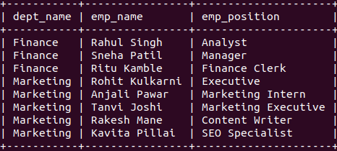

5. Display emp_position, D_name who have Project cost >30000

SELECT DISTINCT E.emp_position, D.dept_name
FROM Employee E
INNER JOIN Dept D ON E.dept_id = D.dept_id
INNER JOIN Project P ON D.dept_id = P.dept_id
WHERE P.proj_cost > 30000;

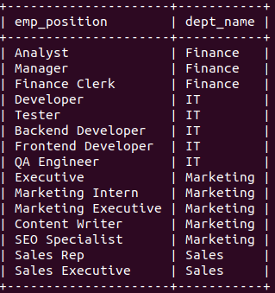

6. Find the names of all the Projects that started in the year 2015.
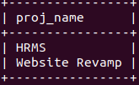
SELECT proj_name FROM Project
WHERE proj_year = 2015;

7. List the Dept_name having no_of_emp=5

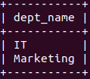
SELECT D.dept_name FROM Dept
WHERE dept_id IN (
SELECT dept_id
FROM Employee
GROUP BY dept_id
HAVING COUNT(emp_id) = 5
);

8. Display the total number of employee who have joined any project before 2009
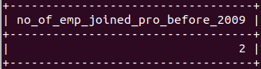
SELECT COUNT(E.emp_id) AS no_of_emp_joined_pro_before_2009
FROM Employee E
JOIN Project P ON P.dept_id = E.dept_id
WHERE YEAR(E.emp_joinDate) < 2009 AND P.proj_year < 2009;

9. Create a view showing the employee and Department details.

CREATE VIEW emp_dept_view AS
SELECT CONCAT(E.emp_fname, ' ', E.emp_lname) AS emp_name, E.emp_position, E.emp_salary, E.emp_joinDate, D.dept_name, D.dept_location
FROM Employee E, Dept D
WHERE E.dept_id = D.dept_id;

SELECT * FROM emp_dept_view;

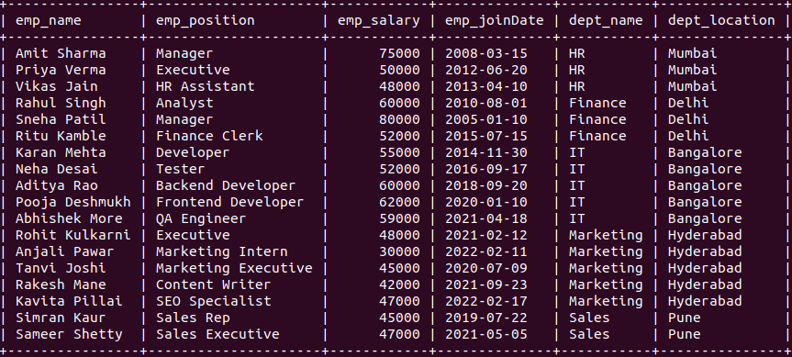

10. Perform Manipulation on simple view-Insert, update, delete, drop view.

CREATE VIEW simple_emp_view AS
SELECT
emp_id,
dept_id,
emp_fname,
emp_lname,
emp_position,
emp_salary,
emp_joinDate
FROM Employee;

SELECT * FROM simple_emp_view;

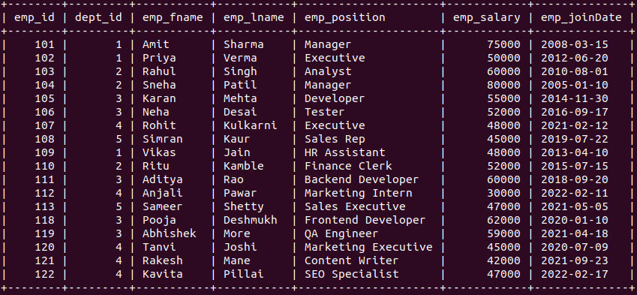

Insert:

INSERT INTO simple_emp_view (dept_id, emp_fname, emp_lname, emp_position, emp_salary, emp_joinDate)
VALUES (1, 'Ravi', 'Sharma', 'Manager', 50000, '2023-06-01');

SELECT * FROM simple_emp_view;
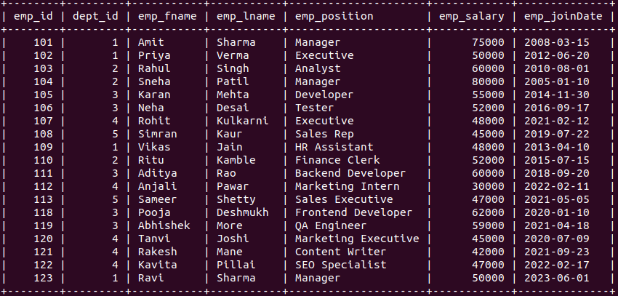

Update:

UPDATE simple_emp_view
SET emp_salary = 65000
WHERE emp_fname = 'Rahul' AND emp_lname = 'Singh';

Delete:

DELETE FROM simple_emp_view
WHERE emp_fname = 'Ritu' AND emp_lname = 'Kamble';

SELECT * FROM Employee WHERE emp_fname IN ('Rahul', 'Ritu');

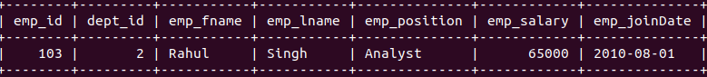

Drop:

DROP VIEW simple_emp_view;

SELECT * FROM simple_emp_view;

