Roll no.: 31145

Assignment no.: 4

USE te31145_db;

CREATE TABLE Borrower (
roll_no INT,
borr_name VARCHAR(50),
date_of_issue DATE,
book_name VARCHAR(50),
status CHAR(1)
);

CREATE TABLE Fine (
roll_no INT,
fine_date DATE,
fine_amt DECIMAL(10, 2)
);

DELIMITER $$

CREATE PROCEDURE ReturnBook (
IN p_rollno INT,
IN p_book_name VARCHAR(50)
)
BEGIN
DECLARE v_date_of_issue DATE;
DECLARE v_status CHAR(1);
DECLARE v_days INT;
DECLARE v_fine_amt DECIMAL(10, 2) DEFAULT 0;
DECLARE exit handler for not found BEGIN
SELECT 'No matching record found.' AS Message;
END;

SELECT date_of_issue, status INTO v_date_of_issue, v_status
FROM Borrower
WHERE roll_no = p_rollno AND book_name = p_book_name;

IF v_status = 'I' THEN
SET v_days = DATEDIFF(CURDATE(), v_date_of_issue);

IF v_days > 30 THEN
SET v_fine_amt = (15*5) + ((v_days-30) * 50);
ELSEIF v_days > 15 THEN
SET v_fine_amt = (v_days-15) * 5;
ELSE
SET v_fine_amt = 0;
END IF;

UPDATE Borrower
SET status = 'R'
WHERE roll_no = p_rollno AND book_name = p_book_name;

IF v_fine_amt > 0 THEN
INSERT INTO Fine (roll_no, fine_date, fine_amt)
VALUES (p_rollno, CURDATE(), v_fine_amt);
END IF;

SELECT 'Book returned successfully.' AS Message, v_fine_amt AS fine;
ELSE
SELECT 'Book already returned.' AS Message;
END IF;
END $$

DELIMITER ;

INSERT INTO Borrower (roll_no, borr_name, date_of_issue, book_name, status)
VALUES (50, 'SJK', '2025-07-03', 'History of Korea', 'I');

SELECT * FROM Borrower;
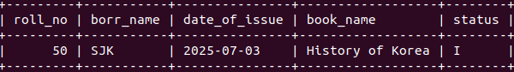

CALL ReturnBook(50, 'History of Korea');
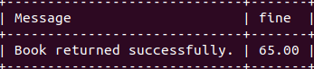

SELECT * FROM Borrower;
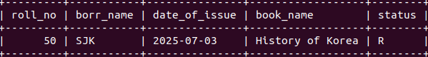

SELECT * FROM Fine;
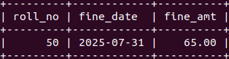

CALL ReturnBook(25, 'Descendents of the Sun');
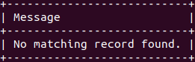

INSERT INTO Borrower (roll_no, borr_name, date_of_issue, book_name, status)
VALUES (16, 'Kim Seon Ho', '2025-07-18', 'Hometown Cha Cha Cha', 'I');

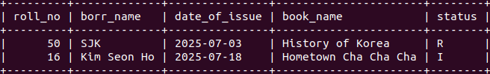

CALL ReturnBook(16, 'Hometown Cha Cha Cha');
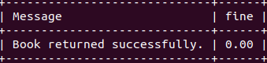

CALL ReturnBook(16, 'Hometown Cha Cha Cha');

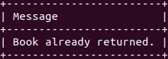

SELECT * FROM Borrower;

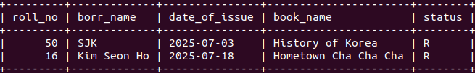

SELECT * FROM Fine;

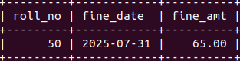

INSERT INTO Borrower (roll_no, borr_name, date_of_issue, book_name, status)
VALUES (3, 'Shaun Murphy', '2025-06-14', 'Good Doctor', 'I');

CALL ReturnBook(3, 'Good Doctor');

SELECT * FROM Borrower;
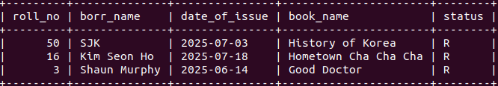

SELECT * FROM Fine;
