Roll no.: 31145

Assignment no.: 5

USE te31145_db;

CREATE TABLE Stud_Marks (
roll_no INT,
name VARCHAR(50) ,
marks INT
);

CREATE TABLE Result (
roll_no INT,
class enum('Distinction', 'First Class', 'Higher Second Class', 'Pass')
);

DELIMITER $$

CREATE PROCEDURE ProcGrade (
IN p_rollno INT
)
BEGIN
DECLARE v_marks INT;
DECLARE v_grade varchar(30);
DECLARE exit handler for not found BEGIN
SELECT 'No matching record found.' AS Message;
END;

SELECT marks INTO v_marks
FROM Stud_Marks
WHERE roll_no = p_rollno;

IF v_marks <= 1500 AND v_marks >= 0 THEN
IF v_marks >= 990 THEN
SET v_grade = 'Distinction';
ELSEIF v_marks >= 900 THEN
SET v_grade = 'First Class';
ELSEIF v_marks >= 825 THEN
SET v_grade = 'Higher Second Class';
ELSE
SET v_grade = 'Pass';
END IF;

INSERT INTO Result (roll_no, class)
VALUES (p_rollno, v_grade);

SELECT 'Student graded successfully.' AS Message, v_grade AS grade;
ELSE
SELECT 'Marks Out of Range.' AS Message;
END IF;
END $$

DELIMITER ;

INSERT INTO Stud_Marks (roll_no, name, marks)
VALUES (50, 'Song Joong Ki', 1450);

SELECT * FROM Stud_Marks;
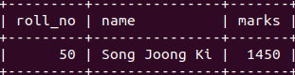

CALL ProcGrade(50);
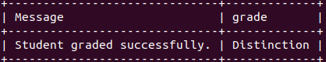

SELECT * FROM Result;
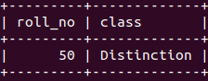

CALL ProcGrade(51);
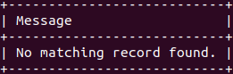

INSERT INTO Stud_Marks (roll_no, name, marks)
VALUES (11, 'Kim Seon Ho', 950);

SELECT * FROM Stud_Marks;

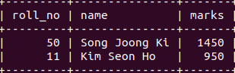

CALL ProcGrade(11);
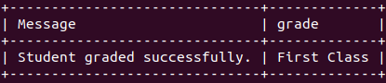

SELECT * FROM Result;

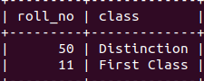

INSERT INTO Stud_Marks (roll_no, name, marks)
VALUES (33, 'Ji Chang-wook', 850);

SELECT * FROM Stud_Marks;
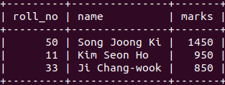

CALL ProcGrade(33);

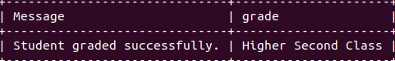

SELECT * FROM Result;
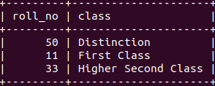

DELIMITER $$

CREATE FUNCTION ReturnGrade (
marks INT
) RETURNS VARCHAR(30)
DETERMINISTIC

BEGIN
DECLARE grade VARCHAR(30);

IF marks > 1500 OR marks < 0 THEN
SET grade = 'Invalid marks';
ELSEIF marks >= 990 THEN
SET grade = 'Distinction';
ELSEIF marks >= 900 THEN
SET grade = 'First class';
ELSEIF marks >= 825 THEN
SET grade = 'Higher second class';
ELSE
SET grade = 'Pass';
END IF;
RETURN grade;
END $$

DELIMITER ;

SELECT * FROM Stud_Marks;

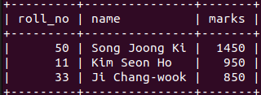

SELECT ReturnGrade(830);
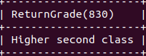

SELECT ReturnGrade(
(SELECT marks FROM Stud_Marks WHERE roll_no = 50)
) AS Grade;

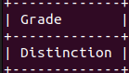

SELECT ReturnGrade(
(SELECT marks FROM Stud_Marks WHERE name = 'Kim Seon Ho')
) AS Grade;

