Roll no.: 31145

Assignment no.: 7

USE te31145_db;

CREATE TABLE Library (
book_id INT PRIMARY KEY NOT NULL,
book_name VARCHAR(100),
author VARCHAR(50),
copies INT
);

CREATE TABLE Library_audit (
audit_id INT AUTO_INCREMENT PRIMARY KEY,
book_id INT,
book_name VARCHAR(100),
author VARCHAR(50),
copies INT,
action_type VARCHAR(10),
action_time TIMESTAMP DEFAULT CURRENT_TIMESTAMP
);

DELIMITER $$

CREATE TRIGGER before_library_update
BEFORE UPDATE ON Library
FOR EACH ROW
BEGIN
INSERT INTO Library_audit(book_id, book_name, author, copies, action_type)
VALUES (OLD.book_id, OLD.book_name, OLD.author, OLD.copies, "UPDATE");
END $$

CREATE TRIGGER before_library_delete
BEFORE DELETE ON Library
FOR EACH ROW
BEGIN
INSERT INTO Library_audit(book_id, book_name, author, copies, action_type)
VALUES (OLD.book_id, OLD.book_name, OLD.author, OLD.copies, "DELETE");
END $$

DELIMITER ;

INSERT INTO Library (book_id, book_name, author, copies) VALUES
(100, 'Crash Landing on You', 'Hyun Bin', 5),
(101, 'It’s Okay to Not Be Okay', 'Kim Soo-hyun', 6),
(102, 'Descendants of the Sun', 'Song Joong-ki', 4),
(103, 'Goblin (Guardian: The Lonely and Great God)', 'Gong Yoo', 5),
(104, 'Itaewon Class (Webtoon Adaptation)', 'Park Seo-joon', 6),
(105, 'Vincenzo', 'Song Joong-ki', 6),
(106, 'Sweet Home (Webtoon Adaptation)', 'Song Kang', 5),
(117, 'Start-Up', 'Bae Suzy', 4),
(118, 'All of Us Are Dead (Webtoon Adaptation)', 'Yoon Chan-young', 5);

SELECT * FROM Library;

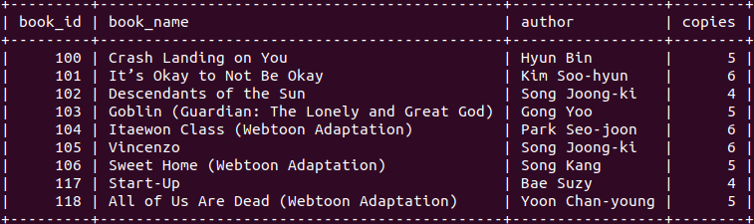

UPDATE Library
SET copies = 15
WHERE book_name = 'Crash Landing on You';

SELECT * FROM Library;

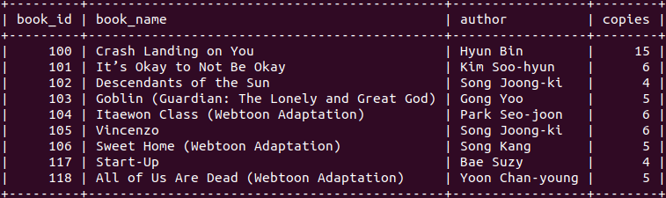

SELECT * FROM Library_audit;

DELETE FROM Library
WHERE author = 'Bae Suzy';

SELECT * FROM Library;
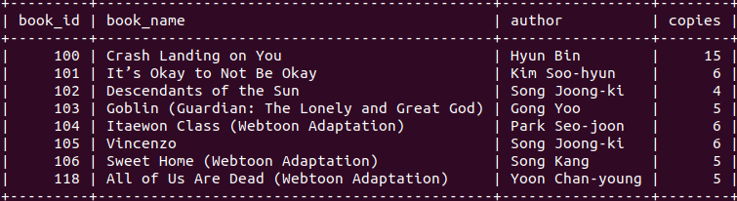

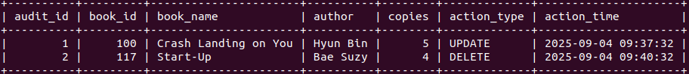
SELECT * FROM Library_audit;

