Roll no. 31145

Assignment No. 9

Connect to mongodb database:
mongo --host 10.10.10.55 --port 27017 te31145_db

Create a new collecion:
db.createCollection("students")

View all collections:
show collections

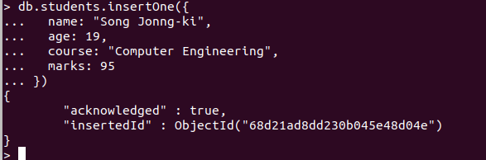
Insert one document:
db.students.insertOne({
name: "Song Jonng-ki",
age: 19,
course: "Computer Engineering",
marks: 95
})

Insert multiple documents:
db.students.insertMany([
{ name: "Kim Seon-ho", age: 21, course: "IT", marks: 88 },
{ name: "Lee Do-hyun", age: 22, course: "ECE", marks: 92 },
{ name: "Park Bo-gum", age: 20, course: "Mechanical", marks: 85 }
])
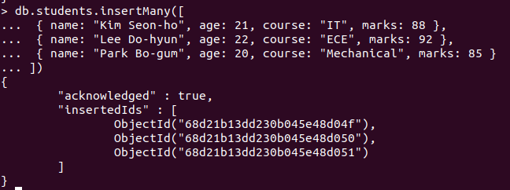

Read/Find all documents:
db.students.find()

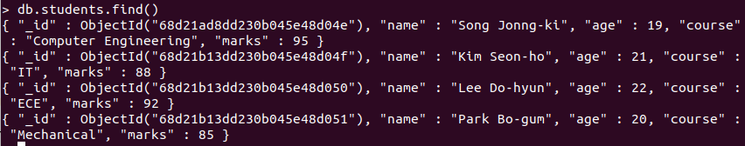

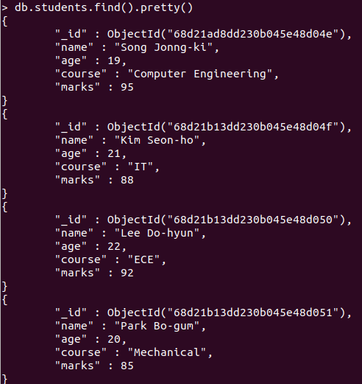
db.students.find().pretty()

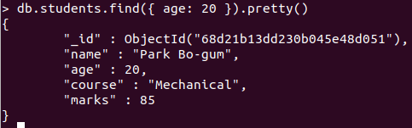
Find with condition:
db.students.find({ age: 20 }).pretty()

Logical Operators:
- $and
db.students.find({ $and: [ { age: 19 }, { marks: { $gt: 90 } } ] }).pretty()
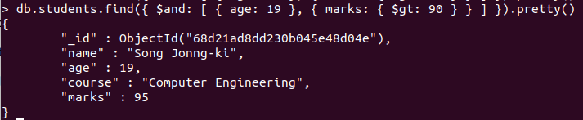

- $or
db.students.find({ $or: [ { course: "IT" }, { marks: { $gt: 90 } } ] }).pretty()
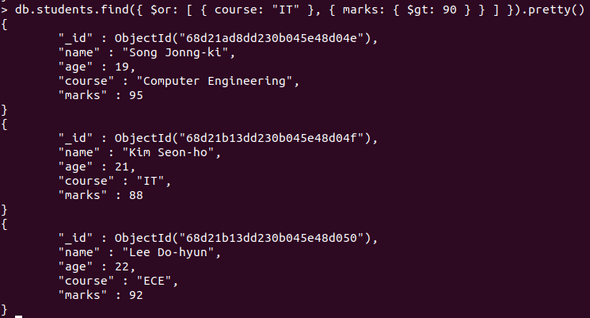

Update one document:
db.students.updateOne(
{ name: "Song Jonng-ki" },
{ $set: { name: "Song Joong-ki", marks: 98 } }
)
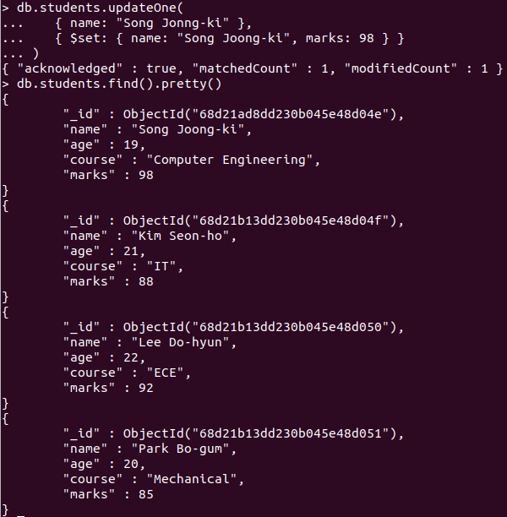

Update multiple documents:
db.students.updateMany(
{ marks: { $gt: 90 } },
{ $set: { course: "Updated Course" } }
)
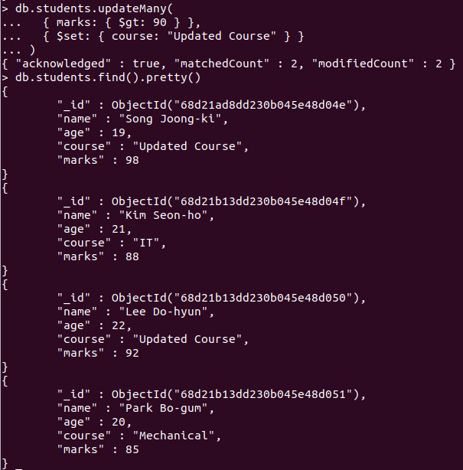

Delete One:
db.students.deleteOne({ name: "Lee Do-hyun" })

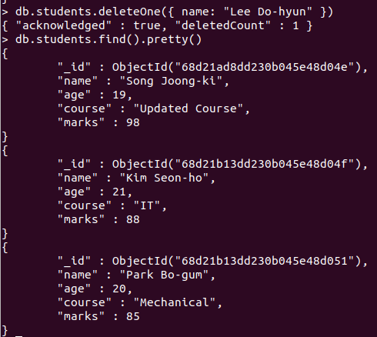

Delete Many:
db.students.deleteMany({ marks: { $lt: 90 } })
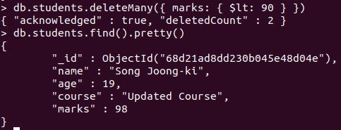

Select specific fields:
db.students.find({}, { name: 1, marks: 1, _id: 0 }).pretty()

Sorting:
db.students.find().sort({ marks: -1 }).pretty() // descending by marks
db.students.find().sort({ age: 1 }).pretty() // ascending by age

Limit number of results:
db.students.find().limit(2).pretty()

Skip documents:
db.students.find().skip(1).limit(2).pretty()

Upsert:- Update if exists, insert if not:
db.students.updateOne(
{ name: "New Student" },
{ $set: { age: 18, course: "New Course", marks: 90 } },
{ upsert: true }
)

Count documents:
db.students.countDocuments({ marks: { $gt: 90 } })
or
db.students.find({ marks: { $gt: 90 } }).count()

Aggregate / Average:
db.students.aggregate([
{ $group: { _id: null, avgMarks: { $avg: "$marks" } } }
])

Indexing:
db.students.createIndex({ name: 1 })

For pattern matching:
db.students.find({ name: /Song/ }).pretty()

