Home Page

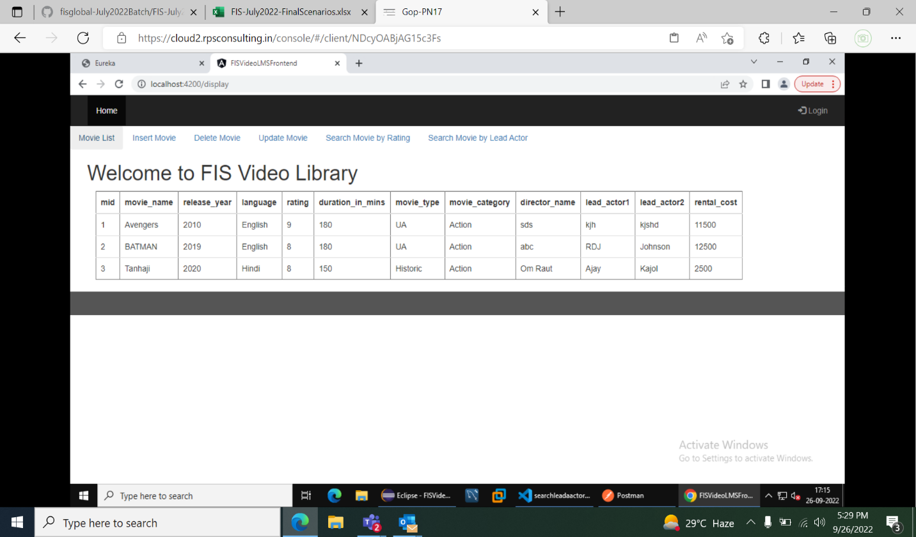

Display List Of Movies

Insert Movie

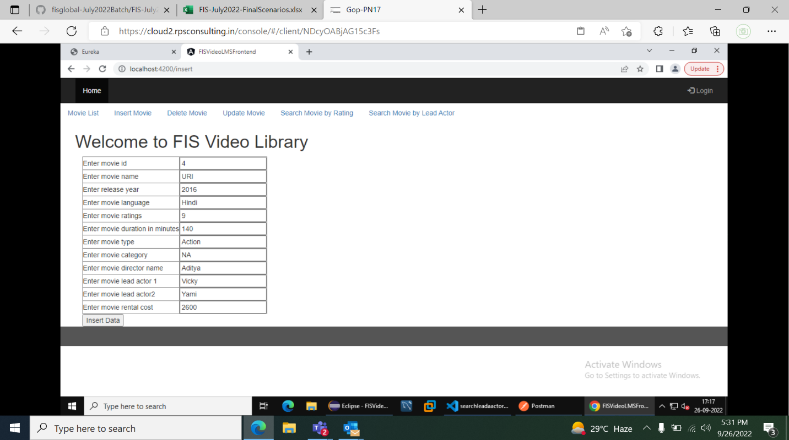

Movie Data Inserted

Movies List After Inserting new Movie

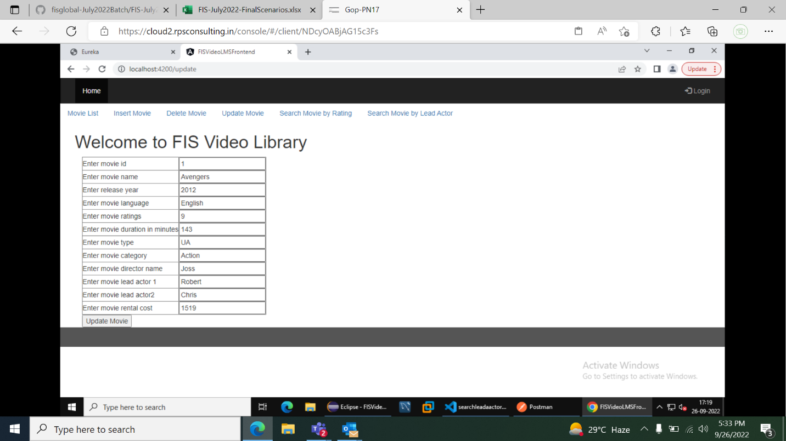

Update Movie

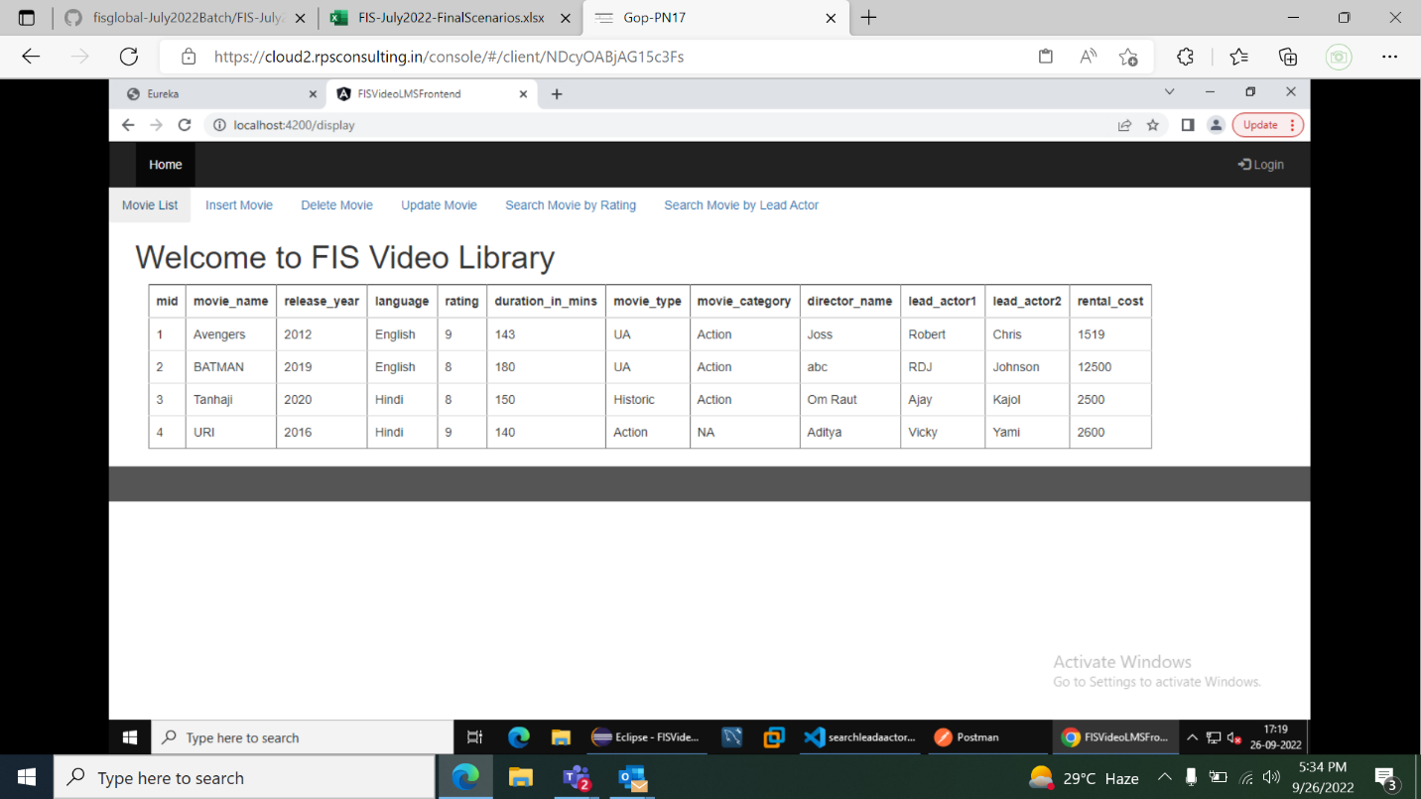

Movie List After Updation

Search Movie Based on Rating

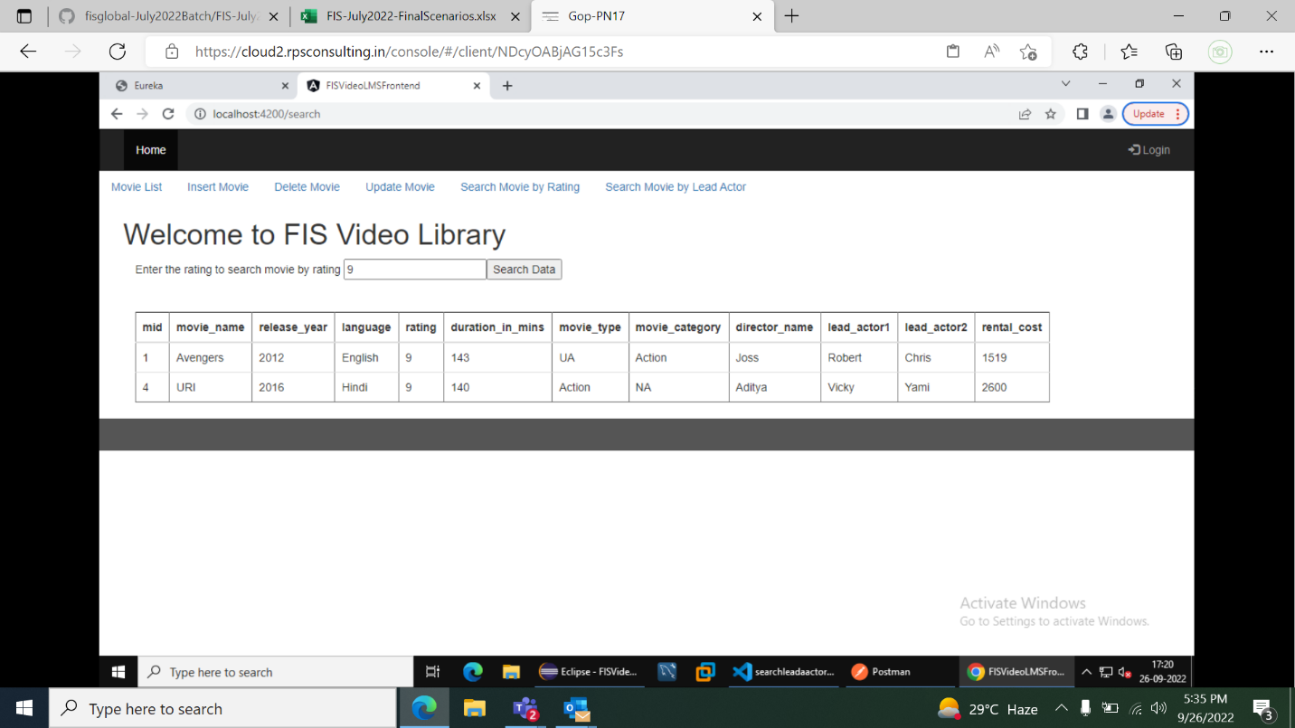

Movie Search Result based on rating

Search movie based on Lead Actor

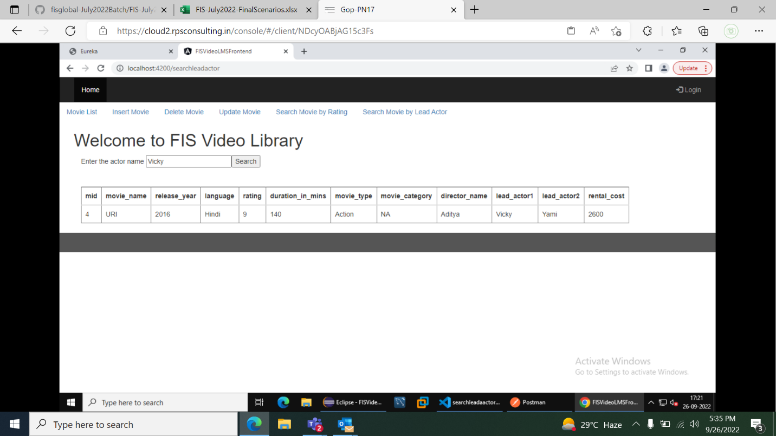

Result of movie searched based on lead actor

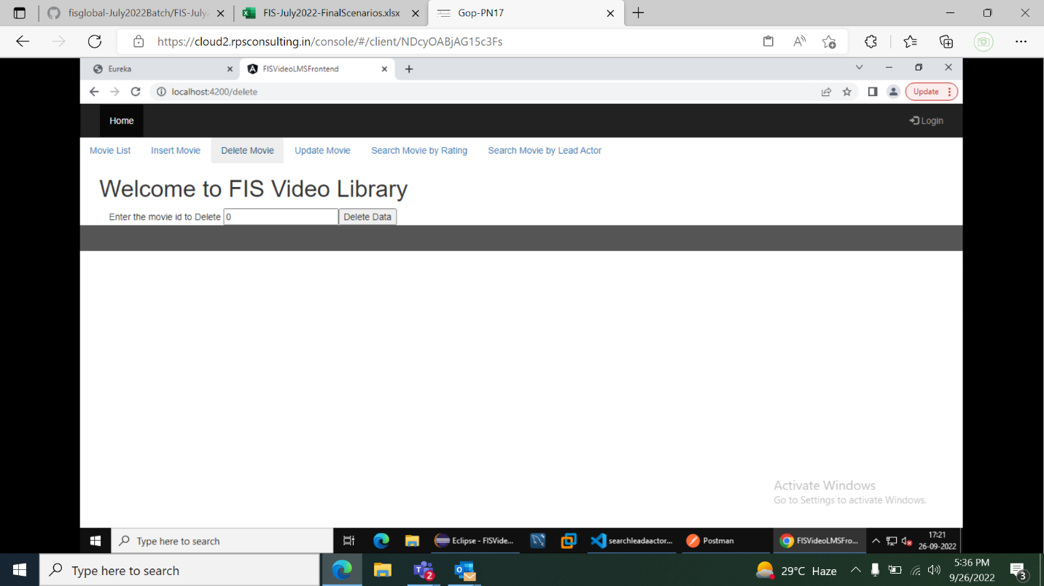

Delete the movie

Enter the movie id to delete

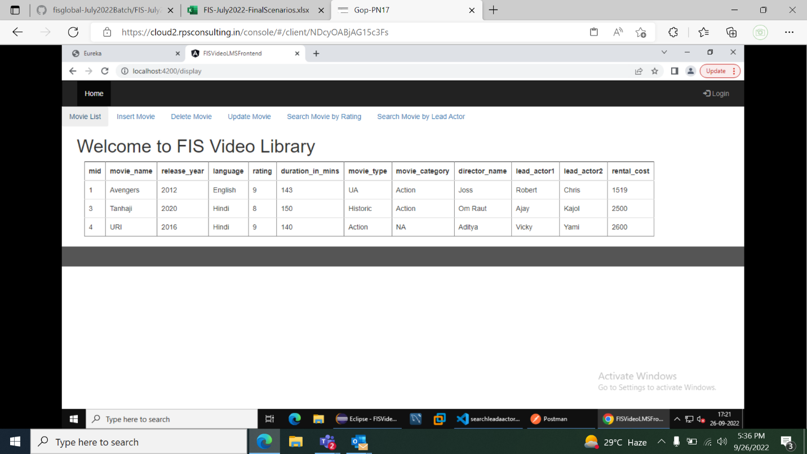

Movie list after deleting movie with id 2