**Assignment No :02**

Name : Mrunal R. Somankar

Roll No : TCOA46

Activity to be Submitted by Students

(Insert, Select, Update, Delete, operators, functions, setoperator, all constraints, view, index, synonym, sequence)

Create following relations and excecute the queries given below.

Account(Acc_no,Branch_Name,Balance)

Branch(Branch_Name,Branch_City,Assets)

Customer(Cust_Name,Cust_Street,Cust_City)

Depositor(Cust_Name,Acc_No)

Loan(Loan_No,Branch_Name,Amount)

Borrower(Cust_Name,Loan_No)

mysql> create database Bank;

mysql> use Bank;

mysql> select * from Account;

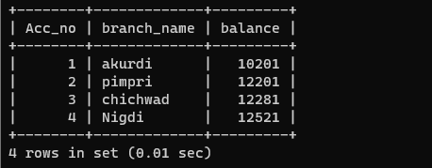

mysql> select * from Branch;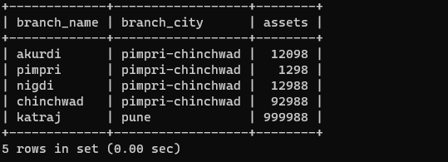

mysql> select * from Customer;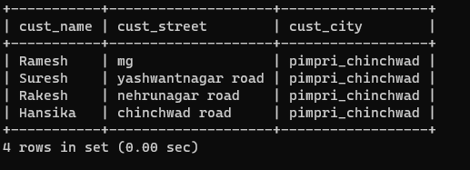

mysql> select * from Depositor;

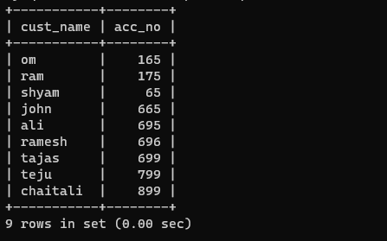

mysql> select * from Loan;

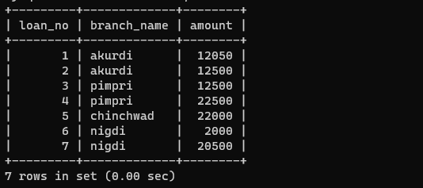

mysql> select * from Borrower;

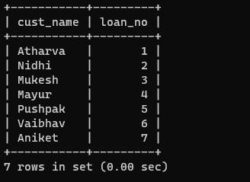

Q1. Find the names of all branches in loan relation.

mysql> select branch_name from Loan;

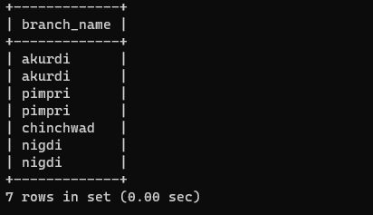

Q2. Find all loan numbers for loans made at Akurdi Branch with loan amount > 12000.

mysql> select loan_No from Loan where branch_name='akurdi' and amount>12000;



3. Find all customers who have a loan from bank. Find their names,loan_no and loan amount.

mysql> select Loan.loan_no,cust_name,amount from Loan,Borrower where Loan.loan_no=Borrower.loan_no;



4.List all customers in alphabetical order who have loan from Akurdi branch.

mysql> select loan.loan_no,cust_name,amount from Loan,Borrower where Loan.loan_no=Borrower.loan_no and branch_name='akurdi' order by cust_name asc;



5. Find all customers who have an account or loan or both at bank.

mysql> select cust_name from Borrower union select cust_name from Depositor;



6. Find all customers who have both account and loan at bank.

mysql> select cust_name from Borrower where cust_name in(select cust_name from Depositor);

7.Find all customer who have account but no loan at the bank.

mysql> select cust_name from Depositor where cust_name not in(select cust_name from Borrower);



8. Find average account balance at Akurdi branch.

mysql> select branch_name,avg(balance) from Account where branch_name='akurdi';



9. Find the average account balance at each branch

mysql> select branch_name,avg(balance) from Account group by branch_name;

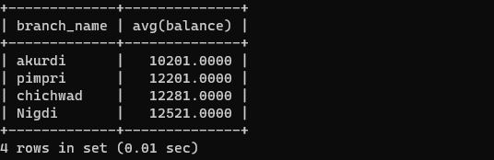

10. Find no. of depositors at each branch.

mysql> select branch_name,count(Account.Acc_No) from Depositor,Account where Depositor.acc_No=Account.Acc_No group by branch_name;

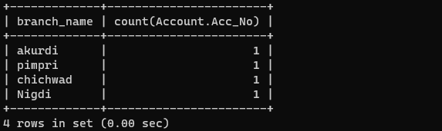

11. Find the branches where average account balance > 12000.

mysql> select branch_name,avg(balance) from Account group by branch_name having avg(balance)>12000;

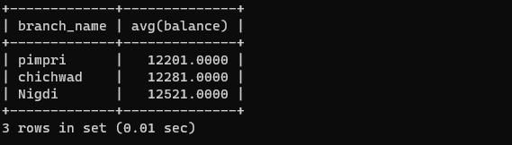

12. Find number of tuples in customer relation.

mysql> select count(*) from Customer;



13. Calculate total loan amount given by bank.

mysql> select sum(Amount) from Loan;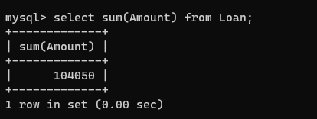

14. Delete all loans with loan amount between 1300 and 1500.

mysql> delete from Loan where Amount>900 and Amount<2500;

mysql> select* from Loan;



15. Delete all tuples at every branch located in Nigdi.

mysql> delete from Branch where branch_name='nigdi';

mysql> select * from Branch;

