**Assignment No :03**

Name : Mrunal R. Somankar

Roll No : TCOA46

**Activity to be Submitted by Students**

**Design SQL queries for suitable database application using SQL DML statements: all types of Join, Sub-Query and View.**

1. Create following Tables

cust_mstr(cust_no,fname,lname)

add_dets(code_no,add1,add2,state,city,pincode)

Retrieve the address of customer Fname as 'xyz' and Lname as 'pqr'.

mysql> use Bank;

mysql> create table cust_mstr(cust_no int,fname varchar(100),lname varchar(100));

mysql> select * from cust_mstr;

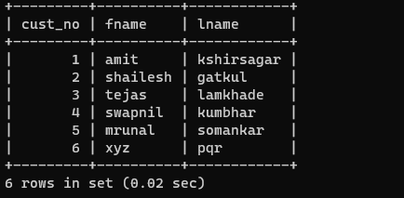

mysql> select * from add_dets;

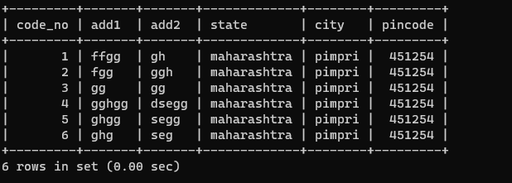

mysql> select * from cust_mstr inner join add_dets oncust_mstr.cust_no=add_dets.code_no where fname='xyz' and lname='pqr';

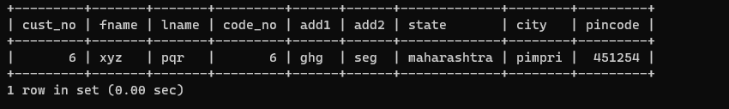

2.Create following Tables

cust_mstr(custno,fname,lname)

acc_fd_cust_dets(codeno,acc_fd_no)

fd_dets(fd_sr_no,amt)

List the customer holding fixed deposit of amount more than 5000.

mysql> select * from acc_fd_cust_dets;

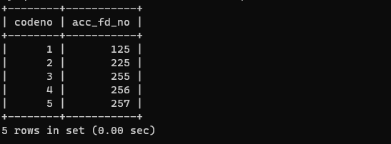

mysql> select * from fd_dets;

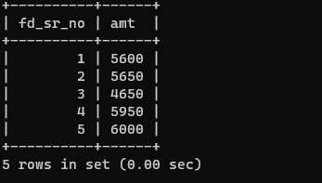

mysql> select * from cust_mstr join fd_dets on cust_mstr.cust_no=fd_dets.fd_sr_no where amt>5000;

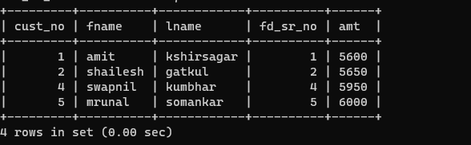

3. Create following Tables

emp_mstr(e_mpno,f_name,l_name,m_name,dept,desg,branch_no)

branch_mstr(name,b_no)

List the employee details along with branch names to which they belong

mysql> select * from emp_mstr;

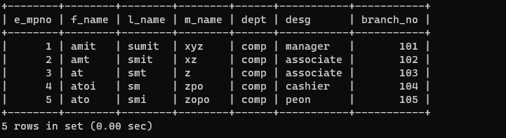

mysql> select * from branch_mstr;

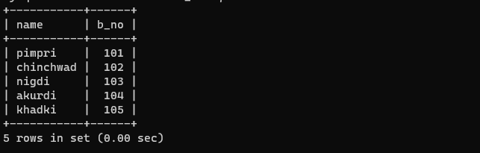

mysql> select * from emp_mstr join branch_mstr on emp_mstr.branch_no=branch_mstr.b_no;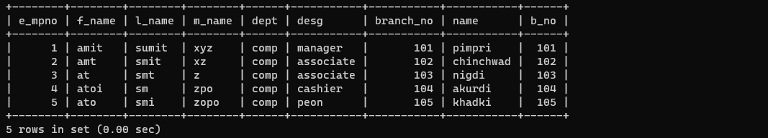

4. Create following Tables

emp_mstr(emp_no,f_name,l_name,m_name,dept)

cntc_dets(code_no,cntc_type,cntc_data)

List the employee details along with contact details using left outer join & right join.

mysql> select * from cntc_dets;

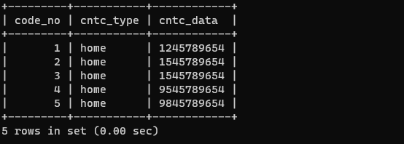

mysql> select * from emp_mstr left join cntc_dets on emp_mstr.e_mpno=cntc_dets.code_no;

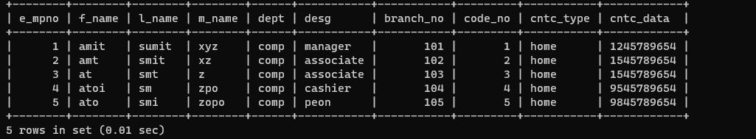

mysql> select * from emp_mstr right join cntc_dets on emp_mstr.e_mpno=cntc_dets.code_no;



5. Create following Tables

cust_mstr(cust_no,fname,lname)

add_dets(code_no,pincode)

List the customer who do not have bank branches in their vicinity.

mysql> select * from cust_mstr;

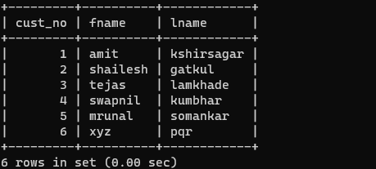

mysql> select* from add_dets;

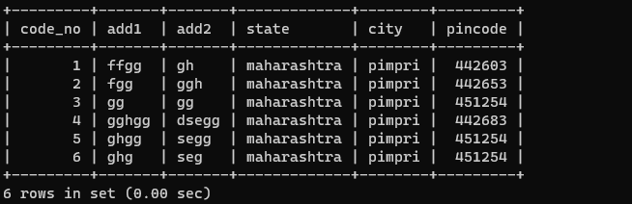

mysql> select * from cust_mstr where cust_no not in (select code_no from add_dets,branch_mstr where add_dets.pincode=branch_mstr.pincode);

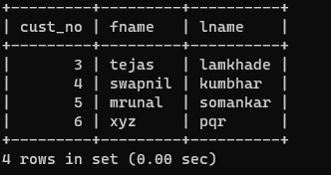

6. a) Create View on borrower table by selecting any two columns and perform insert update delete operations

mysql> create view VIEW as select cust_name,loan_no from Borrower;

mysql> select * from VIEW;

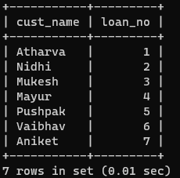

mysql> insert into view values("Ram",8);

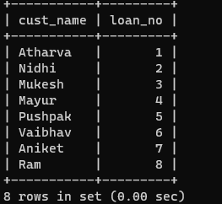

mysql> update view set loan_no=9 where cust_name="Vaibhav";

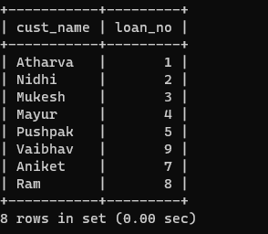

mysql> delete from view where loan_no=2;

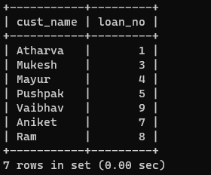

b) Create view on borrower and depositor table by selecting any one column from each table perform insert update delete operations.

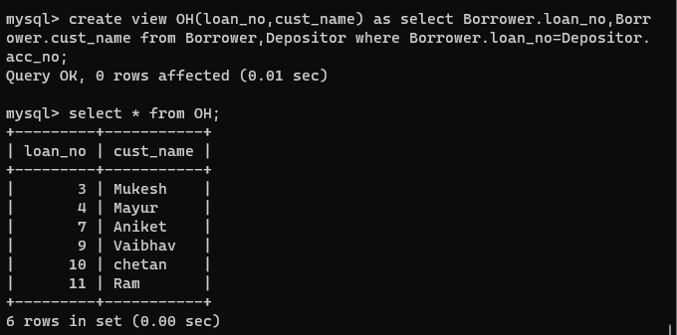

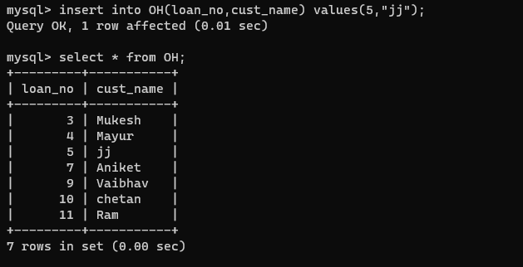

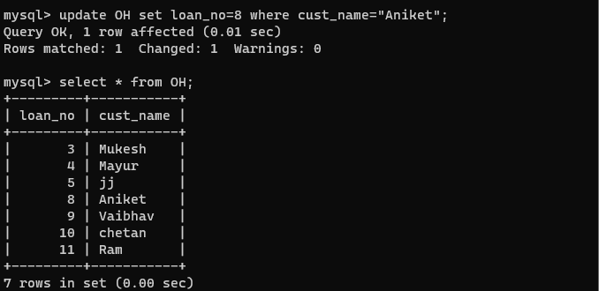

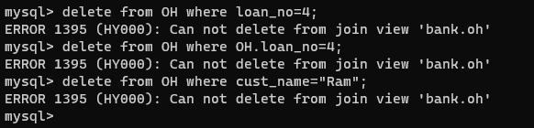

c) create updateable view on borrower table by selecting any two columns and perform insert, update and delete operations.

mysql> create view my_view as select cust_name,loan_no from Borrower;

mysql> select * from my_view;

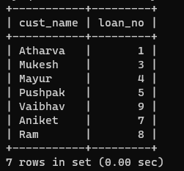

mysql> insert into my_view values("chetan",10);

mysql> select * from my_view;

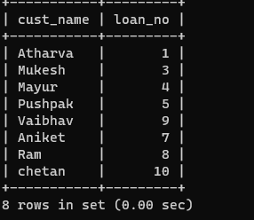

mysql> update my_view set loan_no=11 where cust_name="Ram";

mysql> select * from my_view;

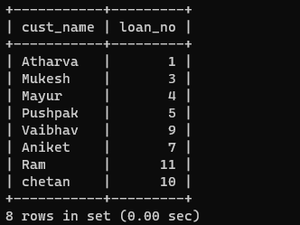

mysql> delete from my_view where loan_no=5;

mysql> select * from my_view;

