RETAIL SALES ANALYSIS
A Python-Based Data Analytics and Visualization Project

PROJECT REPORT
Submitted by
Atharva Sachin Bhamre
Datta Meghe College of Engineering, Airoli
Department: Artificial Intelligence and Data Science
Academic Year: 2026–2027

Abstract
Retail businesses generate transaction data that can be used to understand revenue, profitability, product demand, customer purchasing patterns, and regional performance. This project, Retail Sales Analysis, uses Python data-analysis libraries to process and explore a structured dataset containing 2,500 sales records and 14 attributes. Pandas and NumPy support data handling and calculations, while Matplotlib, Seaborn, and Plotly support visualization. Streamlit provides an interactive dashboard for presenting key performance indicators and charts. In the supplied dataset, total sales are 300641.91, total cost is 198261.13, and total profit is 102380.78, with an overall profit margin of 34.05%. Clothing is the highest-revenue category, Central is the highest-revenue region, and online sales exceed in-store sales. The project demonstrates how data analysis can turn raw transaction records into understandable business insights. The dataset is synthetic and is intended for educational analysis.

1. Introduction
Sales analysis is an important business activity because it helps organizations measure performance and make evidence-based decisions. A transaction file may contain many rows and attributes, making it difficult to identify patterns by manual inspection. Data analysis tools can organize these records, calculate summary measures, compare categories, and display changes over time. This project applies a reproducible Python workflow to retail sales data and presents the results through an interactive Streamlit dashboard.

2. Problem Statement
Raw sales records do not immediately explain which categories and regions contribute most to revenue and profit, how sales change month by month, or how channels and customer groups perform. The project addresses this problem by cleaning and summarizing the data, calculating key performance indicators, and visualizing comparisons that are easy for a user to interpret.

3. Objectives
- Load and inspect retail sales data using Python.
- Check data quality, including missing values and duplicate records.
- Calculate total sales, cost, profit, units sold, order count, average order value, and profit margin.
- Compare revenue and profit across product categories and regions.
- Analyze monthly trends, sales channels, customer types, and payment methods.
- Build an interactive dashboard that communicates findings through charts and KPI cards.
- Use the findings to suggest practical areas for business improvement.

4. Tools and Technologies
Technology | Purpose
Python | Main programming language for analysis and dashboard logic.
Pandas | Loading CSV data, cleaning, grouping, and aggregation.
NumPy | Numerical operations and data calculations.
Streamlit | Interactive web dashboard.
Plotly | Interactive charts and visual exploration.
Matplotlib / Seaborn | Statistical plots and supporting visualizations.
CSV | Portable tabular format for the input dataset.

5. Dataset Description
The supplied file sales.csv contains 2,500 rows and 14 columns. It covers 01 January 2024 to 31 December 2025. Each row represents one synthetic order record with a unique Order_ID. The data includes order date, product, category, region, sales channel, customer type, payment method, unit price, quantity, discount, sales, cost, and profit.
Columns: Order_ID, Order_Date, Product, Category, Region, Sales_Channel, Customer_Type, Payment_Method, Unit_Price, Quantity, Discount, Sales, Cost, Profit. Discount is stored as a decimal fraction (for example, 0.10 means 10%). Sales, cost, and profit are numerical amounts in the dataset's currency units; the dataset does not specify a currency symbol, so the report does not assume a particular currency.

6. Methodology
- Data loading: Read sales.csv into a Pandas DataFrame.
- Data inspection: Review column names, data types, record count, date range, missing values, and duplicates.
- Data preparation: Convert Order_Date to a datetime type and check the consistency of numerical fields.
- Exploratory analysis: Group the data by category, region, month, sales channel, customer type, and payment method.
- KPI calculation: Calculate sales, cost, profit, quantity sold, distinct order count, average order value, and profit margin.
- Visualization: Use bar charts and time-series plots to compare performance and identify peaks and lows.
- Dashboard presentation: Present the results through Streamlit, with interactive filters and charts where implemented.

7. Implementation Overview
The project follows a simple pipeline: CSV file → Pandas DataFrame → data validation and transformation → aggregations and KPI calculations → charts → Streamlit dashboard. Pandas groupby operations can calculate sales and profit by category or region, while a monthly period derived from Order_Date supports trend analysis. Streamlit is launched locally using the command streamlit run dashboard.py from the project directory.
Example calculation definitions:
- Total Sales = sum of the Sales column.
- Total Profit = sum of the Profit column.
- Profit Margin (%) = (Total Profit ÷ Total Sales) × 100.
- Average Order Value = Total Sales ÷ number of distinct orders.
- Monthly Sales = sum of Sales grouped by calendar month.

8. Results and Dataset Findings
The following results were calculated directly from the uploaded sales.csv file.
Metric | Result
Sales records | 2,500
Distinct orders | 2,500
Total sales | 300,641.91
Total cost | 198,261.13
Total profit | 102,380.78
Profit margin | 34.05%
Units sold | 5,445
Average order value | 120.26
Average discount | 5.23%
Missing cells | 0
Duplicate rows | 0
Duplicate order IDs | 0

8.1 Category Performance
Clothing generated the highest sales at 81,360.27, followed by Electronics at 79,545.12. Clothing generated the highest category profit (27,714.59).
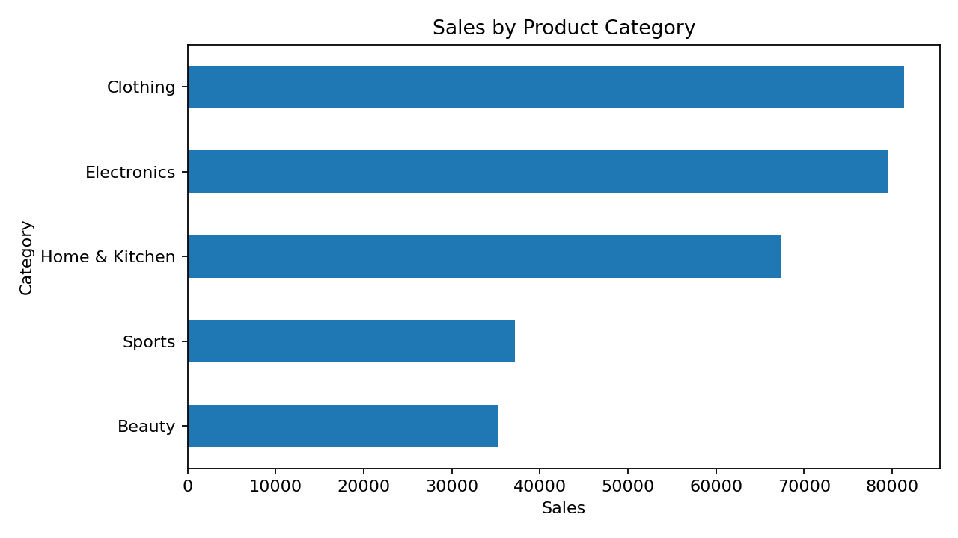
Category | Sales | Profit | Orders
Clothing | 81,360.27 | 27,714.59 | 540
Electronics | 79,545.12 | 27,403.72 | 595
Home & Kitchen | 67,418.24 | 22,809.39 | 583
Sports | 37,125.12 | 12,225.94 | 378
Beauty | 35,193.16 | 12,227.14 | 404

8.2 Regional Performance
Central recorded the highest regional sales at 66,336.59. Central also produced the highest regional profit at 22,307.81. The differences between regions can help prioritize further investigation into demand, customer mix, and marketing.
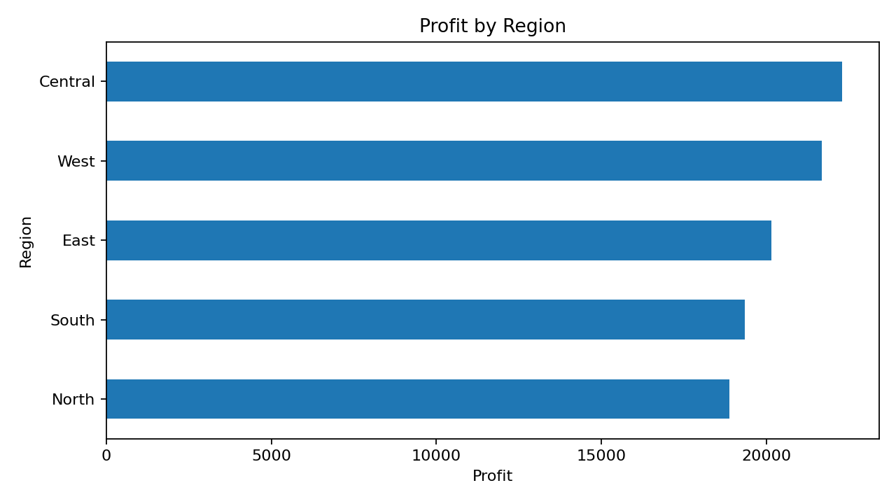
Region | Sales | Profit | Orders
Central | 66,336.59 | 22,307.81 | 540
West | 62,732.03 | 21,693.82 | 513
East | 59,894.07 | 20,150.21 | 478
South | 56,696.48 | 19,352.27 | 495
North | 54,982.74 | 18,876.67 | 474

8.3 Monthly Sales Trend
The highest monthly sales occurred in 2024-11, totaling 15,455.89. The lowest monthly sales occurred in 2025-02, totaling 9,663.50. Monthly movement suggests that performance varies over time; the peaks should be investigated alongside campaigns, seasonality, inventory, and customer demand before making operational decisions.
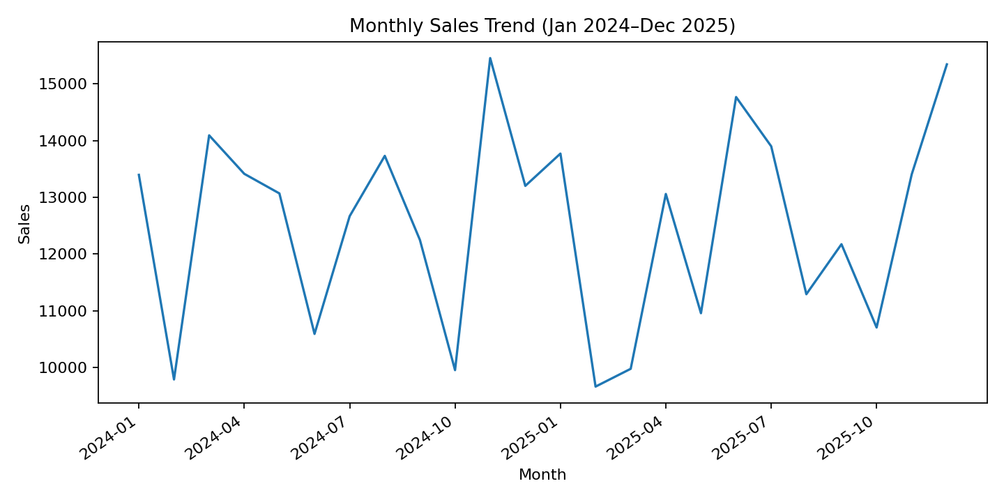

8.4 Sales Channel, Customer, and Payment Insights
Online generated 173,529.64 in sales across 1,462 orders, compared with 127,112.27 across 1,038 in-store orders. Returning customers contributed the most sales among customer types (123,270.25). Credit Card was the largest payment method by sales (81,289.20).
Sales Channel | Sales | Profit | Orders
In-Store | 127,112.27 | 43,413.51 | 1,038
Online | 173,529.64 | 58,967.27 | 1,462

8.5 Product and Discount Insights
The top product by sales was Jacket with 30,907.78. The correlation between discount and profit in this dataset is -0.188. This indicates a weak-to-moderate negative linear association in these records, not proof that discounts alone cause lower profit. Product costs, quantities, and product mix may also affect the result.

9. Discussion
The results show that sales are distributed across multiple categories and regions, with Clothing leading category revenue and Central leading regional revenue. Online orders contribute more revenue than in-store orders in this dataset. The leading product and monthly peak provide useful starting points for examining inventory and promotional planning. Since the dataset is synthetic, the findings are suitable for demonstrating analytical techniques but should not be interpreted as evidence about a real retailer.

10. Recommendations
- Review stock availability and product-level margins for high-revenue items such as Jackets and Portable SSDs.
- Investigate why Clothing leads revenue while comparing margins and units, not revenue alone.
- Explore the Central region's strong sales and test whether similar approaches work in other regions.
- Compare online and in-store order values, costs, and profitability before allocating additional marketing budget.
- Evaluate discount bands by category and profit rather than applying broad discounts across all products.
- Track monthly performance over multiple years before drawing conclusions about seasonality.

11. Limitations
- The dataset is synthetic and does not represent verified real-world transactions.
- The currency is not specified in the source data.
- Customer identifiers and geographic detail are limited, restricting retention and location-level analysis.
- Correlation between discount and profit does not establish causation.
- Dashboard functionality depends on the filters and visualizations implemented in the actual dashboard code.

12. Future Scope
- Add a database backend such as MySQL for persistent storage and structured querying.
- Include customer-level analysis, repeat-purchase rates, and customer lifetime value when suitable identifiers are available.
- Develop sales forecasting using time-series methods.
- Add downloadable filtered reports and CSV exports.
- Add automated data validation and scheduled refreshes.
- Deploy the dashboard to a cloud platform for access by multiple users.
- Add authentication and role-based access if used with private business data.

13. Conclusion
This project demonstrates a complete introductory workflow for retail sales analysis using Python. The uploaded dataset contains 2,500 records and produces total sales of 300,641.91, total profit of 102,380.78, and a profit margin of 34.05%. Category, region, monthly, channel, customer, and payment-method comparisons reveal where revenue and profit are concentrated. By combining Pandas-based calculations with visualizations and a Streamlit interface, the project makes sales data easier to explore. The analysis also shows the importance of validating data and acknowledging limitations, especially because the dataset is synthetic.

References
- The pandas development team. pandas documentation. https://pandas.pydata.org/docs/
- NumPy developers. NumPy documentation. https://numpy.org/doc/
- Streamlit, Inc. Streamlit documentation. https://docs.streamlit.io/
- Plotly Technologies Inc. Plotly Python documentation. https://plotly.com/python/
- Matplotlib Development Team. Matplotlib documentation. https://matplotlib.org/stable/
- Waskom, M. L. Seaborn: statistical data visualization. https://seaborn.pydata.org/

Appendix: Dataset Fields
Field | Description
Order_ID | Unique order reference.
Order_Date | Date of the order.
Product | Product name.
Category | Product category.
Region | Sales region.
Sales_Channel | Online or in-store channel.
Customer_Type | New, returning, or member customer type.
Payment_Method | Payment type used for the order.
Unit_Price | Price per unit before discount.
Quantity | Number of units in the order.
Discount | Discount fraction; 0.10 represents 10%.
Sales | Recorded sales amount after discount.
Cost | Recorded cost amount.
Profit | Recorded profit amount.

