ASSIGNMENT 1

DBMS

Airline Management System

NAME: ATHARVA BHARGUDE

PRN: 124B1F012

BATCH:A1

ER DIAGRAM:
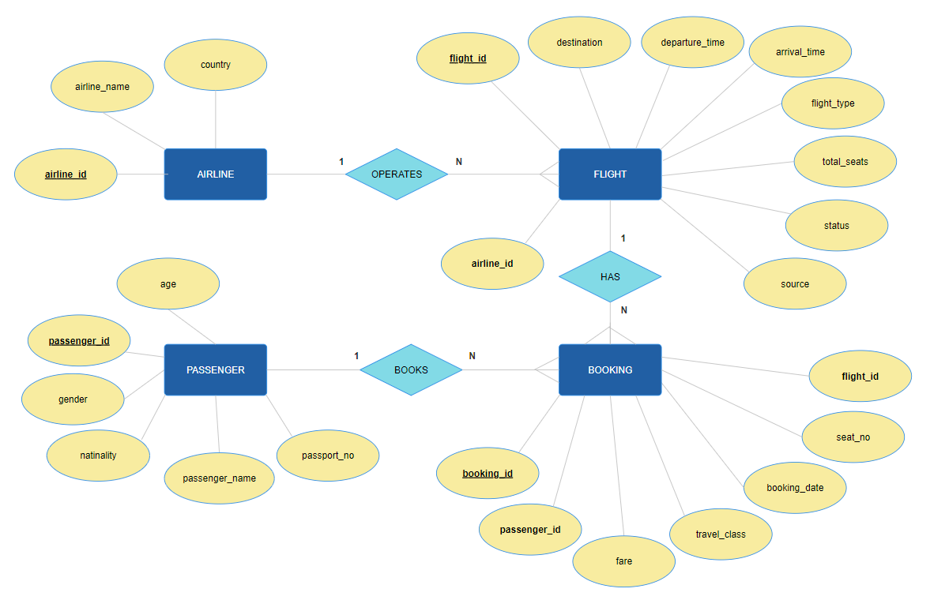

EER DIAGRAM:
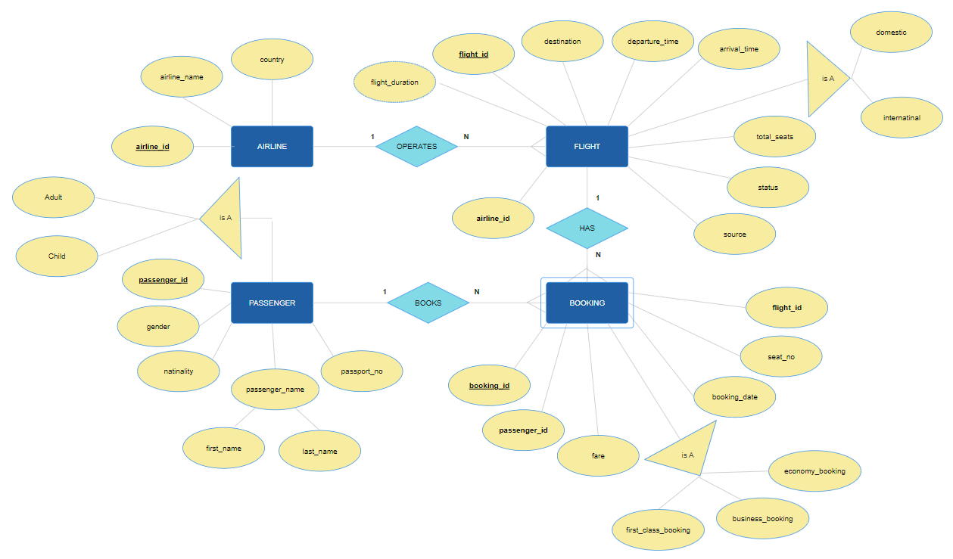

MINI PROJECT

DBMS
E-commerce management System
ER DIAGRAM:
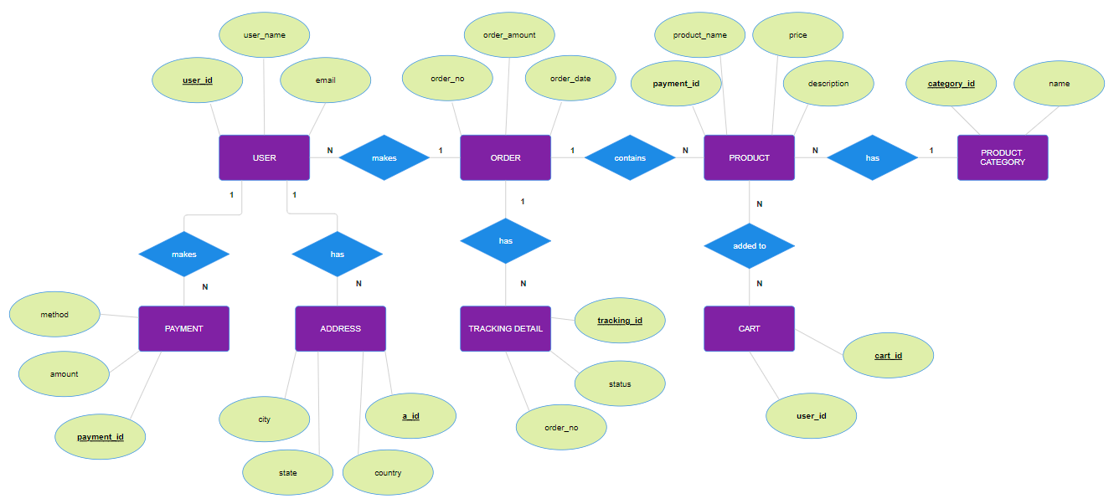

EER DIAGRAM:
