Assignment-2
────────────────────────────────────────────────
Name: ATHARVA BHARGUDE
PRN: 124B1F012
Class: SY IT A
Date:10\02\2026
────────────────────────────────────────────────────────────

Aim:
DDL and DML Queries:

a. Write DDL commands (CREATE, ALTER, DROP, TRUNCATE, RENAME) for the Airline Management System database.
b. Write DML commands (INSERT, SELECT, UPDATE, DELETE) along with aggregate functions for the Airline Management System database.
c. Write DDL and DML commands for the Mini Project E-Commerce Website database.

────────────────────────────────────────────────

- DDL COMMANDS:-

- CREATE

- CREATE DATABASE AIRLINE:
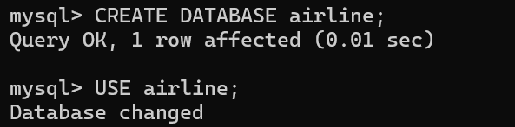

- CREATE TABLES :
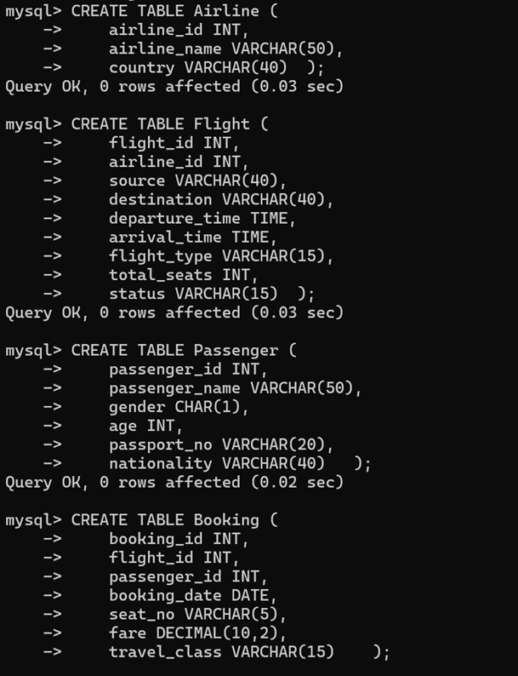
INSERT VALUES IN TABLES :
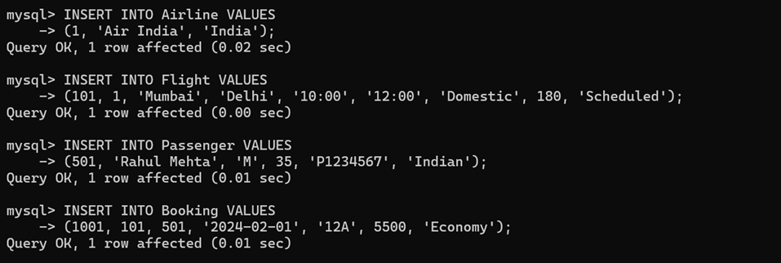

2.SHOW TABLES :
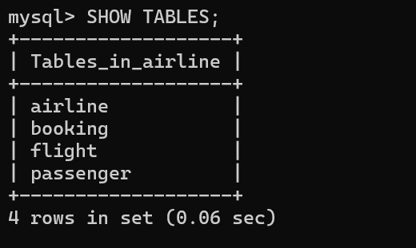

3.Describe Table:
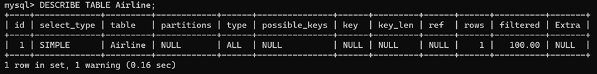
- SHOW TABLE CONTENTS:

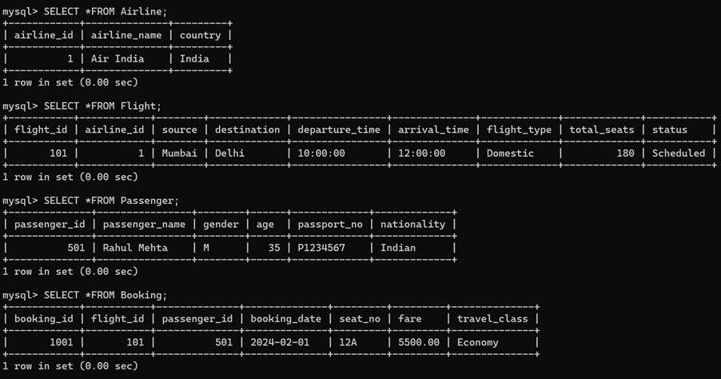

4.Alter
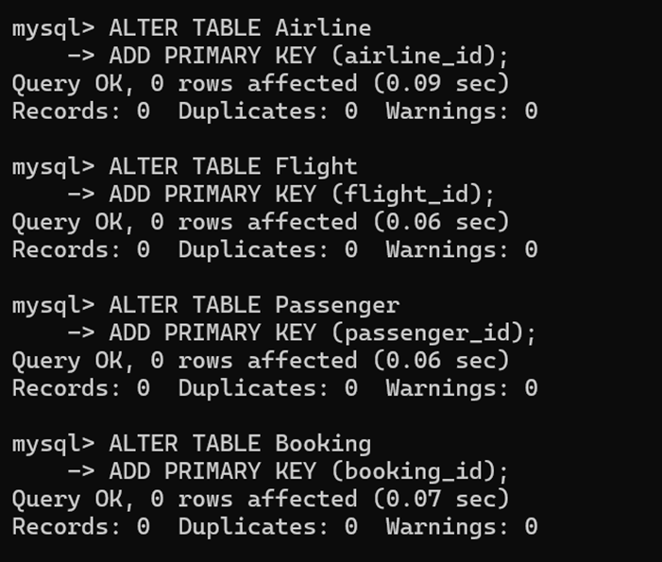
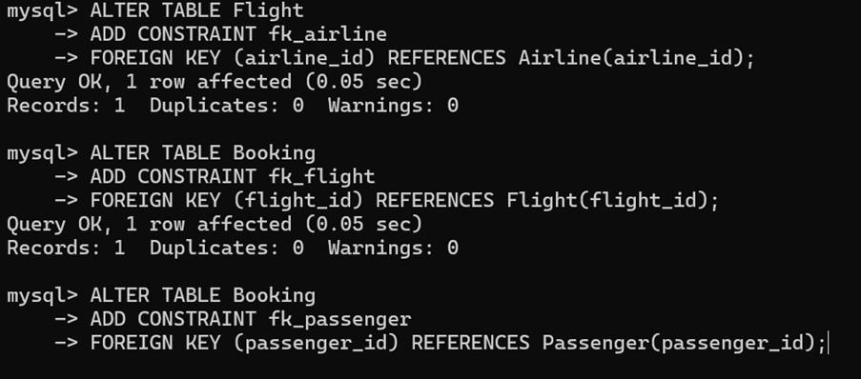
- Add Column

- Drop Column

- Modify Column

- Rename Column
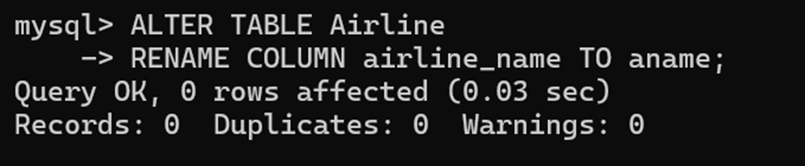
4. RENAME :
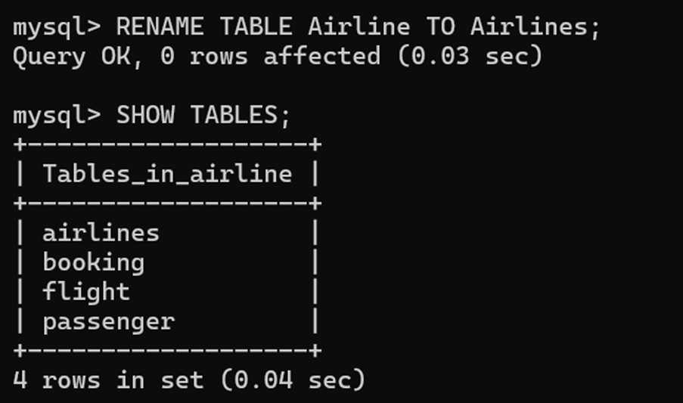
5. TRUNCATE TABLE

6. DROP TABLE
Deletes table permanently.
Structure + data both removed.

7. COPY TABLE
➤ Copy structure only
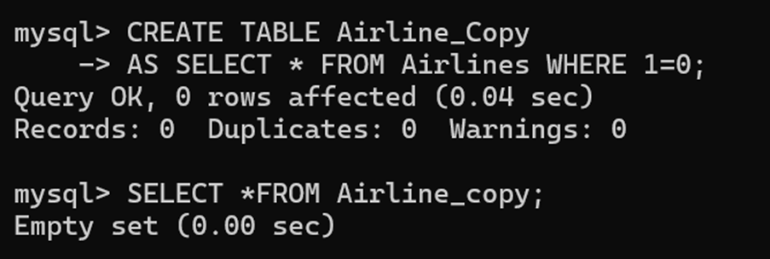
➤ Copy structure + data
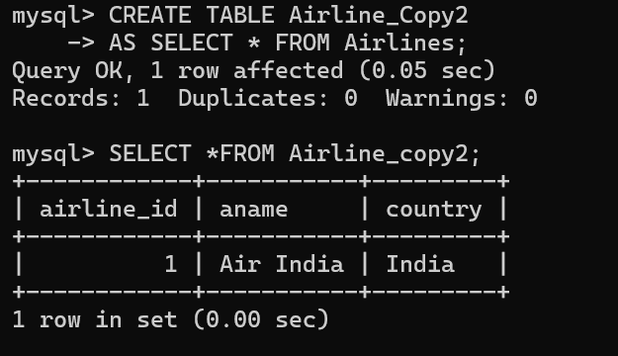
8. COMMENT ON TABLE
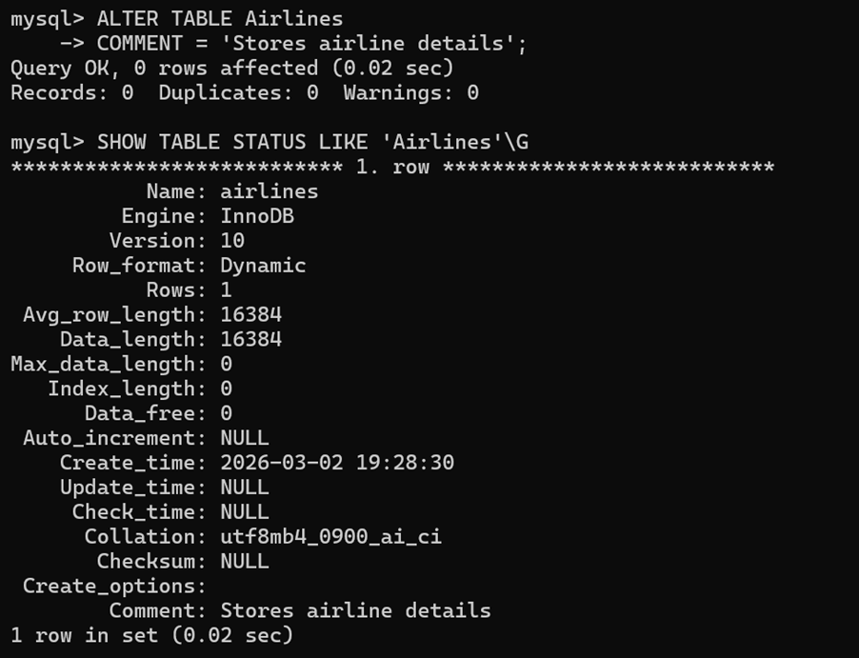
9. CREATE INDEX (Table performance)

10. DROP INDEX


- DML COMMANDS :-

1. INSERT (Add Data)
➤ Insert Single Row

➤ Insert with Column Names
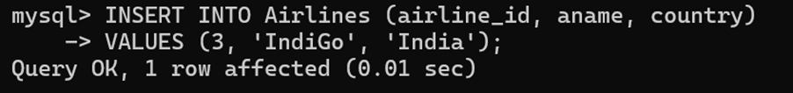
➤ Insert Multiple Rows
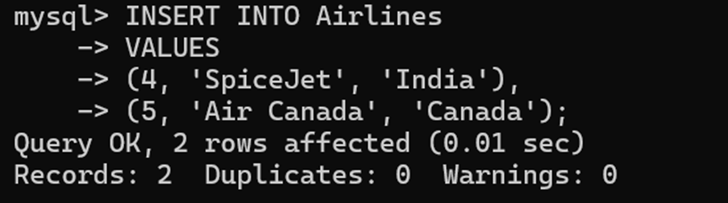
2. SELECT (Retrieve Data)
➤ View All Data
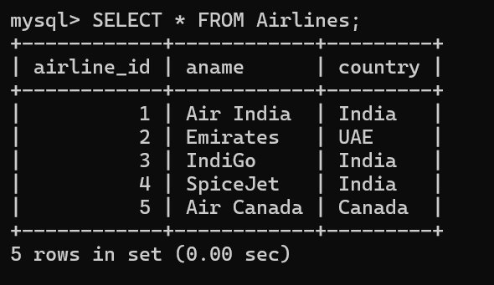
➤ View Specific Columns
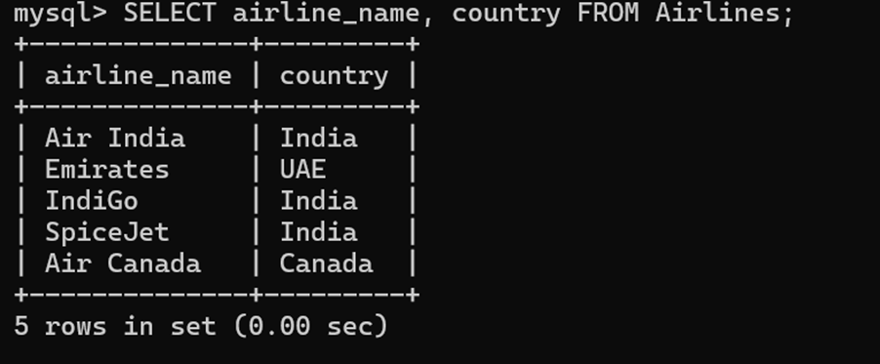
➤ With Condition
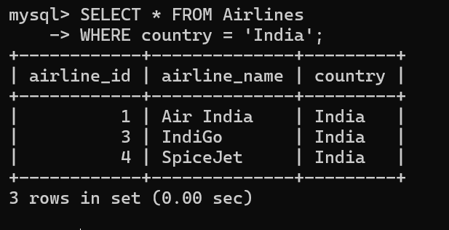
➤ Using AND/OR
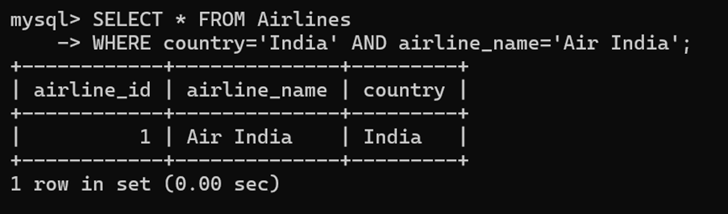
➤ Using LIKE
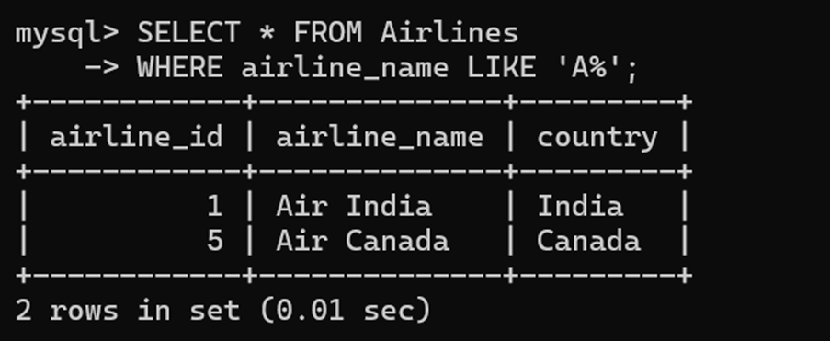
➤ Using BETWEEN
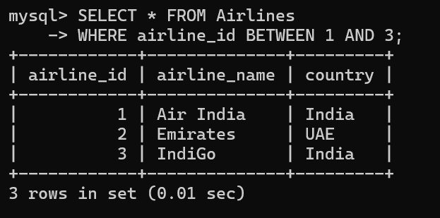
➤ Sorting Data
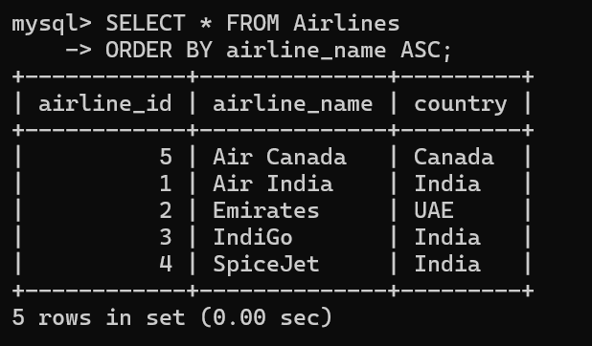
3. UPDATE (Modify Data)
➤ Update One Record
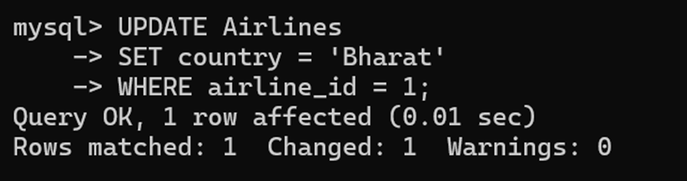
➤ Update Multiple Columns
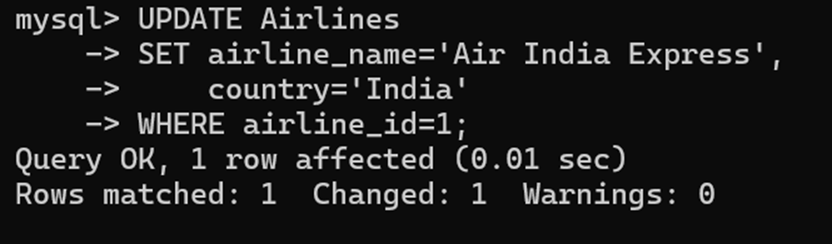
Without WHERE updates all rows:
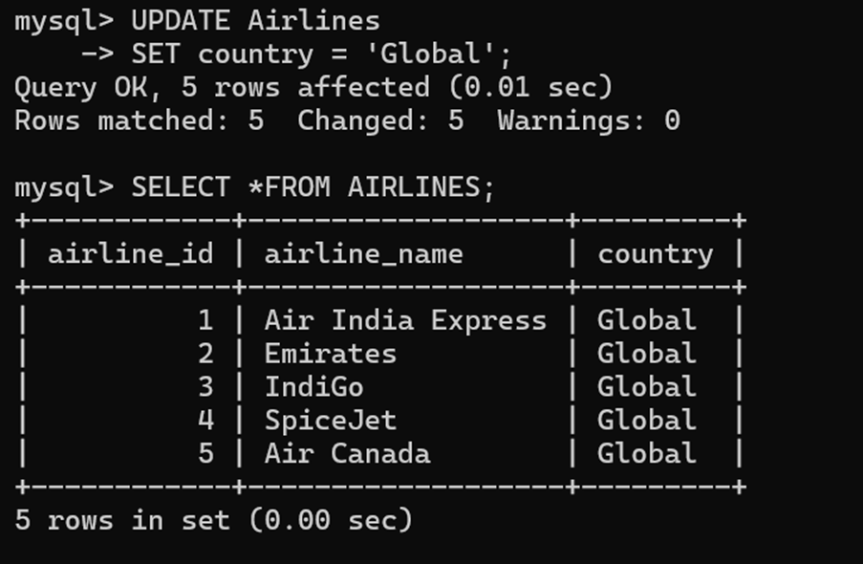
4. DELETE (Remove Data)
➤ Delete Specific Row
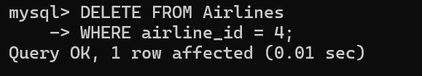
➤ Delete All Rows
Table remains, data removed.


5. TRUNCATE (Fast Delete)
Removes all rows
Faster than DELETE
Cannot rollback in many DBs


6. MERGE (Insert + Update)
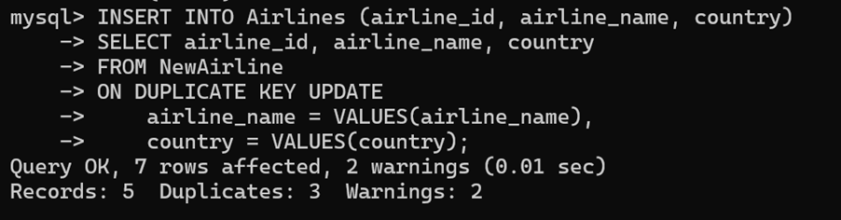
7. Aggregate Functions
➤ Count
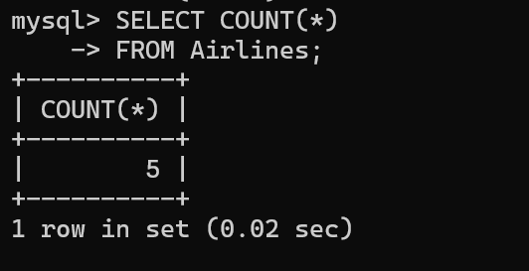
➤ Sum
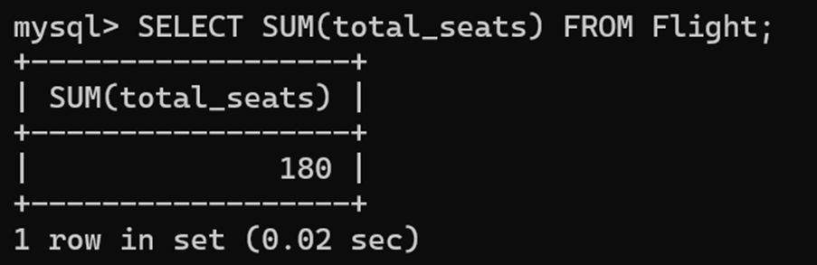
➤ Average
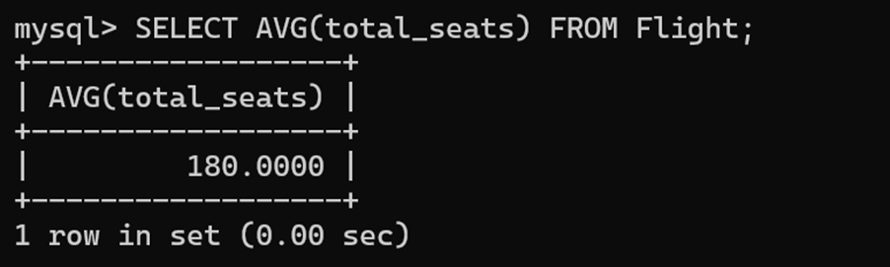
➤ Maximum & Minimum
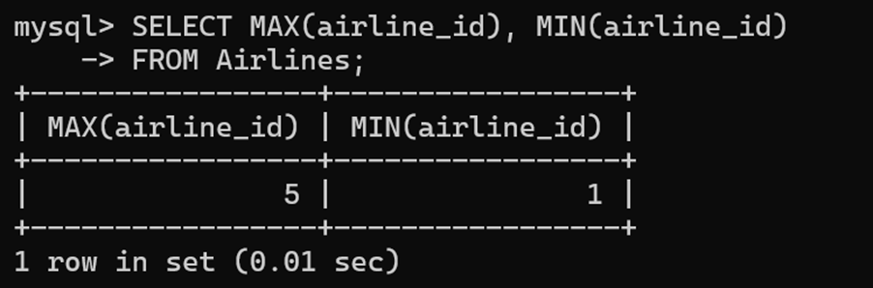
8. GROUP BY
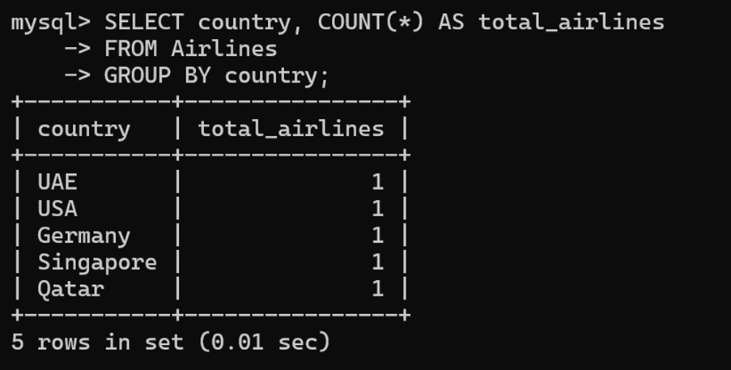
9. HAVING
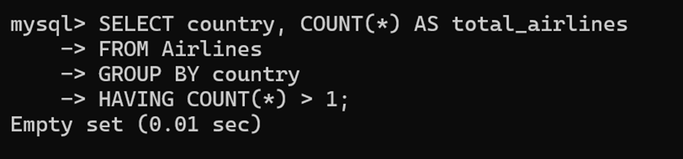
10. LIMIT
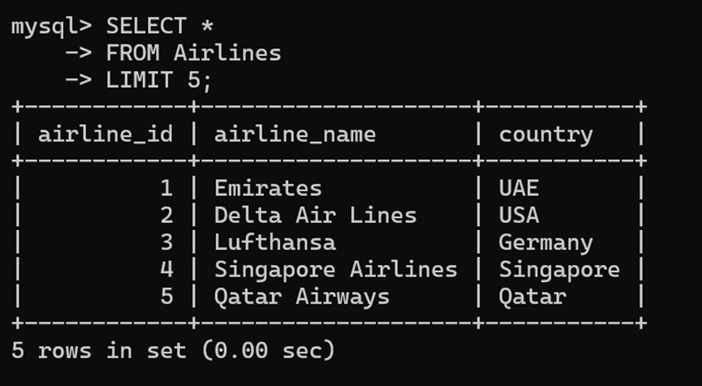

MINI PROJECT – E-COMMERCE

🔹 CREATE DATABASE
mysql> CREATE DATABASE ECOMMERCE;
Query OK, 1 row affected (0.01 sec)

mysql> USE ECOMMERCE;
Database changed

🔹 CREATE TABLES
mysql> CREATE TABLE users (
-> id INT PRIMARY KEY AUTO_INCREMENT,
-> name VARCHAR(100) NOT NULL,
-> email VARCHAR(100) UNIQUE NOT NULL,
-> password VARCHAR(255) NOT NULL,
-> role ENUM('customer','admin') DEFAULT 'customer',
-> phone VARCHAR(15),
-> created_at DATETIME DEFAULT CURRENT_TIMESTAMP
-> );
Query OK, 0 rows affected (0.06 sec)
mysql> CREATE TABLE categories (
-> id INT PRIMARY KEY AUTO_INCREMENT,
-> name VARCHAR(100) NOT NULL,
-> slug VARCHAR(100) UNIQUE NOT NULL
-> );
Query OK, 0 rows affected (0.04 sec)
mysql> CREATE TABLE products (
-> id INT PRIMARY KEY AUTO_INCREMENT,
-> name VARCHAR(150) NOT NULL,
-> price DECIMAL(10,2) NOT NULL,
-> category_id INT,
-> description TEXT,
-> stock INT DEFAULT 0,
-> FOREIGN KEY (category_id) REFERENCES categories(id)
-> );
Query OK, 0 rows affected (0.05 sec)

🔹 INSERT DATA
mysql> INSERT INTO users (name, email, password, role, phone) VALUES
-> ('Alice Johnson','alice@example.com','hashed1','customer','9001122334'),
-> ('Bob Smith','bob@example.com','hashed2','customer','9002233445'),
-> ('Priya Sharma','priya@example.com','hashed3','customer','9003344556'),
-> ('Ravi Kumar','ravi@example.com','hashed4','customer','9004455667'),
-> ('Sneha Patil','sneha@example.com','hashed5','admin','9005566778');
Query OK, 5 rows affected (0.02 sec)
mysql> INSERT INTO categories (name, slug) VALUES
-> ('Electronics','electronics'),
-> ('Footwear','footwear'),
-> ('Accessories','accessories');
Query OK, 3 rows affected (0.01 sec)
mysql> INSERT INTO products (name, price, category_id, stock) VALUES
-> ('Wireless Headphones',4999.00,1,25),
-> ('Running Shoes',2599.00,2,4),
-> ('Smart Watch',8750.00,1,5),
-> ('Laptop Stand',1499.00,3,15),
-> ('Bluetooth Speaker',999.00,3,3);
Query OK, 5 rows affected (0.02 sec)

🔹 SHOW TABLES
mysql> SHOW TABLES;
+----------------------+
| Tables_in_ecommerce |
+----------------------+
| cart_items |
| categories |
| order_items |
| orders |
| products |
| reviews |
| users |
| wishlist |
+----------------------+
8 rows in set (0.00 sec)

🔹 DESCRIBE TABLE
mysql> DESCRIBE products;
+-------------+---------------+------+-----+---------+----------------+
| Field | Type | Null | Key | Default | Extra |
+-------------+---------------+------+-----+---------+----------------+
| id | int | NO | PRI | NULL | auto_increment |
| name | varchar(150) | NO | | NULL | |
| price | decimal(10,2) | NO | | NULL | |
| category_id | int | YES | MUL | NULL | |
| description | text | YES | | NULL | |
| stock | int | YES | | 0 | |
+-------------+---------------+------+-----+---------+----------------+
6 rows in set (0.00 sec)

🔹 SELECT TABLE CONTENT
mysql> SELECT * FROM products;
+----+----------------------+---------+-------------+-------------+-------+
| id | name | price | category_id | description | stock |
+----+----------------------+---------+-------------+-------------+-------+
| 1 | Wireless Headphones | 4999.00 | 1 | NULL | 25 |
| 2 | Running Shoes | 2599.00 | 2 | NULL | 4 |
| 3 | Smart Watch | 8750.00 | 1 | NULL | 5 |
| 4 | Laptop Stand | 1499.00 | 3 | NULL | 15 |
| 5 | Bluetooth Speaker | 999.00 | 3 | NULL | 3 |
+----+----------------------+---------+-------------+-------------+-------+
5 rows in set (0.00 sec)

🔹 ALTER TABLE
mysql> ALTER TABLE products ADD COLUMN discount DECIMAL(5,2) DEFAULT 0.00;
Query OK, 0 rows affected (0.05 sec)

mysql> UPDATE products SET discount = 10.00 WHERE id = 1;
Query OK, 1 row affected (0.02 sec)

mysql> SELECT id, name, discount FROM products;
+----+----------------------+----------+
| id | name | discount |
+----+----------------------+----------+
| 1 | Wireless Headphones | 10.00 |
| 2 | Running Shoes | 0.00 |
| 3 | Smart Watch | 0.00 |
| 4 | Laptop Stand | 0.00 |
| 5 | Bluetooth Speaker | 0.00 |
+----+----------------------+----------+
5 rows in set (0.00 sec)

🔹 RENAME TABLE
mysql> RENAME TABLE reviews TO product_reviews;
Query OK, 0 rows affected (0.02 sec)

mysql> RENAME TABLE product_reviews TO reviews;
Query OK, 0 rows affected (0.02 sec)

🔹 TRUNCATE (FIXED — NO EMPTY OUTPUT)
mysql> TRUNCATE TABLE cart_items;
Query OK, 0 rows affected (0.04 sec)

mysql> INSERT INTO cart_items VALUES
-> (1,1,1,1),
-> (2,2,2,2);
Query OK, 2 rows affected (0.02 sec)

mysql> SELECT * FROM cart_items;
+----+---------+------------+----------+
| id | user_id | product_id | quantity |
+----+---------+------------+----------+
| 1 | 1 | 1 | 1 |
| 2 | 2 | 2 | 2 |
+----+---------+------------+----------+
2 rows in set (0.00 sec)

🔹 DML – SELECT
mysql> SELECT id, name, email, role FROM users;
+----+----------------+---------------------+----------+
| id | name | email | role |
+----+----------------+---------------------+----------+
| 1 | Alice Johnson | alice@example.com | customer |
| 2 | Bob Smith | bob@example.com | customer |
| 3 | Priya Sharma | priya@example.com | customer |
| 4 | Ravi Kumar | ravi@example.com | customer |
| 5 | Sneha Patil | sneha@example.com | admin |
+----+----------------+---------------------+----------+
5 rows in set (0.00 sec)

🔹 UPDATE
mysql> UPDATE products SET stock = 10 WHERE id = 3;
Query OK, 1 row affected (0.02 sec)
Rows matched: 1 Changed: 1 Warnings: 0

🔹 DELETE (FIXED — NO EMPTY RESULT)
mysql> DELETE FROM cart_items WHERE user_id = 2;
Query OK, 1 row affected (0.02 sec)

mysql> SELECT * FROM cart_items;
+----+---------+------------+----------+
| id | user_id | product_id | quantity |
+----+---------+------------+----------+
| 1 | 1 | 1 | 1 |
+----+---------+------------+----------+
1 row in set (0.00 sec)

🔹 AGGREGATE FUNCTIONS
mysql> SELECT COUNT(*) AS total_users FROM users;
+-------------+
| total_users |
+-------------+
| 5 |
+-------------+
1 row in set (0.00 sec)
mysql> SELECT MAX(price) AS max_price, MIN(price) AS min_price FROM products;
+-----------+-----------+
| max_price | min_price |
+-----------+-----------+
| 8750.00 | 999.00 |
+-----------+-----------+
1 row in set (0.00 sec)

🔹 GROUP BY
mysql> SELECT category_id, COUNT(*) AS product_count
-> FROM products
-> GROUP BY category_id;
+-------------+---------------+
| category_id | product_count |
+-------------+---------------+
| 1 | 2 |
| 2 | 1 |
| 3 | 2 |
+-------------+---------------+
3 rows in set (0.00 sec)

🔹 LIMIT
mysql> SELECT name, price FROM products ORDER BY price ASC LIMIT 3;
+----------------------+---------+
| name | price |
+----------------------+---------+
| Bluetooth Speaker | 999.00 |
| Laptop Stand | 1499.00 |
| Running Shoes | 2599.00 |
+----------------------+---------+
3 rows in set (0.00 sec)

