**Branch :- Computer Sci. & Engg. Class :- III Year**

**Subject :- DBMS Sem :- V**

**Teacher Manual**

**PRACTICAL NO 9**

**AIM**: Study of Mango DB Database.

MongoDB is an open-source document database which provides high performance, high availability, and automatic scaling. A record in MongoDB is a document, which is a data structure composed of field and value pairs (Key:Value pair). MongoDB documents are similar to JSON objects. The values of fields may include other documents, arrays and arrays of documents.

The advantages of using documents are:

1. Documents (i.e. objects) correspond to native data types in many programming languages.
2. Embedded documents and arrays reduce need for expensive joins.
3. Dynamic schema supports fluent polymorphism.

**MongoDB Features**

1. Each database contains collections which in turn contains documents. Each document can be different with a varying number of fields. The size and content of each document can be differe nt from each other.
2. The document structure is more in line with how developers construct their classes and objects in their respective programming languages. Developers will often say that their classes are not rows and columns but have a clear structure with key-value pairs.
3. The rows (or documents as called in MongoDB) doesn’t need to have a schema defined beforehand. Instead, the fields can be created on the fly.
4. The data model available within MongoDB allows you to represent hierarchical relationships, to store arrays, and other more complex structures more easily.
5. Scalability – The MongoDB environments are very scalable. Companies across the world have defined clusters with some of them running 100+ nodes with around millions of documents within the database
6. High Performance – MongoDB provides high performance data persistence. In particular, it supports for embedded data models reduces I/O activity on database system, indexes support faster queries and can include keys from embedded documents and arrays.
7. Rich Query Language - MongoDB supports a rich query language to support read and write operations (CRUD) as well as data aggregation and text searching.
8. High Availability – MongoDb’s replication facility, called replica set, provides automatic failover and data redundancy. A replica set is a group of MongoDB servers

that maintain the same data set, providing redundancy and increasing data availability.

**Overview**

MongoDB is an open-source document database and leading NoSQL database. MongoDB is written in C++. MongoDB is a cross-platform, document oriented database that provides high performance, high availability and easy scalability. MongoDB works on concept of collection and document

**Database** - Database is a physical container for collections. Each database gets its own set of files on the file system.

**Collection** - Collection is a group of MongoDB documents. It is the equivalent of a RDBMS table. Collections do not enforce a schema. Documents within a collection can have different fields. Typically, all documents in a collection are of similar or related purpose.

**Document** - A document is a set of key- value pairs. Documents have dynamic schema. Dynamic schema means that documents in the same collection do not need

to have the same set of fields or structure, and common fields in a collection’s documents may hold different types of data.

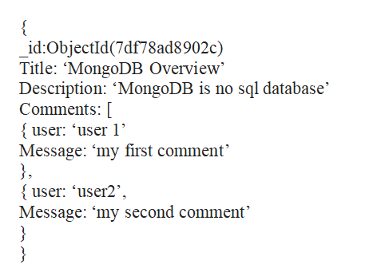

**Sample Document**

Above example shows the document structure of a blog site, which is simply a comma separated key value pair.

**Advantages of MongoDB**

Any relational database has a typical schema design that shows number of tables and the relationship between these tables. While in MongoDB, there is no concept of relationship. Advantages of MongoDB over RDBMS can be described as:

1. MongoDB is a document database in which one collection holds different documents. Number of fields, content and size of the document can differ from one document to another.
2. Structure of a single object is clear.
3. No complex joins.
4. Deep query ability. MongoDB supports dynamic queries on documents using a document-based query language that’s nearly as powerful as SQL.
5. Ease of scale out. MongoDB is easy to scale.
6. Conversion/mapping of application objects to database objects not needed.
7. Uses internal memory for storing the (windowed) working set, enabling faster access of data.

**Applications of MongoDB**

MongoDB has document oriented storage; data is stored in the form of JSON style documents. It can be indexed on any attributes. We can also explain where to use MongoDB:

* Big Data
* Content Management and Delivery
* Mobile and Social Infrastructure
* User Data Management
* Data Hub

**CONCLUSION:**  Thus we have studied Open Source NoSQL Databases Mongo DB.