

**WALCHAND INSTITUTE OF TECHNOLOGY**

**An Autonomous Institute**

**MINI PROJECT REPORT**

**VIBRATION SENSING AND PULSE LOGGING OF A MACHINE**

BY

**Mr. Pranam Bande(03)**

**Mr. Atharva Bitode(06)**

**Mr. Abdussamad Dadapure(13)**

**Mr. Shubham Gade(17)**

Under The Guidance of

Mr.Sunil Kalshetti

Department of

Electronics and Computer Engineering

**CERTIFICATE**

This is to certify that Mini Project Entitled

**VIBRATION SENSING AND PULSE LOGGING OF A MACHINE**

Submitted By

Mr. Pranam Bande 03

Mr. Atharva Bitode 06

Mr. Abdussamad Dadapure 13

Mr. Shubham Gade 17

has been approved as the partial fulfilment for the award of Third year of Electronics and Computer Engineering by PAH Solapur University, Solapur in the academic year 2023-24.

Mr. Sunil Kalshetti DR. S.R. Gengaje

Project Guide Head,Electronics Department

Dr. V.A. Athavale

Principal

**ACKNOWLEDGEMENT**

The project has certainly enlightened us with the modern era of Technologies and it has boosted our confidence. The project work has certainly rendered us tremendous learning as well as practical experience.

We are thankful to Dr.V.A.Athavale, Principal of W.I.T College, Dr. S.R.Gengaje Head of Electronics and Computer Engineering Department for granting permission to undertake this project.

We are very grateful to Mr. Sunil Kalshetti for their valuable guidance about hardware implementation and programming.

This project would not have been possible without the collective efforts and contributions of all individuals and entities mentioned above. We are truly grateful for their support and involvement in making this project a reality.

At last, but not least we are thankful to staff of Electronics & Computer Engineering Department W.I.T. Solapur.

**INDEX**

|  |  |  |
| --- | --- | --- |
| Sr. No. | Contents | Page No. |
| 1 | Introduction | 5 |
| 2 | Literature Review | 6 |
| 3 | Block Diagram | 7 |
| 4 | Components | 9 |
| 5 | Circuit Diagram | 11 |
| 6 | Software Flow Design | 13 |
| 7 | Application | 16 |
| 8 | Future Scope | 16 |
| 9 | Experiment Setup | 17 |
| 10 | Conclusion | 17 |

* **INTRODUCTION:**

In today's fast-paced industrial landscape, ensuring the seamless operation of machinery is essential for maintaining productivity and minimizing downtime. The ability to monitor the health of equipment in real-time has become a critical aspect of modern maintenance strategies. Vibration sensing technology, particularly through the utilization of sensors like the SW420, has emerged as a powerful tool in this regard, offering insights into the condition of machinery by detecting subtle changes in vibration patterns.

This project is centered around the development of a vibration sensing and logging system leveraging the SW420 sensor, tailored for monitoring the pulse of machines. With its compact size and high sensitivity, the SW420 sensor is well-suited for detecting even the slightest vibrations, providing crucial data for early detection of mechanical issues. By capturing and analyzing vibration data in real-time, this system aims to enable proactive maintenance interventions, thus preventing costly breakdowns and prolonging equipment lifespan.

This introduction sets the stage for exploring the design, implementation, and implications of the proposed vibration sensing and logging system utilizing the SW420 sensor. Through a combination of hardware and software components, including the SW420 sensor module, microcontrollers, and data logging mechanisms, the system aims to enhance equipment health monitoring, ultimately contributing to improved operational efficiency and cost-effectiveness in industrial settings.

* **LITERATURE REVIEW:**

Vibration sensing technology has gained significant traction in industrial applications due to its ability to provide valuable insights into machinery health. Research by Liu et al. (2019) emphasizes the importance of vibration analysis for condition monitoring, highlighting its role in detecting faults such as misalignment, bearing defects, and imbalance in rotating machinery. The study underscores the effectiveness of vibration sensors in identifying early signs of deterioration, enabling timely maintenance interventions to prevent catastrophic failures.

The SW420 sensor, known for its compact size and high sensitivity, has garnered attention in various fields for its versatility and reliability. A study by Gupta et al. (2020) explores the performance characteristics of the SW420 sensor in detecting vibrations and tilts, particularly in structural health monitoring applications. The research highlights the sensor's capability to detect subtle vibrations with minimal noise interference, making it suitable for monitoring the dynamic behavior of structures and machinery.

Real-time monitoring and data logging systems play a crucial role in capturing, storing, and analyzing vibration data for predictive maintenance purposes. Research by Zhang et al. (2018) discusses the design and implementation of a vibration monitoring system using wireless sensor networks for data transmission and cloud-based storage for data logging and analysis.

* **BLOCK DIAGRAM:**

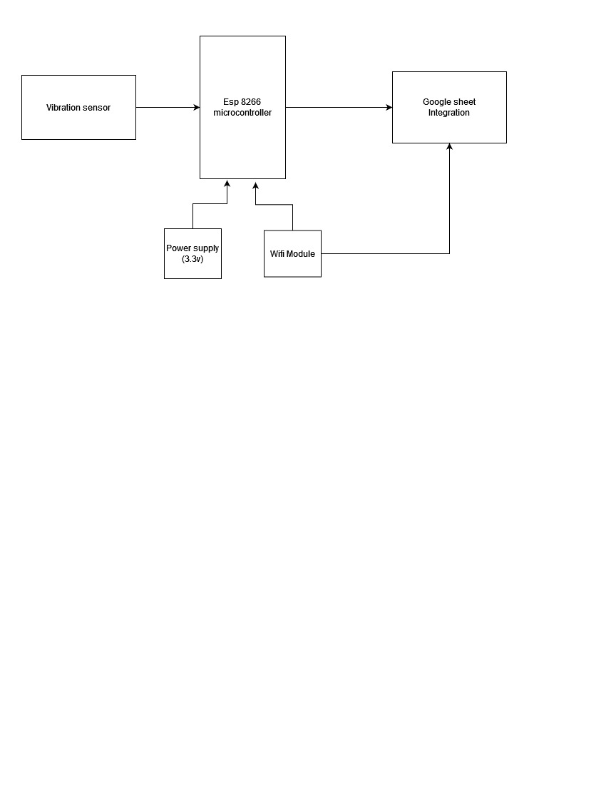

1. Vibration Sensor: [SW420]

This sensor detects vibrations or mechanical oscillations in its vicinity. It could be attached to a machine, structure, or any other object that experiences vibrations. The sensor acts as the input source for the system, providing data related to vibrations.

1. ESP8266 Microcontroller:

The ESP8266 is a WiFi-enabled microcontroller. It receives data from the vibration sensor and processes it. Its WiFi capability allows it to communicate wirelessly with other devices.

1. WiFi Module:

The WiFi module facilitates communication between the ESP8266 and external systems. It likely connects to a local WiFi network and enables data transmission. The module ensures seamless wireless communication within the system.

1. Google Sheets:

Google Sheets serves as the data storage and analysis platform. The data collected by the vibration sensor is integrated into Google Sheets. It allows for logging and visualization of sensor data. Researchers, engineers, or project managers can access and analyze the data for further insights.

* **COMPONENTS:**

1. **ESP 8266:**

The ESP8266, a compact and cost-effective Wi-Fi module by Espressif Systems, is renowned in maker and IoT communities for its versatility. Featuring an integrated TCP/IP protocol stack, it effortlessly connects to Wi-Fi networks, enabling seamless communication with other devices. Its GPIO pins facilitate interfacing with various sensors and peripherals. Programming through Arduino IDE or ESP-IDF is user-friendly. Its affordability, coupled with connectivity options, makes it perfect for remote monitoring, home automation, and smart devices. In this project, we exploit the ESP8266's Wi-Fi capabilities to develop a vibration sensing and logging system, integrating it with the SW420 sensor to enhance industrial operational efficiency and minimize downtime.

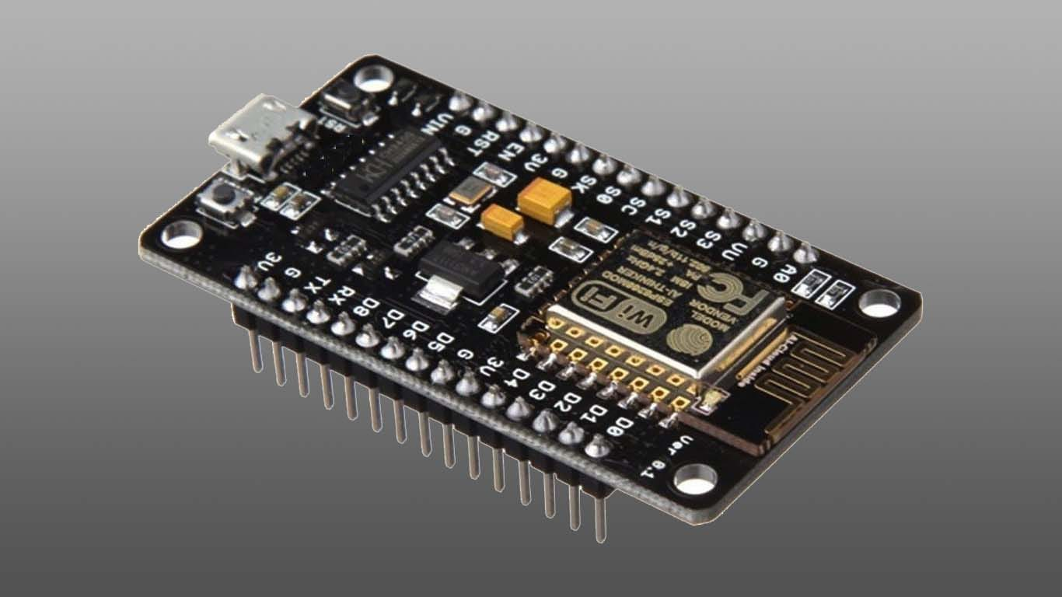

1. **SW 420:**

The SW420 sensor is a highly sensitive vibration and tilt detection module widely utilized for its compact design and remarkable performance. Developed for diverse applications, it boasts exceptional sensitivity, enabling the detection of even subtle vibrations. Its small form factor and low power consumption make it ideal for integration into various electronic systems. Leveraging its capabilities, the SW420 sensor is commonly employed in structural health monitoring, security systems, and industrial machinery monitoring. In this project, we harness the SW420 sensor's capabilities to develop a vibration sensing and logging system, aiming to enhance equipment health monitoring and minimize downtime in industrial settings.

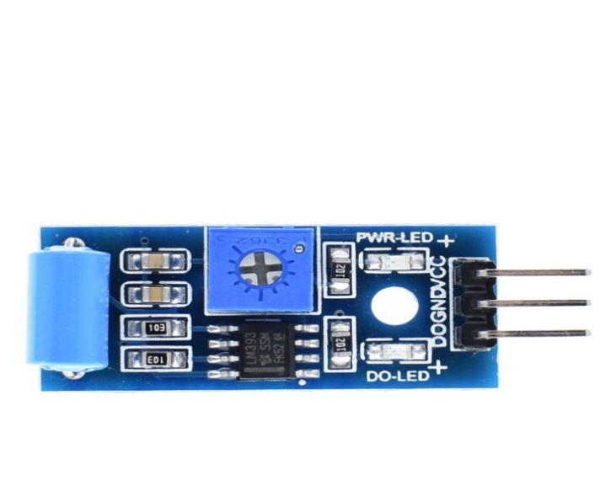

1. **LED:**

Light Emitting Diodes (LEDs) are semiconductor devices that emit light when an electric current passes through them. We explore the capabilities of LEDs and their applications in various contexts, from basic lighting to advanced lighting systems. By understanding the principles of LED operation and control, we aim to harness their potential for creating efficient, customizable, and innovative lighting solutions.

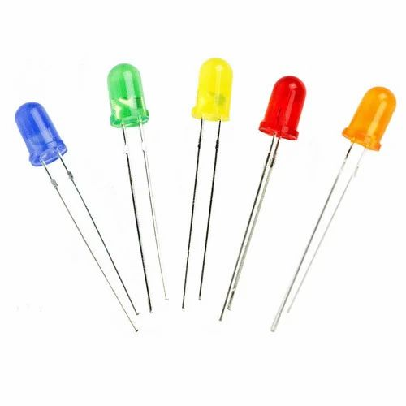

* **CIRCUIT DIAGRAM:**

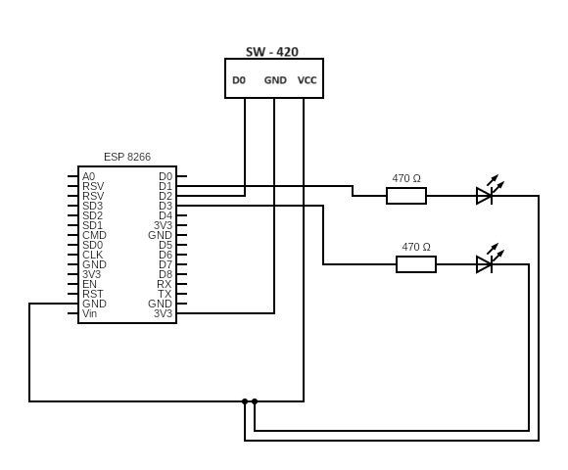

Working of the circuit:

First we have to connect the ESP 8266 to our computer and then upload the code into it through Arduino IDE. Once the code is uploaded on the Node MCU it starts working.

1.Sensing Vibration:

The vibration sensor detects mechanical vibrations and converts them into electrical signals. These signals are then fed into the signal conditioning circuitry.

2. Signal Conditioning: The raw signal from the sensor is conditioned to remove noise, amplify the signal if necessary, and make it suitable for processing by the Node MCU. If the vibration are more than the threshold then the HighLED will blink or else the LowLED will blink.

3. ESP 8266 Processing:

The conditioned signal is then fed into the ESP. The microcontroller can analyze the signal in real-time to detect patterns, measure the intensity of vibrations, and make decisions based on predefined criteria.

4. Data Logging:

The microcontroller logs the processed data into the memory storage. This could involve storing raw sensor data, processed data, timestamps, or any other relevant information depending on the application. After doing all this the data is logged onto google sheets with time stamp.

* **SOFTWAREFLOW DESIGN:**

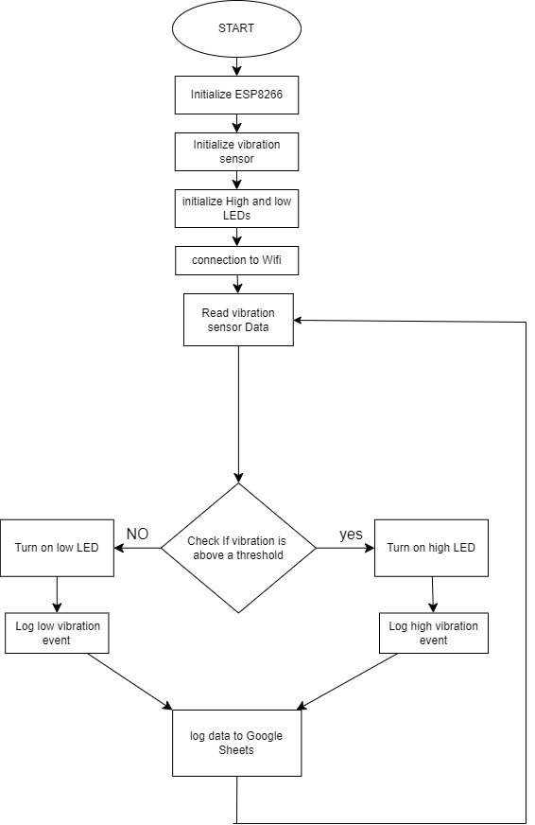

1. Initialization:

The process begins with initializing the ESP8266 microcontroller. This step ensures that the device is ready for operation.

Initialization may involve setting up pins, configuring parameters, and preparing the system for data collection.

2. Connect to Wi-Fi:

The ESP8266 establishes a connection to a Wi-Fi network. This is crucial for transmitting data and interacting with external services.

The flowchart shows a decision point based on whether the Wi-Fi connection is successful or not.

3. Sensor Initialization:

The SW-420 vibration sensor is initialized. This step involves configuring the sensor and preparing it to detect vibrations.

Sensor initialization may include setting thresholds, calibrating, and ensuring proper connections.

4. Read Vibration Data:

The ESP8266 continuously reads data from the SW-420 sensor.

The vibration data could be in the form of digital signals (e.g., HIGH or LOW) indicating vibration presence or intensity.

5. Threshold Check:

The flowchart includes a decision point where the vibration data is compared against a threshold.

If the vibration level exceeds the threshold, it indicates significant vibration.

6. LED Control:

Depending on the threshold check result, the ESP8266 controls LEDs:

If vibration is above the threshold, the high LED is turned on.

If vibration is below the threshold, the low LED is turned on.

This visual feedback helps indicate the vibration status.

7. Log Event to Google Sheets:

The flowchart shows a step where the event (vibration occurrence) is logged to Google Sheets.

This could involve sending data over Wi-Fi to a Google Sheets document for record-keeping or further analysis.

8. End:

The process concludes, and the ESP8266 may enter a low-power state or wait for the next cycle.

* **APPLICATIONS:**

1. Structural Health Monitoring:

In civil engineering, vibration sensing and logging are used to monitor the structural integrity of buildings, bridges, dams, and other infrastructure. By continuously monitoring vibrations, engineers can detect anomalies or structural weaknesses before they lead to catastrophic failures.

1. Machine Condition Monitoring:

Vibration sensing and logging can be used to monitor the health of rotating machinery such as motors, pumps, compressors, and turbines. Changes in vibration patterns can indicate issues such as misalignment, bearing wear, or imbalance, allowing for predictive maintenance to prevent costly breakdowns.

There are many more such industrial application for our project.

* **FUTURE SCOPE:**

1. Integration with Internet of Things (IoT): Connecting vibration sensors and pulse monitors to IoT platforms can enable remote monitoring and data analysis. Integration with IoT ecosystems can facilitate data sharing, centralized monitoring, and real-time alerts for anomalies or critical events. This could be particularly useful in industrial settings for predictive maintenance of machinery and equipment.

**2.Advanced Data Analytics:** Incorporating machine learning and AI algorithms for data analysis can enhance the capabilities of the system. These techniques can improve the accuracy of pulse detection, enable predictive analytics for identifying patterns or trends in vibration data, and help in anomaly detection for early warning of potential issues.

* **EXPERIMENT SETUP:**

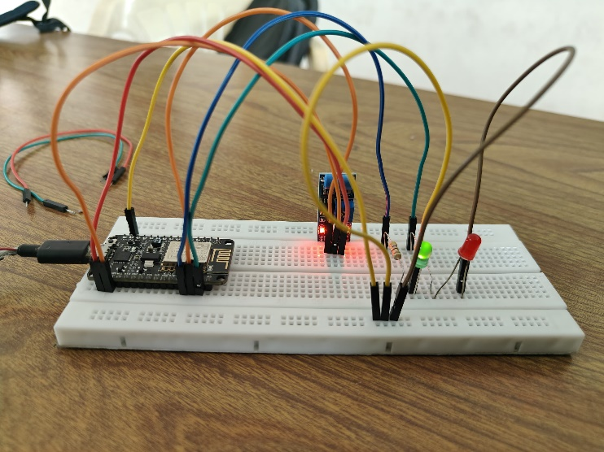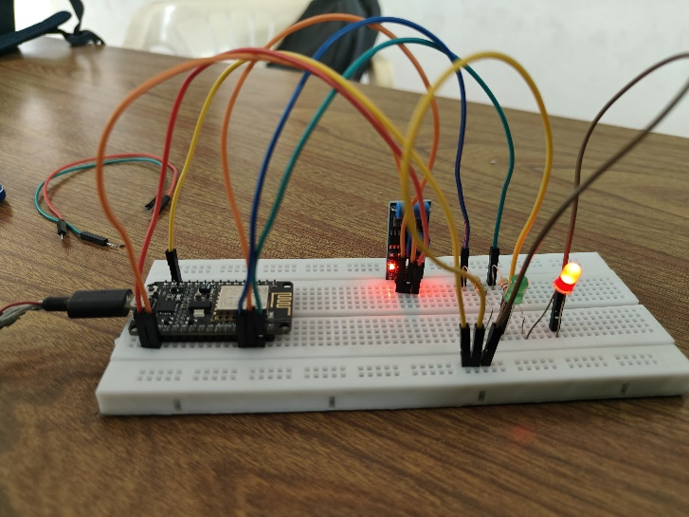

When the vibration is LOW When the vibration is HIGH

* **CONCLUSION:**

The vibration sensing and logging project showcased the importance and effectiveness of continuous monitoring in various industries. The insights gained from this project have practical implications for improving asset reliability, reducing maintenance costs, and enhancing operational efficiency. Moving forward, continued research and innovation in this field will contribute to the advancement of predictive maintenance strategies and overall asset management practices.