Project report on ADC PBL

Topic: AM and FM Modulation Simulation



Project report submitted to

Vishwakarma Institute of Information Technology, Pune.

**Department of Electronics and Telecommunication Engineering**

**AY 2024-25**

By

|  |  |  |  |
| --- | --- | --- | --- |
| **Name** | **PRN** | **Roll no.** | **Mail** |
| Atharva Suryavanshi | 22310847 | 211030 | [atharva.22310847@viit.ac.in](mailto:atharva.22310847@viit.ac.in) |
| Atharva Maslekar | 22310981 | 211037 | [atharva.22310981@viit.ac.in](mailto:atharva.22310981@viit.ac.in) |
| Sameer Chavan | 22311008 | 211039 | [sameer.22311008@viit.ac.in](mailto:sameer.22311008@viit.ac.in) |
| Atharva Rajendra Joshi | 22311496 | 211049 | [atharva.22311496@viit.ac.in](mailto:atharva.22311496@viit.ac.in) |

Div: A Batch: A2 Class: SY B.Tech

Faculty:

Prof.Milind Patil

# Abstract

This project presents a simulation and visualization of Amplitude Modulation **(AM)** and Frequency Modulation **(FM)** using Python programming. Modulation is a key aspect of communication systems, where message signals are superimposed on high-frequency carrier signals for efficient transmission. The main focus of this project is to demonstrate the behaviour and impact of varying the modulation index on both AM and FM signals through a real-time interactive interface. Python libraries such as Tkinter and Matplotlib are utilized for GUI creation and plotting. The developed simulation offers an effective learning tool for students and learners to grasp fundamental concepts of modulation intuitively and visually.

# Introduction

Analog modulation techniques are widely used in communication systems to transmit information over long distances. Modulation helps in adjusting a message signal to a frequency range suitable for transmission and also ensures better signal reception by minimizing noise and interference.

There are major two types of modulations used:

1. **AM i.e., Amplitude modulation**: Amplitude of the carrier signal is varied in accordance with the amplitude of the message signal.
2. **FM i.e., Frequency modulation**: Frequency of the carrier signal is varied as per the instantaneous amplitude of the message signal.

This project simulates these modulation types, emphasizing how the modulation index influences the resulting waveform. An interactive Python-based GUI provides a user-friendly interface for live experimentation.

# Design Constraints

Since this project is implemented as a software-based simulation using Python and matplotlib, the design does not involve physical components like resistors, capacitors, or transistors. Instead, we choose various signal parameters that influence the accuracy and clarity of the modulation visualization. Parameters which are used in the simulation are:

1. AM modulation index
2. FM modulation index
3. Message frequency for AM and FM
4. Carrier frequency

These software-based components mirror hardware functionality in a conceptual simulation. All of these parameters are set to be user-defined , so the user can vary any of these parameters interacting with the interface that we developed.

# Methodology

AM and FM both are methods used to encode information onto a carrier wave by varying either the amplitude or frequency of the carrier signal.

1. **AM (Amplitude Modulation)**: In AM, the **amplitude** of the carrier signal is varied in proportion to the message signal. The carrier wave's frequency remains constant.
2. **FM (Frequency Modulation)**: In FM, the **frequency** of the carrier wave is varied according to the amplitude of the message signal, while the amplitude of the carrier remains constant.

The goal of this project is to simulate both AM and FM modulation and visualize their waveforms in real time. The methodology involves the following steps:

1. **Setup the Python Environment**

We use Python because it offers easy-to-use libraries like **Tkinter** for the graphical interface and **Matplotlib** for plotting signals. **Matplotlib** is essential for plotting the modulated signals, while **Tkinter** helps us create an interactive graphical user interface (GUI).

1. **GUI Creation with Tkinter**

The user interface includes:

1. *Sliders*: For controlling parameters like carrier frequency, modulation frequency, and modulation depth. These sliders provide interactive control to dynamically adjust the modulation in real time.
   1. Carrier Frequency: Controls the frequency of the carrier wave.
   2. Modulation Frequency: Controls the frequency of the message (modulating) signal.
   3. Modulation Depth: Controls the amount of variation in the amplitude (for AM) or frequency (for FM).
2. *Canvas*: This will display the plotted modulated signal.
3. *Buttons*: To trigger the plotting of the modulated signals and reset parameters.
4. **Implementing the Mathematical Model**

The signals will be plotted using Matplotlib. Here’s how the signal generation and plotting flow works:

1. *User input*: The user adjusts sliders to set the parameters for carrier frequency, modulation frequency, and modulation depth.
2. *Signal computation*: Based on these inputs, the corresponding mathematical model (AM or FM) is applied to generate the modulated wave.
3. *Plotting:* The modulated wave is plotted on the Tkinter GUI canvas in real time.
4. **Testing and Evaluation**

Testing the system involves running the simulation with different modulation parameters and observing if:

1. The AM signal varies in amplitude according to the input.
2. The FM signal varies in frequency.
3. The GUI is responsive and accurately reflects the changes in the modulated signals.

# Results

The simulation performs effectively in demonstrating modulation behaviors:

* **In AM:**
  + Low modulation index results in slight amplitude changes.
  + Higher modulation index leads to noise and overlapping.
  + High modulation index causes deeper amplitude variations and possible overmodulation.
* **In FM:**
  + Low modulation index leads to narrowband FM.
  + High modulation index results in wideband FM with more pronounced frequency shifts.

**Initially**, we simulated AM and FM modulation using **fixed** **parameters** to build a clear foundational understanding of how modulation works. This involved setting predefined values for the message and carrier frequencies, as well as the modulation index, to generate consistent and easily interpretable waveforms. By observing these fixed-parameter simulations, we were able to verify the correctness of the modulation logic and ensure the visual distinction between AM and FM signals was accurately represented.

**Observations:**

* In AM systems, maintaining m≤1*m*≤1 ensures undistorted transmission and reception.
* In FM systems, choosing an optimal β*β* balances bandwidth usage and signal quality. For example, broadcast FM typically uses wideband FM with high fidelity, while narrowband FM is used in communication systems where bandwidth is limited

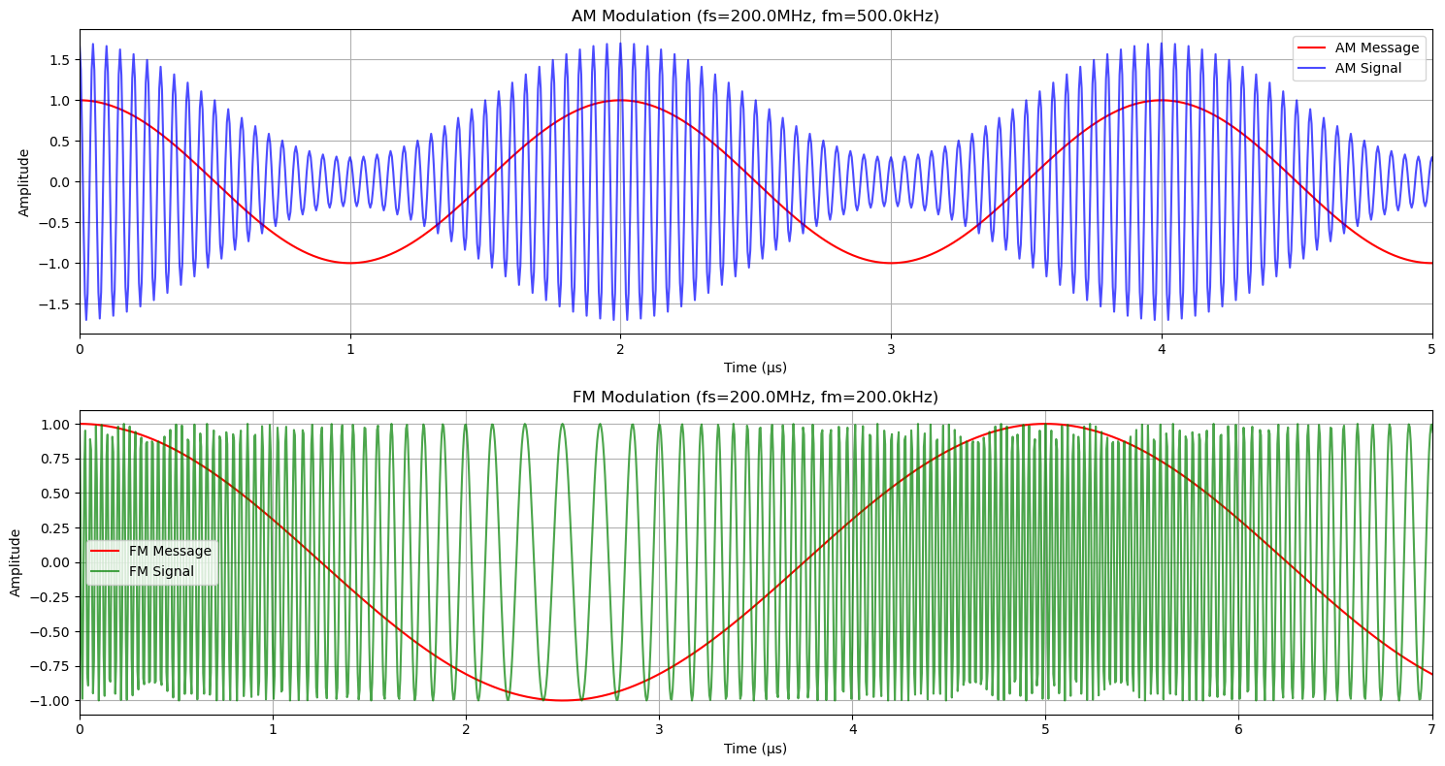

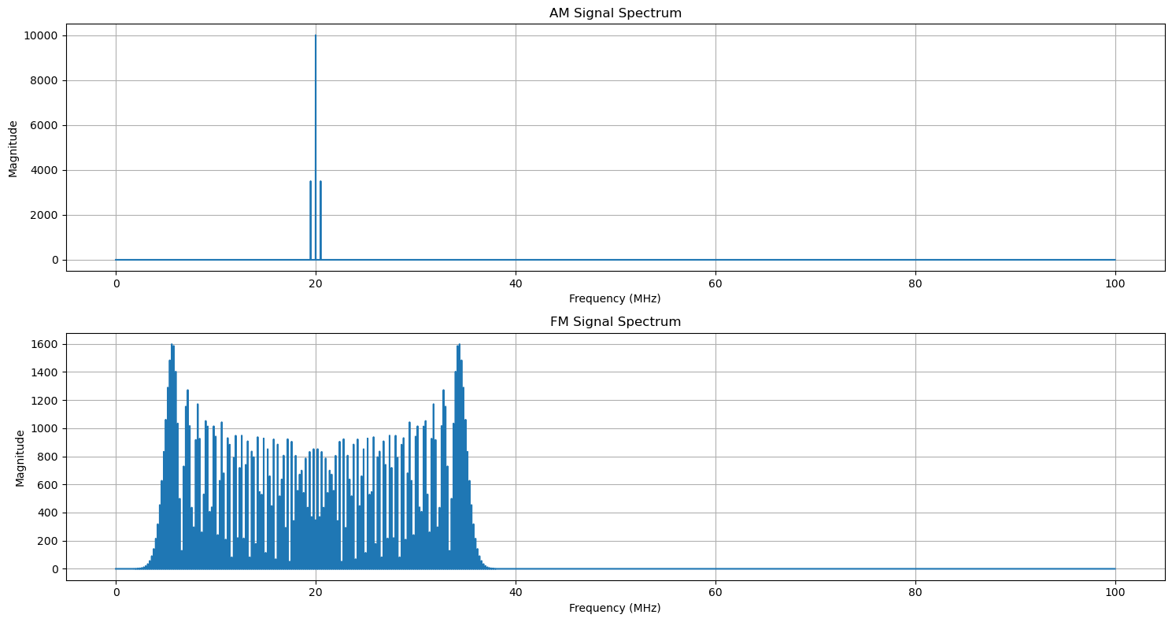

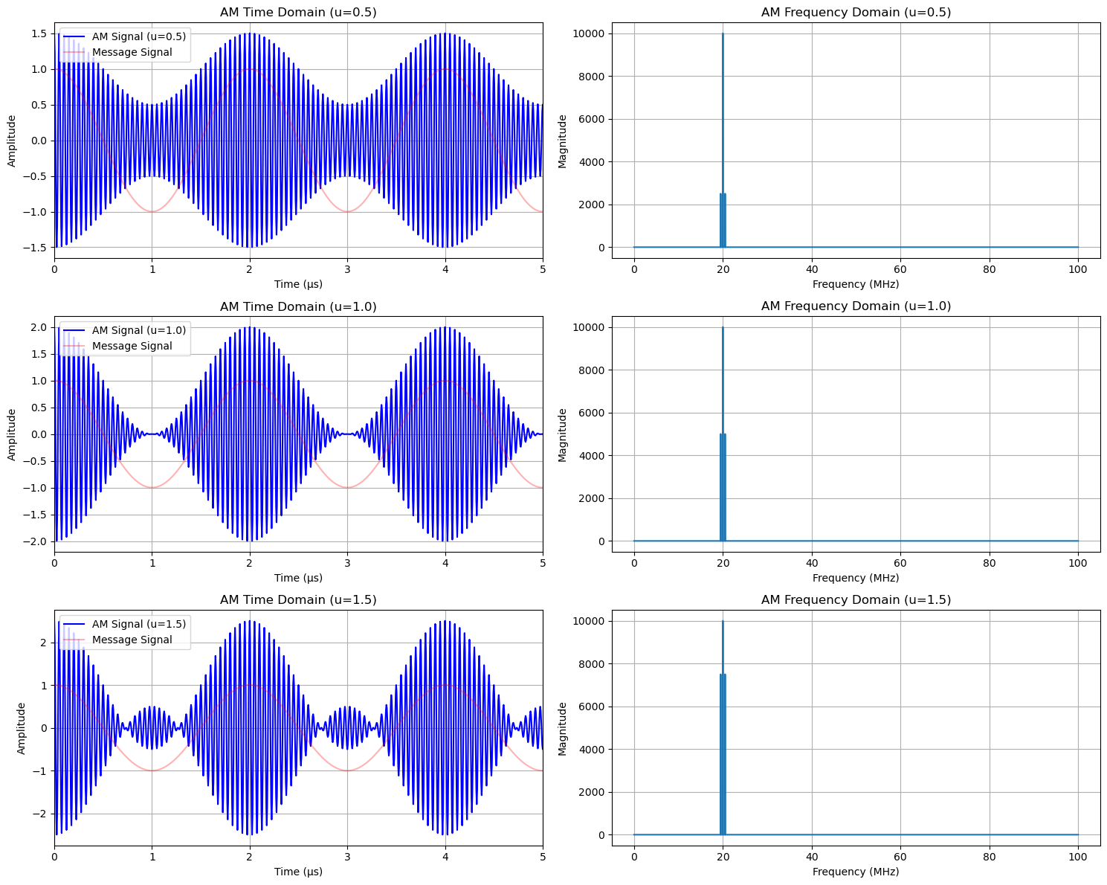

After verifying the initial simulations, we introduced interactive components such as **sliders** for adjusting the modulation index and **buttons** for setting and resetting purposes. These controls were implemented using Tkinter’s intuitive widget system, allowing users to dynamically modify parameters and instantly visualize their impact on the waveform.

**Observations:**

* Real-time updates enhance understanding.
* GUI improves interactivity and accessibility.
* Clear visual differentiation between AM and FM waveforms.

Following are the GUI views :

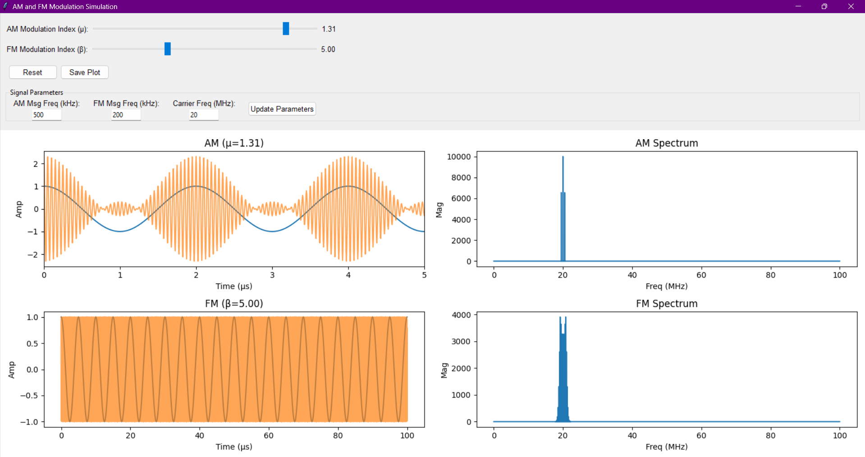

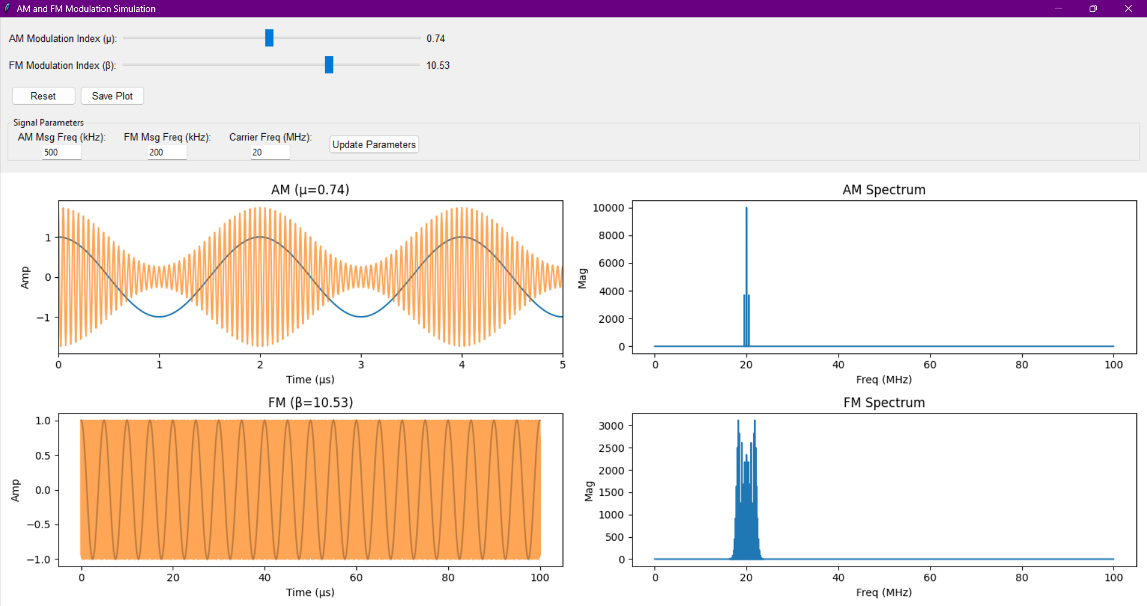

# Conclusion

This project successfully demonstrates the core concepts of amplitude and frequency modulation using Python and Matplotlib . By creating an interactive simulation, it provides users with the ability to observe how the modulation index influences signal characteristics. The use of Python, Tkinter, and Matplotlib ensures the project remains open-source, easy to use, and suitable for educational environments. Overall, the tool serves as a valuable aid in understanding modulation principles, helping in better understanding of the concepts.