Android Assignment 5

**Name :- Atharva Mahamuni**

**Enroll No :- 2002276**

--------------------------------------------------------------------------------

Q1. Create Following Table:

Emp (emp_no, emp_name, address, phone, salary)

Dept (dept_no, dept_name, location)

Emp-Dept is related with many-one relationship. Create a java android application for performing the following operations on the table.

(Using sqlite database)

1) Add Records into Emp and Dept table.

2) Accept Department name from User and delete employee information which belongs to that department.

MainActivity.java

package com.example.a5q1;

import androidx.appcompat.app.AlertDialog;

import androidx.appcompat.app.AppCompatActivity;

import android.database.Cursor;

import android.os.Bundle;

import android.view.View;

import android.widget.Button;

import android.widget.EditText;

import android.widget.Toast;

public class MainActivity extends AppCompatActivity {

Button empInsertBtn, deptInsertBtn, deleteBtn, viewEmpBtn, viewDeptBtn;

EditText empNo, empName, empAddr, empPhone, empSal, FK, deptNo, deptName, deptLoc;

@Override

protected void onCreate(Bundle savedInstanceState) {

super.onCreate(savedInstanceState);

setContentView(R.layout.activity_main);

empNo = findViewById(R.id.empNo);

empName = findViewById(R.id.empName);

empAddr = findViewById(R.id.empAddr);

empPhone = findViewById(R.id.empPhone);

empSal = findViewById(R.id.empSal);

FK = findViewById(R.id.FK);

deptNo = findViewById(R.id.deptNo);

deptName = findViewById(R.id.deptName);

deptLoc = findViewById(R.id.deptLoc);

empInsertBtn = findViewById(R.id.empInsertBtn);

deptInsertBtn = findViewById(R.id.deptInsertBtn);

deleteBtn = findViewById(R.id.deleteBtn);

viewEmpBtn = findViewById(R.id.viewEmpBtn);

viewDeptBtn = findViewById(R.id.viewDeptBtn);

DatabaseHandler db = new DatabaseHandler(this);

empInsertBtn.setOnClickListener(new View.OnClickListener() {

@Override

public void onClick(View v) {

String empNotxt = empNo.getText().toString();

String empNametxt = empName.getText().toString();

String empAddrtxt = empAddr.getText().toString();

String empPhonetxt = empPhone.getText().toString();

String empSaltxt = empSal.getText().toString();

String FKtxt = FK.getText().toString();

boolean insertResult = db.insertEmpRecord(empNotxt, empNametxt, empAddrtxt, empPhonetxt, empSaltxt, FKtxt);

if(insertResult == true) {

Toast.makeText(MainActivity.this, "Record inserted successfully!", Toast.LENGTH_LONG).show();

}

else {

Toast.makeText(MainActivity.this, "Record not inserted!", Toast.LENGTH_LONG).show();

}

}

});

deptInsertBtn.setOnClickListener(new View.OnClickListener() {

@Override

public void onClick(View v) {

String deptNotxt = deptNo.getText().toString();

String deptNametxt = deptName.getText().toString();

String deptLoctxt = deptLoc.getText().toString();

boolean insertResult = db.insertDeptRecord(deptNotxt, deptNametxt, deptLoctxt);

if(insertResult == true) {

Toast.makeText(MainActivity.this, "Record inserted successfully!", Toast.LENGTH_LONG).show();

}

else {

Toast.makeText(MainActivity.this, "Record not inserted!", Toast.LENGTH_LONG).show();

}

}

});

viewEmpBtn.setOnClickListener(new View.OnClickListener() {

@Override

public void onClick(View v) {

Cursor curResult = db.getData1();

if(curResult.getCount()==0) {

Toast.makeText(MainActivity.this, " Employee table is empty !", Toast.LENGTH_LONG).show();

return;

}

StringBuffer buffer = new StringBuffer();

while (curResult.moveToNext()) {

buffer.append("EmpNo: " + curResult.getString(0)+ "\n");

buffer.append("EmpName: " + curResult.getString(1)+ "\n");

buffer.append("Address: " + curResult.getString(2)+ "\n");

buffer.append("Phone No.: " + curResult.getString(3)+ "\n");

buffer.append("Salary: " + curResult.getString(4)+ "\n");

buffer.append("Dept_no:" + curResult.getString(5)+ "\n\n");

}

AlertDialog.Builder builder = new AlertDialog.Builder(MainActivity.this);

builder.setCancelable(true);

builder.setTitle("Employee data: ");

builder.setMessage(buffer);

builder.show();

}

});

viewDeptBtn.setOnClickListener(new View.OnClickListener() {

@Override

public void onClick(View v) {

Cursor curResult = db.getData2();

if(curResult.getCount()==0) {

Toast.makeText(MainActivity.this, " Department table is empty !", Toast.LENGTH_LONG).show();

return;

}

StringBuffer buffer = new StringBuffer();

while (curResult.moveToNext()) {

buffer.append("Dept_No: " + curResult.getString(0)+ "\n");

buffer.append("Dept_Name: " + curResult.getString(1)+ "\n");

buffer.append("Dept_Loc: " + curResult.getString(2)+ "\n\n");

}

AlertDialog.Builder builder = new AlertDialog.Builder(MainActivity.this);

builder.setCancelable(true);

builder.setTitle("Department data: ");

builder.setMessage(buffer);

builder.show();

}

});

deleteBtn.setOnClickListener(new View.OnClickListener() {

@Override

public void onClick(View v) {

String deptNotxt = deptNo.getText().toString();

Boolean deleteData = db.deleteData(deptNotxt);

if(deleteData == true)

{

Toast.makeText(MainActivity.this,"Employee Deleted successfully",Toast.LENGTH_LONG).show();

}

else

{

Toast.makeText(MainActivity.this," NOT deleted ",Toast.LENGTH_LONG).show();

}

}

});

}

}

DatabaseHandler.java

package com.example.a5q1;

import android.content.ContentValues;

import android.content.Context;

import android.database.Cursor;

import android.database.sqlite.SQLiteDatabase;

import android.database.sqlite.SQLiteOpenHelper;

import androidx.annotation.Nullable;

public class DatabaseHandler extends SQLiteOpenHelper {

public DatabaseHandler(@Nullable Context context) {

super(context, "Emp_Dept_DB", null, 1);

}

@Override

public void onCreate(SQLiteDatabase db) {

db.execSQL("create table employee(emp_no INTEGER primary key, emp_name VARCHAR(30), address TEXT, phone INTEGER, salary FLOAT, dept_no INTEGER NOT NULL, FOREIGN KEY (dept_no) REFERENCES department(dept_no))");

db.execSQL("create table department(dept_no INTEGER primary key, dept_name VARCHAR(30), location VARCHAR(20))");

}

@Override

public void onUpgrade(SQLiteDatabase db, int oldVersion, int newVersion) {

db.execSQL("DROP table if exists employee");

db.execSQL("DROP table if exists department");

}

public boolean insertEmpRecord(String eno, String ename, String eaddr, String ephone, String esal, String fk_dept_no) {

SQLiteDatabase sqldb = this.getWritableDatabase();

ContentValues cv = new ContentValues();

cv.put("emp_no", eno);

cv.put("emp_name", ename);

cv.put("address", eaddr);

cv.put("phone", ephone);

cv.put("salary", esal);

cv.put("dept_no", fk_dept_no);

long result = sqldb.insert("employee", null, cv);

if(result == -1) {

return false;

}

else {

return true;

}

}

public boolean insertDeptRecord(String dno, String dname, String dloc) {

SQLiteDatabase sqldb = this.getWritableDatabase();

ContentValues cv = new ContentValues();

cv.put("dept_no", dno);

cv.put("dept_name", dname);

cv.put("location", dloc);

long result = sqldb.insert("department", null, cv);

if(result == -1) {

return false;

}

else {

return true;

}

}

public Cursor getData1() {

SQLiteDatabase sqldb = this.getWritableDatabase();

Cursor cursor = sqldb.rawQuery("Select * from employee", null);

return cursor;

}

public Cursor getData2() {

SQLiteDatabase sqldb = this.getWritableDatabase();

Cursor cursor = sqldb.rawQuery("Select * from department", null);

return cursor;

}

public boolean deleteData(String dept_No) {

SQLiteDatabase db=this.getWritableDatabase();

Cursor cursor=db.rawQuery("Select * from employee where dept_no=?",new String[]{dept_No});

if(cursor.getCount()>0) {

long result = db.delete("employee", "dept_no=?", new String[]{dept_No});

if (result == -1) {

return false;

} else {

return true;

}

}

else

{

return false;

}

}

}

Activity_main.xml

<?xml version="1.0" encoding="utf-8"?>

<androidx.constraintlayout.widget.ConstraintLayout xmlns:android="http://schemas.android.com/apk/res/android"

xmlns:app="http://schemas.android.com/apk/res-auto"

xmlns:tools="http://schemas.android.com/tools"

android:layout_width="match_parent"

android:layout_height="match_parent"

tools:context=".MainActivity">

<TextView

android:id="@+id/textView"

android:layout_width="416dp"

android:layout_height="34dp"

android:layout_marginTop="16dp"

android:text="Employee-Department DB"

android:textAlignment="center"

android:textColor="#000000"

android:textSize="22sp"

android:textStyle="normal"

app:layout_constraintEnd_toEndOf="parent"

app:layout_constraintHorizontal_bias="0.666"

app:layout_constraintStart_toStartOf="parent"

app:layout_constraintTop_toTopOf="parent" />

<TextView

android:id="@+id/textView2"

android:layout_width="100dp"

android:layout_height="32dp"

android:layout_marginTop="28dp"

android:text="Employee :"

android:textColor="#000000"

android:textSize="20sp"

app:layout_constraintEnd_toEndOf="parent"

app:layout_constraintHorizontal_bias="0.051"

app:layout_constraintStart_toStartOf="parent"

app:layout_constraintTop_toBottomOf="@+id/textView" />

<TextView

android:id="@+id/textView3"

android:layout_width="118dp"

android:layout_height="29dp"

android:layout_marginTop="28dp"

android:text="Department :"

android:textColor="#000000"

android:textSize="20sp"

app:layout_constraintEnd_toEndOf="parent"

app:layout_constraintHorizontal_bias="0.054"

app:layout_constraintStart_toStartOf="parent"

app:layout_constraintTop_toBottomOf="@+id/FK" />

<EditText

android:id="@+id/empNo"

android:layout_width="wrap_content"

android:layout_height="wrap_content"

android:ems="10"

android:hint="Emp No."

android:inputType="number"

app:layout_constraintEnd_toEndOf="parent"

app:layout_constraintHorizontal_bias="0.079"

app:layout_constraintStart_toStartOf="parent"

app:layout_constraintTop_toBottomOf="@+id/textView2" />

<EditText

android:id="@+id/empName"

android:layout_width="wrap_content"

android:layout_height="wrap_content"

android:ems="10"

android:hint="Emp Name "

android:inputType="textPersonName"

app:layout_constraintEnd_toEndOf="parent"

app:layout_constraintHorizontal_bias="0.079"

app:layout_constraintStart_toStartOf="parent"

app:layout_constraintTop_toBottomOf="@+id/empNo" />

<EditText

android:id="@+id/empAddr"

android:layout_width="wrap_content"

android:layout_height="wrap_content"

android:ems="10"

android:hint="Address"

android:inputType="textPersonName"

app:layout_constraintEnd_toEndOf="parent"

app:layout_constraintHorizontal_bias="0.079"

app:layout_constraintStart_toStartOf="parent"

app:layout_constraintTop_toBottomOf="@+id/empName" />

<EditText

android:id="@+id/empPhone"

android:layout_width="wrap_content"

android:layout_height="wrap_content"

android:ems="10"

android:hint="Phone"

android:inputType="number"

app:layout_constraintEnd_toEndOf="parent"

app:layout_constraintHorizontal_bias="0.079"

app:layout_constraintStart_toStartOf="parent"

app:layout_constraintTop_toBottomOf="@+id/empAddr" />

<EditText

android:id="@+id/empSal"

android:layout_width="wrap_content"

android:layout_height="wrap_content"

android:ems="10"

android:hint="Salary"

android:inputType="textPersonName"

app:layout_constraintEnd_toEndOf="parent"

app:layout_constraintHorizontal_bias="0.079"

app:layout_constraintStart_toStartOf="parent"

app:layout_constraintTop_toBottomOf="@+id/empPhone" />

<EditText

android:id="@+id/FK"

android:layout_width="wrap_content"

android:layout_height="wrap_content"

android:ems="10"

android:hint="Dept No."

android:inputType="number"

app:layout_constraintEnd_toEndOf="parent"

app:layout_constraintHorizontal_bias="0.079"

app:layout_constraintStart_toStartOf="parent"

app:layout_constraintTop_toBottomOf="@+id/empSal" />

<EditText

android:id="@+id/deptNo"

android:layout_width="wrap_content"

android:layout_height="wrap_content"

android:ems="10"

android:hint="Dept No."

android:inputType="number"

app:layout_constraintEnd_toEndOf="parent"

app:layout_constraintHorizontal_bias="0.079"

app:layout_constraintStart_toStartOf="parent"

app:layout_constraintTop_toBottomOf="@+id/textView3" />

<EditText

android:id="@+id/deptName"

android:layout_width="wrap_content"

android:layout_height="wrap_content"

android:ems="10"

android:hint="Dept Name"

android:inputType="textPersonName"

app:layout_constraintEnd_toEndOf="parent"

app:layout_constraintHorizontal_bias="0.079"

app:layout_constraintStart_toStartOf="parent"

app:layout_constraintTop_toBottomOf="@+id/deptNo" />

<EditText

android:id="@+id/deptLoc"

android:layout_width="wrap_content"

android:layout_height="wrap_content"

android:ems="10"

android:hint="Location"

android:inputType="textPersonName"

app:layout_constraintEnd_toEndOf="parent"

app:layout_constraintHorizontal_bias="0.079"

app:layout_constraintStart_toStartOf="parent"

app:layout_constraintTop_toBottomOf="@+id/deptName" />

<Button

android:id="@+id/empInsertBtn"

android:layout_width="137dp"

android:layout_height="58dp"

android:text="Insert into Emp"

android:textSize="13sp"

app:layout_constraintBottom_toBottomOf="parent"

app:layout_constraintEnd_toEndOf="parent"

app:layout_constraintHorizontal_bias="0.604"

app:layout_constraintStart_toEndOf="@+id/empAddr"

app:layout_constraintTop_toBottomOf="@+id/textView"

app:layout_constraintVertical_bias="0.258" />

<Button

android:id="@+id/deptInsertBtn"

android:layout_width="123dp"

android:layout_height="64dp"

android:text="Insert into Dept"

android:textSize="13sp"

app:layout_constraintBottom_toTopOf="@+id/deleteBtn"

app:layout_constraintEnd_toEndOf="parent"

app:layout_constraintHorizontal_bias="0.645"

app:layout_constraintStart_toEndOf="@+id/deptNo"

app:layout_constraintTop_toBottomOf="@+id/textView3"

app:layout_constraintVertical_bias="0.158" />

<Button

android:id="@+id/viewEmpBtn"

android:layout_width="wrap_content"

android:layout_height="wrap_content"

android:layout_marginTop="56dp"

android:text="View Employee"

app:backgroundTint="#00897B"

app:layout_constraintBottom_toBottomOf="parent"

app:layout_constraintEnd_toEndOf="parent"

app:layout_constraintHorizontal_bias="0.129"

app:layout_constraintStart_toStartOf="parent"

app:layout_constraintTop_toBottomOf="@+id/deptLoc"

app:layout_constraintVertical_bias="0.0" />

<Button

android:id="@+id/viewDeptBtn"

android:layout_width="wrap_content"

android:layout_height="wrap_content"

android:layout_marginTop="56dp"

android:text="View Department"

app:backgroundTint="#00897B"

app:layout_constraintBottom_toBottomOf="parent"

app:layout_constraintEnd_toEndOf="parent"

app:layout_constraintHorizontal_bias="0.892"

app:layout_constraintStart_toStartOf="parent"

app:layout_constraintTop_toBottomOf="@+id/deptLoc"

app:layout_constraintVertical_bias="0.0" />

<Button

android:id="@+id/deleteBtn"

android:layout_width="120dp"

android:layout_height="61dp"

android:layout_marginStart="8dp"

android:layout_marginLeft="8dp"

android:layout_marginBottom="56dp"

android:text="Delete Employee"

android:textSize="13sp"

app:backgroundTint="#C62828"

app:layout_constraintBottom_toTopOf="@+id/viewEmpBtn"

app:layout_constraintEnd_toEndOf="parent"

app:layout_constraintHorizontal_bias="0.561"

app:layout_constraintStart_toEndOf="@+id/deptName" />

</androidx.constraintlayout.widget.ConstraintLayout>

Output:

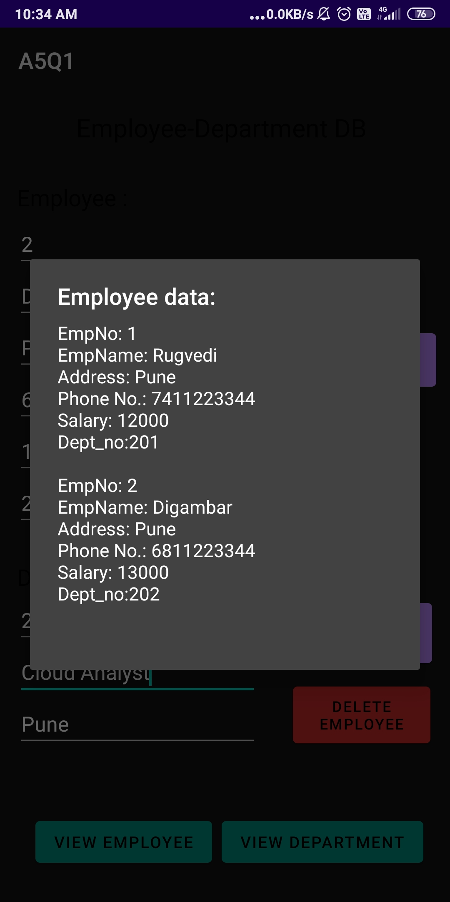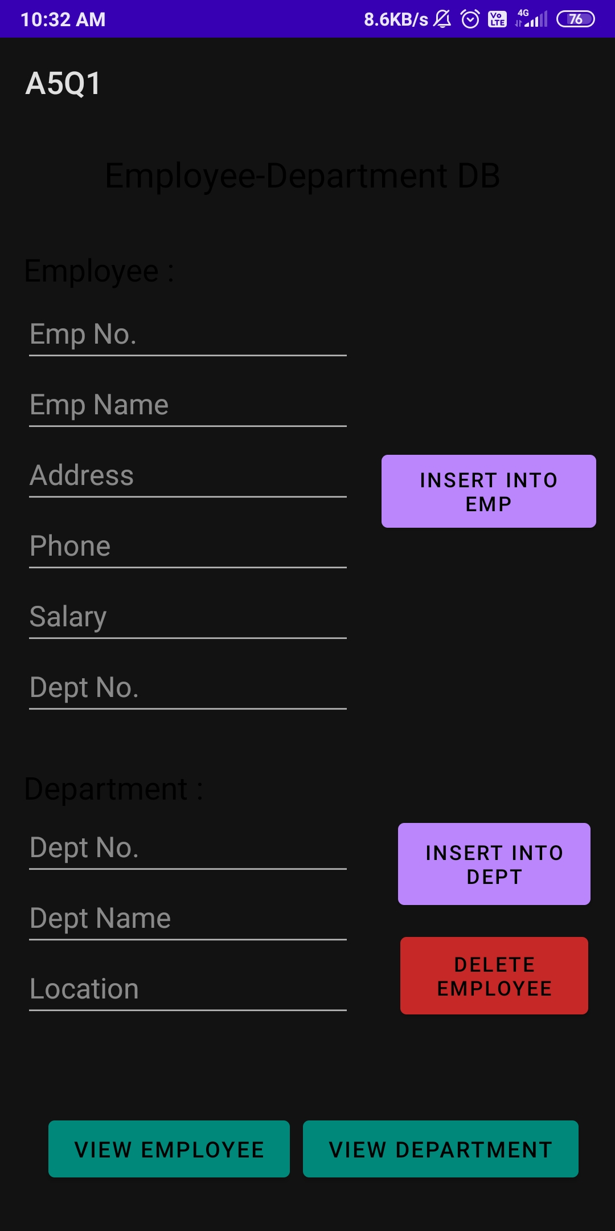

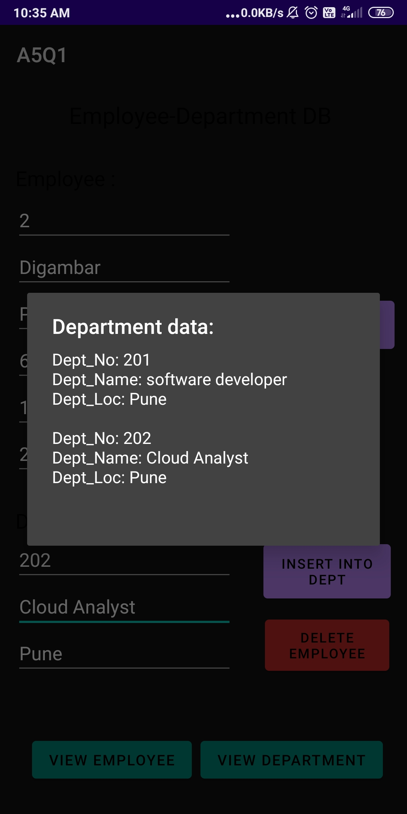After Deleting

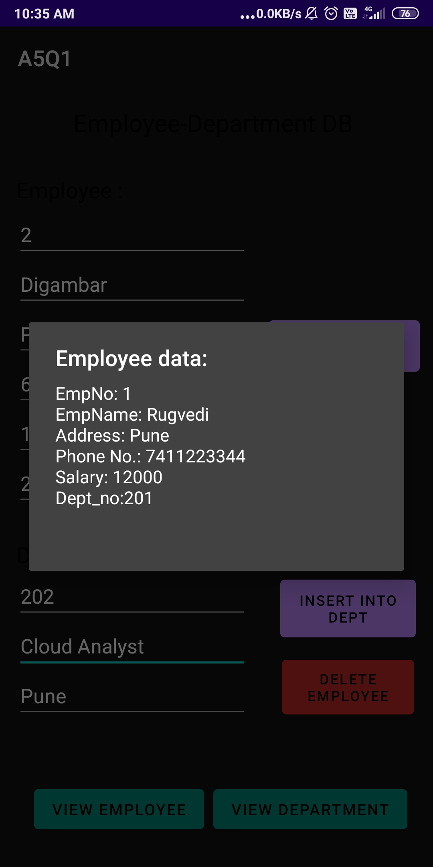

2. Create table Customer (id, name, address, phno). Create a java android application for Performing the following operations on the table.

(using sqlite database)

i) Insert New Customer Details.

ii) Show All the Customer Details

MainActivity.java

package com.example.a5q2;

import androidx.appcompat.app.AlertDialog;

import androidx.appcompat.app.AppCompatActivity;

import android.database.Cursor;

import android.os.Bundle;

import android.view.View;

import android.widget.Button;

import android.widget.TextView;

import android.widget.Toast;

public class MainActivity extends AppCompatActivity {

Button insertBtn, showbtn;

TextView id, name, addr, phoneno;

@Override

protected void onCreate(Bundle savedInstanceState) {

super.onCreate(savedInstanceState);

setContentView(R.layout.activity_main);

insertBtn = findViewById(R.id.insertBtn);

showbtn = findViewById(R.id.showBtn);

id = findViewById(R.id.custId);

name = findViewById(R.id.custName);

addr = findViewById(R.id.custAddr);

phoneno = findViewById(R.id.custPhone);

DatabaseHandler db = new DatabaseHandler(this);

insertBtn.setOnClickListener(new View.OnClickListener() {

@Override

public void onClick(View v) {

String custID = id.getText().toString();

String custName = name.getText().toString();

String custAddr = addr.getText().toString();

String custPhone = phoneno.getText().toString();

boolean insertResult = db.insertRecord(custID,custName,custAddr,custPhone);

if(insertResult == true) {

Toast.makeText(MainActivity.this, "Record inserted successfully!", Toast.LENGTH_SHORT).show();

}

else {

Toast.makeText(MainActivity.this, "Record not inserted!", Toast.LENGTH_SHORT).show();

}

}

});

showbtn.setOnClickListener(new View.OnClickListener() {

@Override

public void onClick(View v) {

Cursor curResult = db.getData();

if(curResult.getCount()==0) {

Toast.makeText(MainActivity.this, "Customer table is empty!", Toast.LENGTH_SHORT).show();

return;

}

StringBuffer buffer = new StringBuffer();

while (curResult.moveToNext()) {

buffer.append("ID: " + curResult.getString(0)+ "\n");

buffer.append("Name: " + curResult.getString(1)+ "\n");

buffer.append("Address: " + curResult.getString(2)+ "\n");

buffer.append("Phone No.: " + curResult.getString(3)+ "\n\n");

}

AlertDialog.Builder builder = new AlertDialog.Builder(MainActivity.this);

builder.setCancelable(true);

builder.setTitle("Your data: ");

builder.setMessage(buffer);

builder.show();

}

});

}

}

DatabaseHandler.java

package com.example.a5q2;

import android.content.ContentValues;

import android.content.Context;

import android.database.Cursor;

import android.database.sqlite.SQLiteDatabase;

import android.database.sqlite.SQLiteOpenHelper;

import androidx.annotation.Nullable;

public class DatabaseHandler extends SQLiteOpenHelper {

public DatabaseHandler(@Nullable Context context) {

super(context, "customerDB", null, 1);

}

@Override

public void onCreate(SQLiteDatabase db) {

db.execSQL("create table customer(id VARCHAR(20) primary key, name TEXT, address TEXT, phno INTEGER)");

}

@Override

public void onUpgrade(SQLiteDatabase db, int oldVersion, int newVersion) {

db.execSQL("DROP table if exists customer");

}

public boolean insertRecord(String cid, String cname, String caddr, String cphone) {

SQLiteDatabase sqldb = this.getWritableDatabase();

ContentValues cv = new ContentValues();

cv.put("id", cid);

cv.put("name", cname);

cv.put("address", caddr);

cv.put("phno", cphone);

long result = sqldb.insert("customer", null, cv);

if(result == -1) {

return false;

}

else {

return true;

}

}

public Cursor getData() {

SQLiteDatabase sqldb = this.getWritableDatabase();

Cursor cursor = sqldb.rawQuery("Select * from customer", null);

return cursor;

}

}

Activity_main.xml

<?xml version="1.0" encoding="utf-8"?>

<androidx.constraintlayout.widget.ConstraintLayout xmlns:android="http://schemas.android.com/apk/res/android"

xmlns:app="http://schemas.android.com/apk/res-auto"

xmlns:tools="http://schemas.android.com/tools"

android:layout_width="match_parent"

android:layout_height="match_parent"

tools:context=".MainActivity">

<EditText

android:id="@+id/custAddr"

android:layout_width="365dp"

android:layout_height="44dp"

android:layout_marginTop="20dp"

android:ems="10"

android:hint="Address"

android:inputType="textPersonName"

android:textSize="22sp"

android:textStyle="normal"

app:layout_constraintEnd_toEndOf="parent"

app:layout_constraintHorizontal_bias="0.347"

app:layout_constraintStart_toStartOf="parent"

app:layout_constraintTop_toBottomOf="@+id/custName" />

<EditText

android:id="@+id/custPhone"

android:layout_width="365dp"

android:layout_height="44dp"

android:layout_marginTop="20dp"

android:ems="10"

android:hint="Phone No."

android:inputType="number"

android:textSize="22sp"

android:textStyle="normal"

app:layout_constraintEnd_toEndOf="parent"

app:layout_constraintHorizontal_bias="0.347"

app:layout_constraintStart_toStartOf="parent"

app:layout_constraintTop_toBottomOf="@+id/custAddr" />

<EditText

android:id="@+id/custId"

android:layout_width="365dp"

android:layout_height="44dp"

android:layout_marginTop="28dp"

android:ems="10"

android:hint="Customer ID"

android:inputType="textPersonName"

android:textSize="22sp"

android:textStyle="normal"

app:layout_constraintEnd_toEndOf="parent"

app:layout_constraintHorizontal_bias="0.347"

app:layout_constraintStart_toStartOf="parent"

app:layout_constraintTop_toBottomOf="@+id/textView" />

<EditText

android:id="@+id/custName"

android:layout_width="365dp"

android:layout_height="44dp"

android:layout_marginTop="20dp"

android:ems="10"

android:hint="Name"

android:inputType="textPersonName"

android:textSize="22sp"

android:textStyle="normal"

app:layout_constraintEnd_toEndOf="parent"

app:layout_constraintHorizontal_bias="0.347"

app:layout_constraintStart_toStartOf="parent"

app:layout_constraintTop_toBottomOf="@+id/custId" />

<TextView

android:id="@+id/textView"

android:layout_width="213dp"

android:layout_height="33dp"

android:layout_marginTop="52dp"

android:text="Customer DB"

android:textAlignment="center"

android:textSize="22sp"

android:textStyle="normal|bold"

app:layout_constraintEnd_toEndOf="parent"

app:layout_constraintStart_toStartOf="parent"

app:layout_constraintTop_toTopOf="parent" />

<Button

android:id="@+id/insertBtn"

android:layout_width="158dp"

android:layout_height="51dp"

android:text="Insert"

android:textSize="21sp"

app:layout_constraintBottom_toTopOf="@+id/showBtn"

app:layout_constraintEnd_toEndOf="parent"

app:layout_constraintStart_toStartOf="parent"

app:layout_constraintTop_toBottomOf="@+id/custPhone"

app:layout_constraintVertical_bias="0.621" />

<Button

android:id="@+id/showBtn"

android:layout_width="362dp"

android:layout_height="52dp"

android:layout_marginBottom="216dp"

android:text="Show Customer Records "

android:textSize="21sp"

app:layout_constraintBottom_toBottomOf="parent"

app:layout_constraintEnd_toEndOf="parent"

app:layout_constraintStart_toStartOf="parent" />

</androidx.constraintlayout.widget.ConstraintLayout>

Output:

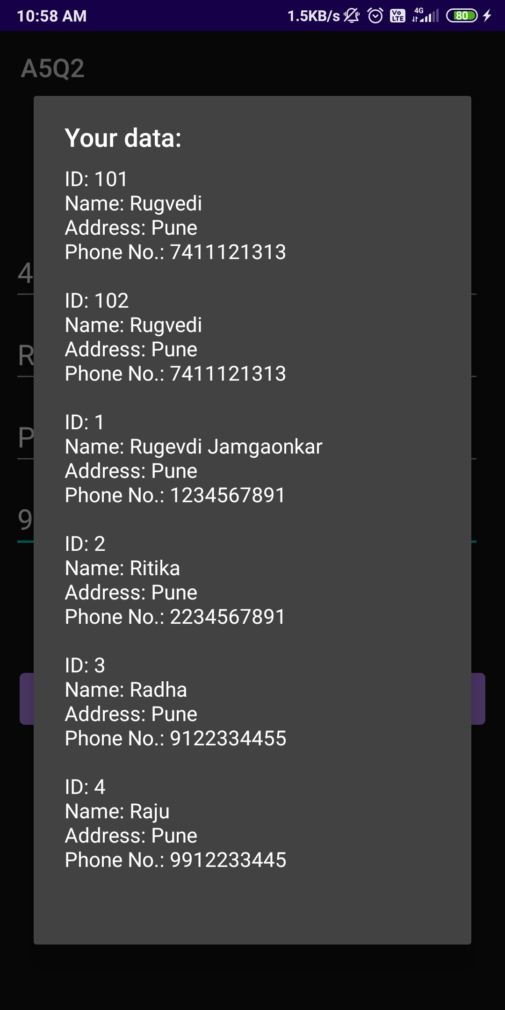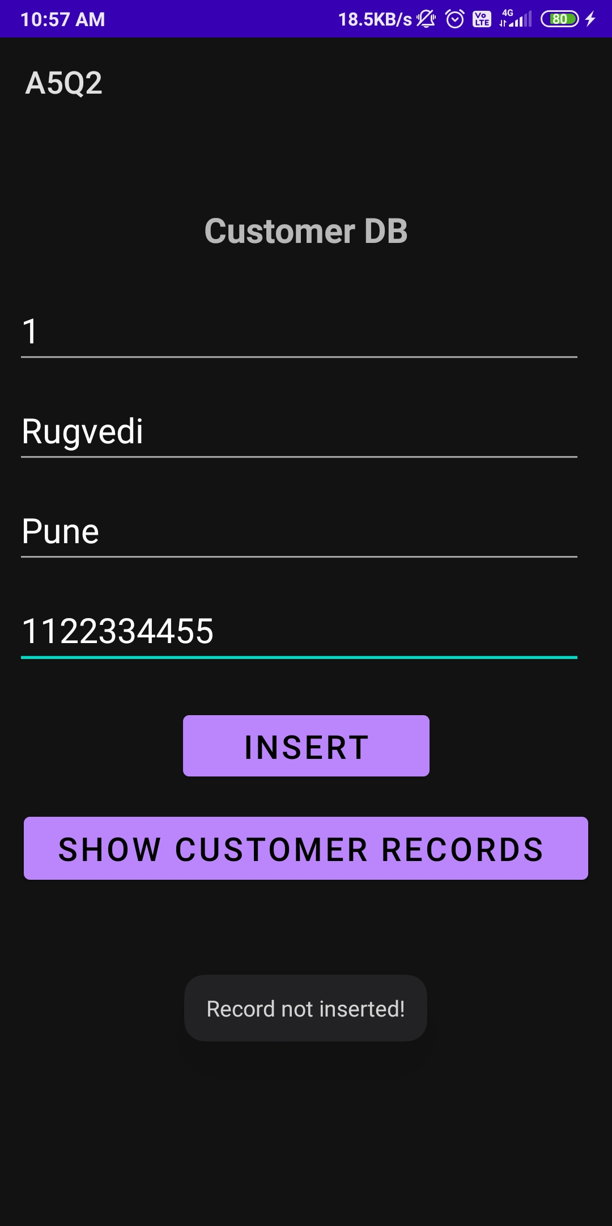

3. Create a java android application with login module (Check username and password). On successful login, pass username to next screen And on failing login, alert user using Toast. Use Login(username, password) Table.

MainActivity.java

package com.example.a5q3;

import androidx.appcompat.app.AppCompatActivity;

import android.content.Intent;

import android.os.Bundle;

import android.text.method.LinkMovementMethod;

import android.view.View;

import android.widget.Button;

import android.widget.EditText;

import android.widget.TextView;

import android.widget.Toast;

public class MainActivity extends AppCompatActivity {

public static final String EXTRA_USERNAME = "com.example.a5q3.EXTRA_USERNAME";

TextView txtView;

EditText email, pwd;

Button loginBtn;

@Override

protected void onCreate(Bundle savedInstanceState) {

super.onCreate(savedInstanceState);

setContentView(R.layout.activity_main);

txtView = findViewById(R.id.textView);

//txtView.setMovementMethod(LinkMovementMethod.getInstance());

email = findViewById(R.id.email);

pwd = findViewById(R.id.pwd);

loginBtn = findViewById(R.id.loginBtn);

DatabaseHandler db = new DatabaseHandler(this);

loginBtn.setOnClickListener(new View.OnClickListener() {

@Override

public void onClick(View v) {

String usernametxt = email.getText().toString();

String pwdtxt = pwd.getText().toString();

Boolean checkData = db.check(usernametxt,pwdtxt);

if (checkData == true) {

openActivity2();

}

else {

Toast.makeText(MainActivity.this, "Invalid login credentials !", Toast.LENGTH_SHORT).show();

}

}

});

txtView.setOnClickListener(new View.OnClickListener() {

@Override

public void onClick(View v) {

//Toast.makeText(MainActivity.this, "signup clicked", Toast.LENGTH_SHORT).show();

String usernametxt = email.getText().toString();

String pwdtxt = pwd.getText().toString();

boolean insertResult = db.insertRecord(usernametxt, pwdtxt);

if(insertResult == true) {

Toast.makeText(MainActivity.this, "New user signed up successfully!", Toast.LENGTH_LONG).show();

}

else {

Toast.makeText(MainActivity.this, "Error signing up!", Toast.LENGTH_LONG).show();

}

}

});

}

public void openActivity2() {

email = findViewById(R.id.email);

String username = email.getText().toString();

Intent intent = new Intent(this, MainActivity2.class);

intent.putExtra(EXTRA_USERNAME, username);

startActivity(intent);

}

}

activity_main.xml

<?xml version="1.0" encoding="utf-8"?>

<androidx.constraintlayout.widget.ConstraintLayout xmlns:android="http://schemas.android.com/apk/res/android"

xmlns:app="http://schemas.android.com/apk/res-auto"

xmlns:tools="http://schemas.android.com/tools"

android:layout_width="match_parent"

android:layout_height="match_parent"

tools:context=".MainActivity" >

<EditText

android:id="@+id/email"

android:layout_width="263dp"

android:layout_height="47dp"

android:layout_marginTop="112dp"

android:ems="10"

android:inputType="textPersonName"

android:hint="Email"

app:layout_constraintEnd_toEndOf="parent"

app:layout_constraintHorizontal_bias="0.493"

app:layout_constraintStart_toStartOf="parent"

app:layout_constraintTop_toTopOf="parent" />

<Button

android:id="@+id/loginBtn"

android:layout_width="141dp"

android:layout_height="47dp"

android:layout_marginTop="64dp"

android:text="Login"

app:layout_constraintEnd_toEndOf="parent"

app:layout_constraintStart_toStartOf="parent"

app:layout_constraintTop_toBottomOf="@+id/pwd" />

<TextView

android:id="@+id/textView"

android:layout_width="296dp"

android:layout_height="35dp"

android:layout_marginTop="64dp"

android:text="@string/hyperlink"

android:textAlignment="center"

android:textSize="19sp"

android:textStyle="normal"

app:layout_constraintEnd_toEndOf="parent"

app:layout_constraintHorizontal_bias="0.495"

app:layout_constraintStart_toStartOf="parent"

app:layout_constraintTop_toBottomOf="@+id/loginBtn" />

<EditText

android:id="@+id/pwd"

android:layout_width="266dp"

android:layout_height="47dp"

android:layout_marginTop="48dp"

android:ems="10"

android:inputType="textPassword"

android:hint="Password"

app:layout_constraintEnd_toEndOf="parent"

app:layout_constraintStart_toStartOf="parent"

app:layout_constraintTop_toBottomOf="@+id/email" />

</androidx.constraintlayout.widget.ConstraintLayout>

DatabaseHandler.java

package com.example.a5q3;

import android.content.ContentValues;

import android.content.Context;

import android.database.Cursor;

import android.database.sqlite.SQLiteDatabase;

import android.database.sqlite.SQLiteOpenHelper;

import androidx.annotation.Nullable;

public class DatabaseHandler extends SQLiteOpenHelper {

public DatabaseHandler(@Nullable Context context) {

super(context, "loginDB", null, 1);

}

@Override

public void onCreate(SQLiteDatabase db) {

db.execSQL("create table login(username VARCHAR(50) primary key, password VARCHAR(50))");

}

@Override

public void onUpgrade(SQLiteDatabase db, int oldVersion, int newVersion) {

db.execSQL("DROP table if exists login");

}

public boolean insertRecord(String username, String pwd) {

if (username!="" && pwd!="") {

SQLiteDatabase sqldb = this.getWritableDatabase();

ContentValues cv = new ContentValues();

cv.put("username", username);

cv.put("password", pwd);

long result = sqldb.insert("login", null, cv);

if (result == -1) {

return false;

} else {

return true;

}

}

else {

return false;

}

}

public boolean check(String uname, String pwd) {

SQLiteDatabase db = this.getWritableDatabase();

Cursor cursor=db.rawQuery("Select * from login where username=? and password=?",new String[]{uname, pwd});

if(cursor.getCount()>0) {

return true;

}

else

{

return false;

}

}

}

MainActivity2.java

package com.example.a5q3;

import androidx.appcompat.app.AppCompatActivity;

import android.content.Intent;

import android.os.Bundle;

import android.widget.TextView;

public class MainActivity2 extends AppCompatActivity {

TextView txtView2;

@Override

protected void onCreate(Bundle savedInstanceState) {

super.onCreate(savedInstanceState);

setContentView(R.layout.activity_main2);

Intent intent = getIntent();

String username = intent.getStringExtra(MainActivity.EXTRA_USERNAME);

txtView2 = findViewById(R.id.textView2);

txtView2.setText(username + " logged in successfully!");

}

}

activity_main2.xml

<?xml version="1.0" encoding="utf-8"?>

<androidx.constraintlayout.widget.ConstraintLayout xmlns:android="http://schemas.android.com/apk/res/android"

xmlns:app="http://schemas.android.com/apk/res-auto"

xmlns:tools="http://schemas.android.com/tools"

android:layout_width="match_parent"

android:layout_height="match_parent"

tools:context=".MainActivity2">

<TextView

android:id="@+id/textView2"

android:layout_width="328dp"

android:layout_height="51dp"

android:textAlignment="center"

android:textSize="24sp"

android:textStyle="normal|bold"

app:layout_constraintBottom_toBottomOf="parent"

app:layout_constraintEnd_toEndOf="parent"

app:layout_constraintHorizontal_bias="0.493"

app:layout_constraintStart_toStartOf="parent"

app:layout_constraintTop_toTopOf="parent"

app:layout_constraintVertical_bias="0.298" />

</androidx.constraintlayout.widget.ConstraintLayout>

strings.xml

<resources>

<string name="app_name">A5Q3</string>

<string name="hyperlink">Not a member? <a href="">Sign up now.</a></string>

</resources>

AndroidManifest.xml

<?xml version="1.0" encoding="utf-8"?>

<manifest xmlns:android="http://schemas.android.com/apk/res/android"

package="com.example.a5q3">

<application

android:allowBackup="true"

android:icon="@mipmap/ic_launcher"

android:label="@string/app_name"

android:roundIcon="@mipmap/ic_launcher_round"

android:supportsRtl="true"

android:theme="@style/Theme.A5Q3">

<activity android:name=".MainActivity2"

android:parentActivityName=".MainActivity"></activity>

<activity android:name=".MainActivity">

<intent-filter>

<action android:name="android.intent.action.MAIN" />

<category android:name="android.intent.category.LAUNCHER" />

</intent-filter>

</activity>

</application>

</manifest>

Output:

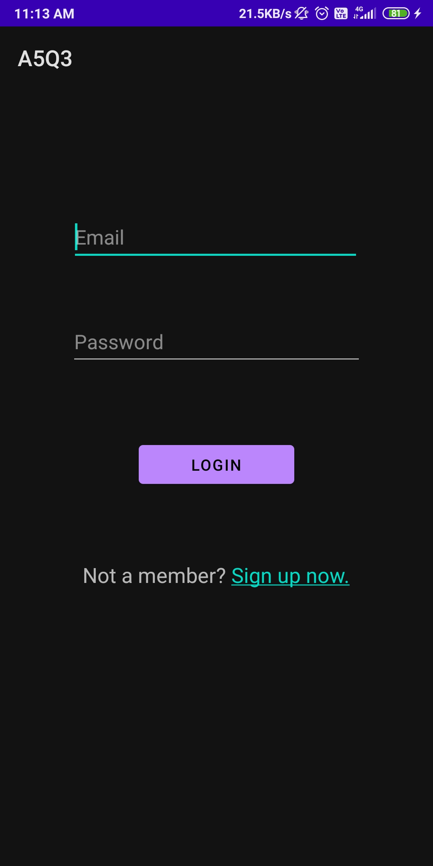

4. Create a java android application as shown below-

Create table Student(Sid ,Sname ,phno).

Use autoincrement for Sid. Perform following Operations.

- Add Student and display its information.

- Delete Student.

MainActivity.java

package com.example.a5q4;

import androidx.appcompat.app.AlertDialog;

import androidx.appcompat.app.AppCompatActivity;

import android.database.Cursor;

import android.os.Bundle;

import android.view.View;

import android.widget.Button;

import android.widget.EditText;

import android.widget.Toast;

public class MainActivity extends AppCompatActivity {

Button addBtn, delBtn, viewBtn;

EditText name, phone, delInput;

Integer sid = 0;

@Override

protected void onCreate(Bundle savedInstanceState) {

super.onCreate(savedInstanceState);

setContentView(R.layout.activity_main);

DatabaseHandler db = new DatabaseHandler(this);

addBtn = findViewById(R.id.addBtn);

delBtn = findViewById(R.id.deleteBtn);

viewBtn = findViewById(R.id.view);

name = findViewById(R.id.nameid);

phone = findViewById(R.id.phoneid);

delInput = findViewById(R.id.deleteInput);

addBtn.setOnClickListener(new View.OnClickListener() {

@Override

public void onClick(View v) {

String nametxt = name.getText().toString();

String phonetxt = phone.getText().toString();

sid+=1; //Autoincrementing sid everytime add is clicked.

Boolean insertResult = db.insertStudent(sid, nametxt, phonetxt);

if(insertResult == true) {

Toast.makeText(MainActivity.this, "Record inserted successfully!", Toast.LENGTH_LONG).show();

}

else {

Toast.makeText(MainActivity.this, "Record not inserted!", Toast.LENGTH_LONG).show();

}

}

});

viewBtn.setOnClickListener(new View.OnClickListener() {

@Override

public void onClick(View v) {

Cursor curResult = db.getData();

if(curResult.getCount()==0) {

Toast.makeText(MainActivity.this, "Student table is empty!", Toast.LENGTH_SHORT).show();

return;

}

StringBuffer buffer = new StringBuffer();

while (curResult.moveToNext()) {

buffer.append("Sid: " + curResult.getString(0)+ "\n");

buffer.append("Name: " + curResult.getString(1)+ "\n");

buffer.append("Phone No.: " + curResult.getString(2)+ "\n\n");

}

AlertDialog.Builder builder = new AlertDialog.Builder(MainActivity.this);

builder.setCancelable(true);

builder.setTitle("Student data: ");

builder.setMessage(buffer);

builder.show();

}

});

delBtn.setOnClickListener(new View.OnClickListener() {

@Override

public void onClick(View v) {

String sidtxt = delInput.getText().toString();

Boolean deleteData = db.delete(sidtxt);

if(deleteData == true)

{

Toast.makeText(MainActivity.this,"Student Deleted successfully ! ",Toast.LENGTH_LONG).show();

}

else

{

Toast.makeText(MainActivity.this,"Error in deleting ! ",Toast.LENGTH_LONG).show();

}

}

});

}

}

DatabaseHandler.java

package com.example.a5q4;

import android.content.ContentValues;

import android.content.Context;

import android.database.Cursor;

import android.database.sqlite.SQLiteDatabase;

import android.database.sqlite.SQLiteOpenHelper;

import androidx.annotation.Nullable;

public class DatabaseHandler extends SQLiteOpenHelper {

public DatabaseHandler(@Nullable Context context) {

super(context, "studentDB", null, 1);

}

@Override

public void onCreate(SQLiteDatabase db) {

db.execSQL("create table student(sid INTEGER primary key, sname VARCHAR(30), phno INTEGER)");

}

@Override

public void onUpgrade(SQLiteDatabase db, int oldVersion, int newVersion) {

db.execSQL("DROP table if exists student");

}

public boolean insertStudent(Integer sid, String name, String phone) {

SQLiteDatabase sqldb = this.getWritableDatabase();

ContentValues cv = new ContentValues();

cv.put("sid", sid);

cv.put("sname", name);

cv.put("phno", phone);

long result = sqldb.insert("student", null, cv);

if(result == -1) {

return false;

}

else {

return true;

}

}

public Cursor getData() {

SQLiteDatabase sqldb = this.getWritableDatabase();

Cursor cursor = sqldb.rawQuery("Select * from student", null);

return cursor;

}

public boolean delete(String sid) {

SQLiteDatabase db = this.getWritableDatabase();

Cursor cursor = db.rawQuery("select * from student where sid=?", new String[]{sid});

if(cursor.getCount()>0) {

long delRes = db.delete("student", "sid=?", new String[]{sid});

if (delRes == -1) {

return false;

} else {

return true;

}

}

else {

return false;

}

}

}

Activity_main.xml

<?xml version="1.0" encoding="utf-8"?>

<androidx.constraintlayout.widget.ConstraintLayout xmlns:android="http://schemas.android.com/apk/res/android"

xmlns:app="http://schemas.android.com/apk/res-auto"

xmlns:tools="http://schemas.android.com/tools"

android:layout_width="match_parent"

android:layout_height="match_parent"

tools:context=".MainActivity">

<TextView

android:id="@+id/textView"

android:layout_width="match_parent"

android:layout_height="37dp"

android:shadowColor="#070404"

android:text="Student Database"

android:textAlignment="center"

android:textColor="#000000"

android:textColorHighlight="#000000"

android:textColorLink="#D6C9C9"

android:textSize="22sp"

android:textStyle="normal|bold"

app:layout_constraintBottom_toBottomOf="parent"

app:layout_constraintTop_toTopOf="parent"

app:layout_constraintVertical_bias="0.023"

tools:layout_editor_absoluteX="0dp" />

<EditText

android:id="@+id/nameid"

android:layout_width="243dp"

android:layout_height="45dp"

android:layout_marginStart="16dp"

android:layout_marginLeft="16dp"

android:layout_marginTop="60dp"

android:ems="10"

android:inputType="textPersonName"

android:textSize="21sp"

android:textStyle="normal"

app:layout_constraintEnd_toEndOf="parent"

app:layout_constraintHorizontal_bias="0.2"

app:layout_constraintStart_toEndOf="@+id/textView4"

app:layout_constraintTop_toBottomOf="@+id/textView" />

<EditText

android:id="@+id/phoneid"

android:layout_width="246dp"

android:layout_height="46dp"

android:layout_marginStart="16dp"

android:layout_marginLeft="16dp"

android:layout_marginTop="36dp"

android:ems="10"

android:inputType="textPersonName"

android:textSize="21sp"

android:textStyle="normal"

app:layout_constraintEnd_toEndOf="parent"

app:layout_constraintHorizontal_bias="0.218"

app:layout_constraintStart_toEndOf="@+id/textView3"

app:layout_constraintTop_toBottomOf="@+id/nameid" />

<TextView

android:id="@+id/textView3"

android:layout_width="101dp"

android:layout_height="35dp"

android:layout_marginStart="16dp"

android:layout_marginLeft="16dp"

android:layout_marginTop="48dp"

android:text="Phone No.:"

android:textAlignment="center"

android:textColor="#000000"

android:textSize="20sp"

android:textStyle="normal"

app:layout_constraintStart_toStartOf="parent"

app:layout_constraintTop_toBottomOf="@+id/textView4" />

<TextView

android:id="@+id/textView4"

android:layout_width="101dp"

android:layout_height="36dp"

android:layout_marginStart="16dp"

android:layout_marginLeft="16dp"

android:layout_marginTop="68dp"

android:text="Name: "

android:textAlignment="center"

android:textColor="#000000"

android:textSize="20sp"

android:textStyle="normal"

app:layout_constraintStart_toStartOf="parent"

app:layout_constraintTop_toBottomOf="@+id/textView" />

<TextView

android:id="@+id/textView5"

android:layout_width="wrap_content"

android:layout_height="wrap_content"

android:layout_marginTop="88dp"

android:text="Enter Student id to delete:"

android:textColor="#000000"

android:textSize="20sp"

android:textStyle="normal"

app:layout_constraintEnd_toEndOf="parent"

app:layout_constraintHorizontal_bias="0.06"

app:layout_constraintStart_toStartOf="parent"

app:layout_constraintTop_toBottomOf="@+id/textView3" />

<EditText

android:id="@+id/deleteInput"

android:layout_width="229dp"

android:layout_height="45dp"

android:layout_marginTop="28dp"

android:ems="10"

android:inputType="number"

app:layout_constraintEnd_toEndOf="parent"

app:layout_constraintHorizontal_bias="0.06"

app:layout_constraintStart_toStartOf="parent"

app:layout_constraintTop_toBottomOf="@+id/textView5" />

<Button

android:id="@+id/addBtn"

android:layout_width="wrap_content"

android:layout_height="wrap_content"

android:layout_marginTop="80dp"

android:text="Add"

app:layout_constraintEnd_toEndOf="parent"

app:layout_constraintHorizontal_bias="0.554"

app:layout_constraintStart_toEndOf="@+id/textView5"

app:layout_constraintTop_toBottomOf="@+id/phoneid" />

<Button

android:id="@+id/deleteBtn"

android:layout_width="wrap_content"

android:layout_height="wrap_content"

android:text="Delete"

app:backgroundTint="@color/teal_700"

app:layout_constraintBottom_toBottomOf="parent"

app:layout_constraintEnd_toEndOf="parent"

app:layout_constraintHorizontal_bias="0.56"

app:layout_constraintStart_toEndOf="@+id/deleteInput"

app:layout_constraintTop_toBottomOf="@+id/addBtn"

app:layout_constraintVertical_bias="0.022" />

<Button

android:id="@+id/view"

android:layout_width="wrap_content"

android:layout_height="wrap_content"

android:text="View Student DB"

app:layout_constraintBottom_toBottomOf="parent"

app:layout_constraintEnd_toEndOf="parent"

app:layout_constraintStart_toStartOf="parent"

app:layout_constraintTop_toBottomOf="@+id/deleteInput"

app:layout_constraintVertical_bias="0.263" />

</androidx.constraintlayout.widget.ConstraintLayout>

Output:

