1.

Agents in Artificial Intelligence

Artificial intelligence is defined as a study of rational agents. A rational agent could be anything which makes decisions, as a person, firm, machine, or software. It carries out an action with the best outcome after considering past and current percepts(agent’s perceptual inputs at a given instance).

An AI system is composed of an agent and its environment. The agents act in their environment. The environment may contain other agents. An agent is anything that can be viewed as :
- perceiving its environment through sensors and
- acting upon that environment through actuators

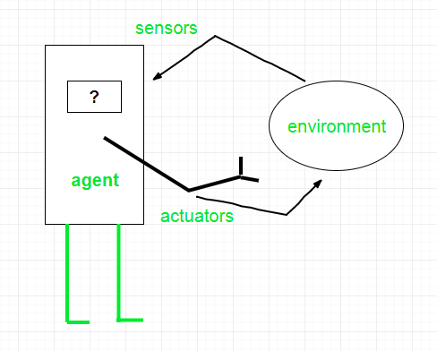

Agent = Architecture + Agent Program
Architecture is the machinery that the agent executes on. It is a device with sensors and actuators, for example : a robotic car, a camera, a PC. Agent program is an implementation of an agent function.
Examples of Agent:-
A software agent has Keystrokes, file contents, received network packages which act as sensors and displays on the screen, files, sent network packets acting as actuators.
A Human agent has eyes, ears, and other organs which act as sensors and hands, legs, mouth, and other body parts acting as actuators.
A Robotic agent has Cameras and infrared range finders which act as sensors and various motors acting as actuators.
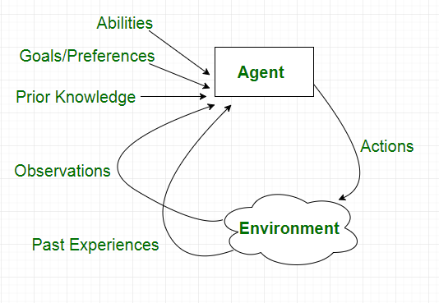

2.

Understanding PEAS in Artificial Intelligence

PEAS System is used to categorize similar agents together. The PEAS system delivers the performance measure with respect to the environment, actuators and sensors of the respective agent. Most of the highest performing agents are Rational Agents.
Rational Agent: The rational agent considers all possibilities and chooses to perform the highly efficient action. For example it chooses the shortest path with low cost for high efficiency.
PEAS stands for Performance measure, Environment, Actuator, Sensor.
Performance Measure: Performance measure is the unit to define the success of an agent.Performance varies with agents based on their different precept.
- Environment: Environment is the surrounding of an agent at every instant. It keeps changing with time if the agent is set in motion.There are 5 major types of environments:
  - Fully Observable & Partially Observable
  - Episodic & Static
  - Static & Dynamic
  - Discrete & Continuous
  - Deterministic & Stochastic
- Actuator: Actuator is a part of the agent that delivers the output of an action to the environment.
- Sensor: Sensors are the receptive parts of an agent which takes in the input for the agent.

Agent | Performance Measure | Environment | Actuator | Sensor
Autonomous Mars Rover | Distance the rover traverses, along the number of collected samples or possibly finding life, or maximize lifetime etc | Mars surface is partially observable, nondeterministic, sequential  dynamic and continuous | wheels, robot arm, drill, radio transmitter | camera, spectrometers
Automated Car Drive | Price, quality, appropriateness, efficiency | Current and future Web sites, vendors, shippers | Display to user, follow URL, fill in form | Web pages (text, graphics, scripts)

3.

Difference between Informed and Uninformed Search in AI

Informed Search: Informed Search algorithms have information on the goal state which helps in more efficient searching. This information is obtained by a function that estimates how close a state is to the goal state.
Example: Greedy Search and Graph Search
Uninformed Search: Uninformed search algorithms have no additional information on the goal node other than the one provided in the problem definition. The plans to reach the goal state from the start state differ only by the order and length of actions.
Examples: Depth First Search and Breadth-First Search

Informed Search vs. Uninformed Search:
Informed Search | Uninformed Search
It uses knowledge for the searching process. | It doesn’t use knowledge for searching process.
It finds solution more quickly. | It finds solution slow as compared to informed search.
It is highly efficient. | It is mandatory efficient.
Cost is low. | Cost is high.
It consumes less time. | It consumes moderate time.
It provides the direction regarding the solution. | No suggestion is given regarding the solution in it.
It is less lengthy while implementation. | It is more lengthy while implementation.
Greedy Search, A* Search, Graph Search | Depth First Search, Breadth First Search

