Name: Atharva Mahamuni.
Enroll No: 2002276
------------------------------------------------------------------------------------------------------------------------
Cloud Computing
Practical Assignment No. 6 - Working and Implementation of Identity and Access Management.
------------------------------------------------------------------------------------------------------------------------
Use the IAM service of AWS.

Step 1: At the top right panel above the console, choose Start Lab to launch your lab.

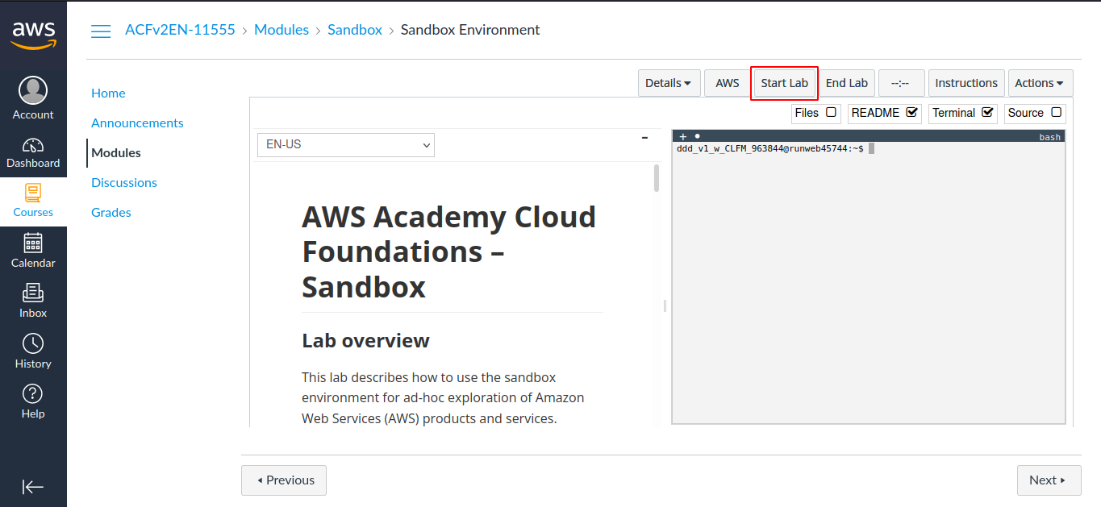

Step 2: Wait until you see the message "Lab status: ready", then choose the X to close the Start Lab panel.

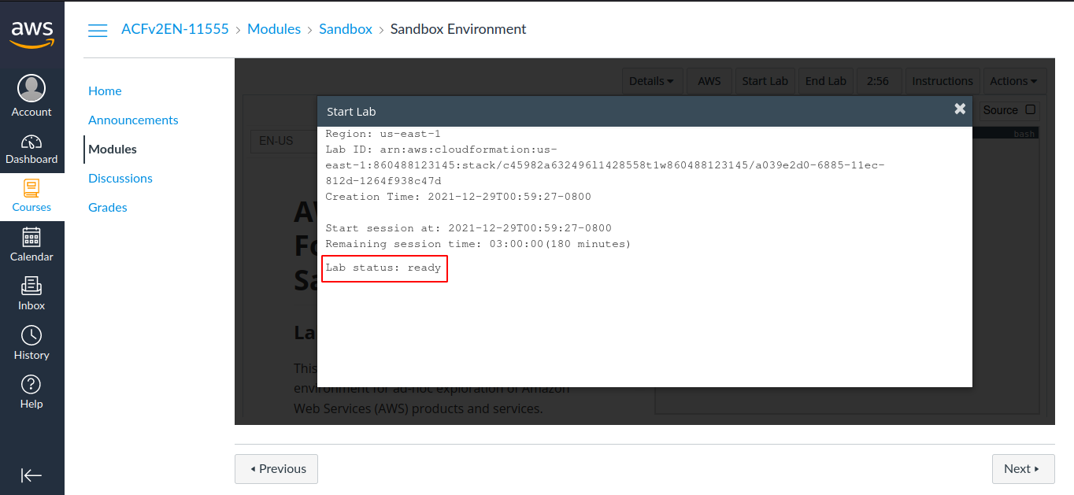

Step 3: Now choose AWS
This will open the AWS Management Console in a new browser tab. The system will automatically log you in.

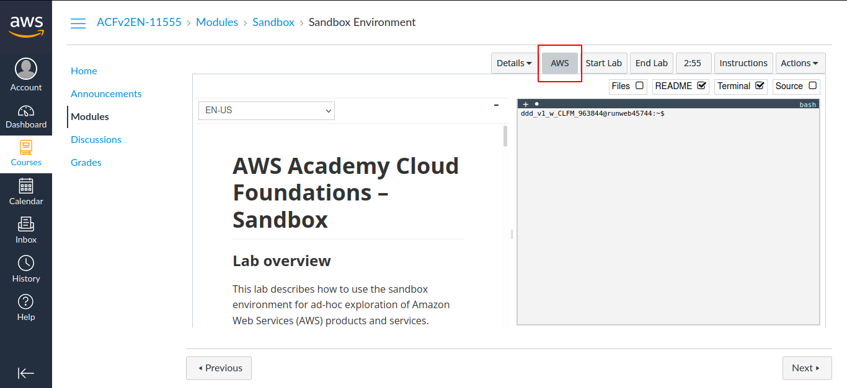

Step 4: In the AWS Management Console on the Services menu, choose IAM.

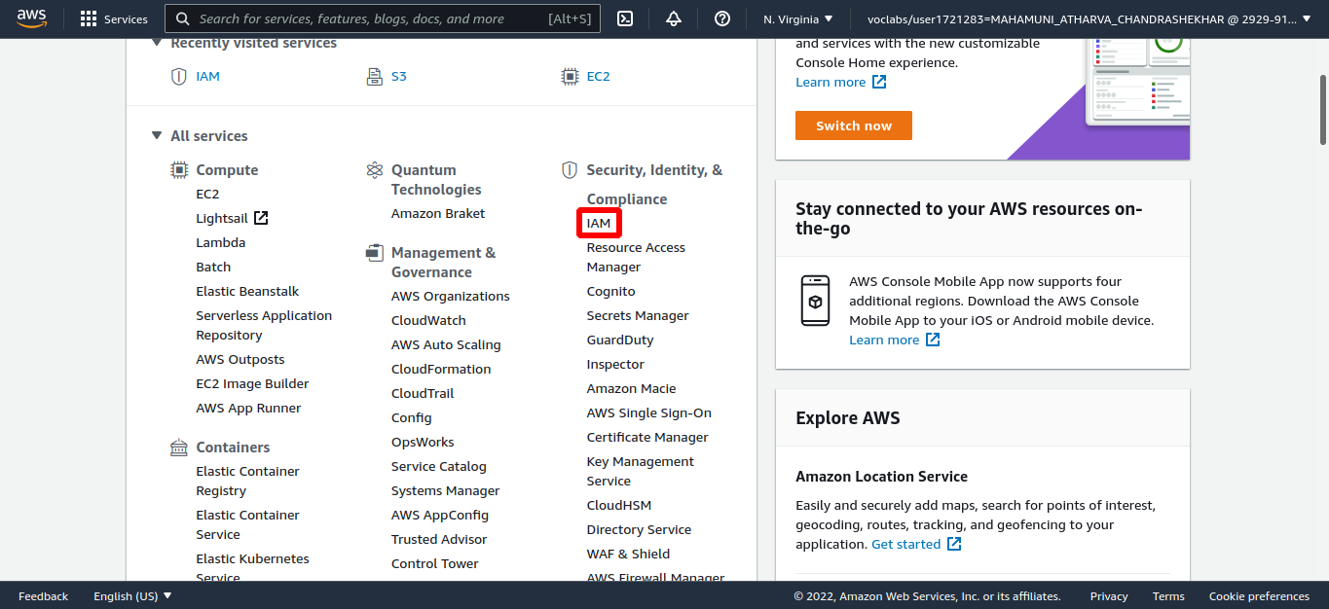

Step 5: In the navigation pane on the left, choose Users.

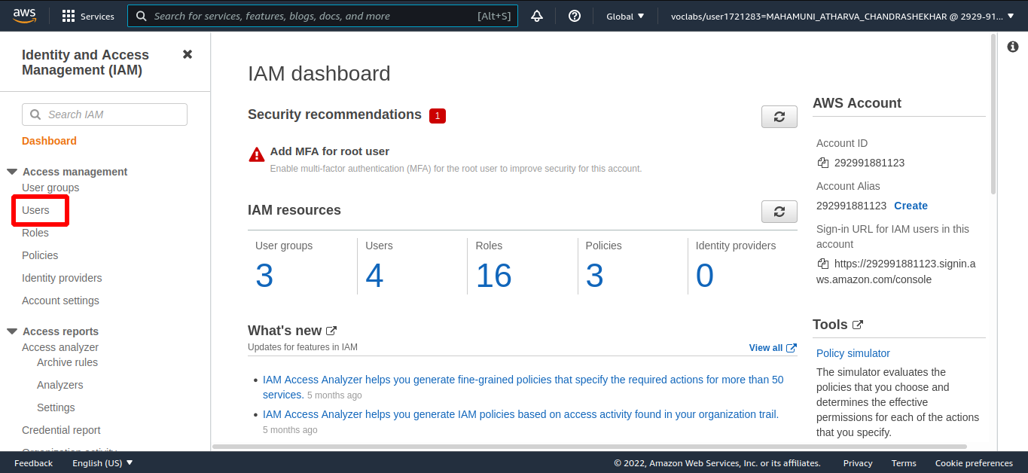

Step 6: Add Users to Groups
In the left navigation pane, choose User groups. Choose the S3-Support group.

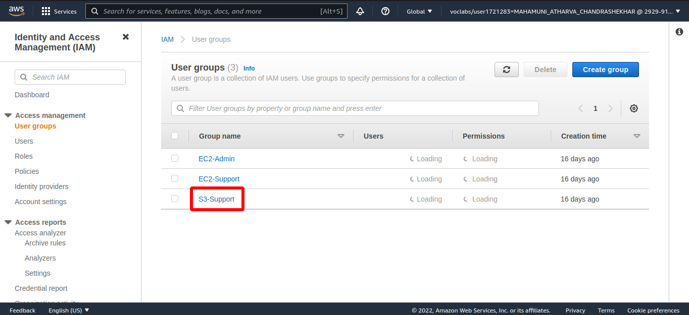

Step 7: Choose the Users tab. In the Users tab, choose Add users.

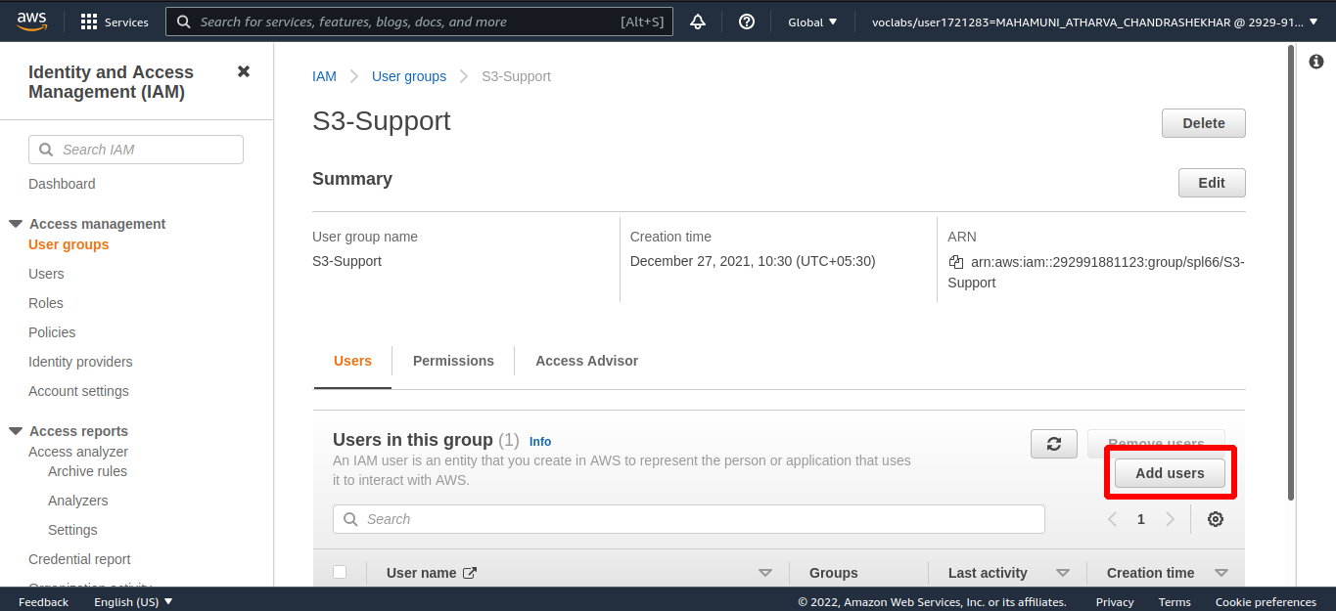

Step 8: In the Add Users to S3-Support window, configure the following:
Select user-1. At the bottom of the screen, choose Add Users.

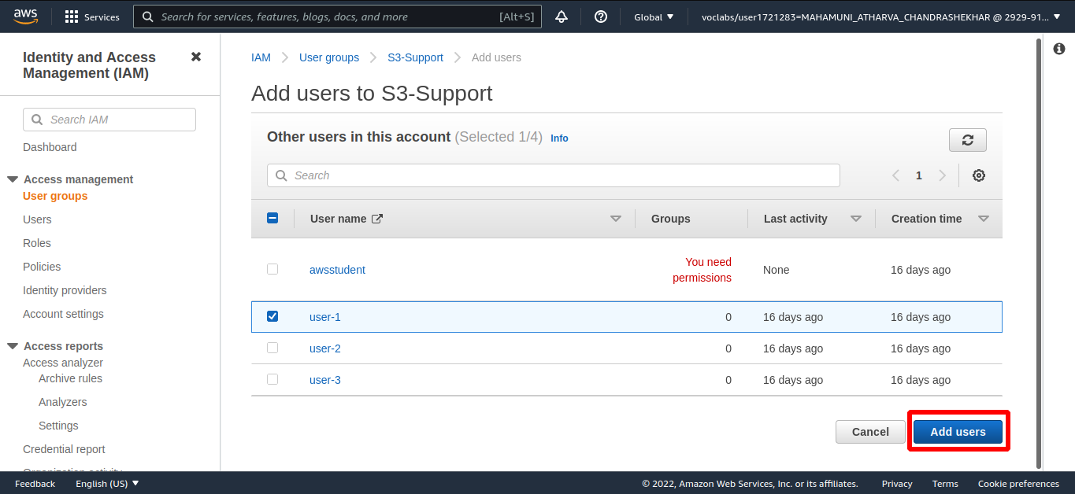

Step 9: Using similar steps to the ones above, add user-2 to the EC2-Support group and user-3 to EC2-Admin group.

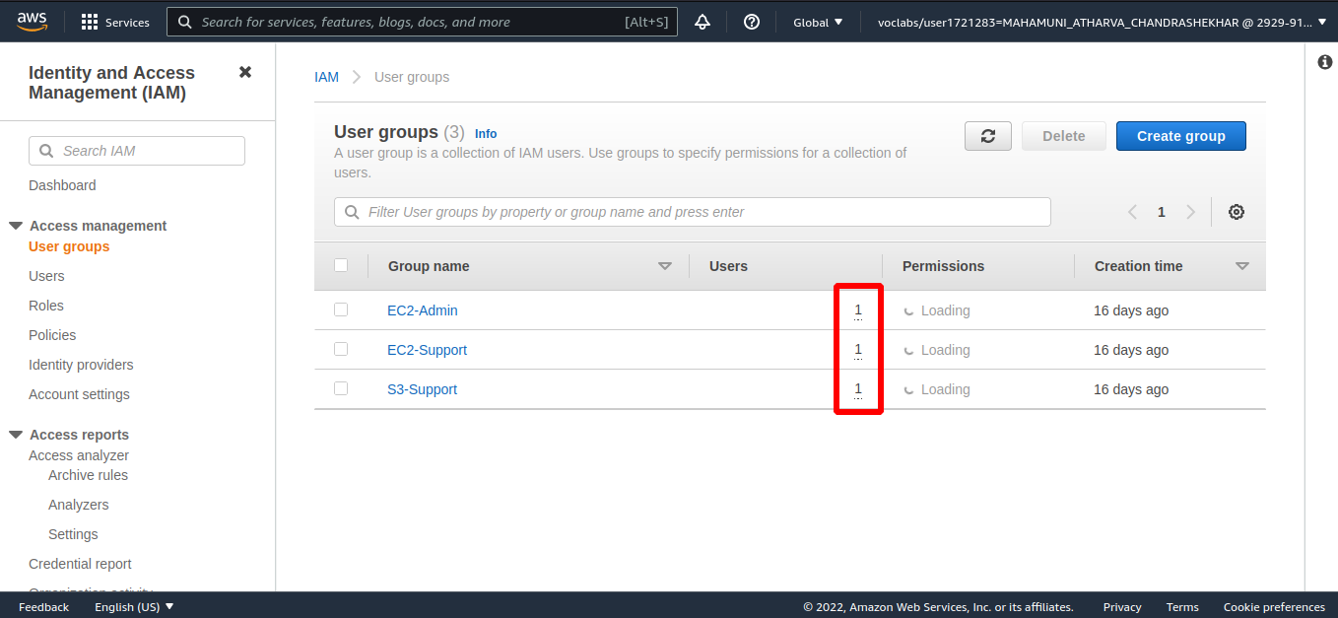

Step 10: Sign-In and Test Users.
In the navigation pane on the left, choose Dashboard. An IAM users sign-in link is displayed on the right. Copy the Sign-in URL.

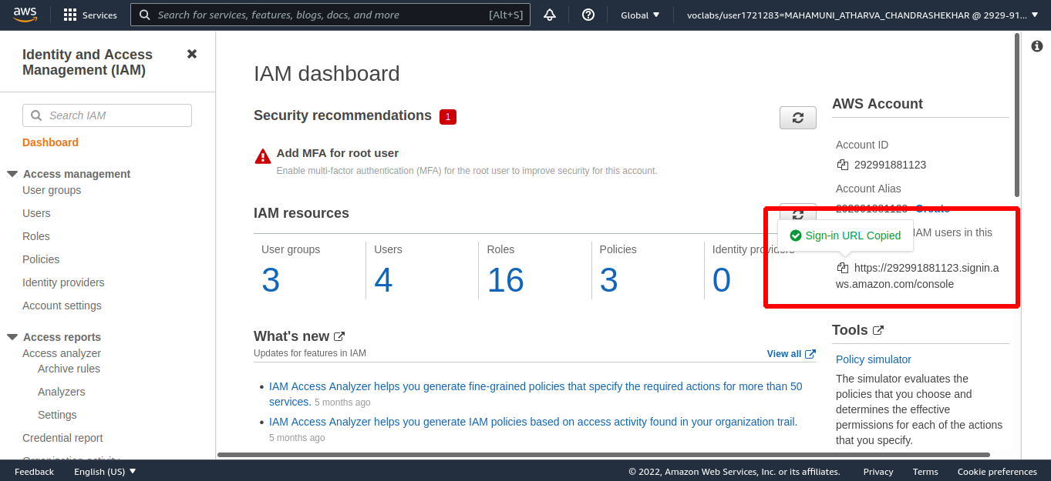

Step 11: Open a private (Incognito) window. Paste the IAM users sign-in link into the address bar of your private browser session and press Enter. Next, you will sign-in as user-1, who has been hired as your Amazon S3 storage support staff.
Sign-in with:
IAM user name: user-1
Password: Lab-Password1

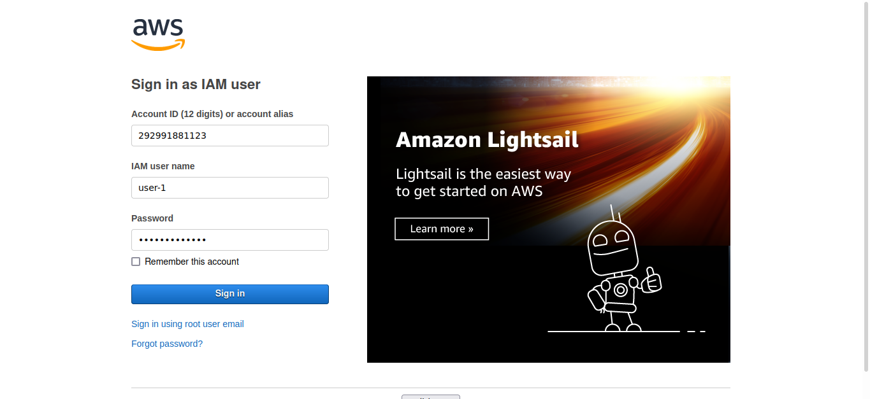

Step 12: In the Services menu, choose S3.

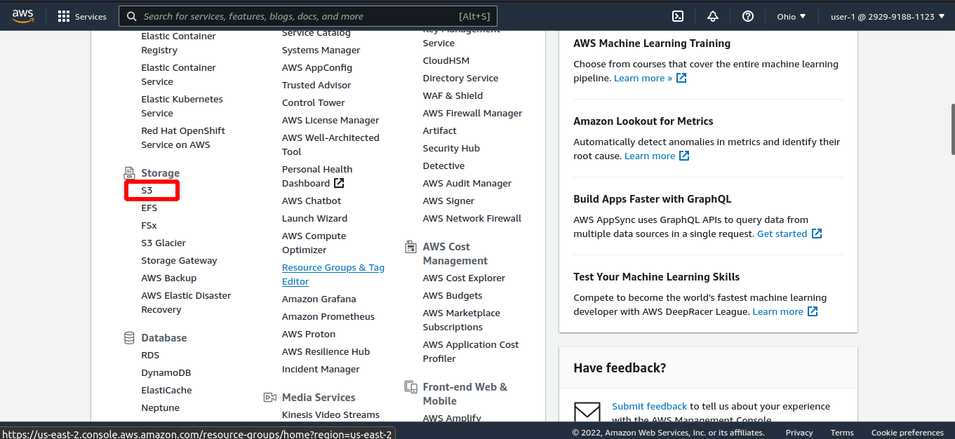

Step 13: Choose the name of the bucket that exists in the account and browse the contents. Since your user is part of the S3-Support Group in IAM, they have permission to view a list of Amazon S3 buckets and the contents.

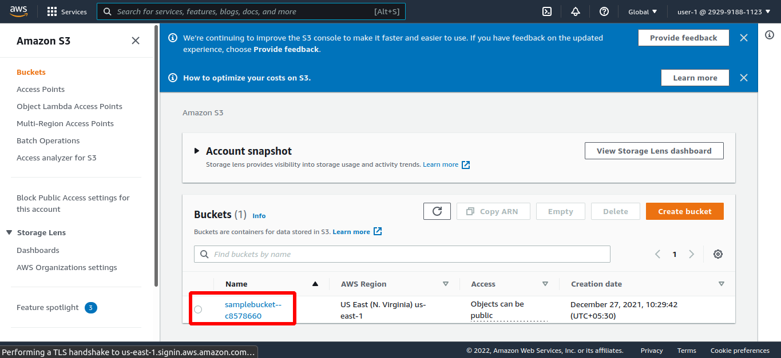

Step 14: In the Services menu, choose EC2.

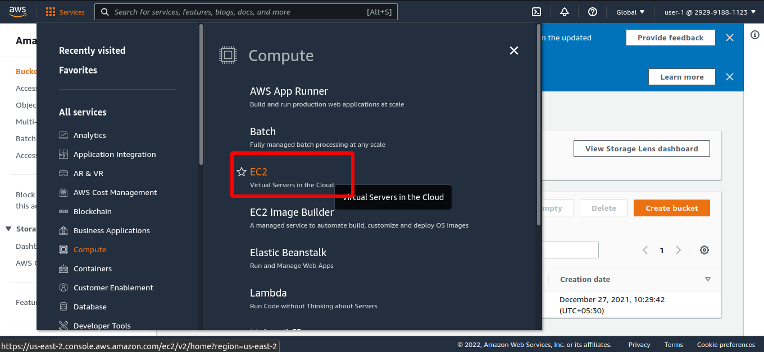

Step 15: In the left navigation pane, choose Instances.
You cannot see any instances. Instead, you see a message that states You are not authorized to perform this operation. This is because this user has not been granted any permissions to access
Amazon EC2.

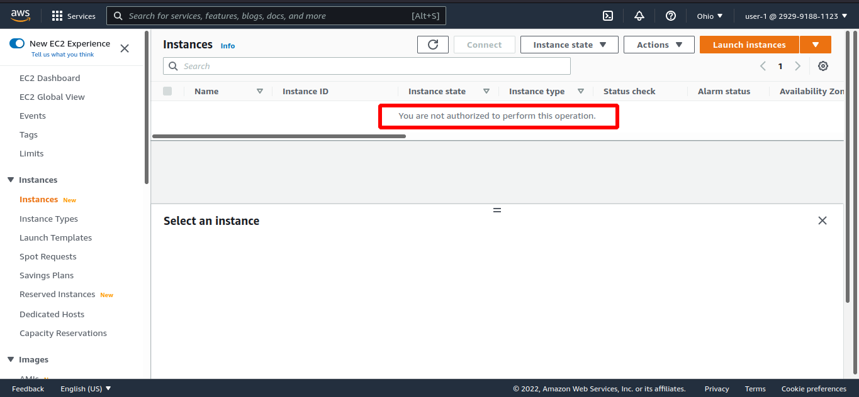

Step 16: You will now sign-in as user-2, who has been hired as your Amazon EC2 support person.
Sign-in with:
IAM user name: user-2
Password: Lab-Password2
In the navigation pane on the left, choose Instances.
You are now able to see an Amazon EC2 instance because you have Read Only permissions. However, you will not be able to make any changes to Amazon EC2 resources.
In the Instance state menu above, select Stop instance.

Step 17 :- Repeat the proces for user-3.
In the navigation pane on the left, choose Instances.
As an EC2 Administrator, you should now have permissions to Stop the Amazon EC2 instance.
Select the instance named LabHost .

Step 18 :- In the Instance state menu, choose Stop instance.
In the Stop instance window, choose Stop.
The instance will enter the stopping state and will shutdown.
Close your private browser window.

Lab complete

