Name: Atharva Mahamuni.
Enroll No: 2002276
------------------------------------------------------------------------------------------------------------------------
Cloud Computing
Practical Assignment No. 7 - Write a program for web feed.
------------------------------------------------------------------------------------------------------------------------

Step 1: At the top right panel above the console, choose Start Lab to launch your lab.

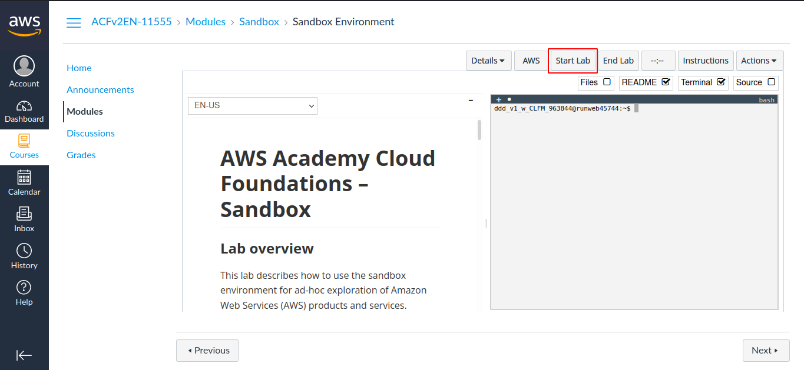

Step 2: Wait until you see the message "Lab status: ready", then choose the X to close the Start Lab panel.

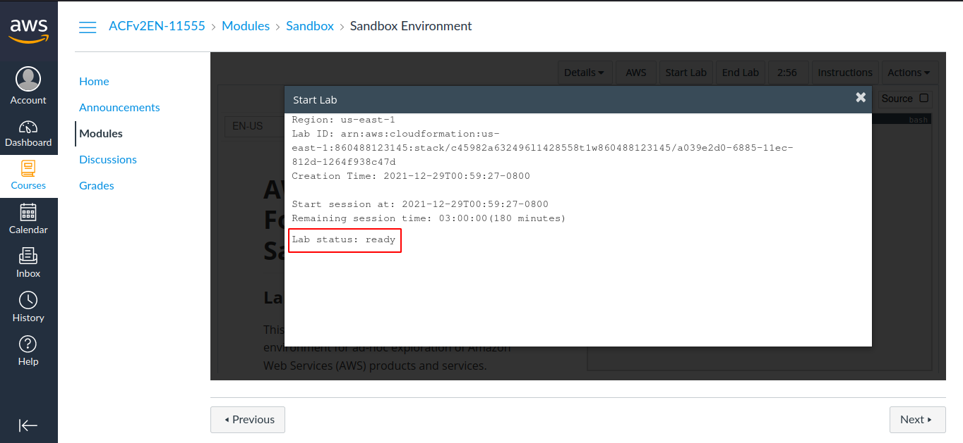

Step 3: Now choose AWS
This will open the AWS Management Console in a new browser tab. The system will automatically log you in.

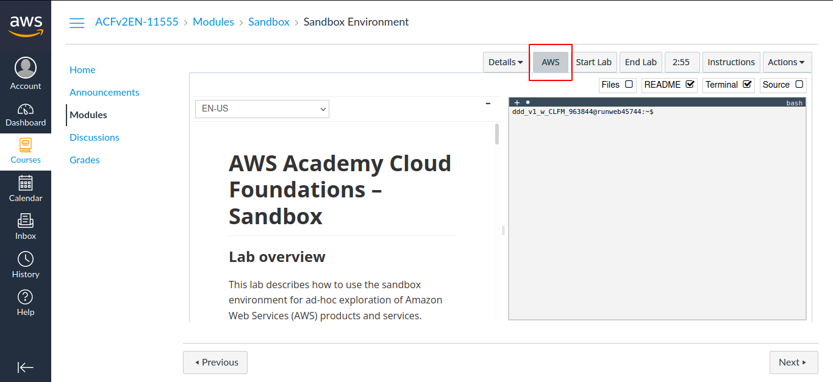

Step 4: In the AWS Management Console on the Services menu, choose EC2.

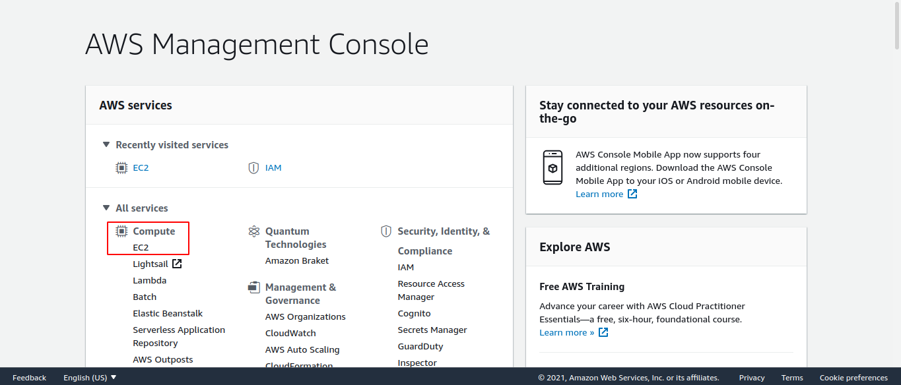

Step 5: Choose Launch instance , then select Launch Instance.

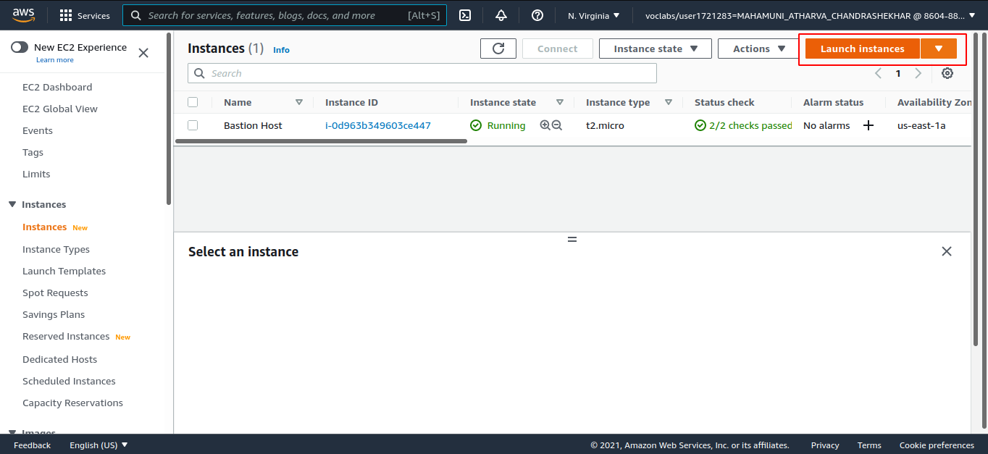

Step 6: Choose an Amazon Machine Image (AMI), select Amazon Linux 2 AMI (HVM)

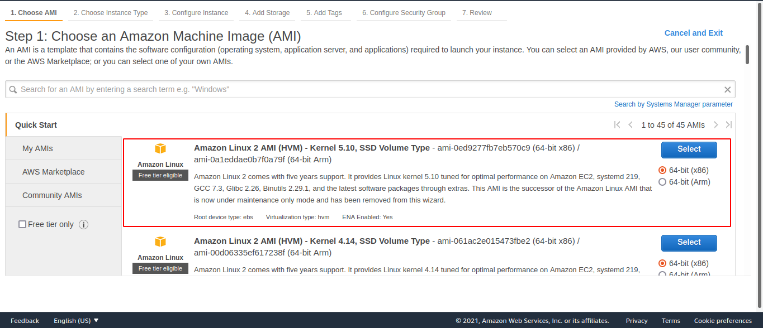

Step 7: Choose an Instance Type, select t2.micro

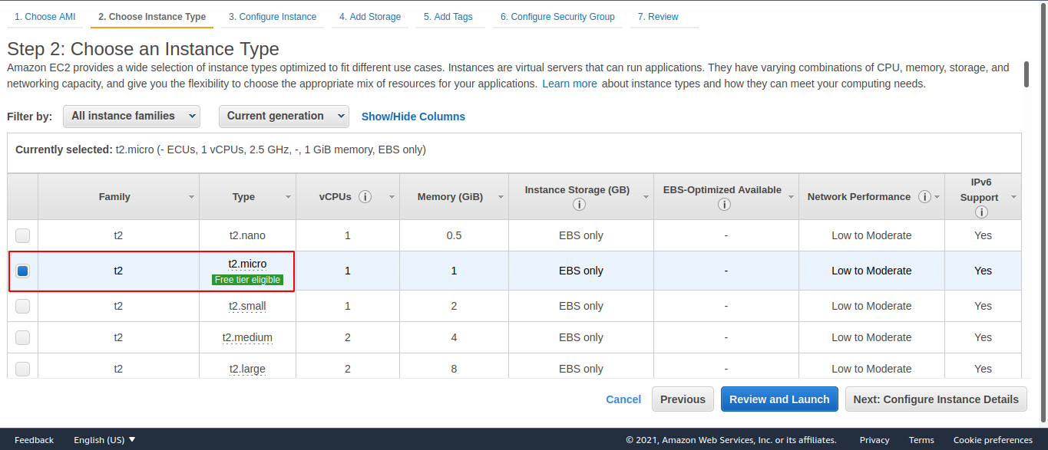
Choose Next: Configure Instance Details

Step 8: Configure Instance Details
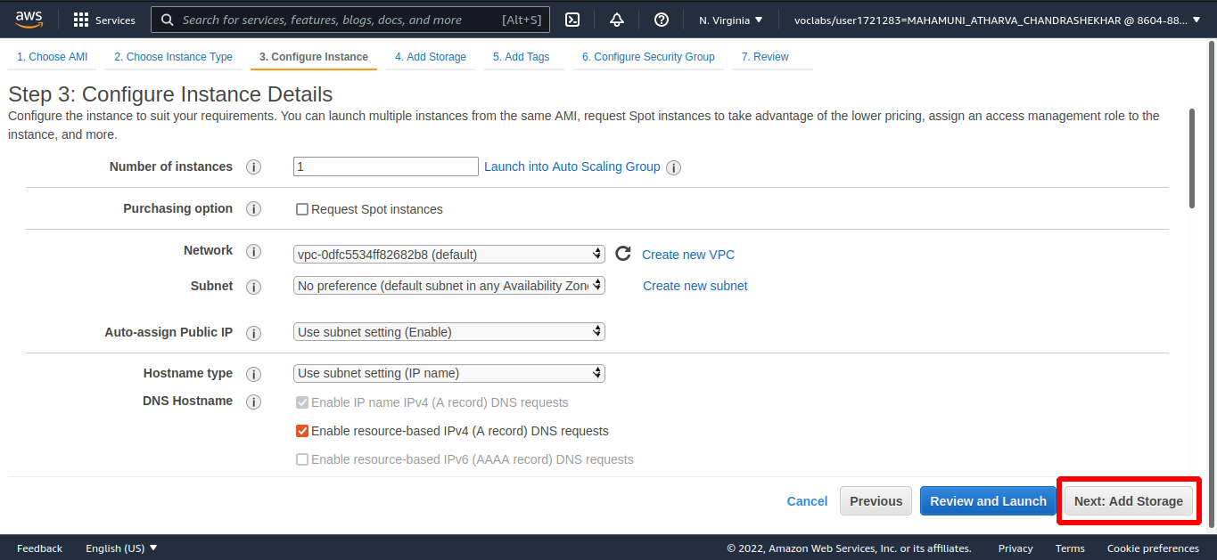
Choose Next: Add Storage

Step 9: Select defualt Storage

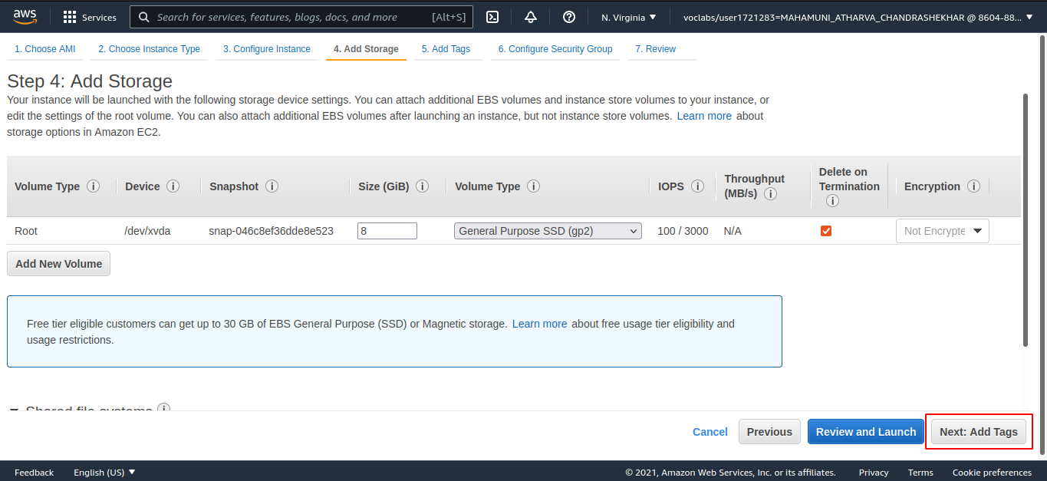
Choose Next: Add Tags

Step 10: Choose Add Tag then configure (key: value):

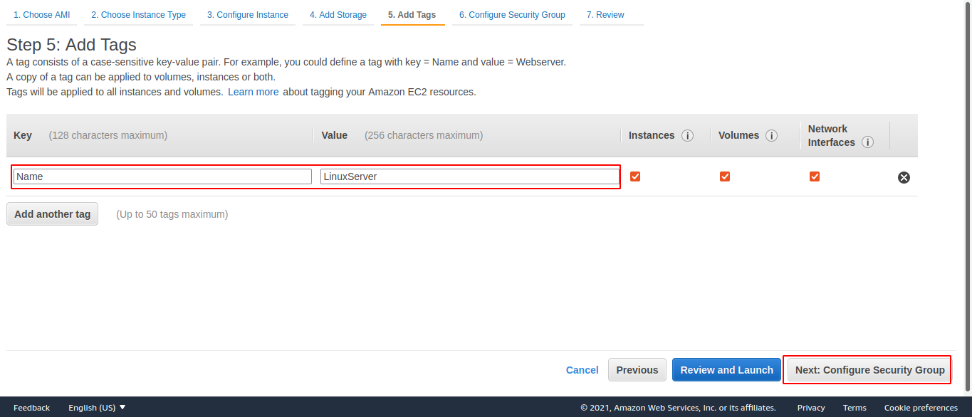
Choose Next: Configure Security Group

Step 11: Select a security group, either an existing one or create a new group.

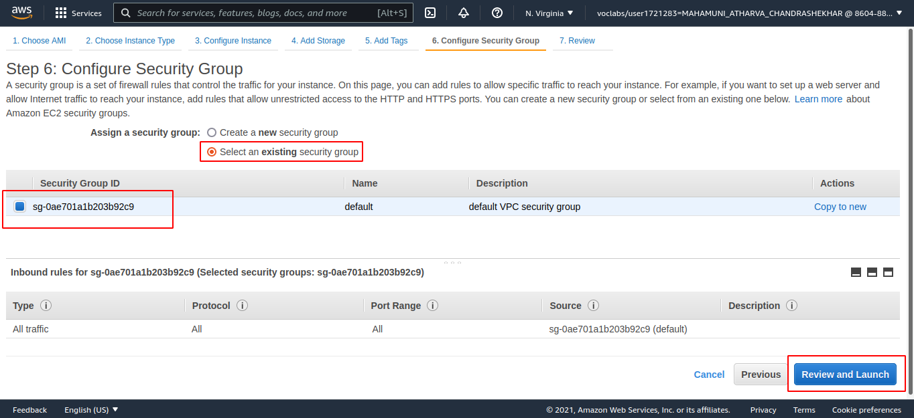
Choose Review and Launch

Step 12: Choose Launch

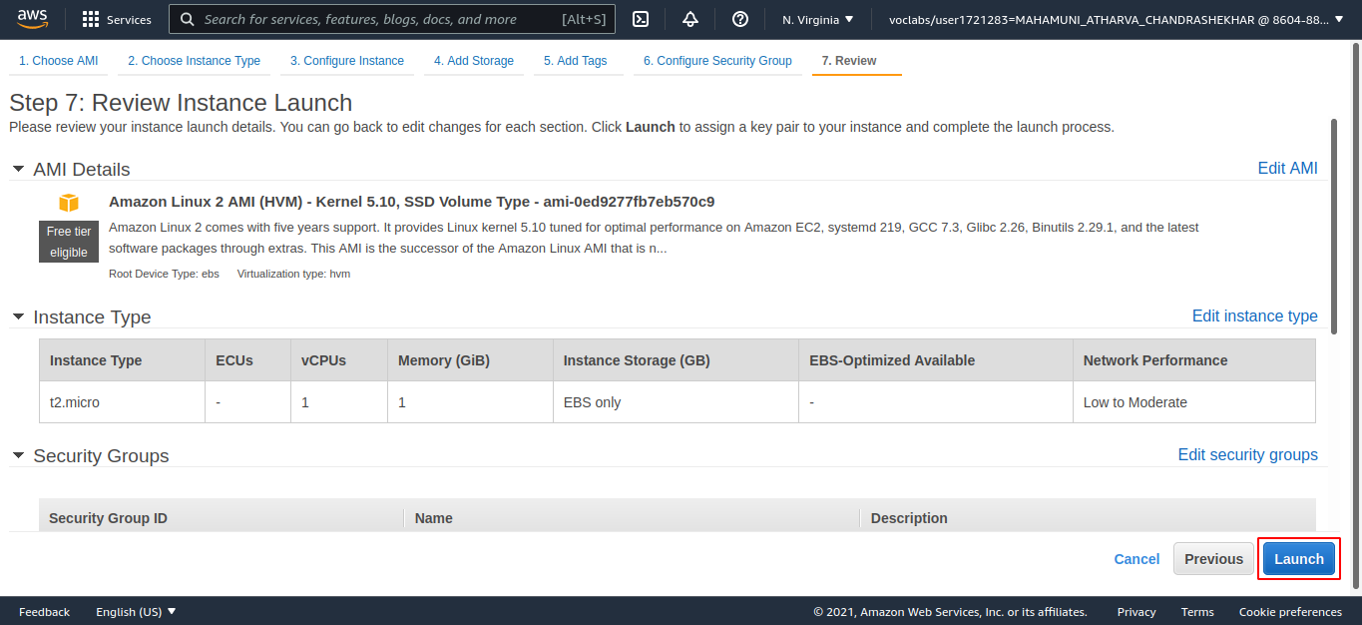

Step 13: A box will appear then select Create a new key pair.

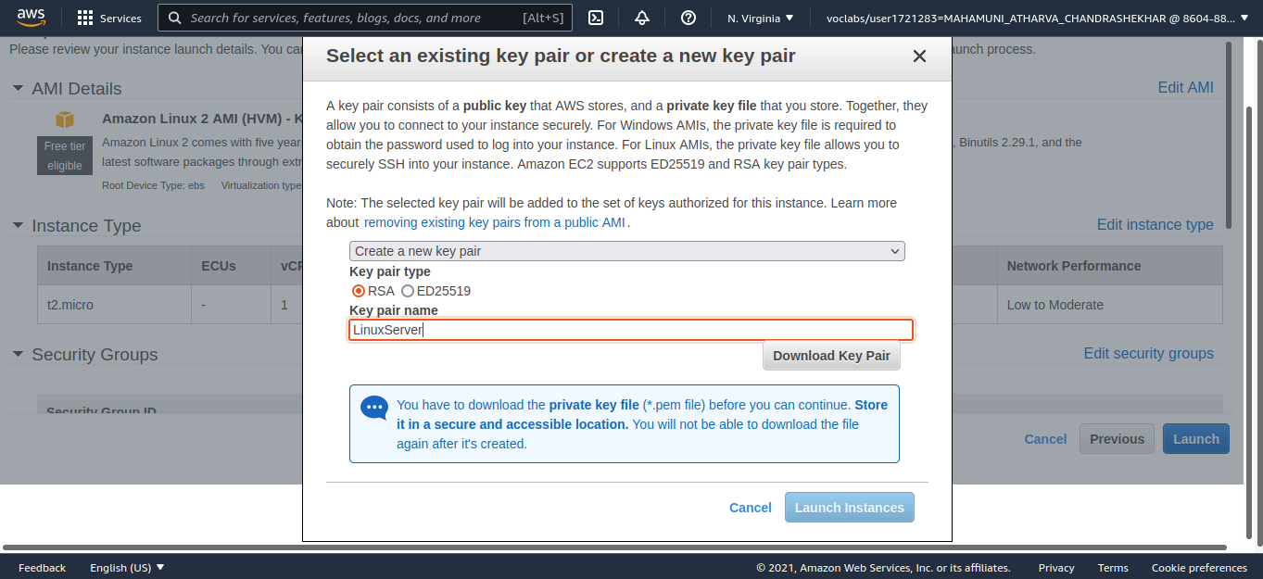
Give it a name and select Download Key Pair
Select Launch Instances.

Step 14: Open terminal and connnect to your instance using SSH.

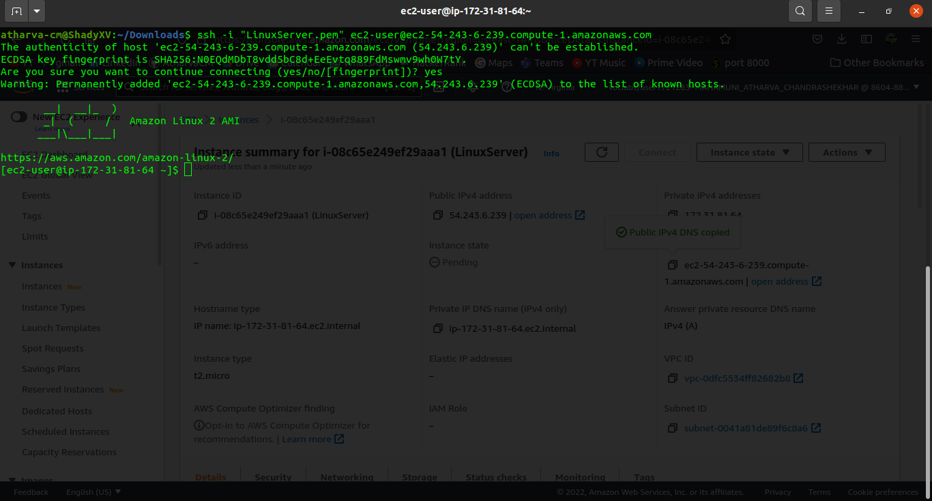

Step 15: Install python3 using following commands.

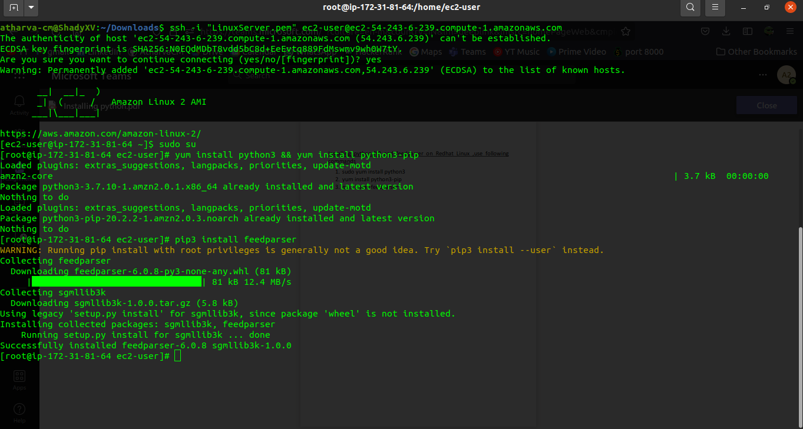

Step 16: Write a feed parser program using nano or vi editor.

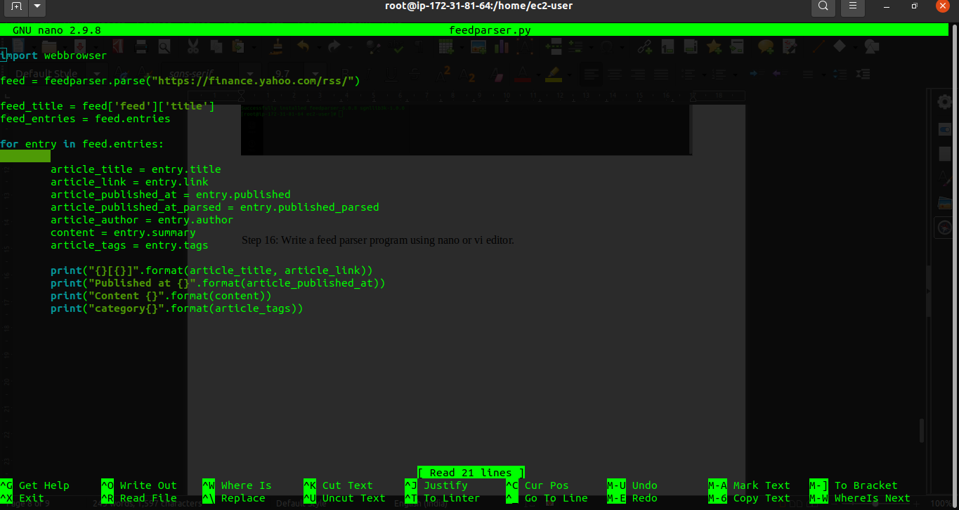

Step 17: execute the program and you will see the rss feed as output.

