Name: Atharva Mahamuni.
Enroll No: 2002276
------------------------------------------------------------------------------------------------------------------------
Cloud Computing
Practical Assignment No. 11
------------------------------------------------------------------------------------------------------------------------
Launch RDS Instance (AWS).

Step 1: At the top right panel above the console, choose Start Lab to launch your lab.

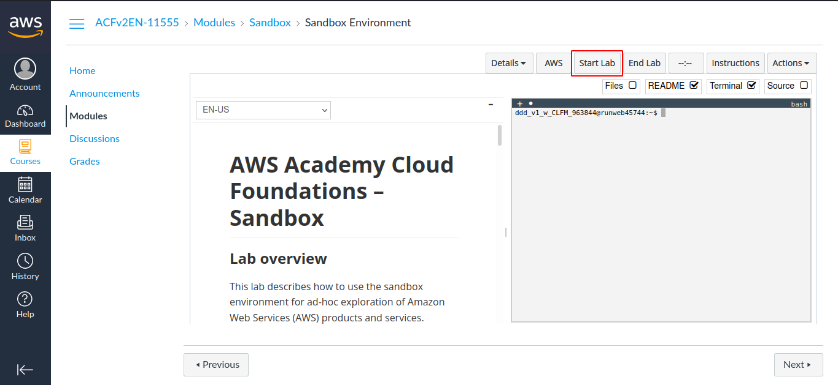

Step 2: Wait until you see the message "Lab status: ready", then choose the X to close the Start Lab panel.

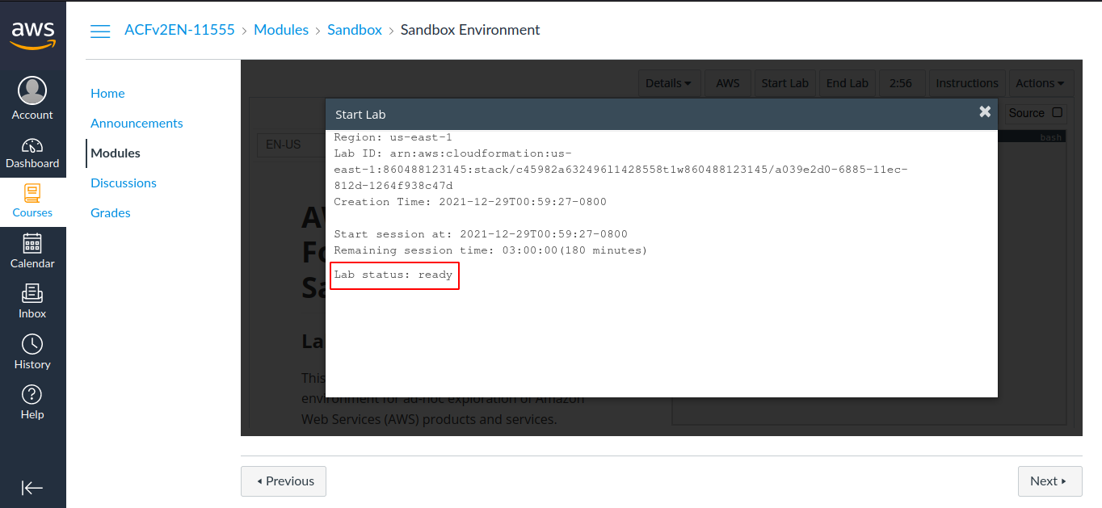

Step 3: Now choose AWS
This will open the AWS Management Console in a new browser tab. The system will automatically log you in.

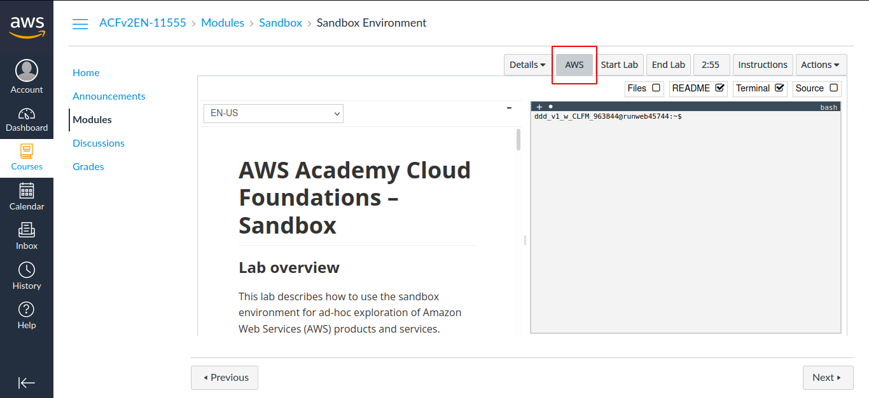

Step 4: In the AWS Management Console on the Services menu, choose VPC.

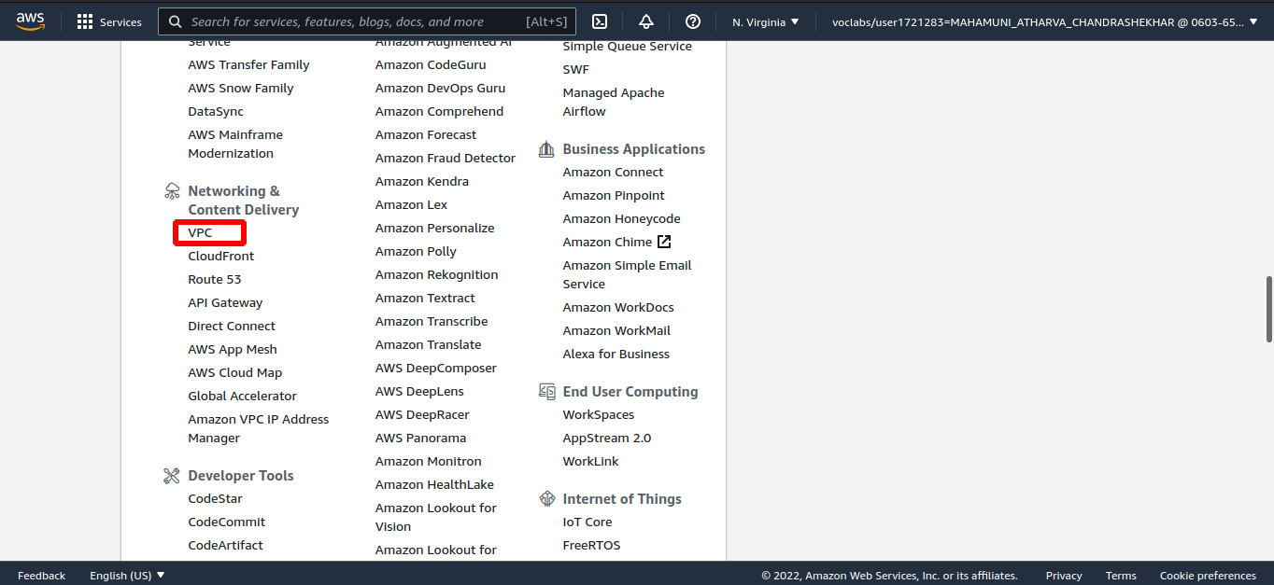

Step 5: In the left navigation pane, choose Security Groups.

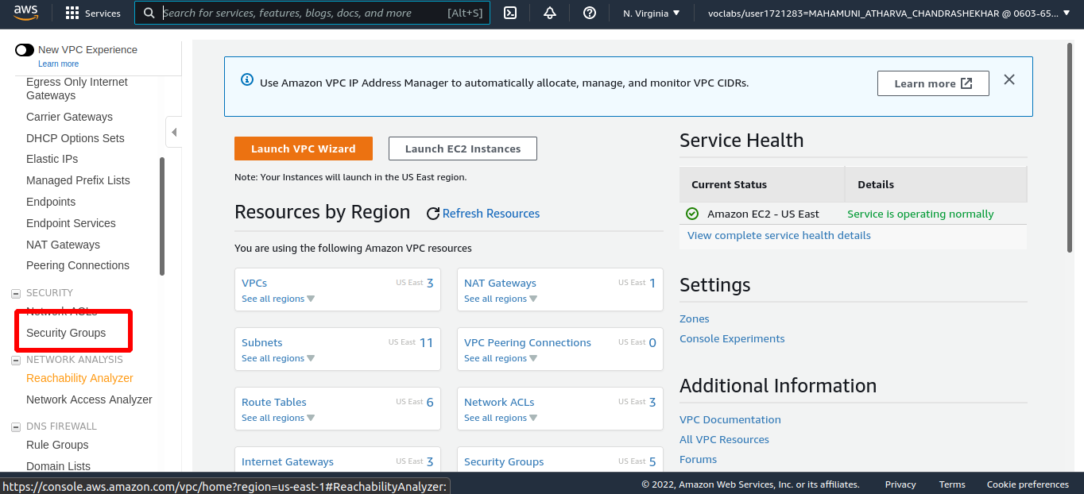

Step 6: Choose Create security group and then configure:

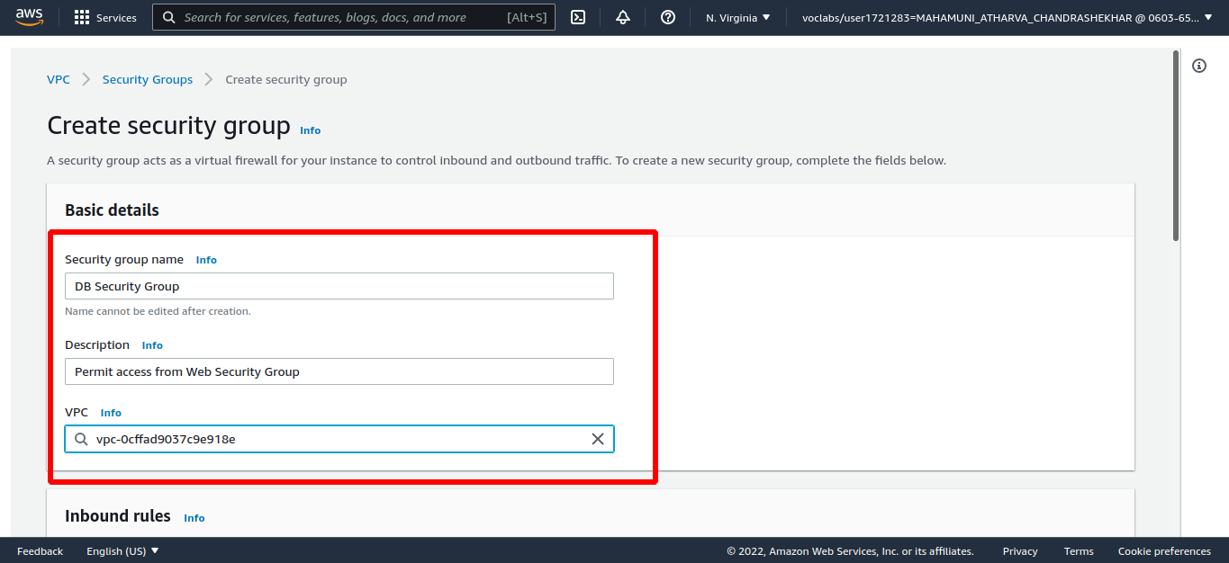

Step 7: In the Inbound rules pane, choose Add rule

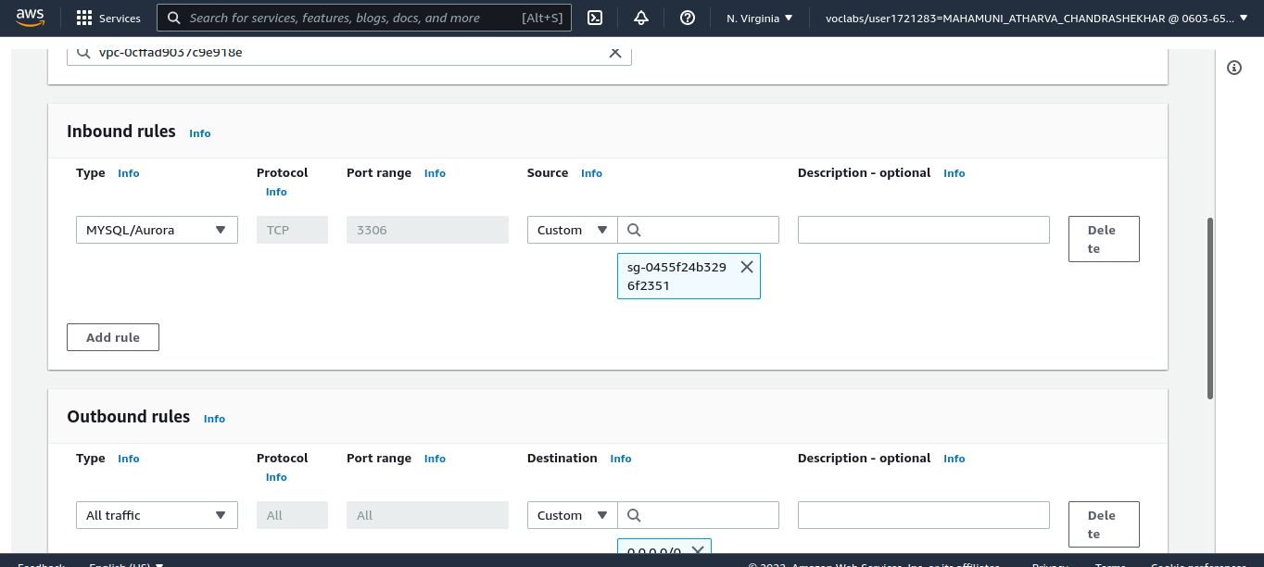
Choose Create security group

Step 8: On the Services menu, choose RDS.

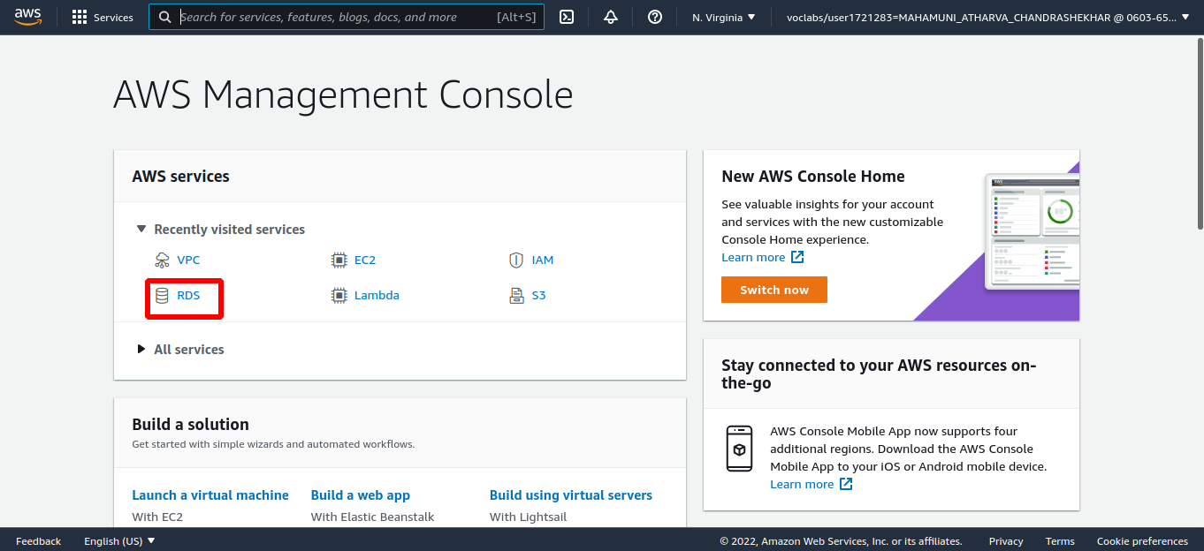

Step 9: In the left navigation pane, choose Subnet groups.
Choose Create DB Subnet Group then configure

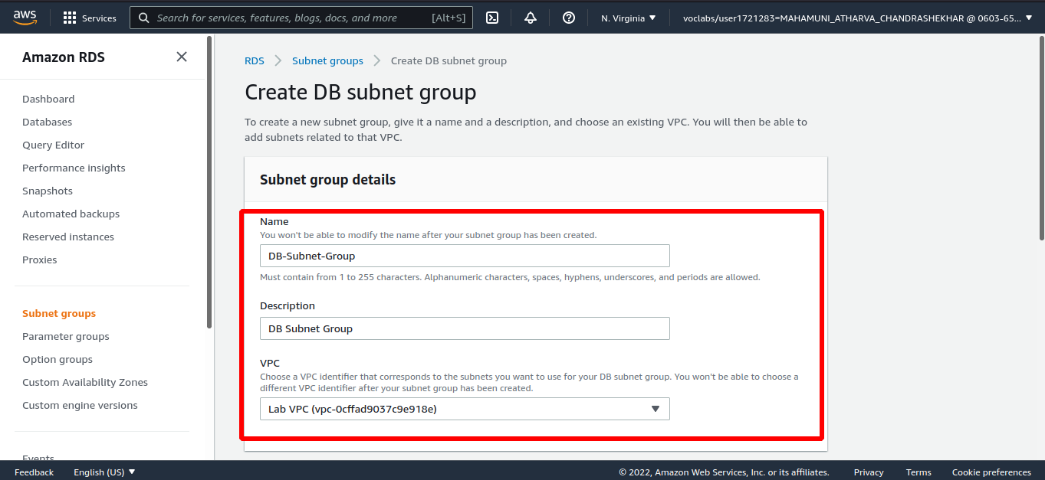
Scroll down to the Add Subnets section.

Step 10: Expand the list of values under Availability Zones and select the first two zones: us-east-1a and us-east-1b.

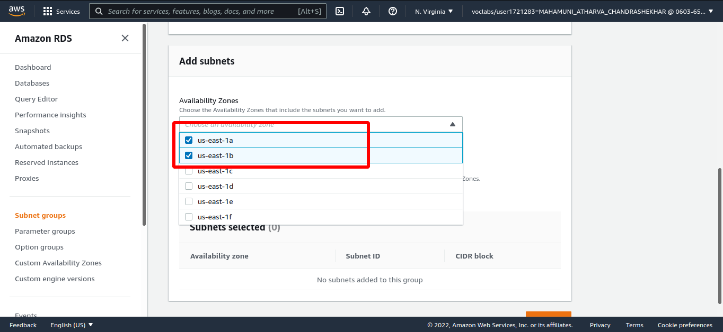

Step 11: Expand the list of values under Subnets and select the subnets associated with the CIDR ranges 10.0.1.0/24 and 10.0.3.0/24.

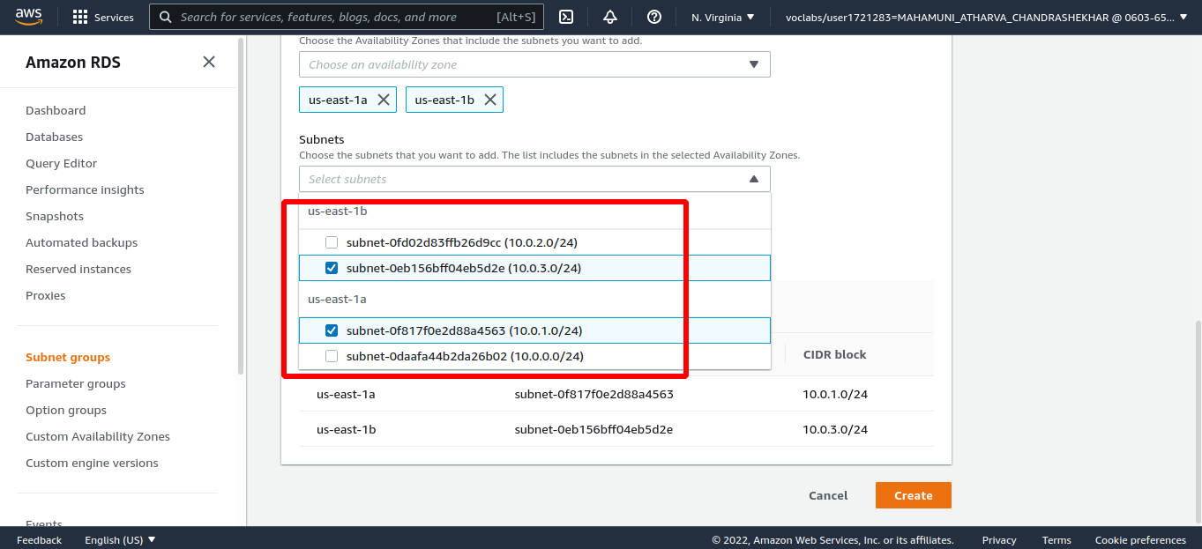
Choose Create

Step 12: In the left navigation pane, choose Databases. Choose Create database
Select MySQL.
- Under Settings, configure:

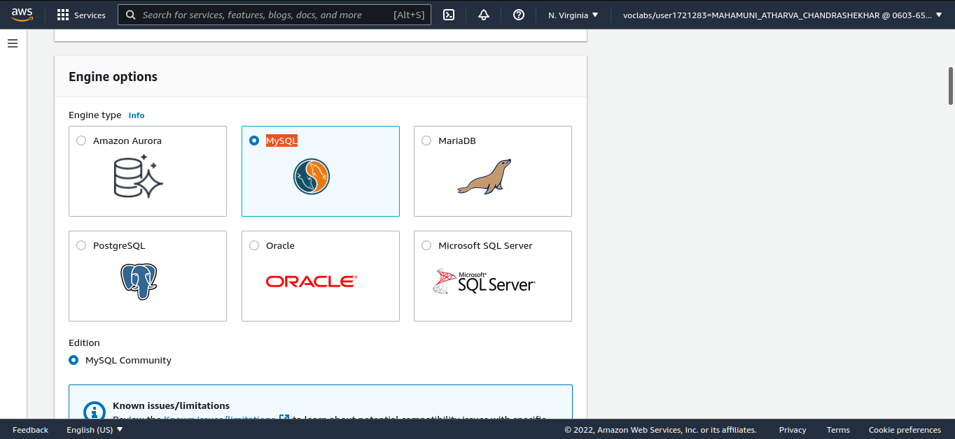
Step 13:
- DB instance identifier: lab-db
- Master username: main
- Master password: lab-password
- Confirm password: lab-password
- Virtual Private Cloud (VPC): Lab VPC
Under Existing VPC security groups, from the dropdown list:
- Choose DB Security Group.
- Deselect default.
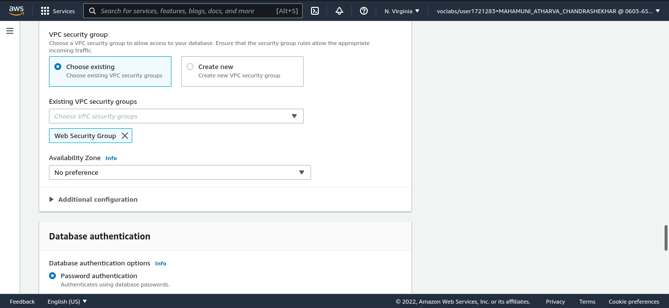

Step 14: Expand Additional configuration, then configure:
- Initial database name: lab
- Uncheck Enable automatic backups, Enable encryption, Enable Enhanced monitoring
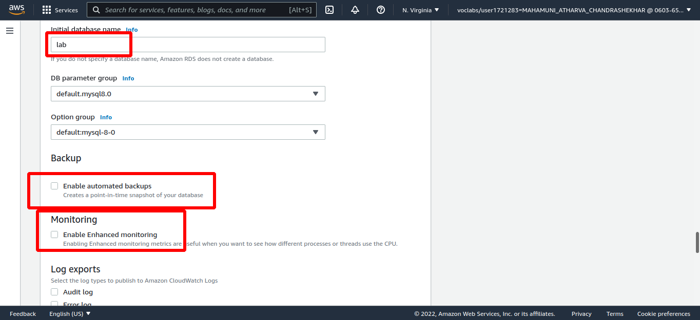

Step 15: Choose Create database, Choose lab-db (choose the link itself).
Wait until Info changes to Modifying or Available.
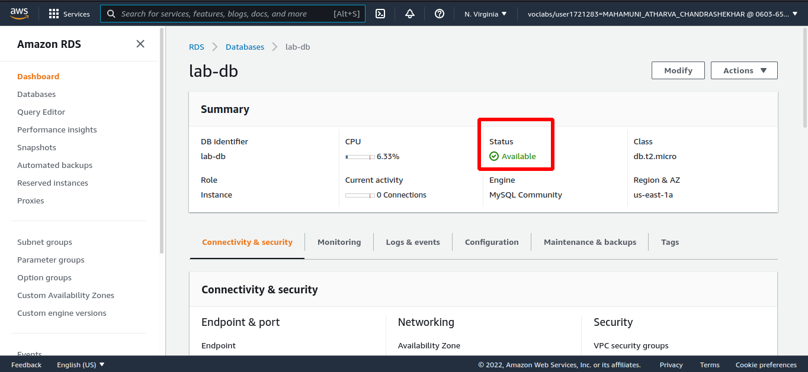

Step 16: Scroll down to the Connectivity & security section and copy the Endpoint field.
Paste the Endpoint value into a text editor. You will use it later in the lab.
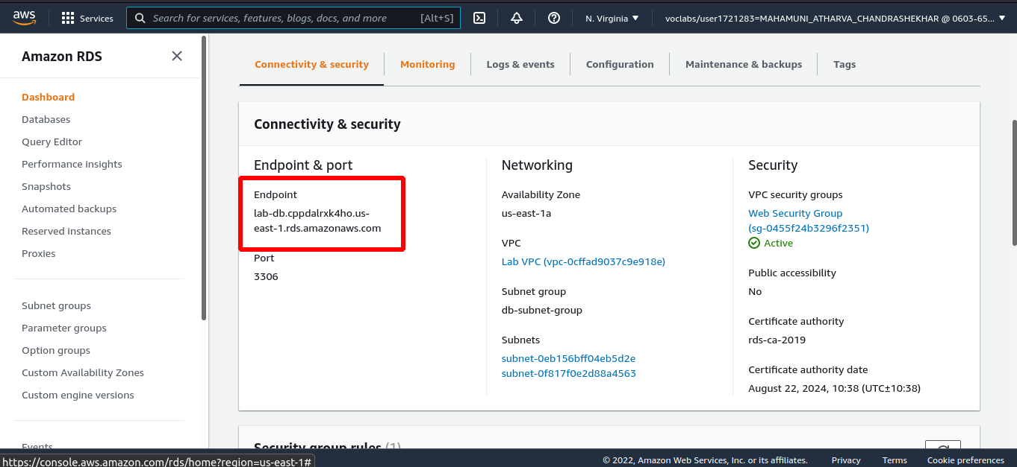

Step 17: Open a new web browser tab, paste the WebServer IP address and press Enter.
The web application will be displayed, showing information about the EC2 instance.
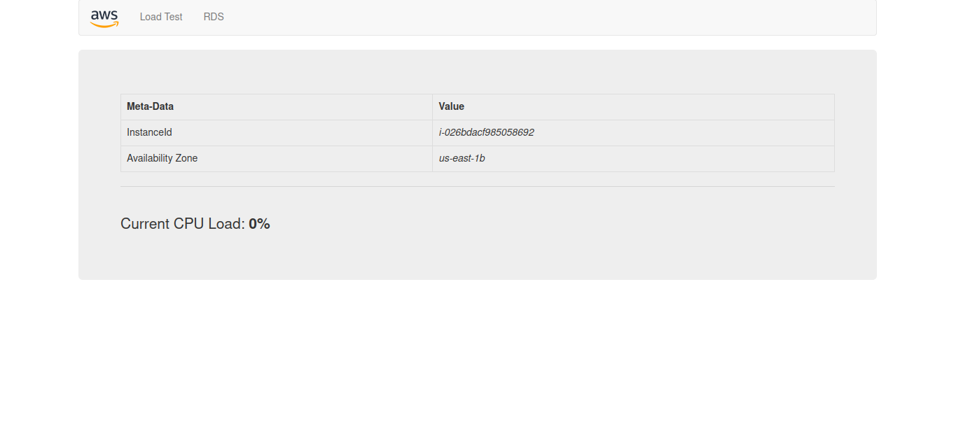

Step 18: Choose the RDS link at the top of the page.
You will now configure the application to connect to your database.
Configure the following settings:
- Endpoint: Paste the Endpoint you copied to a text editor earlier
- Database: lab
- Username: main
- Password: lab-password
- Choose Submit
