Name: Atharva Mahamuni.
Enroll No: 2002276
------------------------------------------------------------------------------------------------------------------------
Cloud Computing
Practical Assignment No. 8 - Working and Implementation of Platform as a service
------------------------------------------------------------------------------------------------------------------------
AWS Elastic Beanstalk: Use this tool to upload sample code for web apps.

Step 1: At the top right panel above the console, choose Start Lab to launch your lab.

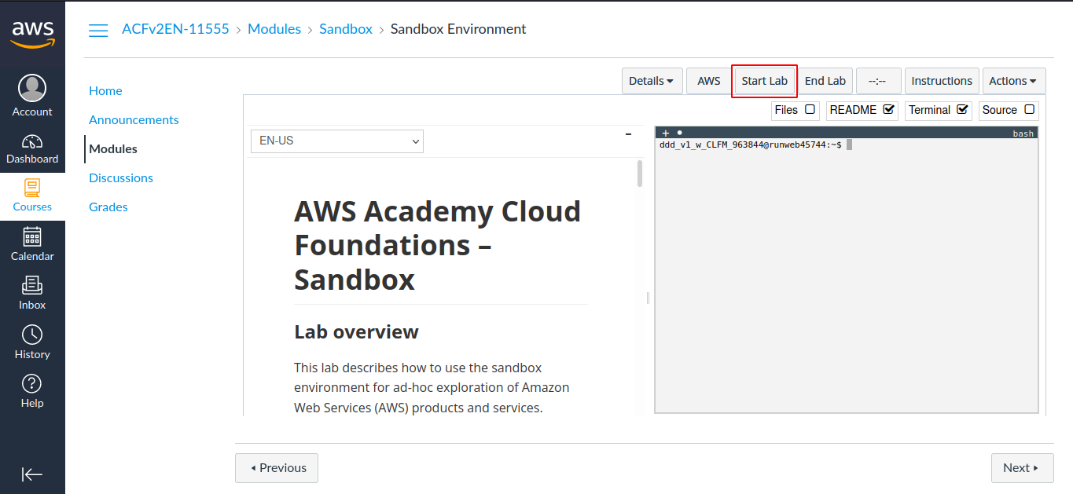

Step 2: Wait until you see the message "Lab status: ready", then choose the X to close the Start Lab panel.

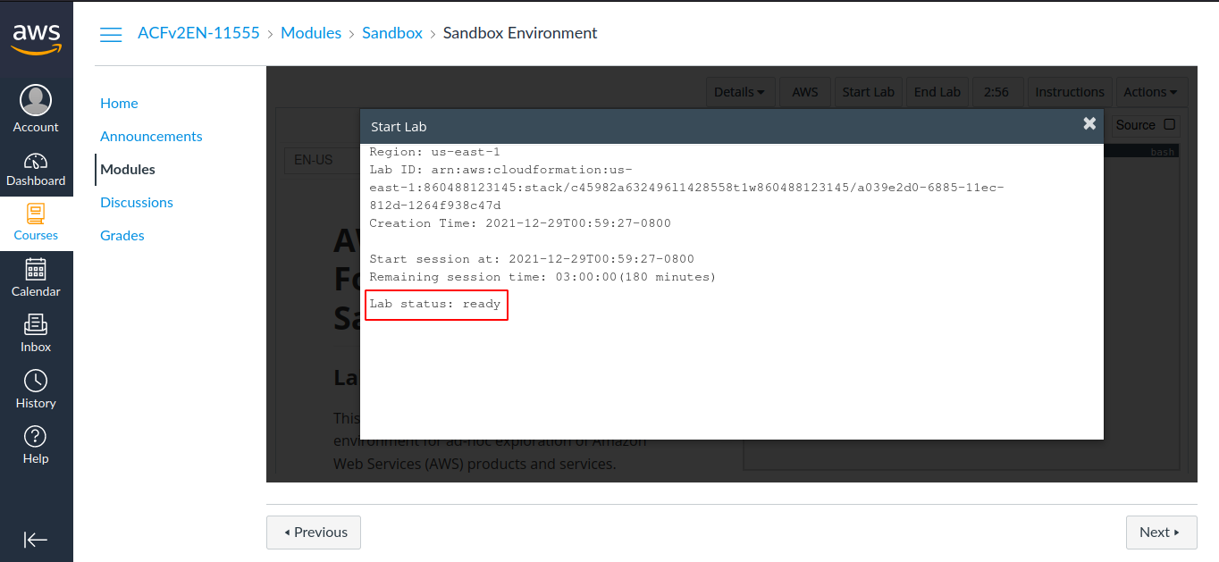

Step 3: Now choose AWS
This will open the AWS Management Console in a new browser tab. The system will automatically log you in.

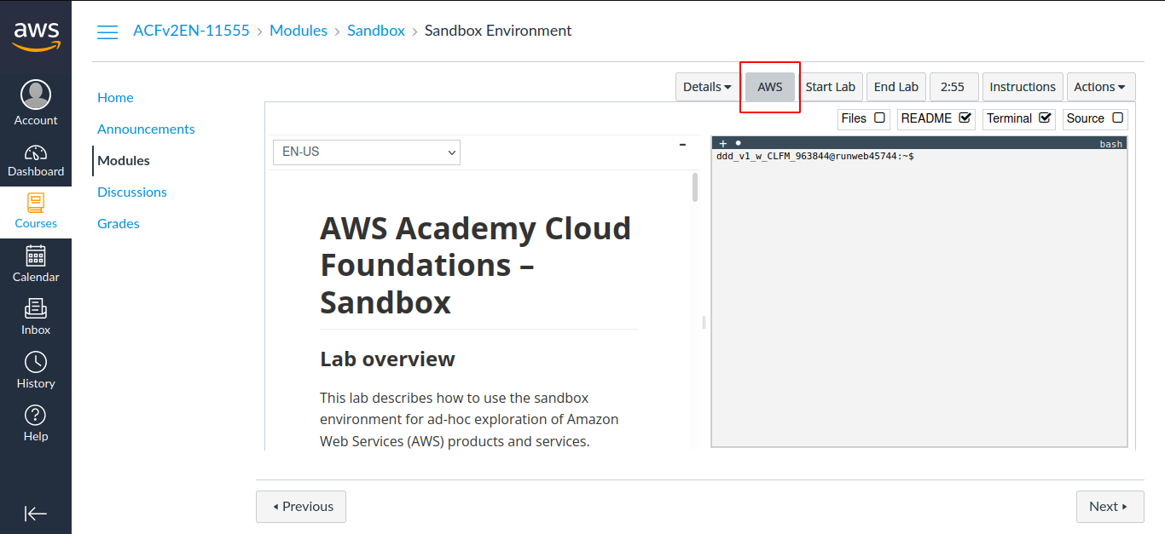

Step 4: In the AWS Management Console on the Services menu, choose Elastic Beanstalk..

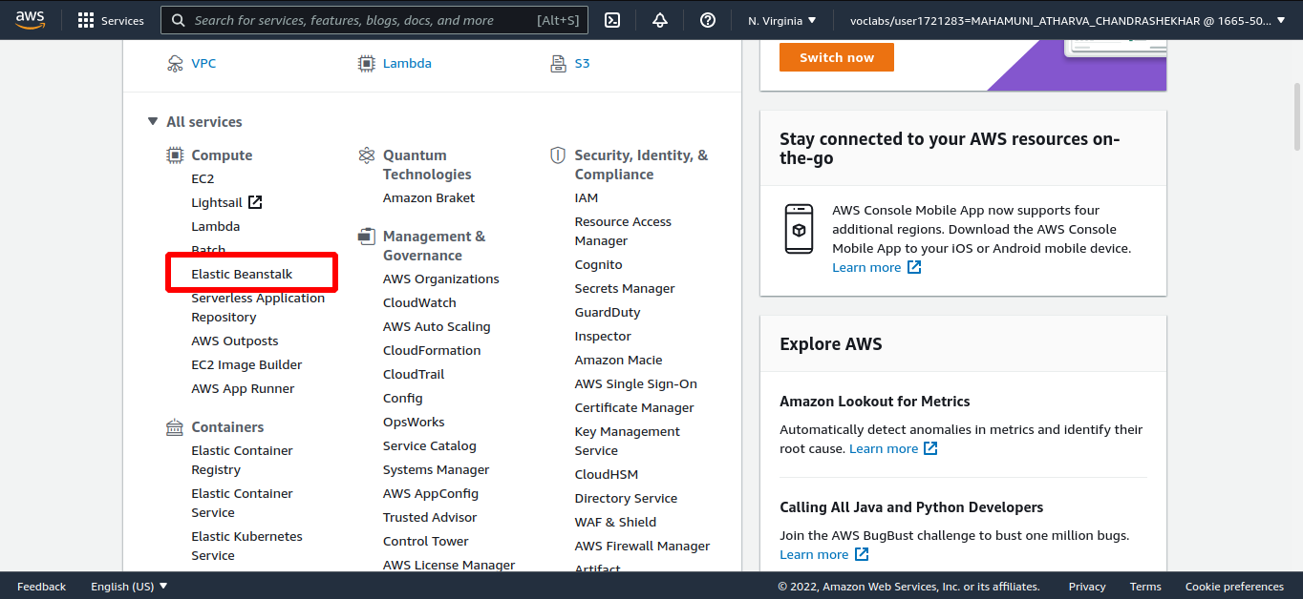

Step 5: Under the Environment name column, choose on the name of the environment.

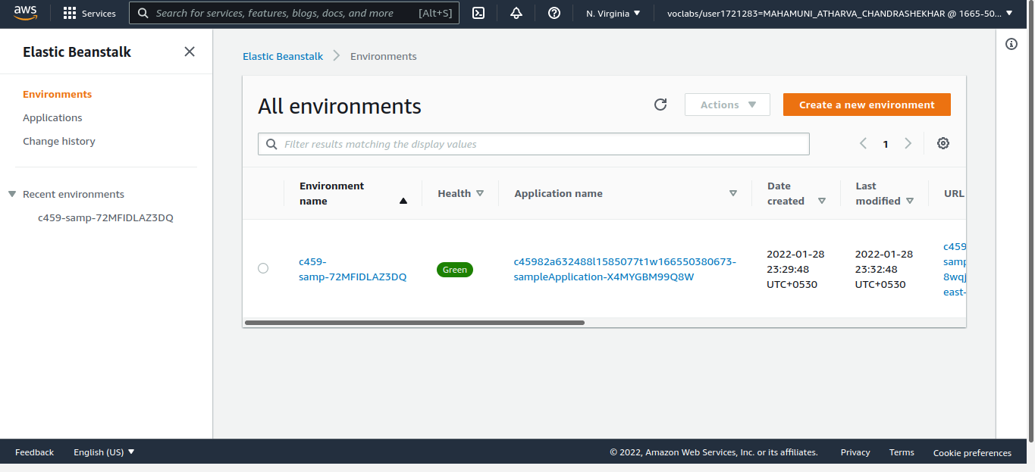

Step 6: Deploy a sample application to Elastic Beanstalk.
In the Elastic Beanstalk Dashboard, choose Upload and Deploy.

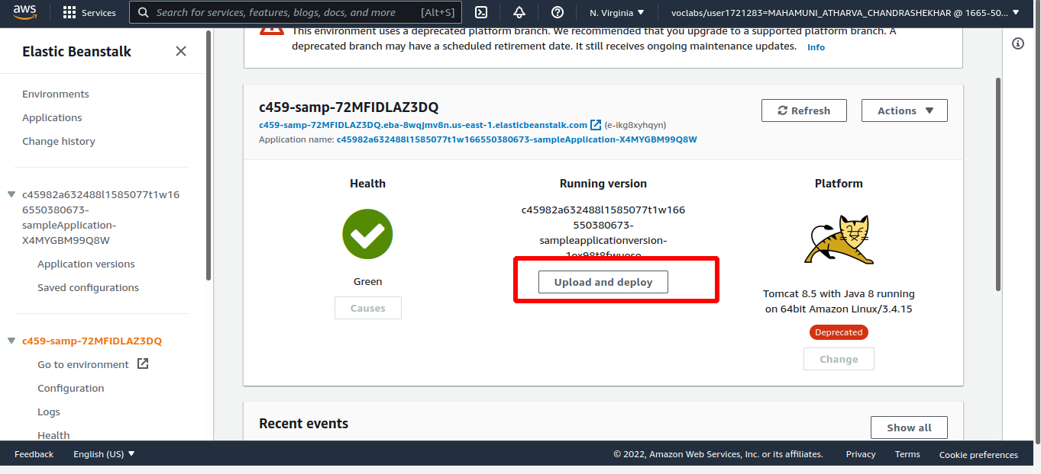

Step 7: Choose Browse or Choose File, then navigate to and open the tomcat.zip file that you just downloaded.

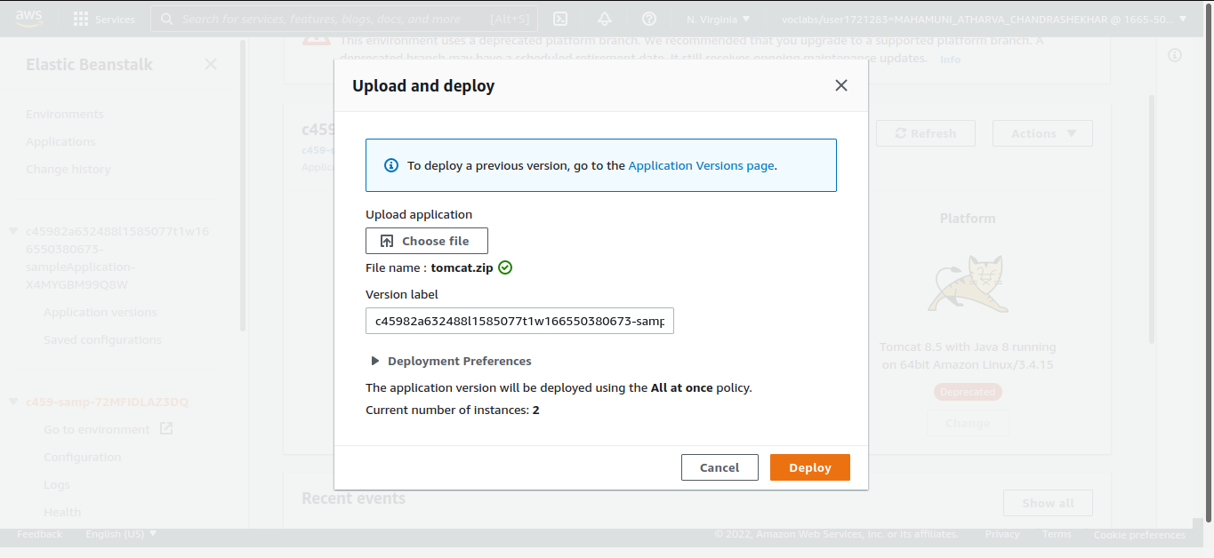
Choose Deploy.

Step 8: After the deployment is complete, choose the URL value near the top of the screen
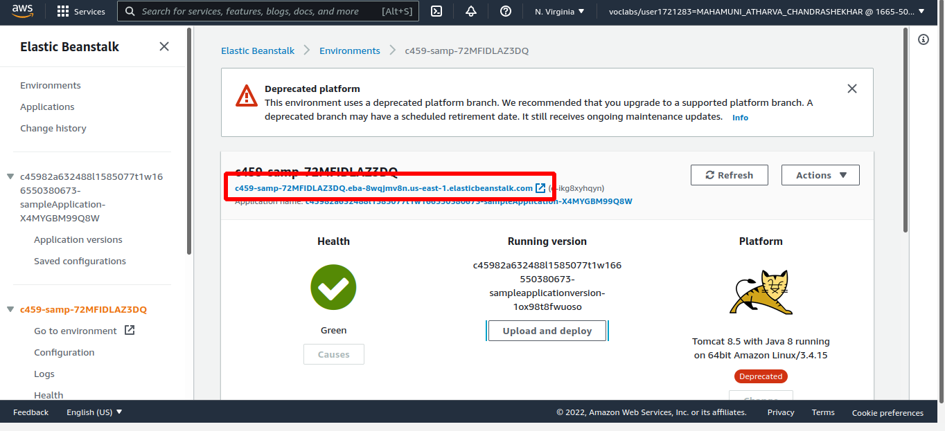
The web application that you deployed displays.

Step 9: In Elastic Beanstalk console, choose Configuration in the left pane.

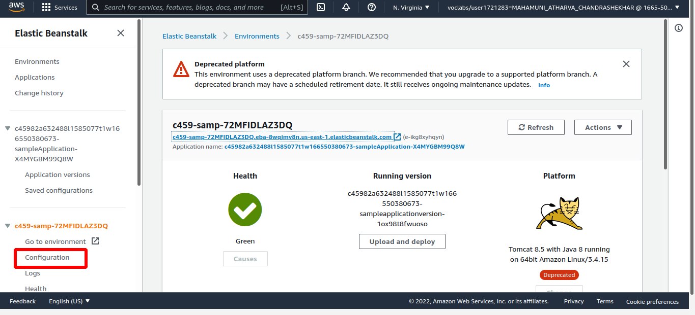

Step 10: Scroll to the bottom of the page to the Database row.
In the Database row, choose Edit.

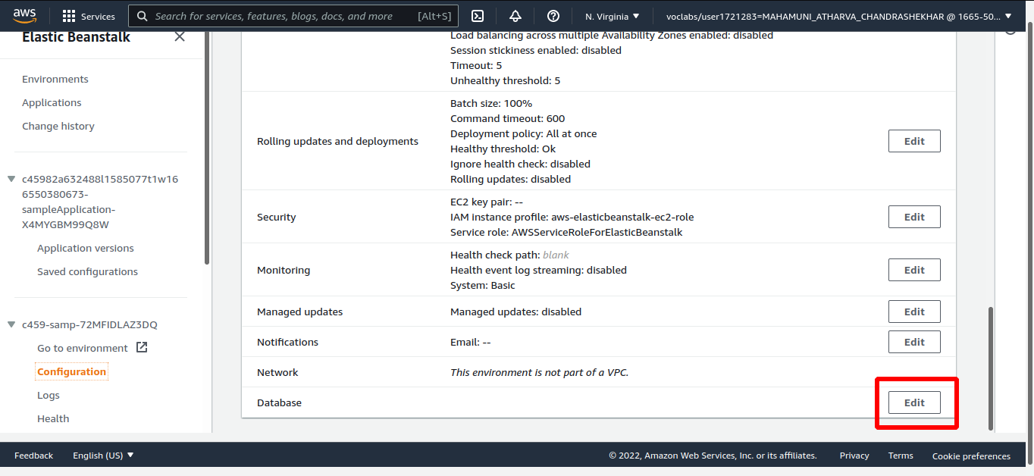

Step 11: Explore the AWS resources that support your application.

